**–Use Database**

Use Ecommerce

**-- 1.1 Select all columns and all rows from the products table**

SELECT * FROM products;

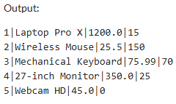

**-- 1.2 Select the name, email, and phone number of all customers**

SELECT Customer_name, Email, Phone_no FROM customers;

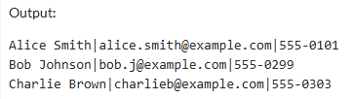

**-- 1.3 Select the Product_name and Price, ordered by Price (descending)**

SELECT Product_name, Price FROM products ORDER BY Price DESC;

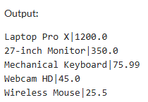

**-- 2.1 Find all orders that are currently 'pending'**

SELECT Order_id, Order_date, Quantity FROM orders WHERE Order_status = 'pending';

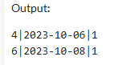

**-- 2.2 Find products that are low in stock (Stock < 20) AND cost more than $100**

SELECT Product_name, Price, Stock FROM products WHERE Stock < 20 AND Price > 100.00;

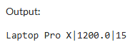

**-- 2.3 Find customers whose name starts with 'A' OR whose address is in 'CityB'**

SELECT Customer_name, Address FROM customers WHERE Customer_name LIKE 'A%' OR Address LIKE '%CityB%';

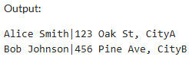

**-- 2.4 Find payments made between October 1st and October 5th, 2023**

SELECT Payment_id, Payment_date, Amount FROM payments WHERE Payment_date BETWEEN '2023-10-01' AND '2023-10-05';

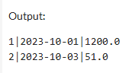

**-- 3.1 Get the 3 cheapest products, ordered by price (ascending)**

SELECT Product_name, Price FROM products ORDER BY Price ASC LIMIT 3;

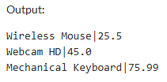

**-- 3.2 Find the details of the most recent order placed (using Order_date)**

SELECT * FROM orders ORDER BY Order_date DESC LIMIT 1;

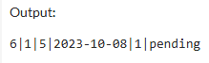

**-- 3.3 Find the details of the oldest completed payment, limited to 1 result**

SELECT * FROM payments WHERE Payment_status = 'completed' ORDER BY Payment_date ASC

LIMIT 1;

