**IBM – BIG DATA ANALYSIS [PH-3]**

**Introduction :**

**In this phase we are going to get the data and to load the data of climate change in different countries and different cities , by using the IBM Db2 service instance, and also to explore the data average temperature in global by running the SQL queries.**

**We will do it by following steps Ahead!**

**Requirements :**

**Ibm Cloud , Dataset**

1. **GO TO CLOUD**

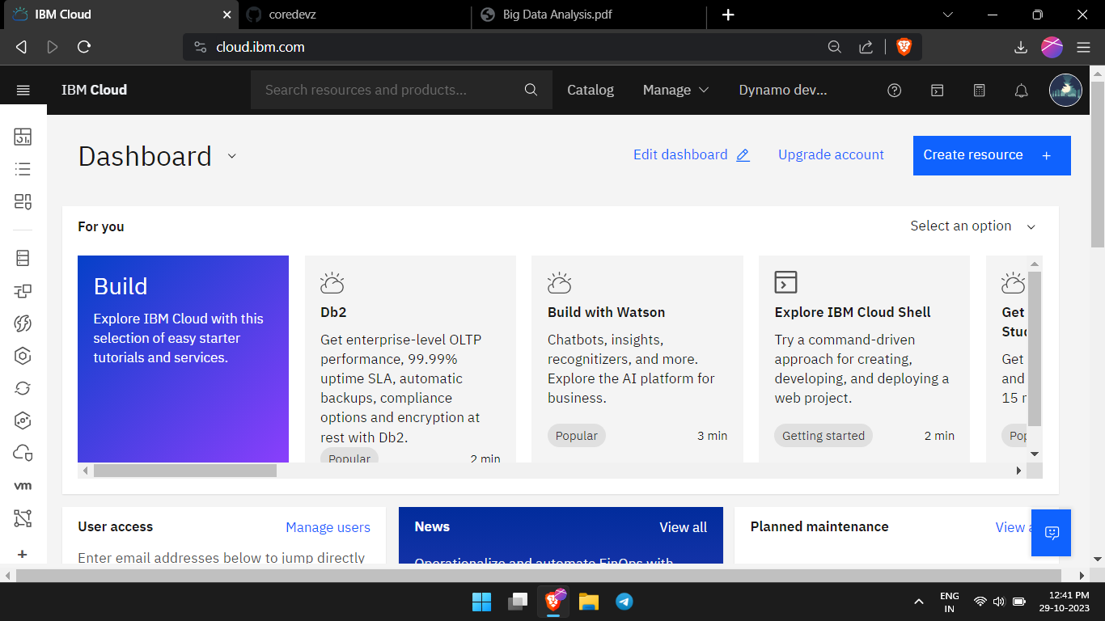

1. **CREATE DB 2 INSTANCE**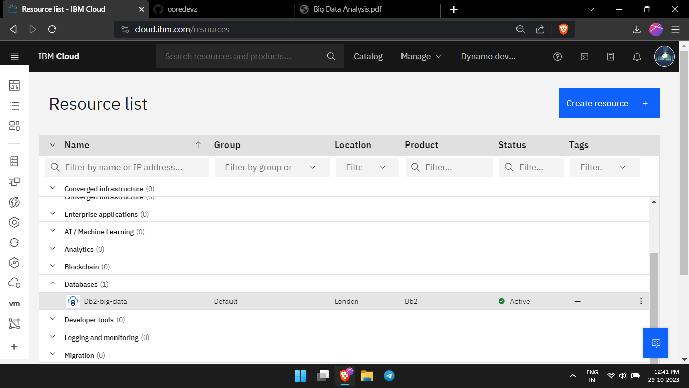
2. **IMPORT THE CSV FILE**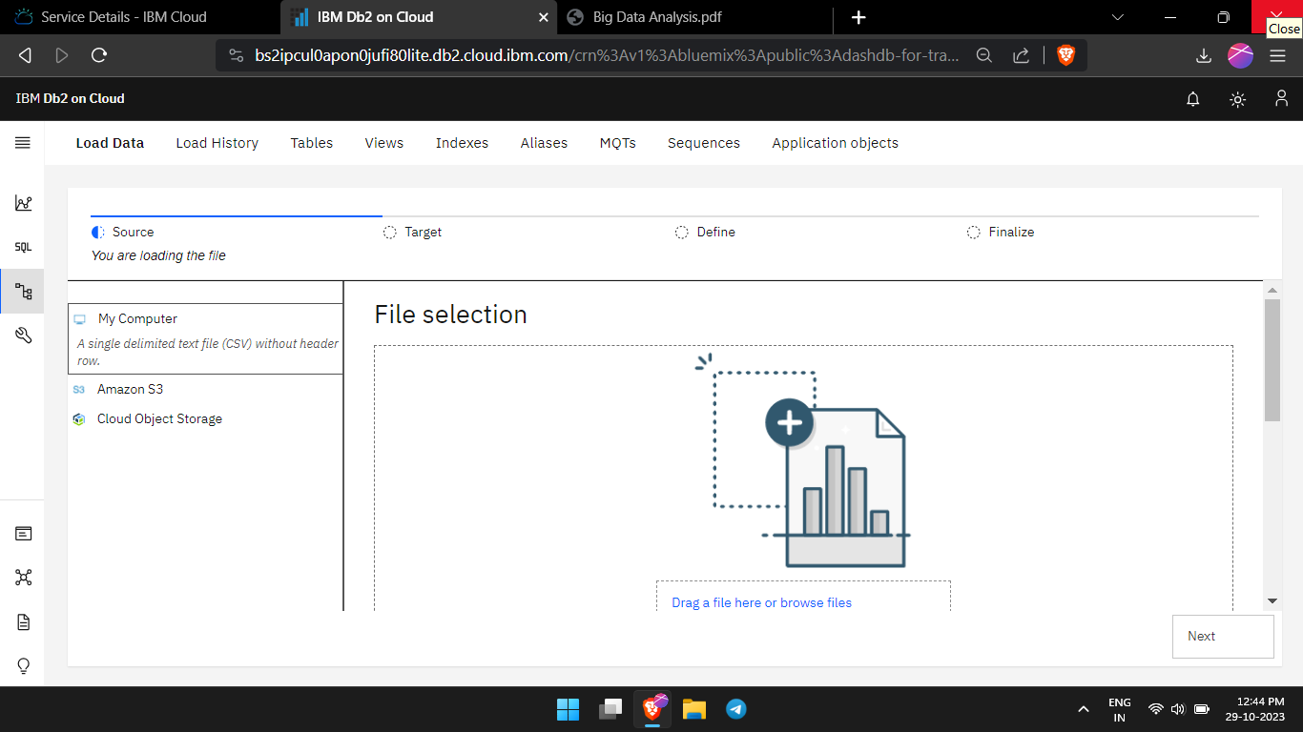
3. **DOWNLOAD THE DATASET**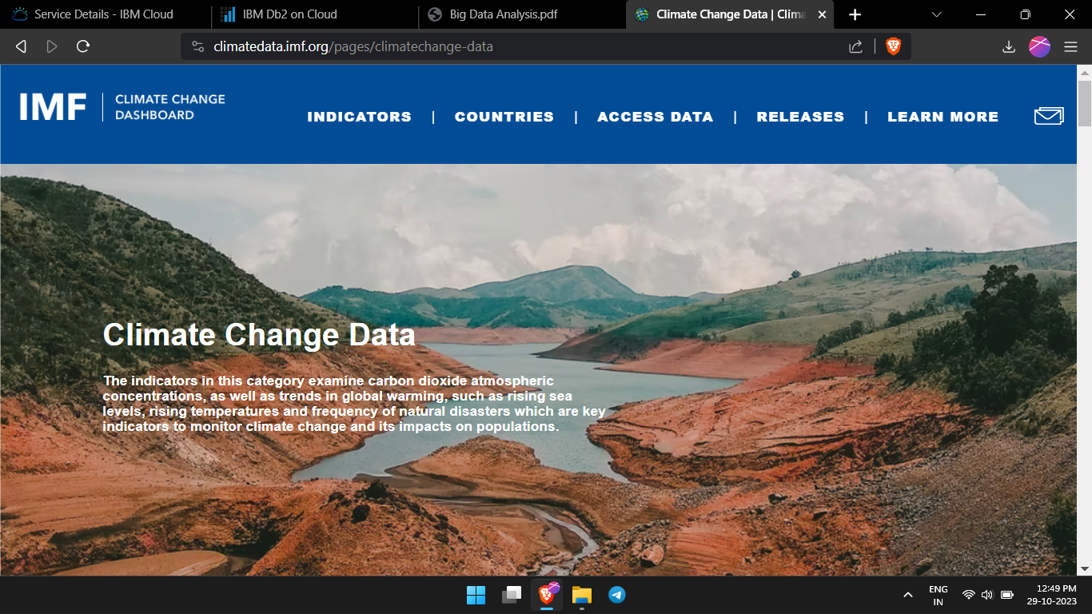
4. **CREATE A SPACE**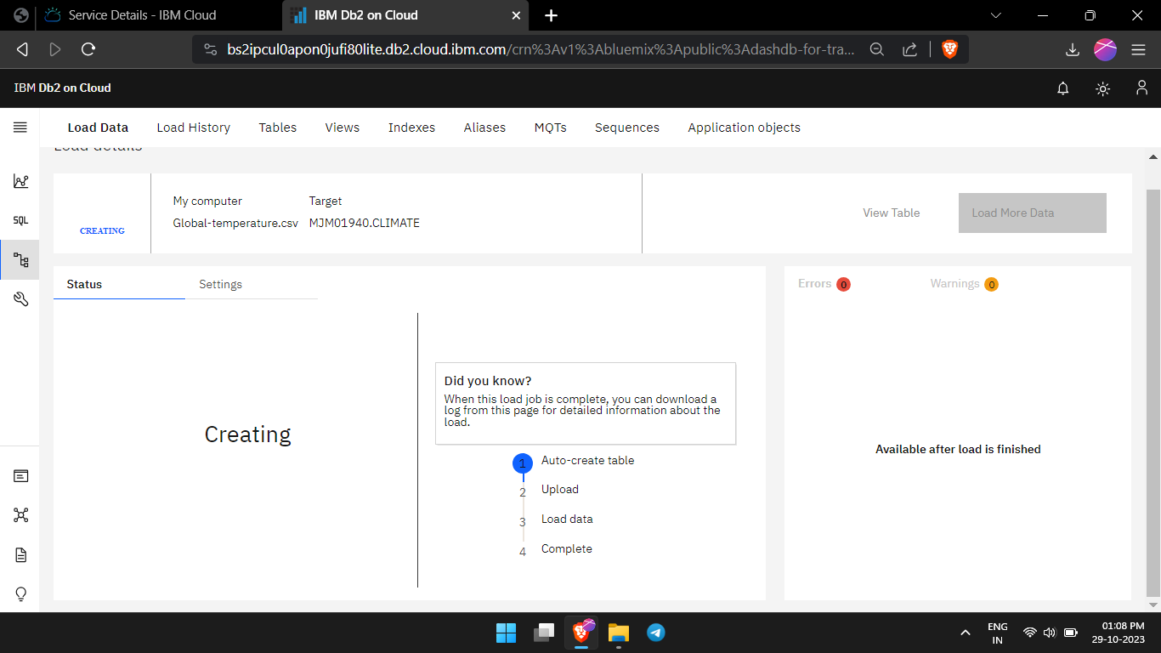
5. **LOAD THE JOB**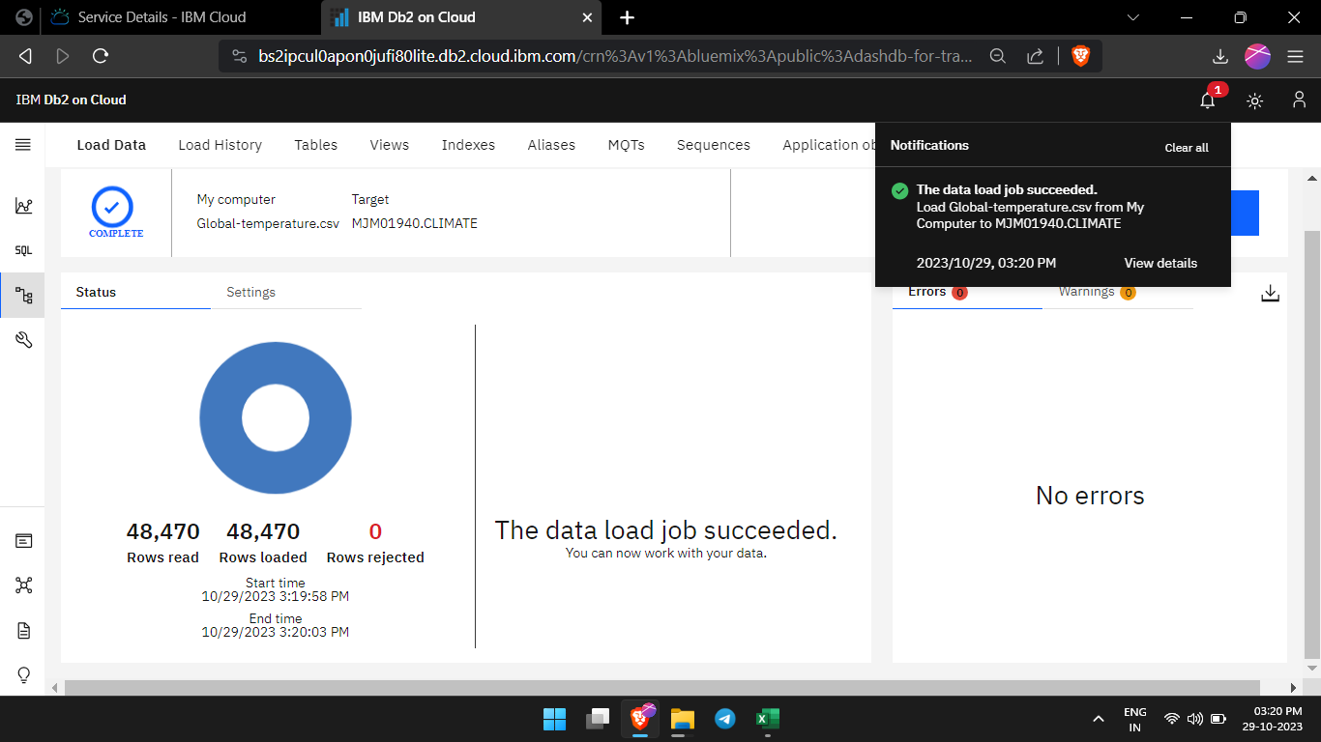
6. **DISPLAY THE DATA**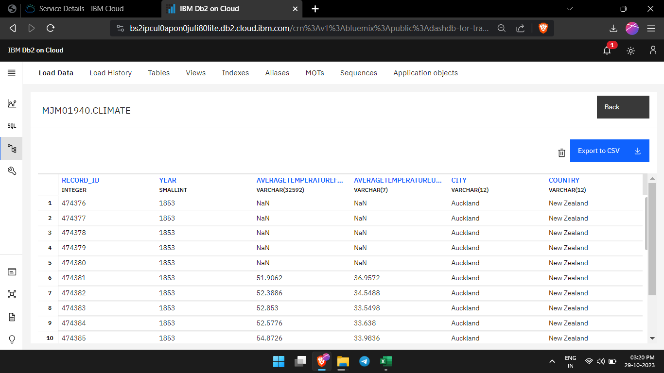
7. **RUN THE SQL SCRIPT**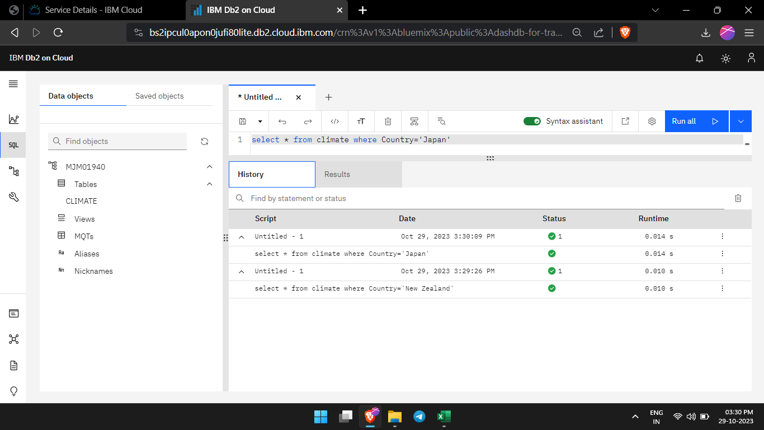
8. **GET THE OITPUT**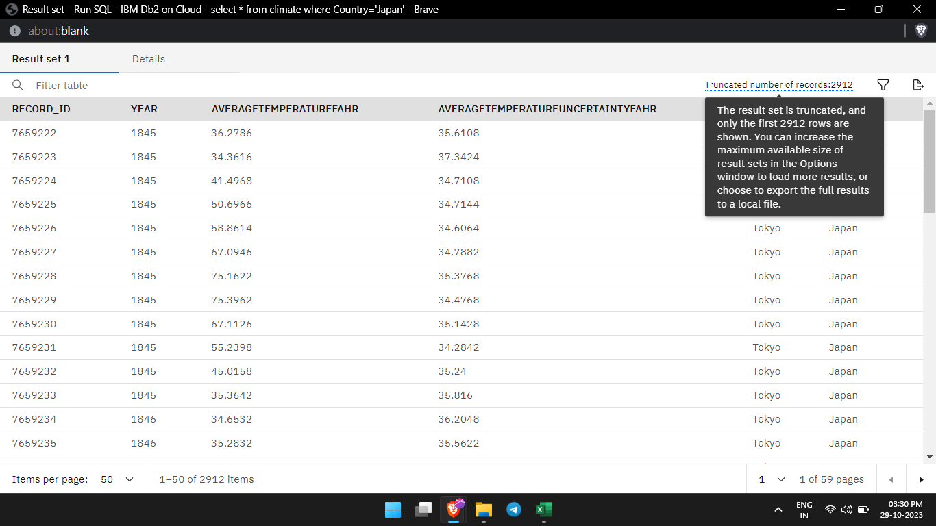
9. **RUN VARIOUS QUERY FOR DATA**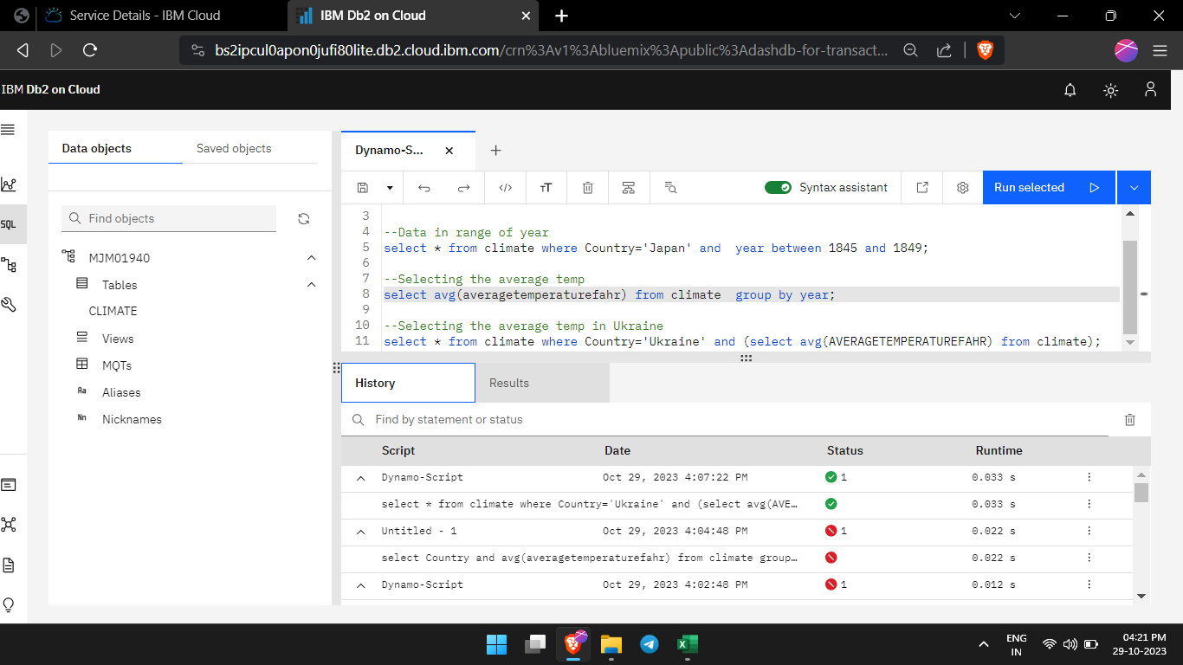
10. **ANALYSE THE RESULTS**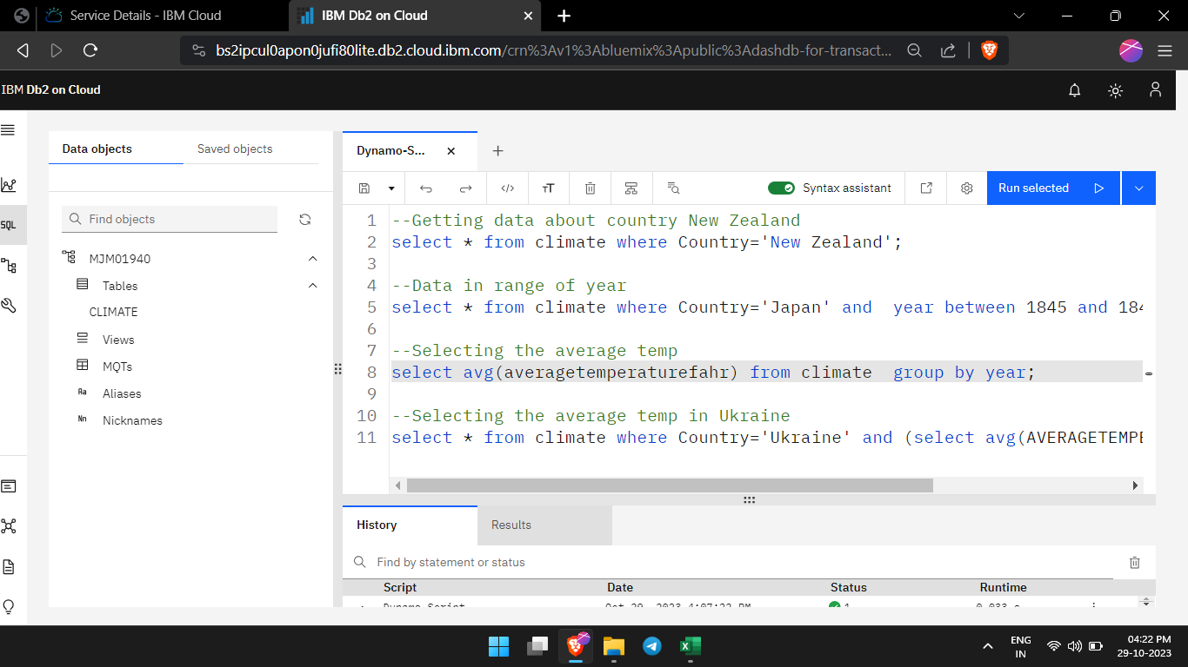
11. **GET THE DATA**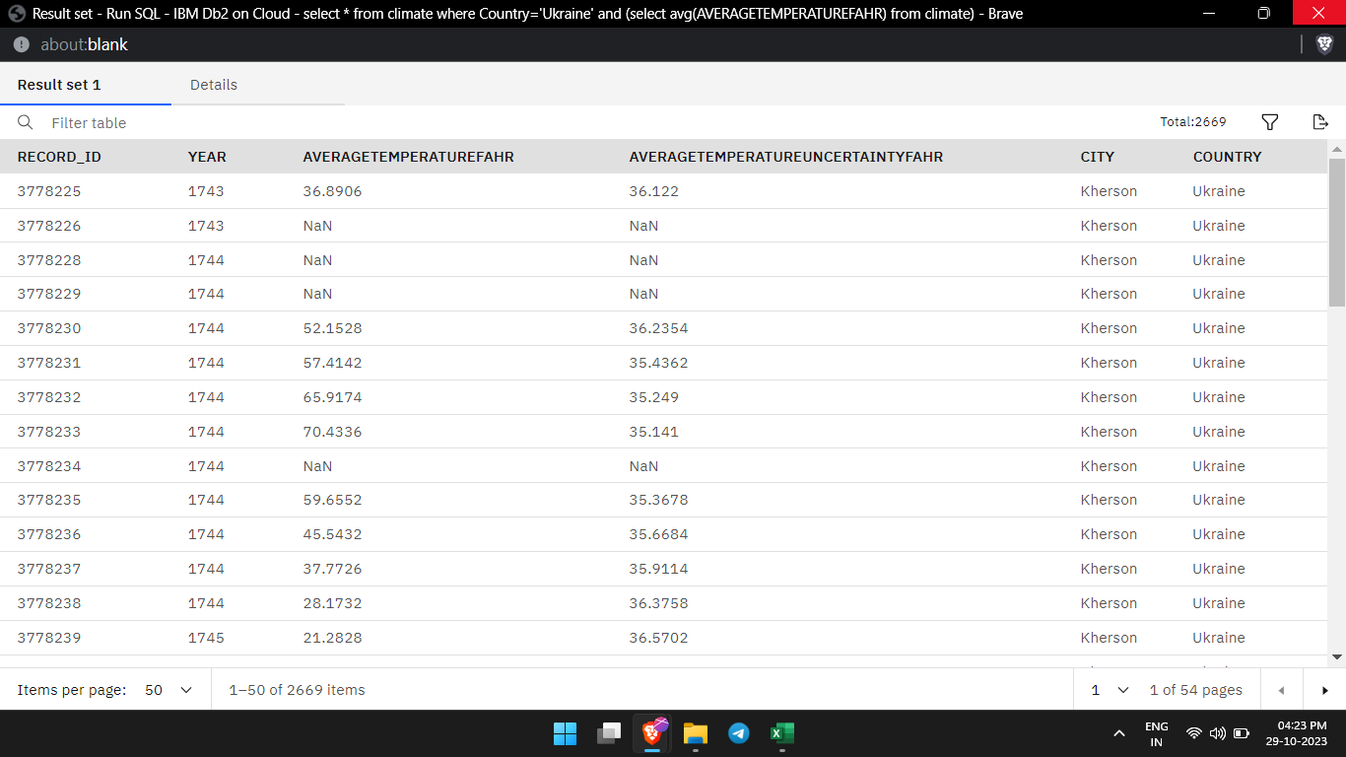

**CONCLUSION :**

Thus we have explored the data in our dataset of climate change in our globe respectively by using the IBM Db2