|  |
| --- |
| **IMAGE SCRAPPER** |

Please find the screenshots of the image scrapper project below. Here I have given the search term as ‘Tiger” and number of images to retrieve is 5.

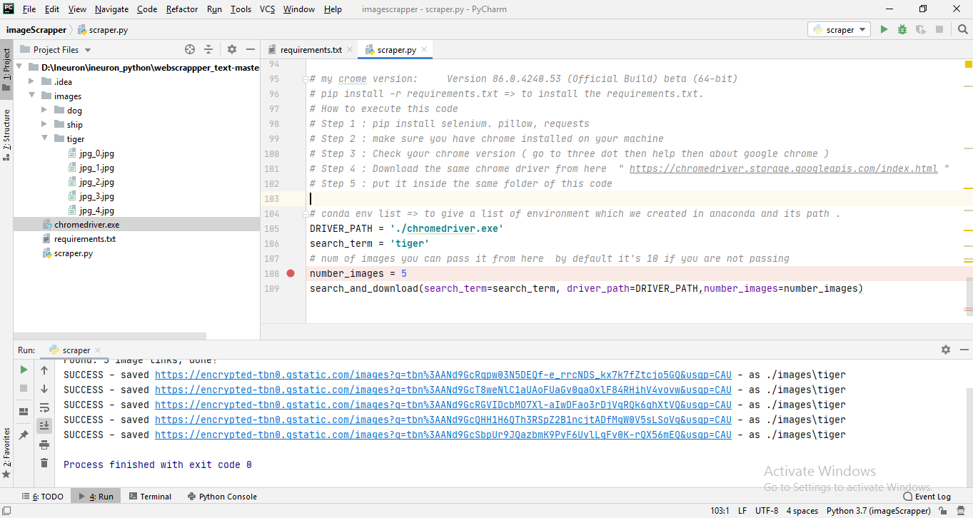

Screenshot while chromedriver is executing to fetch the images automatically as mentioned in the code.

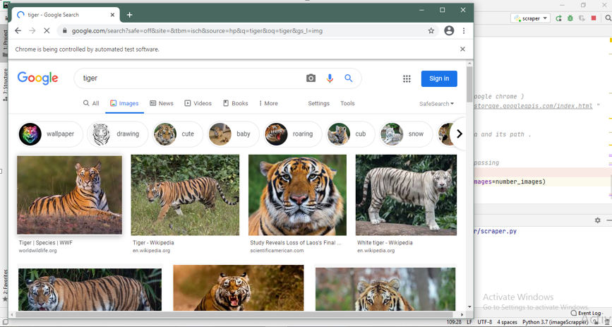

After the successful execution of the image scrapper code, the images are stored in the ‘tiger’ folder inside the project folder.

