**GITHUB:**

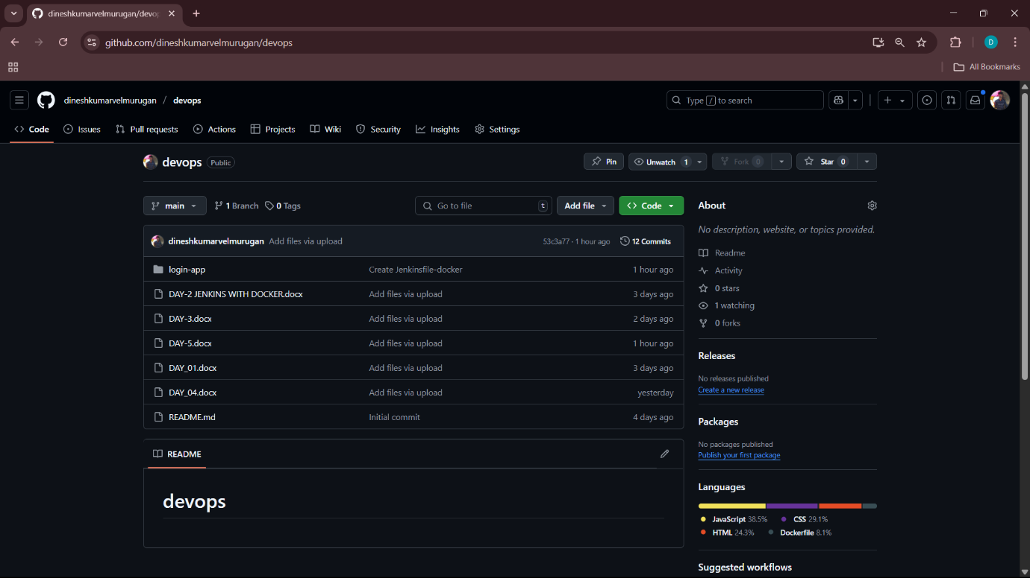

**BUILD:**

**STATUS:**

**CONSOLE OUTPUT:**

**DOCKERFILE:**

**# Use Node.js image for building the React app**

**FROM node:18 AS build**

**# Set working directory in container**

**WORKDIR /app**

**# Copy package.json and package-lock.json**

**COPY package.json package-lock.json ./**

**# Install dependencies**

**RUN npm install**

**# Copy all source files**

**COPY . .**

**# Build the React app**

**RUN npm run build**

**# Use Nginx for serving the build files**

**FROM nginx:latest**

**# Copy built files from previous step to Nginx HTML directory**

**COPY --from=build /app/build /usr/share/nginx/html**

**# Expose port 5003**

**EXPOSE 5003**

**# Start Nginx**

**CMD ["nginx", "-g", "daemon off;"]**

**JENKINS FILE:**

**pipeline {**

**agent any**

**environment {**

**IMAGE_NAME = "dineshv2307/react"**

**CONTAINER_NAME = "devops-react-app"**

**PORT = "5003"**

**}**

**stages {**

**stage('Clone Repository') {**

**steps {**

**git 'https://github.com/dineshkumarvelmurugan/devops.git'**

**}**

**}**

**stage('Install Dependencies') {**

**steps {**

**script {**

**sh 'npm install'**

**}**

**}**

**}**

**stage('Build Docker Image') {**

**steps {**

**script {**

**sh 'docker build -t $IMAGE_NAME .'**

**}**

**}**

**}**

**stage('Run Docker Container') {**

**steps {**

**script {**

**sh 'docker stop $CONTAINER_NAME || true'**

**sh 'docker rm $CONTAINER_NAME || true'**

**sh 'docker run -d --name $CONTAINER_NAME -p $PORT:80 $IMAGE_NAME'**

**}**

**}**

**}**

**}**

**post {**

**success {**

**echo '🎉 Deployment successful! Visit http://localhost:5003'**

**}**

**failure {**

**echo '❌ Deployment failed. Check logs.'**

**}**

**}**

**}**

**PROJECT OUTPUT:**

