E-COMMERCE SALES ANALYSIS
Dashboard Report | KPI Definitions, Trends & Business Insights
Reporting period: 01 January 2026 to 25 September 2026

1. Executive Summary
The workbook contains 112 order records across 30 unique customers. Total recorded revenue is ₹3,406,965.00, total cost is ₹2,643,540.47, and calculated profit is ₹768,580.58. The overall profit margin is 22.6%. Average order value is ₹34,069.65, with 306 units sold.
Profit is calculated as Sales_Amount minus Cost. Profit margin is Profit divided by Sales_Amount. These figures are descriptive of the supplied dataset and should be validated against the business's accounting definitions before being used for financial reporting.

2. KPI Scorecard
KPI | Result | Definition
Total Revenue | ₹3,406,965.00 | Sum of Sales_Amount
Total Cost | ₹2,643,540.47 | Sum of Cost
Total Profit | ₹768,580.58 | Revenue − Cost
Profit Margin | 22.6% | Profit ÷ Revenue
Total Orders | 100 | Distinct Order_ID values
Unique Customers | 30 | Distinct Customer_ID values
Units Sold | 306 | Sum of Quantity
Average Order Value | ₹34,069.65 | Revenue ÷ orders
Average Discount | 13.3% | Average row-level discount
Completed / Cancelled / Returned | 81 / 12 / 8 | Rows in each status
Completion Rate | 72.3% | Completed rows ÷ all rows

3. Revenue Trend
The monthly revenue chart helps identify seasonal peaks, softer months, and possible changes in demand. Use it alongside monthly profit to distinguish high-sales periods from periods that are also profitable.
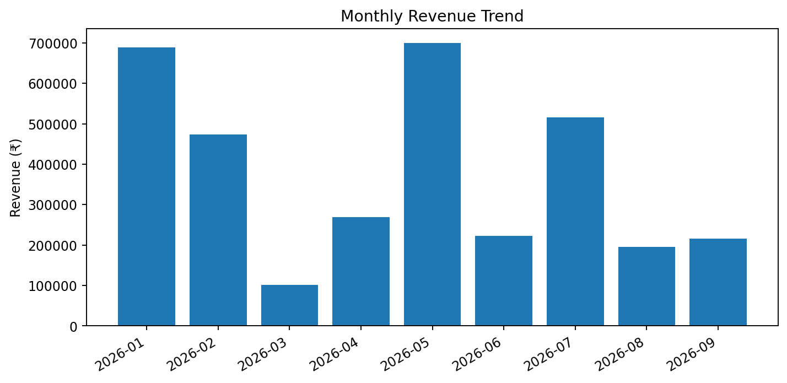
Highest-revenue month in the dataset: 2026-05 (₹699,620.00). Lowest-revenue month: 2026-03 (₹101,460.00).

4. Category Performance
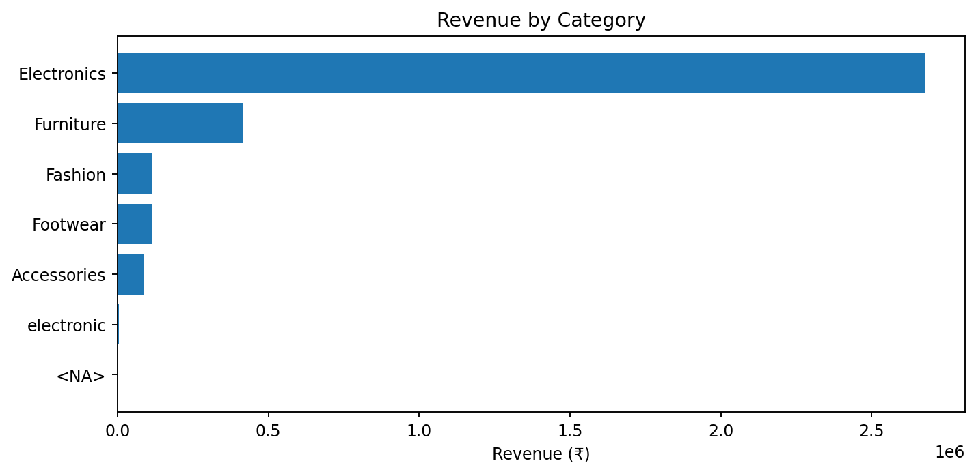
The highest-revenue category is Electronics with ₹2,676,345.00 in revenue and ₹646,426.71 in calculated profit. Review profit margin by category before prioritizing promotions.
A category can lead in revenue without leading in profit. Compare revenue, profit, and margin together when making merchandising decisions.

5. Regional Performance
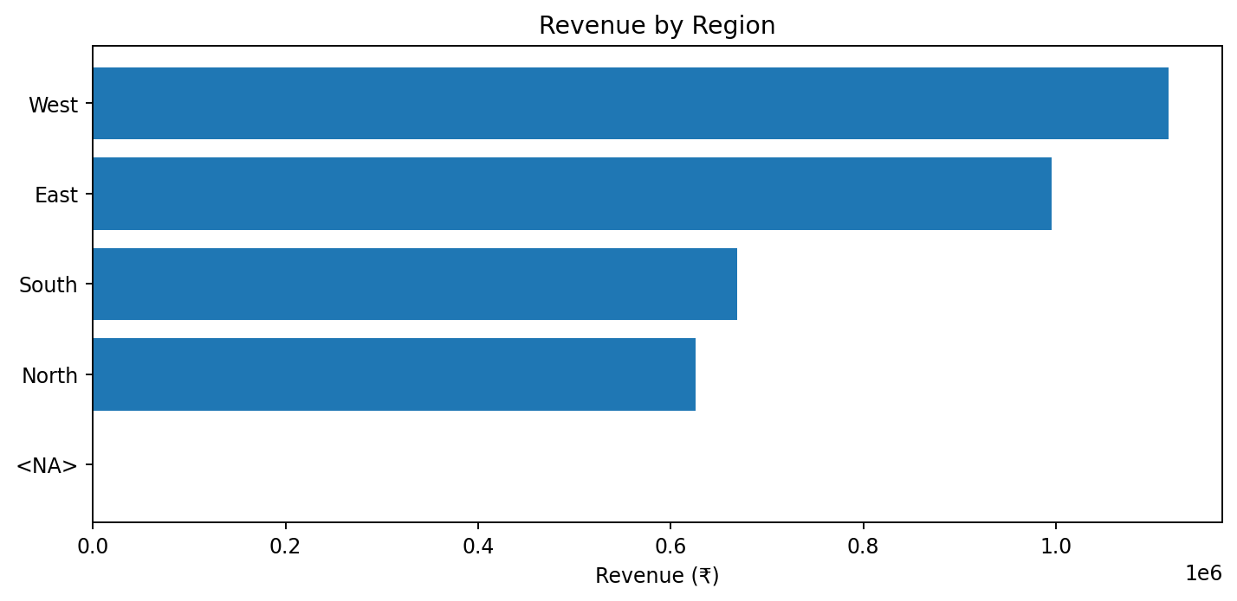
The highest-revenue region is West with ₹1,117,010.00. Use regional results to guide stock allocation, campaign targeting, and follow-up investigation of underperforming areas.

6. Product Profitability
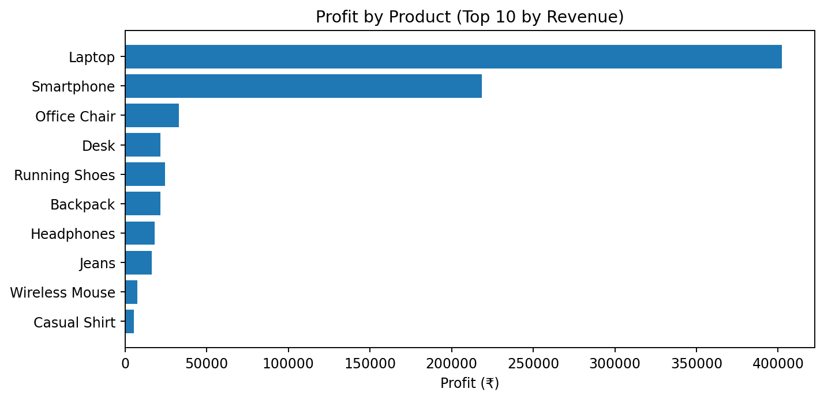
This view shows calculated profit for the ten products with the highest revenue. Products with high revenue but relatively low profit may need pricing, sourcing, discount, or cost review. Products with negative profit, if any, should be investigated.

7. Order Status & Operations
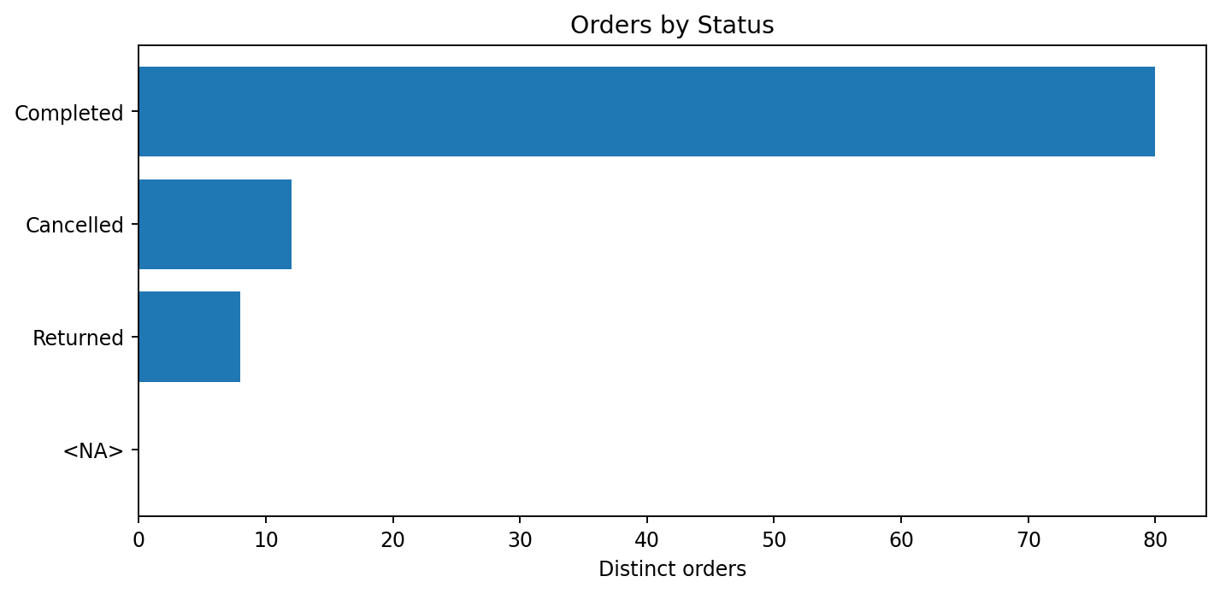
There are 81 completed, 12 cancelled, and 8 returned order rows. Track cancellation and return rates over time and by category, region, and payment mode to identify potential operational issues. The current completion rate is a row-level rate, not necessarily a time-to-delivery or on-time-delivery KPI.

8. Additional KPI Opportunities
KPI | Suggested calculation / use
Revenue growth % | Compare current-period revenue with the previous comparable period: (Current − Previous) ÷ Previous.
Profit growth % | Apply the same period-over-period formula to profit.
Return rate | Returned orders ÷ total orders. Define whether this is based on order count or item quantity.
Cancellation rate | Cancelled orders ÷ total orders.
Revenue per customer | Revenue ÷ unique customers.
Repeat-customer rate | Customers with more than one order ÷ all customers.
Discount impact | Compare margin and conversion/order volume across discount bands.
Product/category margin | Profit ÷ revenue at product and category level.
Payment mix | Share of orders or revenue by payment mode.
Customer-segment contribution | Revenue and profit by customer segment.

9. Data Quality & Limitations
Rows reviewed: 112. Duplicate Order_ID values: 11. Total missing cell count across analyzed columns: 193. Negative sales values: 0; negative costs: 0; negative quantities: 0.
The original Raw_Data and Project_Guide sheets are retained in the Excel output. Clean_Data is a normalized working copy with trimmed text fields and calculated Profit, Profit_Margin, Month, and Year columns. Missing values are not silently imputed. Review any blanks and unusual values before production use.
Columns with missing values: Order_ID: 11; Order_Date: 13; Customer_ID: 11; Customer_Name: 11; Product: 9; Category: 11; Region: 11; Customer_Segment: 11; Quantity: 12; Sales_Amount: 12; Cost: 11; Discount: 11; Order_Status: 11; Payment_Mode: 11; Profit: 12; Profit_Margin: 12; Year: 13.
Important interpretation note: the source includes Cost and Discount, but no explicit shipping cost, tax, advertising spend, or return-cost fields were identified in the analyzed columns. Therefore, the calculated Profit is Sales_Amount minus Cost only and should not be described as net profit unless the business confirms that Cost captures all relevant expenses.

10. Recommended Next Steps
- Confirm the business definition of revenue, cost, profit, returns, and completed orders.
- Review the KPI_Detail sheet to validate formula definitions and totals.
- Investigate the lowest-revenue months, low-margin categories, and products with low or negative profit.
- Add a date filter, category/region slicers, and prior-period comparisons if the workbook will be used interactively.
- Refresh the summary tables and chart data whenever the underlying Clean_Data records change; check formula recalculation in Excel.

Prepared from Ecommerce_Sales_Analysis_Raw_Data.xlsx

