POWER BI DASHBOARD REPORT
Project file review: project_2.pbix
This document summarizes the report page and visual configuration found in the supplied Power BI file. It is intended as a dashboard project/report document. The PBIX layout can show which visuals and fields are configured, but it does not by itself prove that every calculation is correct; values should be validated in Power BI against the underlying data.

1. Dashboard objective
The report is designed to provide a sales and order-performance overview, including product-category sales, delivery delays, monthly trends, payment methods, product ratings, and state-wise sales. These views can help a business user monitor revenue patterns, identify delivery issues, compare product ratings, and investigate geographic performance.
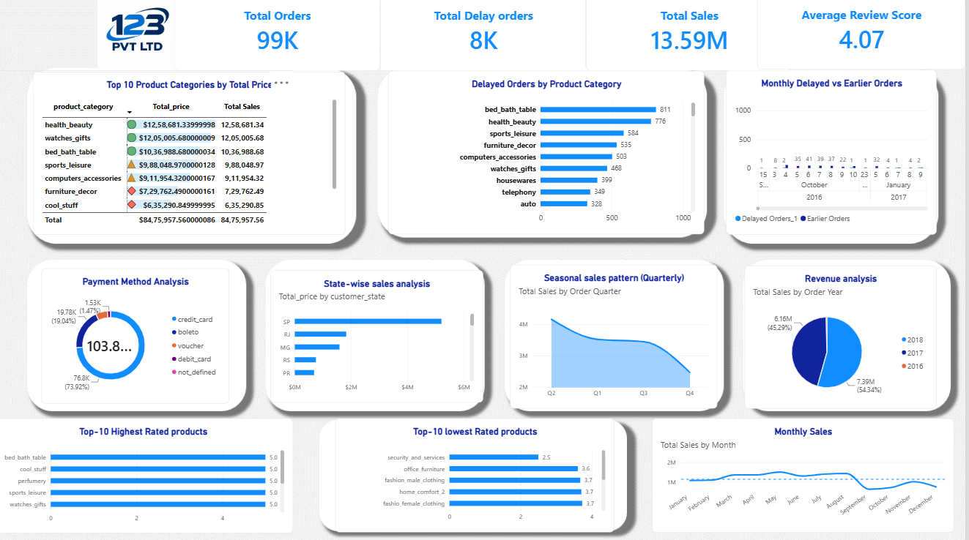
Dashboard overview

2. Visuals identified in the PBIX file
The file contains one report page (Page 1) with 15 visual containers. The configured visual titles and fields below were read from the report layout.

1. Top 10 Product Categories by Total Price
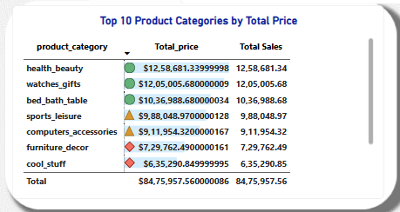
Visual type: tableEx
Configured fields: Values: product_category_name_english; Values: Total_price; Values: Total Sales
Model tables referenced: Nexusgoods_order_items_dataset, product_category_name_translation, Nexusgoods_orders_dataset (1)

2. Delayed Orders by Product Category
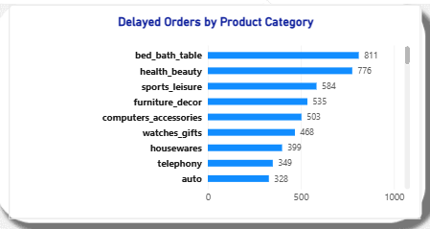
Visual type: clusteredBarChart
Configured fields: Category: product_category_name_english; Y: Delayed Orders Test
Model tables referenced: product_category_name_translation, Nexusgoods_order_items_dataset

3. (Card/image visual)

Visual type: cardVisual
Configured fields: Data: Delayed Orders Test
Model tables referenced: Nexusgoods_order_items_dataset

4. Monthly Delayed vs Earlier Orders
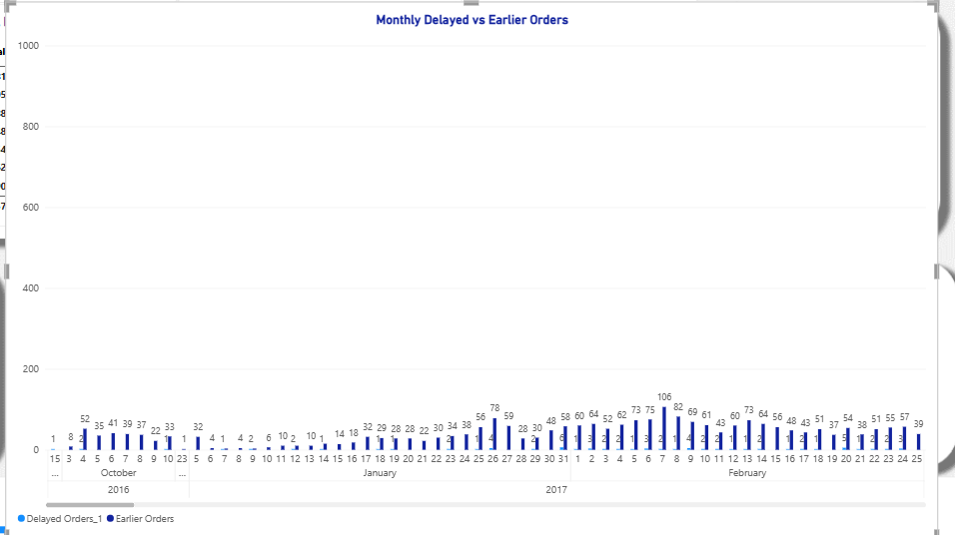
Visual type: clusteredColumnChart
Configured fields: Y: Delayed Orders_1; Y: Earlier Orders; Category: Year; Category: Month; Category: Day
Model tables referenced: Nexusgoods_order_items_dataset, Nexusgoods_orders_dataset (1)

5. Payment Method Analysis
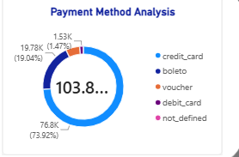
Visual type: donutChart
Configured fields: Category: payment_type; Y: order_id)
Model tables referenced: Nexusgoods_order_payments_dataset

6. Top-10 lowest Rated products
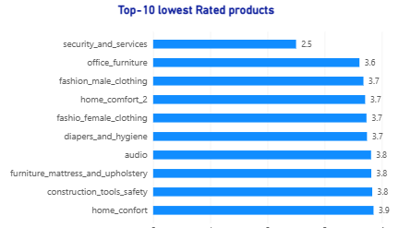
Visual type: clusteredBarChart
Configured fields: Category: product_category_name_english; Y: Test Review Score
Model tables referenced: product_category_name_translation, Nexusgoods_order_reviews_dataset

7. Top-10 Highest Rated products
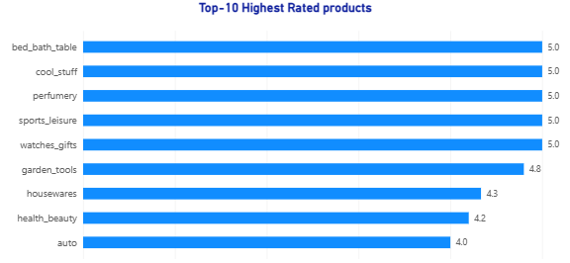
Visual type: clusteredBarChart
Configured fields: Category: product_category_name_english; Y: Test Review Score
Model tables referenced: Nexusgoods_order_reviews_dataset, product_category_name_translation

8. State-wise sales analysis
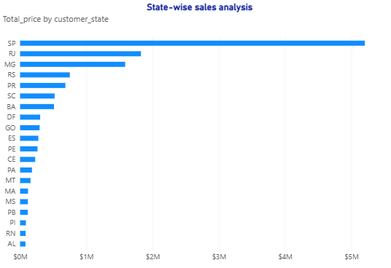
Visual type: clusteredBarChart
Configured fields: Y: Total_price; Category: customer_state
Model tables referenced: Nexusgoods_order_items_dataset, Nexusgoods_customers_dataset

9. Seasonal sales pattern (Quarterly)
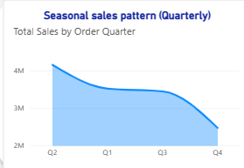
Visual type: areaChart
Configured fields: Category: Order Quarter; Y: Total Sales
Model tables referenced: Nexusgoods_orders_dataset (1)

10. Revenue analysis
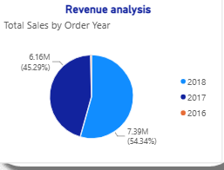
Visual type: pieChart
Configured fields: Category: Order Year; Y: Total Sales
Model tables referenced: Nexusgoods_orders_dataset (1)

11. (Card/image visual)
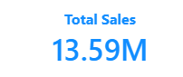
Visual type: cardVisual
Configured fields: Data: Total Sales
Model tables referenced: Nexusgoods_orders_dataset (1)

12. (Card/image visual)
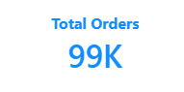
Visual type: cardVisual
Configured fields: Data: Total Orders
Model tables referenced: Nexusgoods_order_items_dataset

13. (Card/image visual)

Visual type: cardVisual
Configured fields: Data: Average Review Score
Model tables referenced: Nexusgoods_order_reviews_dataset

14. Monthly Sales
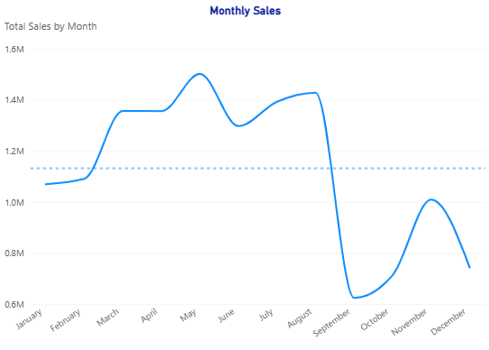
Visual type: lineChart
Configured fields: Category: Month; Y: Total Sales
Model tables referenced: Nexusgoods_orders_dataset (1)

3. Business interpretation and how to use the visuals

Top 10 Product Categories by Total Price
Compare product categories using the configured price/sales measures. Confirm whether Total Price and Total Sales represent the same business definition before comparing them.

Delayed Orders by Product Category
Find categories contributing the most delayed orders. Use this to prioritize delivery-process investigation, but verify that the delay measure counts orders consistently and does not double-count order-item rows.

Total Delay Orders card
Use as a headline KPI for delayed orders. Validate the card against a table of order IDs and the agreed definition of a delayed order.

Monthly Delayed vs Earlier Orders
Compare delivery timing across months. Check that the date axis uses the intended order or delivery date and that delayed/early categories are mutually exclusive if that is the intended design.

Payment Method Analysis
Understand the distribution of payment methods. Decide whether the visual represents order count, customer count, or sales value and label it accordingly.

Top-10 lowest Rated products
Identify products with the lowest average review scores. Ensure the visual is sorted ascending by the final product-rating measure and that products with very few reviews are not misleadingly ranked.

Top-10 Highest Rated products
Identify products with the highest average review scores. Ensure the visual is sorted descending and that the same rating definition is used as in the lowest-rated chart.

State-wise sales analysis
Compare sales by customer state. Verify the state field comes from the customer table and the sales measure is correctly filtered through the customer-to-orders relationship.

Seasonal sales pattern (Quarterly)
Review quarterly changes to spot seasonal patterns. Confirm the quarter comes from a proper date table or a consistent date column and that all periods are represented.

Revenue analysis
Show how revenue is distributed across the categories in the visual. Use a clearly defined sales/revenue measure and avoid describing revenue as profit when cost data is unavailable.

Monthly Sales
Track sales movement over time. Confirm the date hierarchy and aggregation are appropriate, and check for missing months or unexpected date gaps.

4. KPI definitions and data limitations
KPI | Definition / validation
Sales / revenue | Use the existing Total Sales or Total Price measure only after confirming its formula and intended meaning. If price is a per-item price, sales may need quantity multiplied by price, depending on the dataset.
Delayed orders | Define delay explicitly using the promised/estimated delivery date and actual delivery date, where available. Count distinct order IDs if the KPI is intended to count orders rather than order-item lines.
Average product rating | Average review_score by product, filtered through valid review-to-order/order-item/product relationships. Check review counts as well as averages.
Profit | Profit cannot be calculated reliably from price alone. It normally requires revenue minus cost (and potentially discounts, returns, shipping, and other expenses). Do not label sales/revenue as profit.
State-wise sales | Use customer_state for the geographic grouping and validate that the sales measure responds correctly to state filters.

5. Recommended validation checklist
- Compare the Total Sales card/measure with a manually calculated total from the source rows.
- For delayed orders, inspect a sample of order IDs and confirm the delivery-status rule row by row.
- Check that category, month, payment method, product, and state visuals change when relevant slicers or filters are applied.
- For Top 10 and Bottom 10 rating charts, confirm exactly 10 products appear when at least 10 eligible products exist, and confirm sort direction.
- Display review count alongside average rating during validation so products with only one review can be identified.
- Confirm relationships are active and filter direction supports the intended analysis without creating ambiguous paths.
- Check for blank categories, missing dates, duplicate order IDs, and unexpected blank ratings.
- Use consistent currency formatting and descriptive titles; state whether values are counts, averages, or monetary totals.
- If the dashboard is for management, add slicers for date, product category, and state where they support the analysis.

6. Suggested report conclusion
The Power BI report brings together sales, delivery performance, customer geography, payment methods, and product-rating analysis on a single page. It can support monitoring and exploratory analysis once the measure definitions and relationships are validated. The most important next step is to verify the sales and delay calculations against the underlying records, then confirm that the rating Top 10 and Bottom 10 visuals return the intended products. Profit reporting should be added only when reliable cost data becomes available.
Scope note: This document describes the saved report layout and configured visual fields. It does not certify the correctness of the underlying DAX calculations or data values.

