SUPERMARKET SALES
DASHBOARD REPORT
Power BI report review • KPI definitions • Visual interpretation

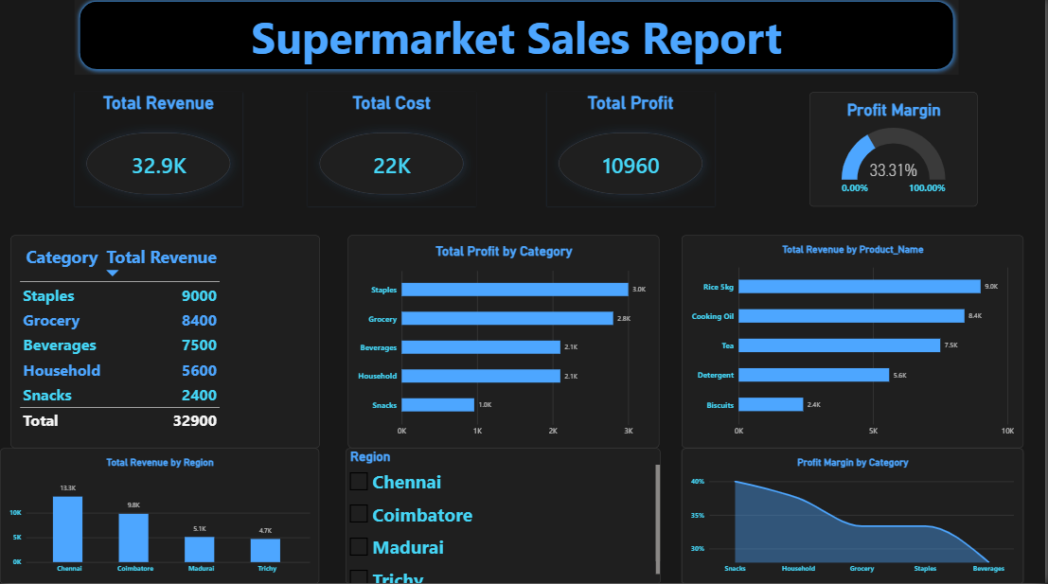
Figure 1. Dashboard layout preview reconstructed from the uploaded PBIX report definition.

1. Executive summary
The uploaded Power BI file contains an executive-style supermarket sales dashboard focused on revenue, cost, profit, and profit margin. It also includes product/category comparisons, a regional revenue view, a table, and a region slicer. The report structure is designed to help a reader review financial performance at a glance and then investigate which products, categories, or regions contribute most.
Important data note: the PBIX definition exposes the visual fields and measures, but this environment cannot render the Power BI canvas or evaluate its live semantic model. For that reason, the images in this document are clearly labelled layout/structure previews and KPI values are not fabricated. Open the PBIX in Power BI Desktop to capture the final, data-filled dashboard screenshot and verify the actual values.

2. KPI overview and business meaning
KPI | What it tells you | How to interpret it
Total Revenue | Total sales value represented by the orders measure. | Use as the headline sales result; compare across region, product, and time if those filters are available.
Total Cost | Total cost measure defined in the model. | Compare with revenue to understand the cost base. Confirm the underlying cost data and aggregation before publishing.
Total Profit | Profit measure defined in the model. | A positive result indicates revenue exceeds the cost basis used by the measure; validate the formula and included expenses.
Profit Margin | Profit margin measure, shown in a gauge and area chart. | Usually expressed as profit divided by revenue. Confirm the measure’s formula and whether the display is formatted as a percentage.

3. Dashboard visuals and insights to review

3.1 Profit by product category
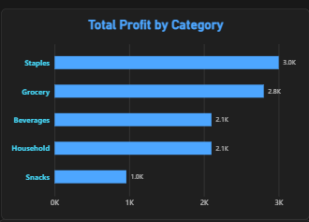
The PBIX visual maps products[Category] to the category axis and orders[Total Profit] to the value axis, sorted descending by profit. Use this visual to identify categories contributing the most profit and categories that may need pricing, promotion, or cost review. After opening the PBIX, record the leading and lowest-profit categories from the actual chart rather than relying on the preview.

3.2 Revenue by product
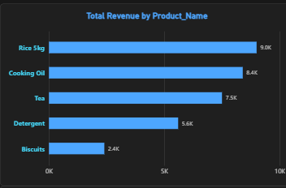
This chart compares products[Product_Name] against orders[Total Revenue] and sorts by revenue. It can highlight best-selling products by revenue, but revenue alone does not show profitability. Compare high-revenue products with profit or margin before making inventory or promotional decisions.

3.3 Revenue by region
A combo chart uses orders[Region] and orders[Total Revenue]. The report also contains a Region slicer. Use the slicer to focus the page on a specific region, then compare the regional revenue pattern. The actual chart title, labels, and any secondary-axis measure should be checked in Power BI because the saved visual definition lists revenue as its explicit value measure.

3.4 Profit margin by category
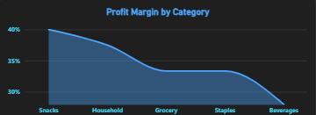
The area chart maps products[Category] to category and orders[Profit Margin] to value. This provides a category-level view of margin. A category with high revenue but weak margin may deserve a different action from a smaller category with stronger margin.

3.5 Category revenue table
The table visual contains products[Category] and orders[Total Revenue], sorted by revenue. It is useful for exact comparisons and for validating whether the chart rankings align with the displayed category totals.

3.6 Profit gauge
The gauge uses orders[Profit Margin]. Check the target/maximum settings and percentage formatting in Power BI. A gauge can be misleading if its scale is not aligned with the business target, so document the target and scale when presenting results.

4. Recommended KPI validation before sharing
- Confirm Total Revenue aggregates the intended sales field and does not double-count order-level values across order items.
- Confirm Total Cost is based on a valid cost field and has the correct granularity.
- Review the Total Profit formula and verify whether it is Revenue minus Cost or includes additional adjustments.
- Confirm Profit Margin is formatted as a percentage and uses the intended denominator.
- Test the Region slicer and confirm all cards and charts respond consistently.
- Check blank categories, duplicate product names, currency formatting, axis labels, and sort order.
- Capture a screenshot from Power BI Desktop after refreshing the data; replace the preview images in this report with the live dashboard screenshot.

5. Suggested business questions
- Which product category contributes the highest total profit?
- Which products generate the most revenue, and do they also deliver strong profit?
- Which region contributes the most revenue?
- Are there categories with relatively low profit margin despite strong revenue?
- How do the KPI values change when the Region slicer is used?

6. How to insert the final live screenshot
- Open supermarket_sales_report.pbix in Power BI Desktop and wait for all visuals to finish loading.
- Select the report page containing the KPI cards and charts; clear slicers if you want the overall view.
- Use View > Page view > Fit to page (or Fit to width) so the full page is visible.
- Take a screenshot using Snipping Tool (Windows + Shift + S) and save it as PNG.
- In Word, replace Figure 1’s preview with the screenshot using Insert > Pictures, then set Wrap Text to In Line with Text and resize to fit the page width.
- Repeat for individual charts if you want larger visual-specific screenshots.

7. Source and limitations
Source file: supermarket_sales_report.pbix (uploaded for this report). The visual inventory was read from the PBIX report definition. The report includes three KPI cards (Total Revenue, Total Cost, Total Profit), a Profit Margin gauge, clustered bar charts for category profit and product revenue, a category/revenue table, a region/revenue combo chart, a Region slicer, and a category/profit-margin area chart. This document is an explanatory report and does not claim to contain evaluated live KPI totals.

