Data Analyst AI: Project Report
Scope: a local AI data analyst built on Open WebUI, tested on a 10-row sales dataset.

1. Project Overview
This project is a chat-based data analyst. A user uploads a CSV file into a chat, asks questions in plain language, and receives answers backed by Python (pandas) calculations run in Open WebUI's Code Interpreter. The goal is to produce reliable answers that match the source data, and to flag any data inconsistencies instead of silently hiding them.

2. Architecture
Component | Details
Chat interface | Open WebUI, running locally at localhost:8080 on a Windows 11 laptop
Language model | NVIDIA Nemotron 3.5 Lightning (free), model ID nvidia/nemotron-3.5-lightning-30b-a3b
Model connection | Cloud API (not a local model)
Calculation | Code Interpreter runs Python and pandas on the host machine
Custom model | "Data Analyst AI", a system prompt with 23 rules on the base model
Data input | CSV file uploaded into the chat

3. Setup Steps
- Install Open WebUI and start it on localhost:8080.
- Connect the free NVIDIA Nemotron 3.5 Lightning model through its API.
- Create a custom model named "Data Analyst AI" on the base model, and paste the system prompt.
- Turn on Code Interpreter in Capabilities and Builtin Tools. Keep Temperature at its default, since it gave correct answers in testing.
- Security: create a strong admin password, and turn off sign-up so no new accounts can be created.
- Keep the app local. It is not exposed to the internet.

4. System Prompt Summary
The system prompt groups its 23 rules into five areas:
- How to work: all figures come from code output; profile the file first; never estimate or use memory for numbers.
- Data quality: check every derived column row by row; use the current file's values for totals; show the original value separately only when a correction exists.
- Answer style: direct answer first, Markdown tables, bold key figures, emoji section headers, no HTML tags, no currency symbols.
- Full reports: fixed section order; every key finding must cite a table value; maximum three key findings; words like "highest" or "only" must be checked against code output.
- Corrections: after a discrepancy is corrected and saved, all later calculations use the corrected file, and the model states which file version it used.

5. Test Dataset
The test file is sales.csv with 10 orders from 2026-01-01 to 2026-01-10. Columns: OrderID, Date, Category, Product, Region, Quantity, UnitPrice, TotalSales. The file has no missing values and no currency code.

6. Verified Results

6.1 Key metrics (after correction)
Metric | Value
Total orders | 10
Total units sold | 72
Total sales, recorded (original file) | 34,228
Total sales, corrected (sales_corrected.csv) | 34,028
Average order value, recorded | 3,422.80
Average order value, corrected | 3,402.80

6.2 Category breakdown (corrected)
Category | Orders | Units | Total sales | Share of sales
Clothing | 3 | 29 | 14,771 | 43.41%
Electronics | 4 | 18 | 12,982 | 38.15%
Groceries | 3 | 25 | 6,275 | 18.44%
Total | 10 | 72 | 34,028 | 100.00%

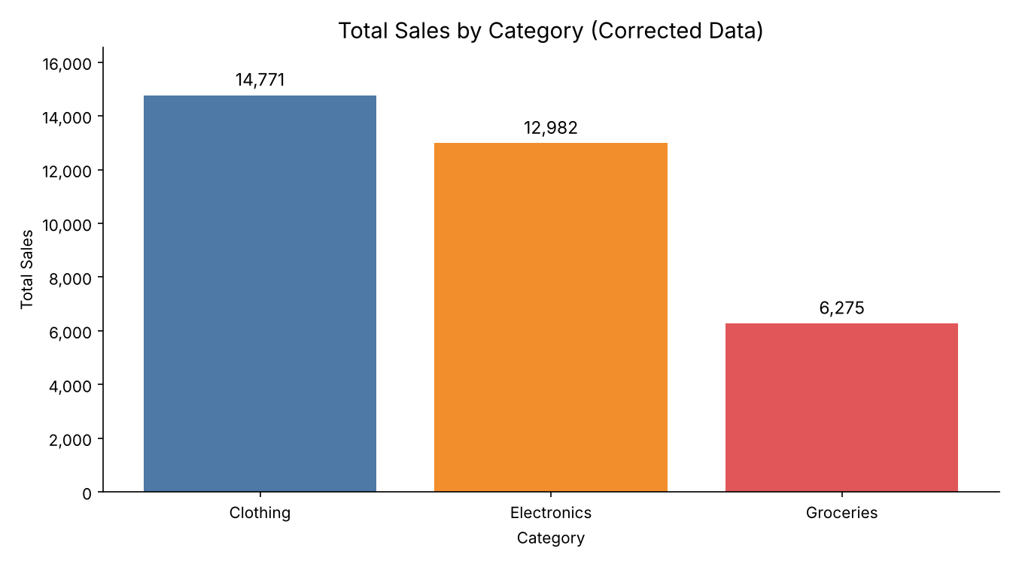
Figure 1: Total sales by category, corrected data (source: sales_corrected.csv)

6.3 Region breakdown (corrected)
Region | Orders | Units | Total sales | Share of sales
North | 3 | 11 | 9,889 | 29.06%
East | 2 | 18 | 9,882 | 29.04%
South | 3 | 24 | 9,776 | 28.73%
West | 2 | 19 | 4,481 | 13.17%
Total | 10 | 72 | 34,028 | 100.00%

6.4 Data-quality finding
One row failed the formula check TotalSales = Quantity × UnitPrice. The other nine rows matched.
OrderID | Product | Qty | UnitPrice | Expected | Recorded | Difference
105 | Denim Jeans | 4 | 1,199 | 4,796 | 4,996 | +200

After the user instructed the correction, TotalSales for OrderID 105 was changed to 4,796 in a new file, sales_corrected.csv. The original sales.csv was not modified.

7. Testing History
Early runs on the same input gave different totals: 34,228, 26,349, and 29,235. These runs happened while the model was being changed. The currently selected model, NVIDIA Nemotron 3.5 Lightning (free), was chosen as the best option after testing. Smaller local models up to 7B were also tried, but they did not run Code Interpreter for calculations, so their answers were wrong.

8. Known Limitations
- Text accuracy: the model can still make wording errors in summary sentences, even when its tables are correct.
- Corrections: a correction applies to a saved file. In a new chat, the corrected file must be uploaded again.
- Code execution: code runs directly on the host machine. It is not isolated.
- Scope: tested on one 10-row file only. No multi-file or large-dataset tests have been run.

9. Future Work
- Support for multiple files and larger datasets.
- Isolated code execution, for example in a Docker container or a separate sandbox.
- Export of results to Excel and PDF.
- Comparison with a larger model, to check whether text accuracy improves.

