Service: <http://www.webservicex.com/globalweather.asmx/GetCitiesByCountry?CountryName=india>

Returns: XML Response

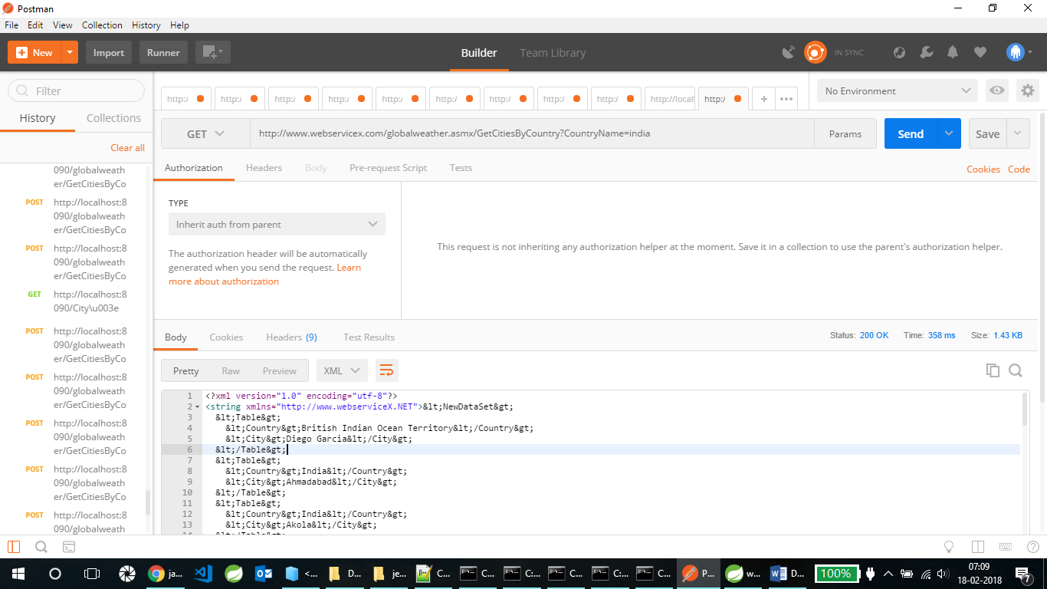

Proxy Service: <http://localhost:8080/v1/globalweather/GetCitiesByCountry>

Returns: JSON Response

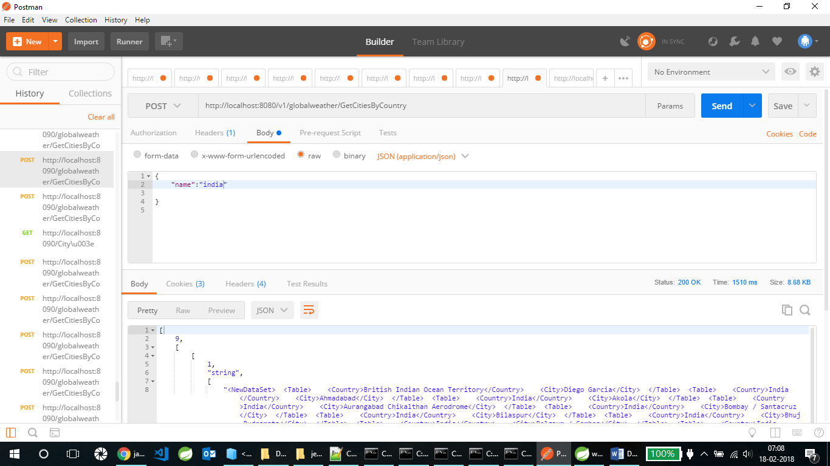

CURL Call:

