DST SOLUTIONS PVT LTD

Business Proposal for SEO +SMM +SMO + ORM


Prepared For

Kunwar Pranav Singh “Champion”

(Cabinet Rank Minister (Mineral), Govt. Of Uttarakhand)

Valid Up to: 30-June-2016

Prepared By

DST Solutions PVT LTD
BH-153, C-Block, Sec-71,
Noida-201301 contact@dolphinesoft.in
Contact No. : 9999761597

SEO + SMO Work Plan
- Site Wide Factors

  - Preliminary SEO Check
  - Detailed SEO Strategy and Plan
  - Keywords Analysis Report
  - Competitive Analysis Report
  - Working With HTML Source Code
  - Crawler Compliance Implementation
  - Google Analytics Analysis report
  - Google Webmaster Analysis report
- SEO Compatibility

  - Cross Browser Compatibility
  - Website Load Time
  - Page Sizeoptimization
  - Broken Links
  - Duplicate Content
  - RSS Feeds

- On Page Optimization–One Time in Month Report

  - Website initial technical analysis
  - Robot.txt optimization
  - XML Sitemap
  - Urllist.txt sitemap
  - HTML sitemap
  - W3c Validation
  - HTML code validation
  - Title tags analysis and development
  - Meta tags analysis and development
  - Navigational structure optimization
  - New SEO Pages Creation if yes, please share
  - New SEO Pages Optimization
  - Heading tag analysis and development
  - Image data optimization
  - Keywords mapping
  - Doc type
  - Canonical issue
  - Content optimization
  - Keywords density management
  - Keywords frequency management
  - Proximity management
  - Prominence management
  - Internal linking
  - Anchor text optimization
- Off Page Activities–Weekly Report

  - Submission sites must be theme or business related category
  - Submission sites page rank should be 1 to 10
  - Higher Domain Authority
  - Higher Page Authority
  - NA SPAM
  - Higher Alexa ranking
  - IP addresses and class c subnets must be different every submission sites
  - Topics And Concepts must be unique for write the content like blog and article
  - How Much Text Do we need to write for your business
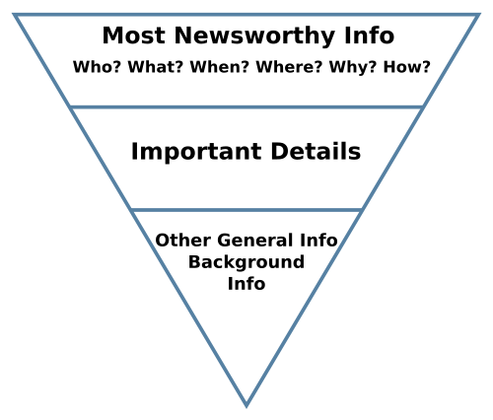
  - Manual article submissions
  - Press release submissions
  - Manual directory submissions
  - Social Bookmarking submissions
  - Forum posting
  - Blog submissions
  - Blog Social Bookmarking
  - Google local listing
  - Article Social Bookmarking
  - Infographics Submission
  - Image Sharing
  - Pinterest Image Submission
  - Slides Submission
  - Local Search Engine Submission
  - Local Business Listing
  - WikimapiaUpdation
  - Classified Submission
  - Social Media Optimization
  - Geo-Social Targeting
  - Video Submission
  - Web 2.0 profile creation
  - Google analytics

Social Media Optimization (SMO)
Facebook Activities
- Number of Key Phrases Optimized
- Tabs Creation
- Posting/Updates
- Polls
- Promoting brand in Target audience specific groups
- Per Day or week / month Page Traffic
- Tracking trending hashtags relating to the industry
- Review
- Page Likes
- User Engagement / Commenting
- Post likes and sharing
- Page view
- Post Reach

Twitter Activities
- Tweetspost
- followers
- Participation in trending hashtags
- Participation in conversations of active groups
- Promoting brand in Target audience specific groups
- Running Promoted Hashtags

Google + Activities
- Posting/updates
- followers
- User Engagement
- Participation in conversations of active groups
- Post likes and sharing
Linkedin Activities
- Posting/updates
- Participation in target audience specific groups/ communities/forums
- Influncer Targeting
- Post likes and sharing
- Pulse/article

Youtube Activities
- video views
- video submission
- video commenting
- Promotion of videos on social platforms
- YouTube Channel creation

Online Reputation Management (ORM)
- Diagnose Your Google Ranking & Online Reputation
- Intro to Personal Search Engine Optimization (SEO)

- Building the Foundation of Your Online Presence for Google Search Results

- Advanced Tactics to Boost your Google Ranking & Online Reputation

- Emergency Tactics For Fixing a Negative Google Search Result

- Improving your Google Image Results

Pay Per Click/Adwords (PPC)
- Add PPC Keywords: Expand the reach of your PPC campaigns by adding keywords that are relevant to your business.
- Add Negative Keywords: Add non-converting terms as negative keywords to improve campaign relevancy and reduce wasted spend.
- Split Ad Groups: Improve click-through rate (CTR) and Quality Score by splitting up your ad groups into smaller, more relevant ad groups, which help you create more targeted ad text and landing pages.
- Review Costly PPC Keywords: Review expensive, under-performing keywords and shut them off if necessary.
- Refine Landing Pages: Modify the content and calls-to-action (CTAs) of your landing pages to align with individual search queries in order to boost conversion rates. Don’t send all your traffic to the same page.
- Weekly Reports of campaing

