Program:

<html>

<head>

<style>

div

{

padding:300px 300px 300px 300px;

}

</style>

</head>

<body>

<div>CSS padding clears the area around the content</div>

</body>

</html>

Output: 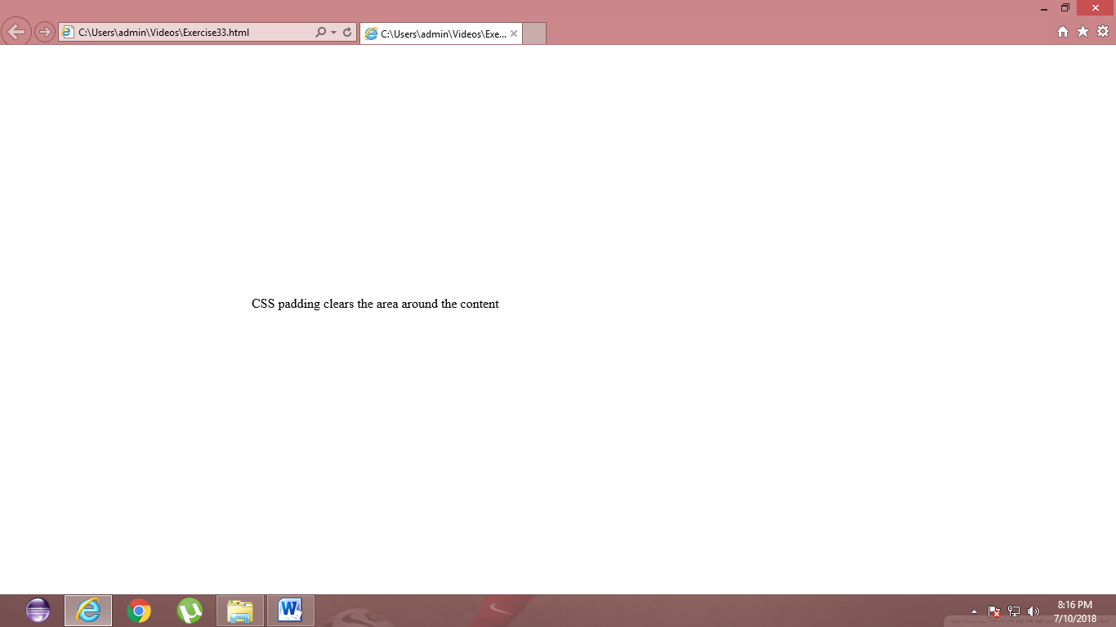

Program:

<!DOCTYPE html>

<html>

<head>

<style>

div {

margin-top: 100px;

margin-bottom: 100px;

margin-right: 150px;

margin-left: 80px;

}

</style>

</head>

<body>

<h2>Implementing CSS margins</h2>

<div>CSS margin does not have background color and it is completely transaprent</div>

</body>

</html>

Output:

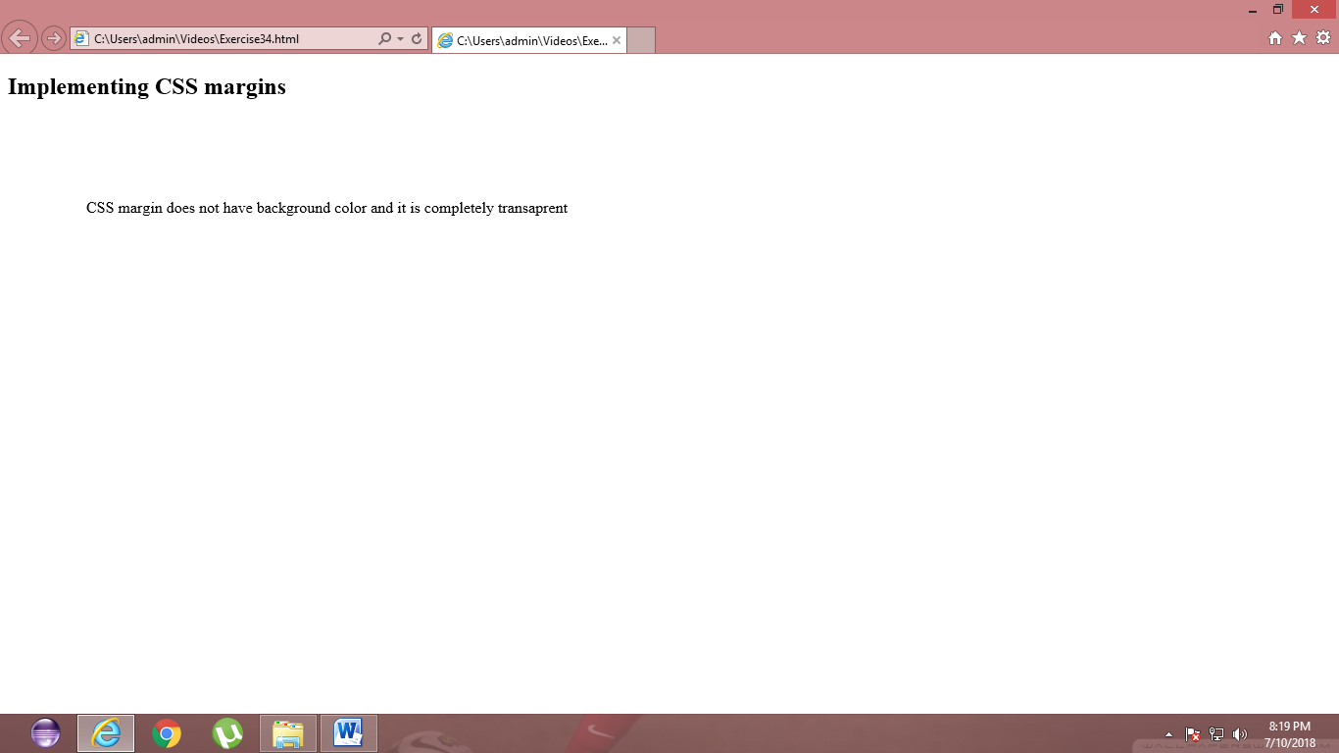

Result:

Program:

<!DOCTYPE html>

<html>

<head>

<style>

a:link

{

color: red;

}

a:visited

{

color: green;

}

a:hover

{

color: hotpink;

}

a:active

{

color: blue;

}

</style>

</head>

<body>

<a href="http://www.flightradar24.com">touch here to see live flight flying status</a>

</body>

</html>

Output:



Result:

<html>

<head>

<body>

<h1>RAJALAKSHMI GROUP OF INSTITUTIONS</h1><br><br>

<ol>

<li>Rajalakshmi Institute of Technology</li>

<li>Rajalakshmi Engineering College</li><br>

<style>

div

{

margin:50px 50px 50px 50px;

}

</style>

<div>Approved by AICTE;Affiliated to ANNA UNIVERSITY</div>

<h1>list of courses offered</h1>

<ol>

<li>CSE</li>

<li>MECH</li>

<li>ECE</li>

<li>EEE</li>

</body>

</head>

</html>

Output:



Result:

<html>

<body>

<h2>HTML Forms</h2>

<form action="/action_page.php">

First name:<br>

<input type="text" name="firstname" value="Mickey">

<br>

Last name:<br>

<input type="text" name="lastname" value="Mouse">

<br><br>

</form>

</body>

</html>

Output:

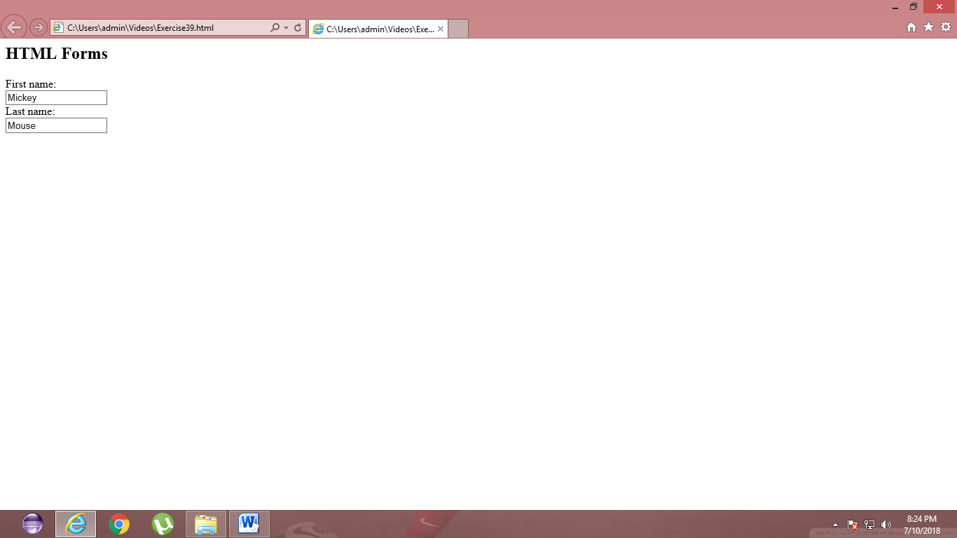

Result:

<!DOCTYPE html>

<html>

<body>

<h3>upload</body><br><br>

<input type="file" name="pic" accept="image/*">

</form>

</body>

</html>

Output:

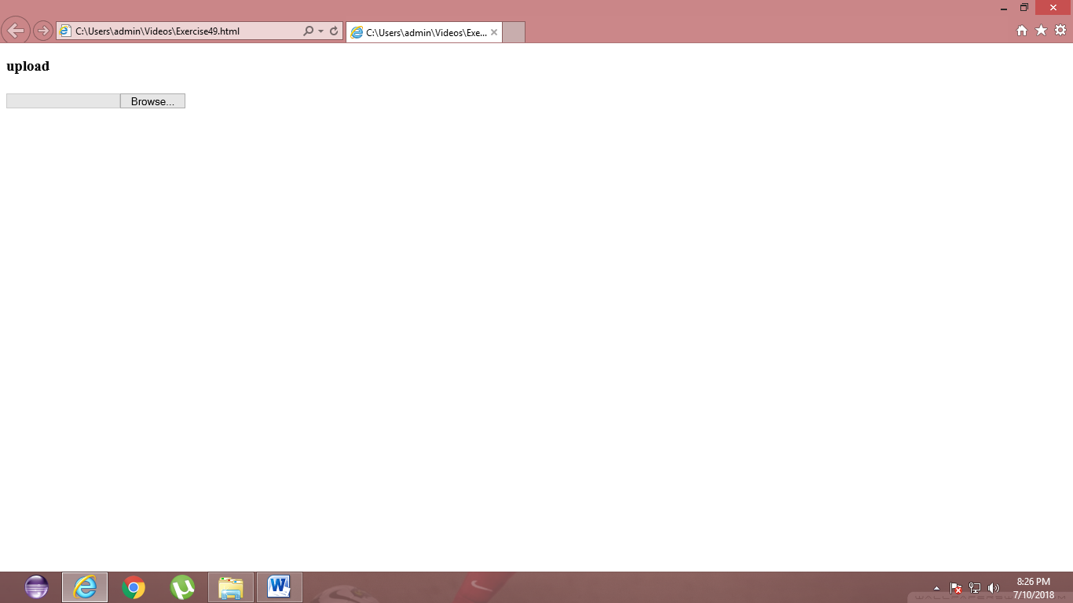

Result: