<html>

Welcome to Html

</html>

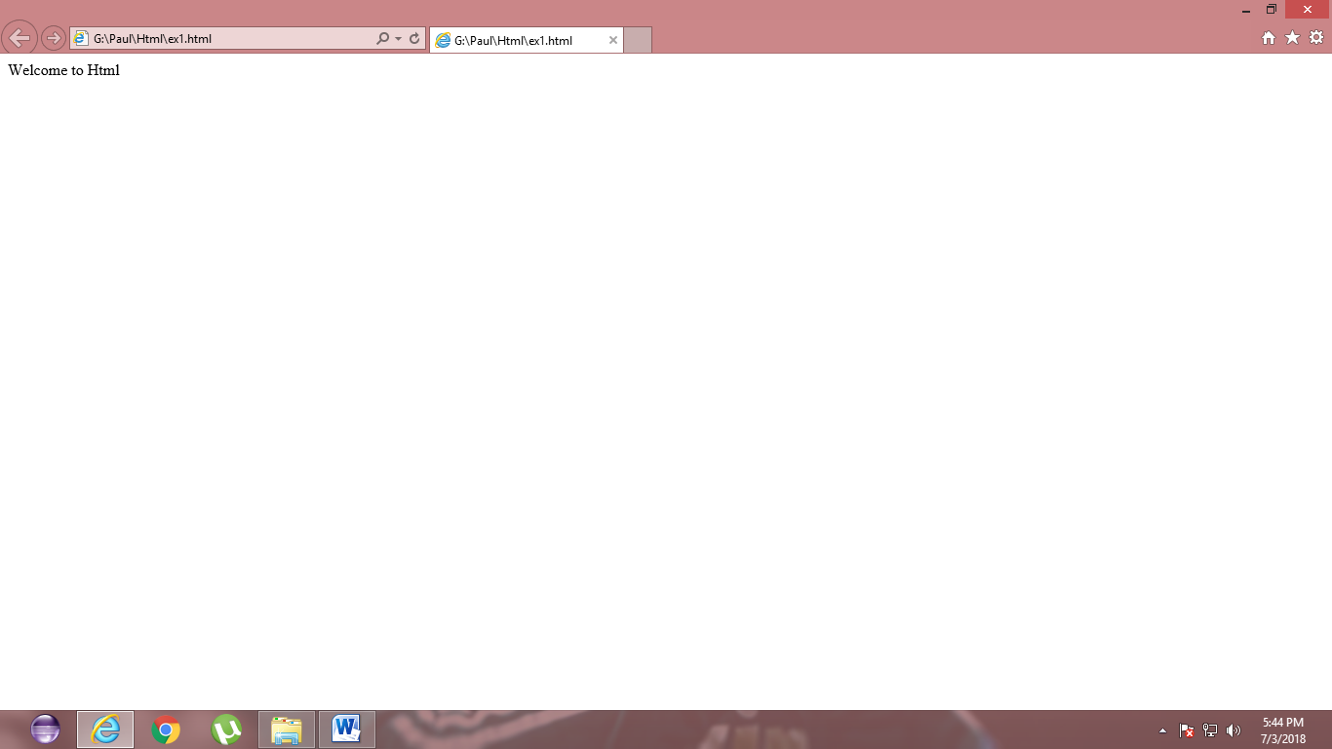

<html>

<body>

<title>Hello</title>

Html is used for designing web pages

</body>

</html>

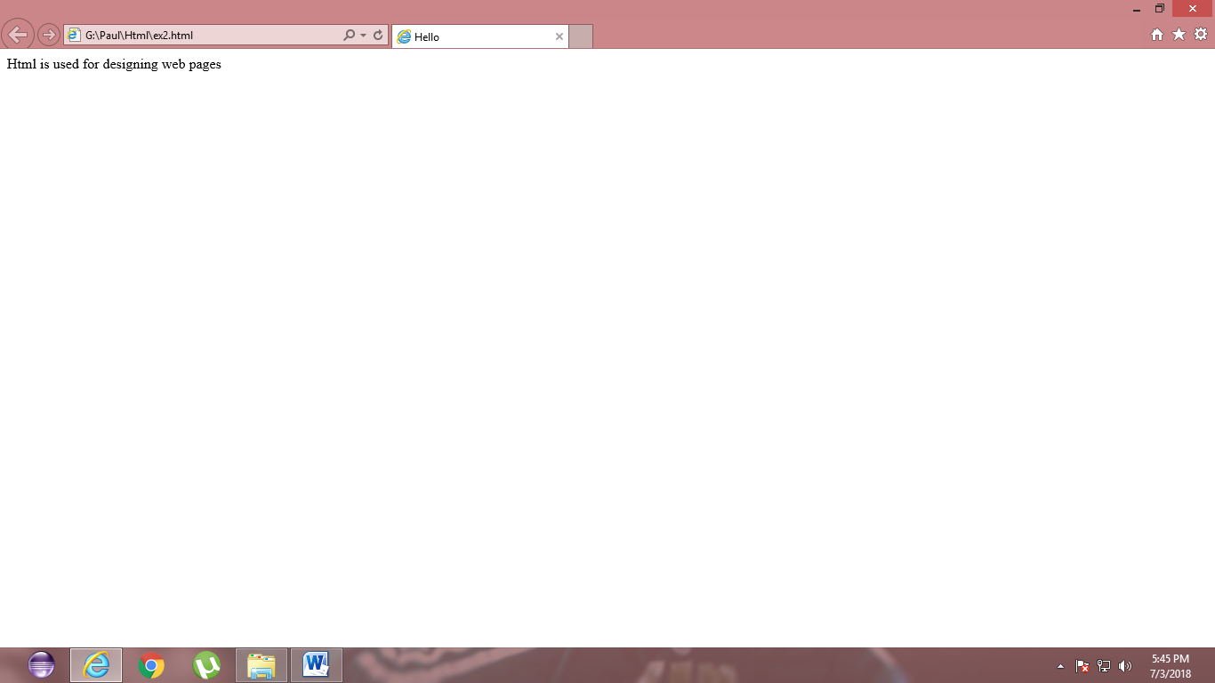

<html>

<body>

<h1>Hello</h1>

Hi how are you

</body>

</html>

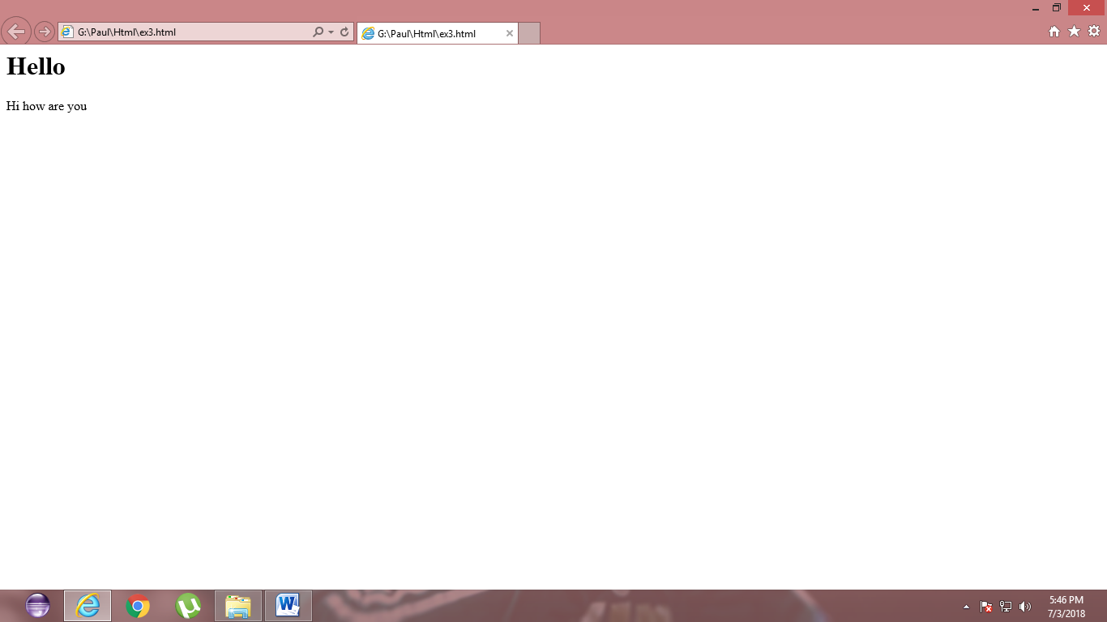

<html>

<body>

<h1>Web Technology</h1>

<p>Paragraph tag</p>

</body>

</html>

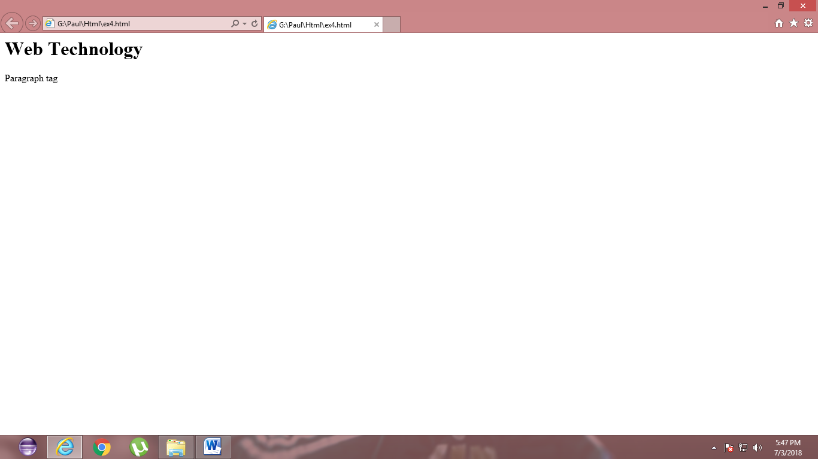

<html>

<body>

<h1>Web Technology</h1>

<h2>Web Technology</h2>

<h3>Web Technology</h3>

<h4>Web Technology</h4>

<h5>Web Technology</h5>

<h6>Web Technology</h6>

<h7>Hello</h7>

</body>

</html>

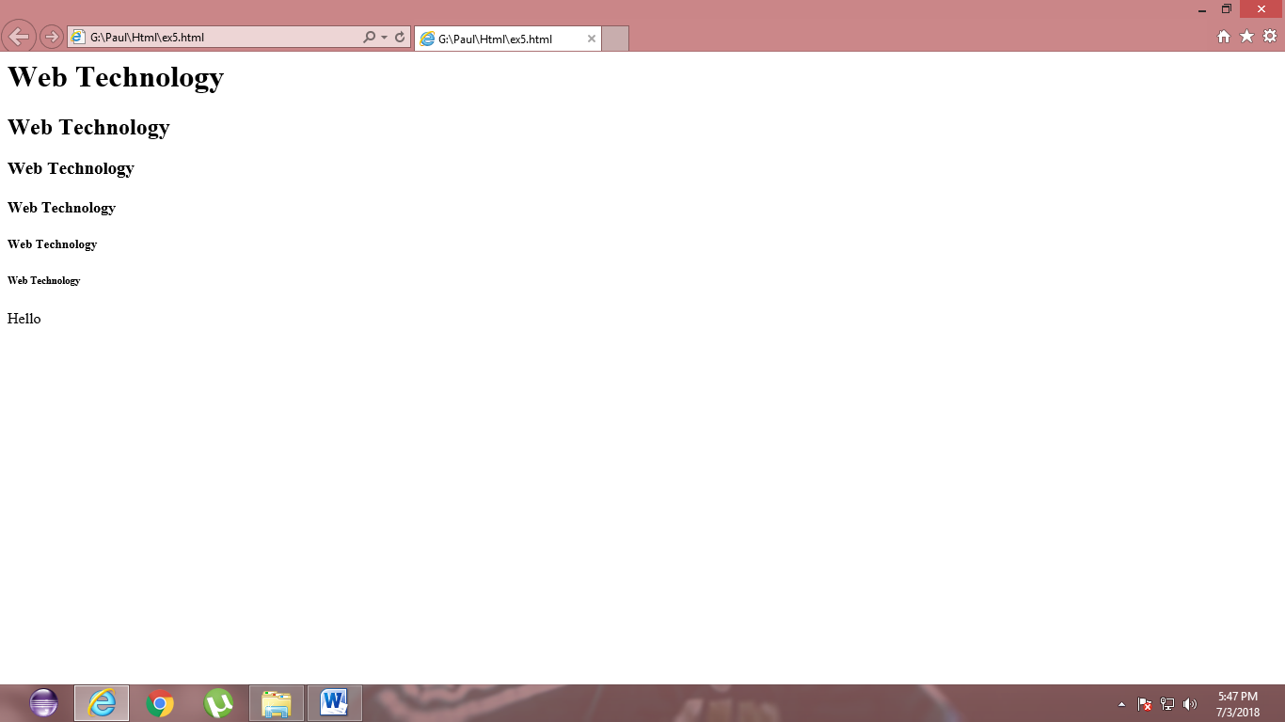

<html>

<body>

<h1>Web Technology</h1><b>Bold</b>

<br><i>emphasize</i></br>

<br><strong>st</strong></br>

<br>a<sup>2</sup>2</br>

<br>H<sub>2</sub></br>

<br><del>delete</del></br>

<br><code>html is used for designing web pages</code>

</body>

</html>

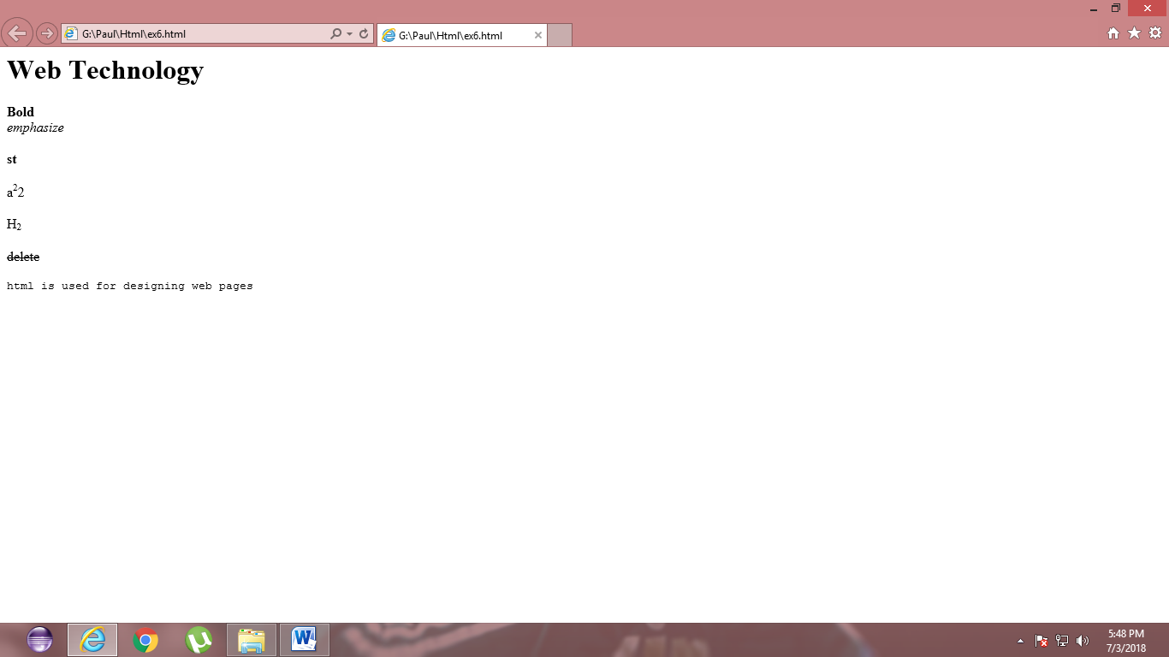

<html>

<body>

<h1>Web Technology</h1>

<br>web</br> technology

</body>

</html>

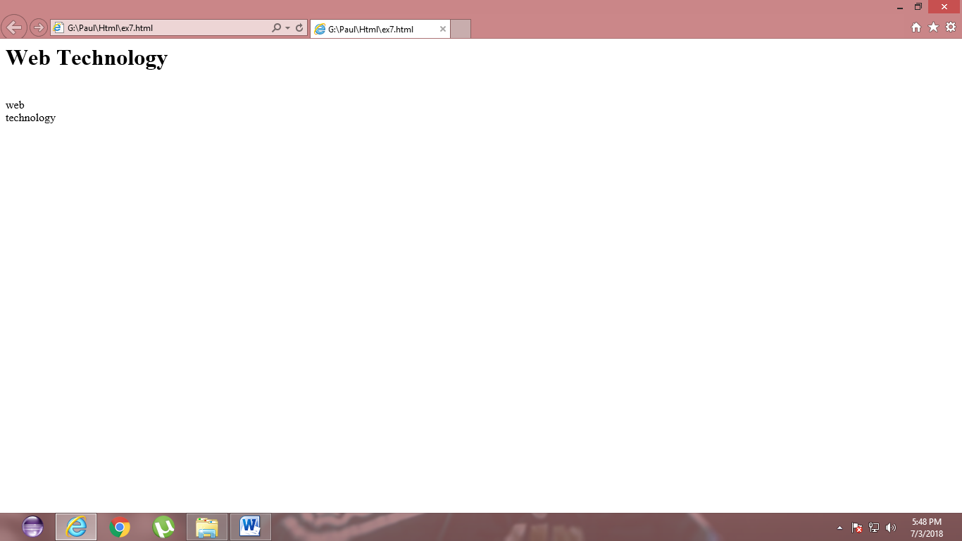

<html>

<body>

<h1>Web Technology</h1>

<pre>html is used for designing web pages</pre>

</body>

</html>

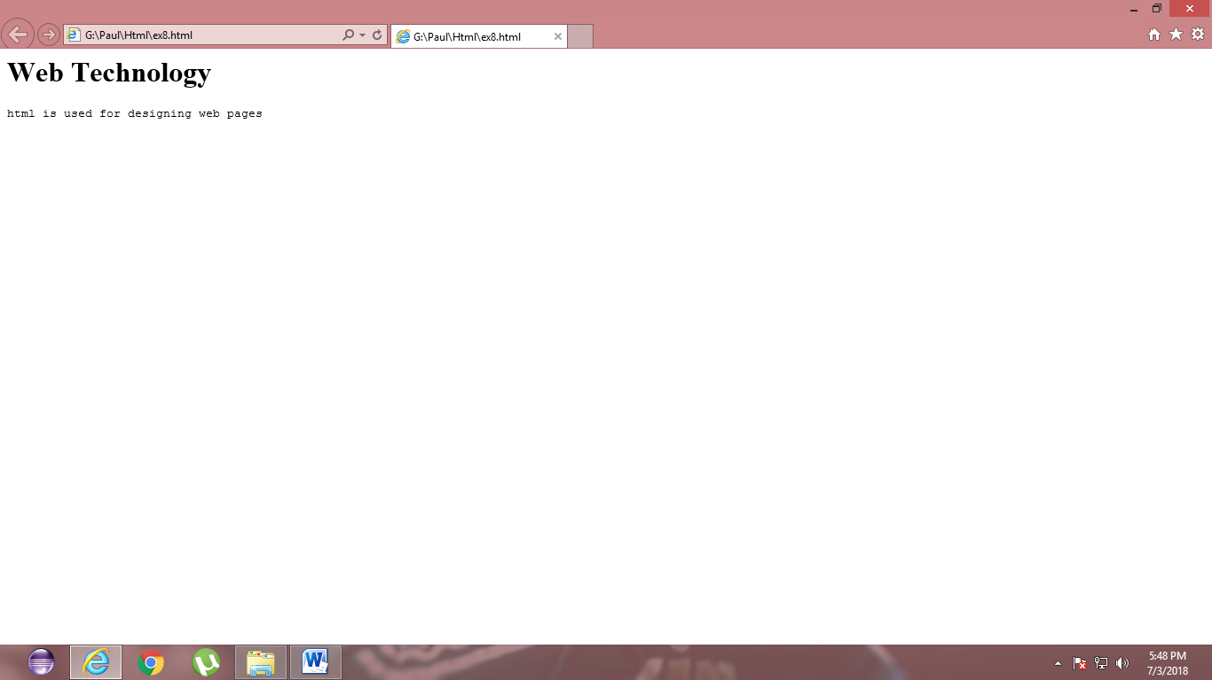

<html>

<body>

<title>General Message</title>

<h1>Web technology</h1>

<P align="right">

Html is used for designing web pages

</body>

</html>

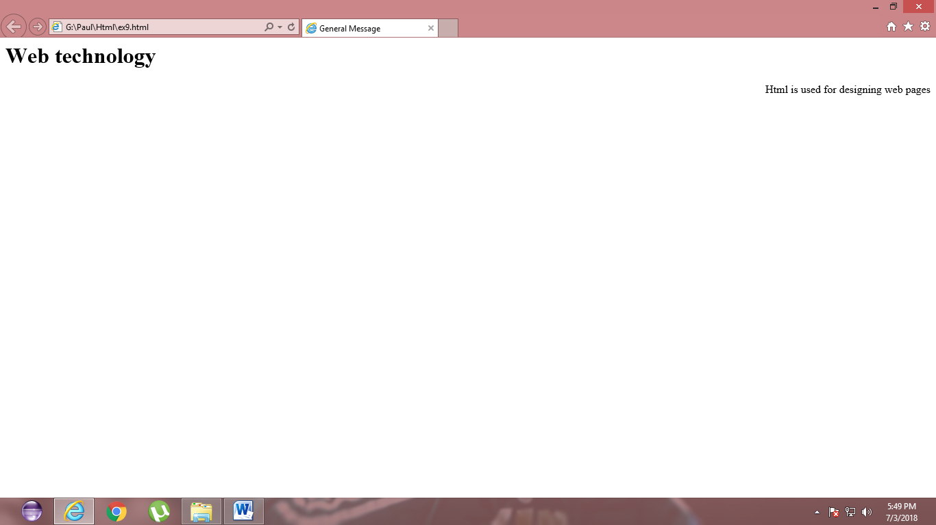

<html>

<body>

<font color ="blue" size="25">Hi...Happy day

</body>

</html>

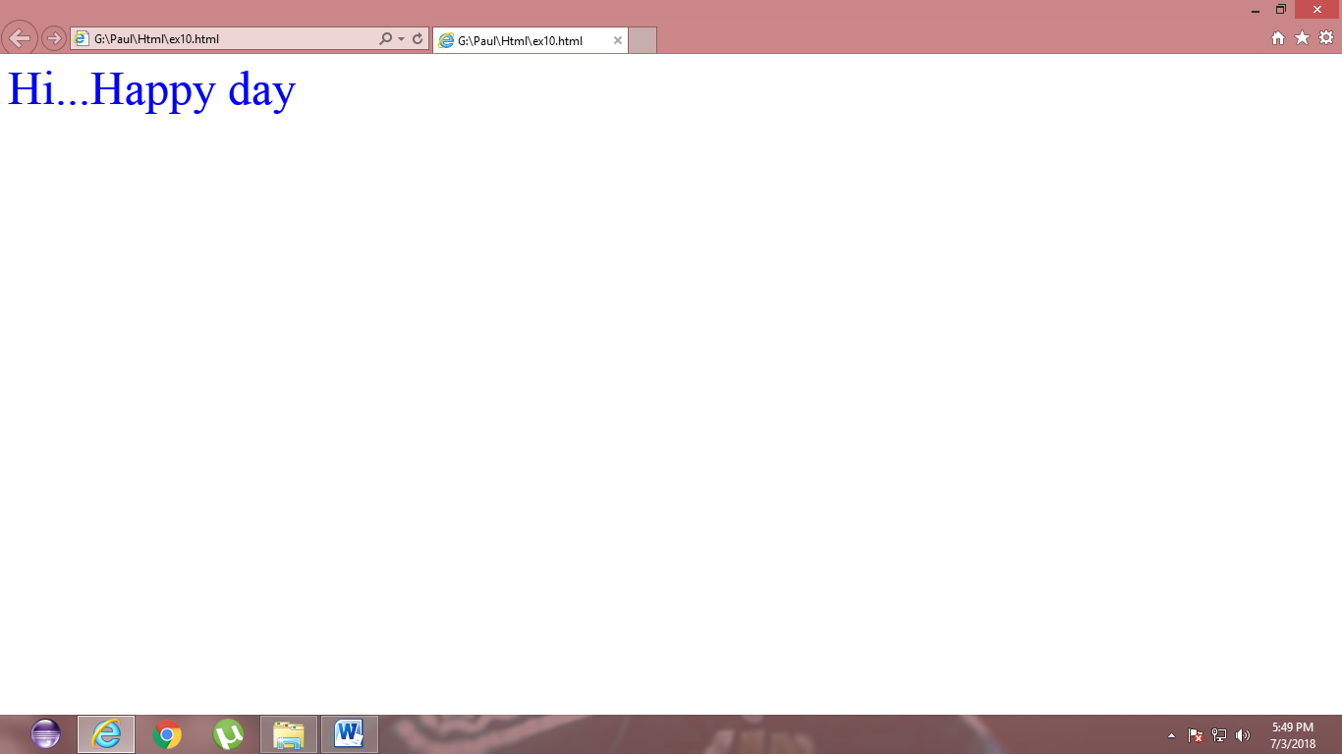

<html>

<body>

<br><a href="http://www.youtube.com">

www.youtube.com</a>

</br>

<br><a href="http://www.google.com">

www.google.com</a>

</br>

<br><a href="http://www.yahoo.com">

www.yahoo.com</a>

</br>

</body>

</html>

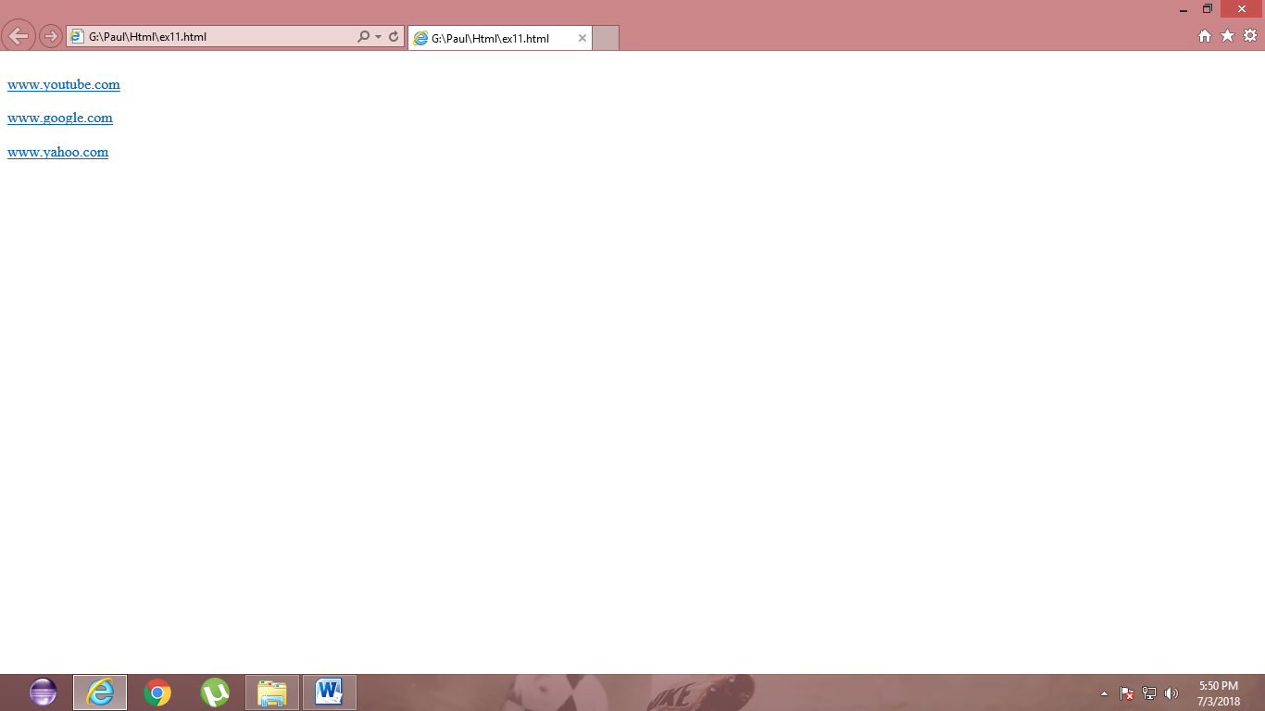

<html>

<body>

<br><a href="http://email@ritchennai.edu.in/target="blank">

email@RITchennai</a>

</br>

<br><a href="http://text document/download="blank">

text document</a>

</br>

</body>

</html>

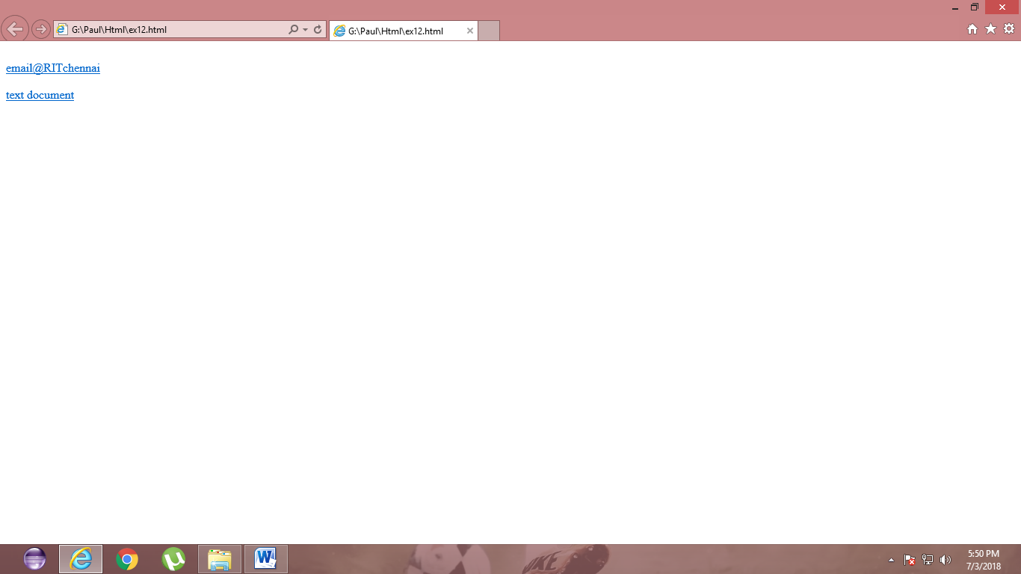

<html>

<body>

<comment>Web technology includes the concept of Html</comment>

</body>

</html>

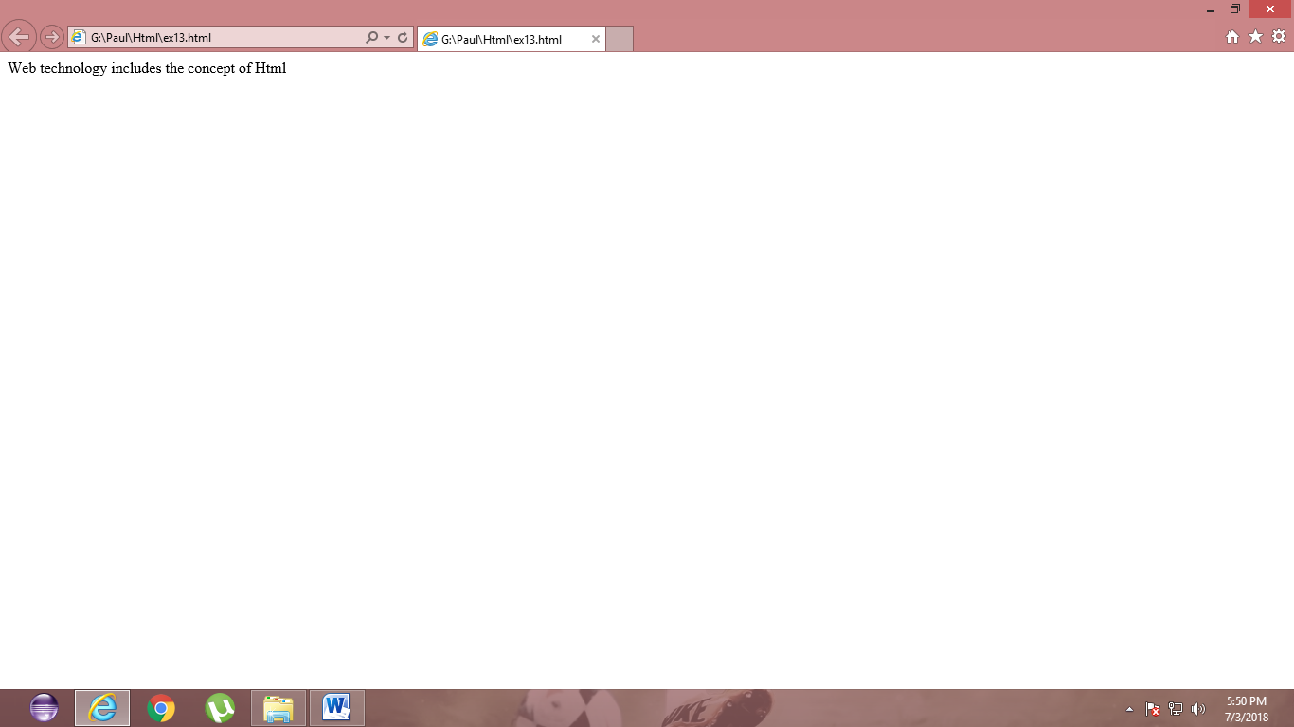

<html>

<body>

<h1>List of Fruits</h1>

<ul>

<li>Apple</li>

<li>Orange</li>

<li>Mango</li>

<li>Grapes</li>

<li>Butterfruit</li>

</ul>

</body>

</html>

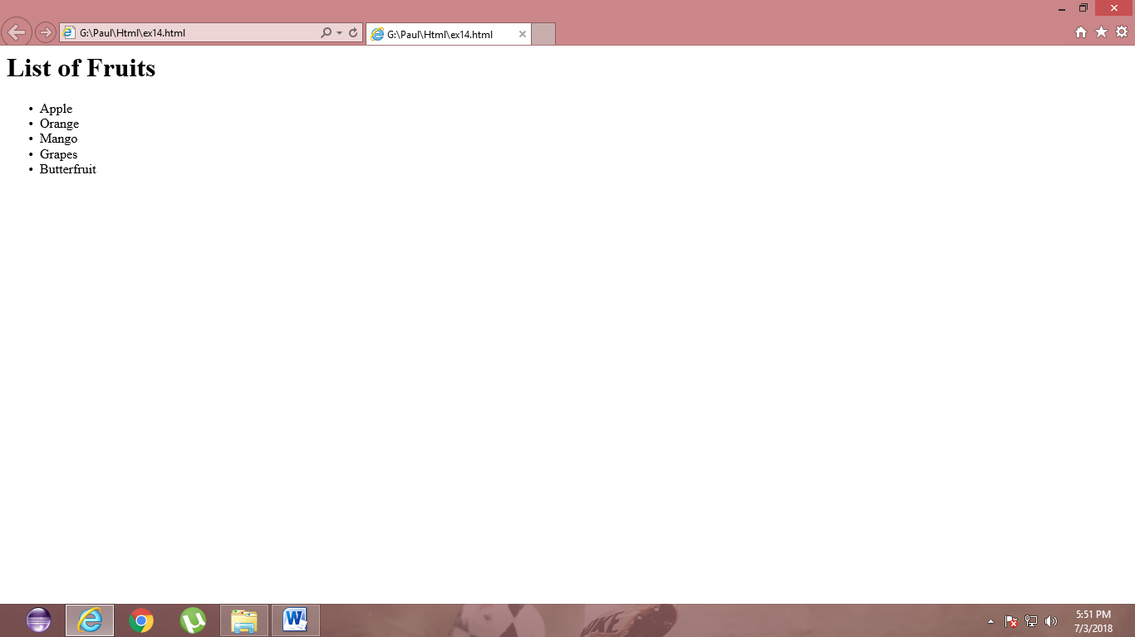

<html>

<body>

<h1>List of Fruits</h1>

<ol>

<li>Apple</li>

<li>Orange</li>

<li>Mango</li>

<li>Grapes</li>

<li>Butterfruit</li>

</ol>

</body>

</html>

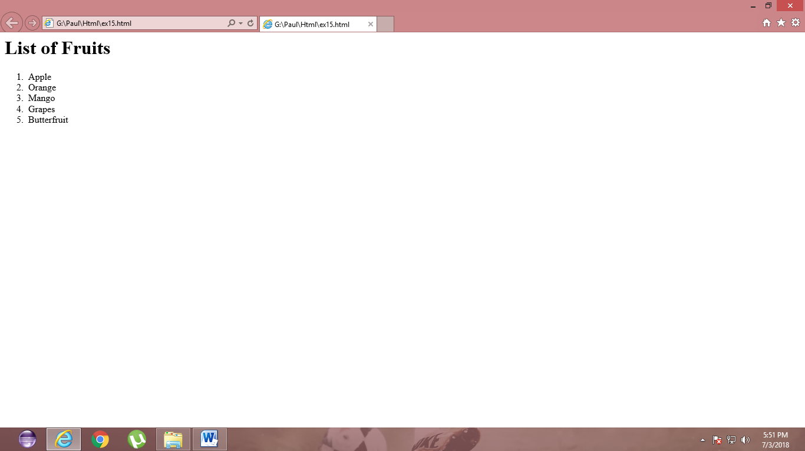

<html>

<body>

<title>Definition tag</title>

<dl>

<dt>Fruits<dt>

<dd>Apple</dd>

<dd>Orange</dd>

<dd>Mango</dd>

<dd>Grapes</dd>

<dd>Butterfruit</dd>

</dl>

</body>

</html>

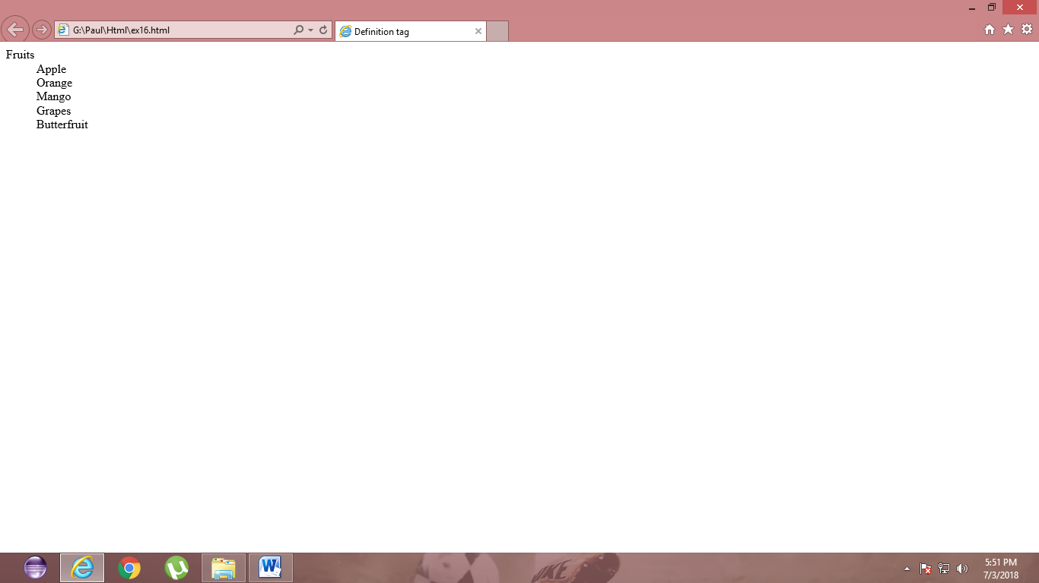

<html>

<body>

<h1>Hog image</h1>

<img src="C:\Users\admin\Desktop\Harley.jpg"width="180"height="185"/>

</body>

</html>

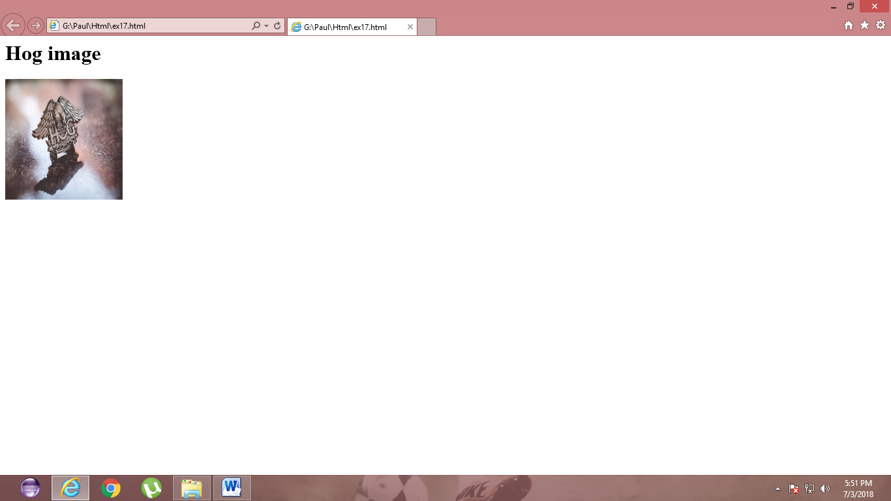

<html>

<body>

<h1>Harley Owner Group image</h1>

<img src="C:\Users\admin\Desktop\Harley.jpg"width="180"height="185"border="10"/>

</body>

</html>

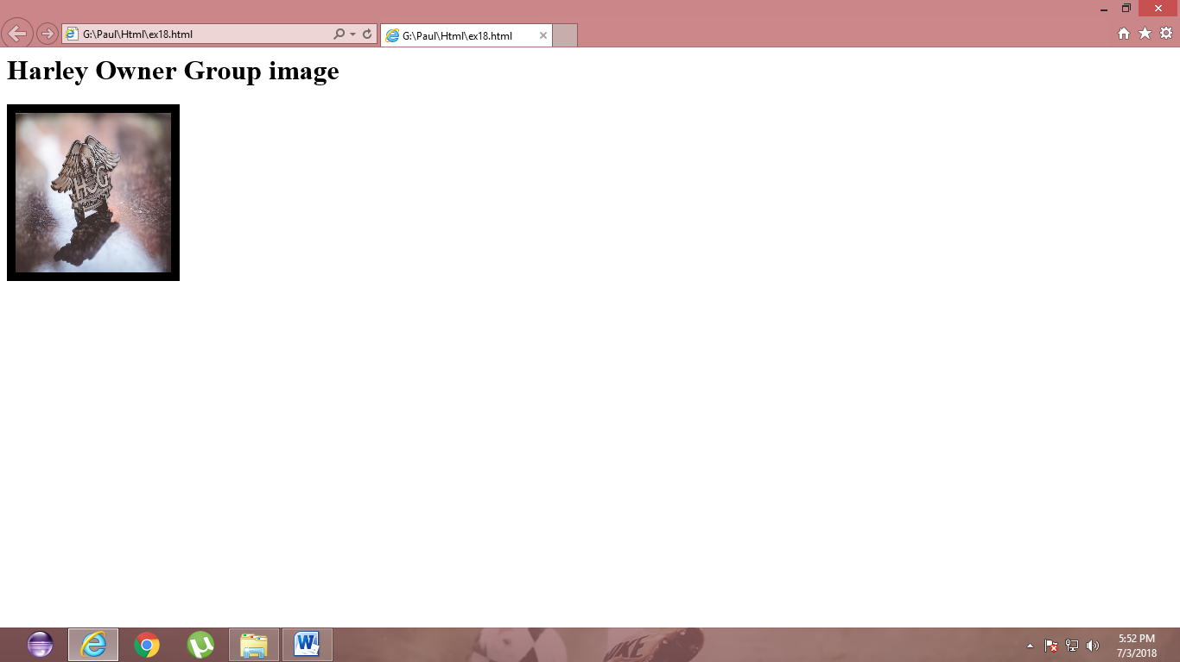

<html>

<body>

<table border="10">

<tr>

<td>Name</td>

<td>class</td>

</tr>

<tr>

<td>Dinesh Kumar</td>

<td>3rd Year</td>

</tr>

</table>

</body>

</html>

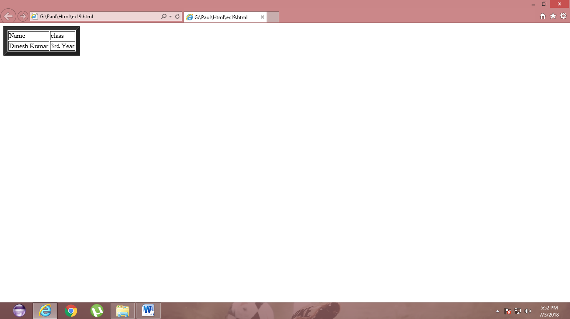

<html>

<body>

<table border="1" bgcolor="Red">

<tr>

<td>Name</td>

<td>class</td>

</tr>

<tr>

<td>Dinesh Kumar</td>

<td>3rd Year</td>

</tr>

</table>

</body>

</html>

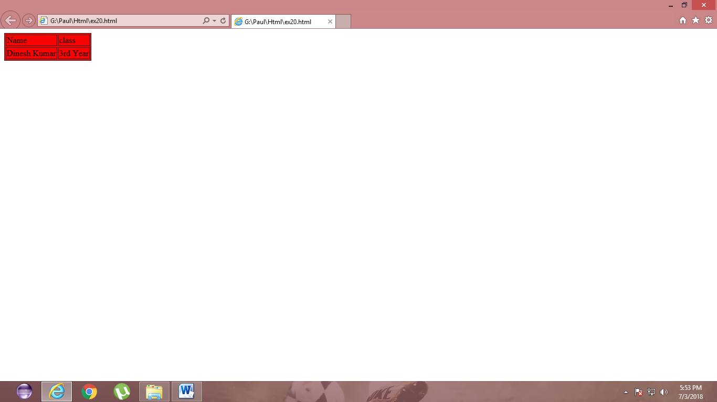

<html>

<body>

<h1>Database</h1>

<table border="1">

<tr>

<td>Name</td>

<td>Age</td>

</tr>

<tr>

<td>Dinesh Kumar</td>

<td>19</td>

<th rowspan="2" colspan="2">

male</th>

</tr>

</table>

</body>

</html>

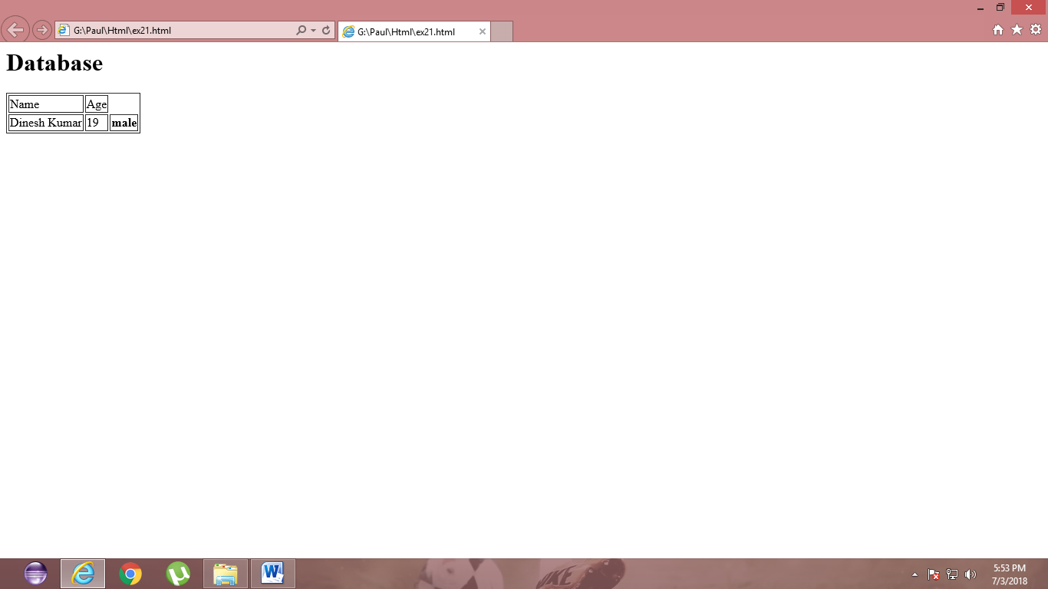

<html>

<body>

<h3>database</h3>

<table border="3" cellspacing="3" cellpadding="3">

<tr>

<td>name</td>

<td>age</td>

<td>dept</td>

</tr>

<tr>

<td>Dinesh Kumar</td>

<td>19</td>

<td>IT</td>

<th rowspan="2" colspan="2">

</th>

</tr>

</table>

</body></html>

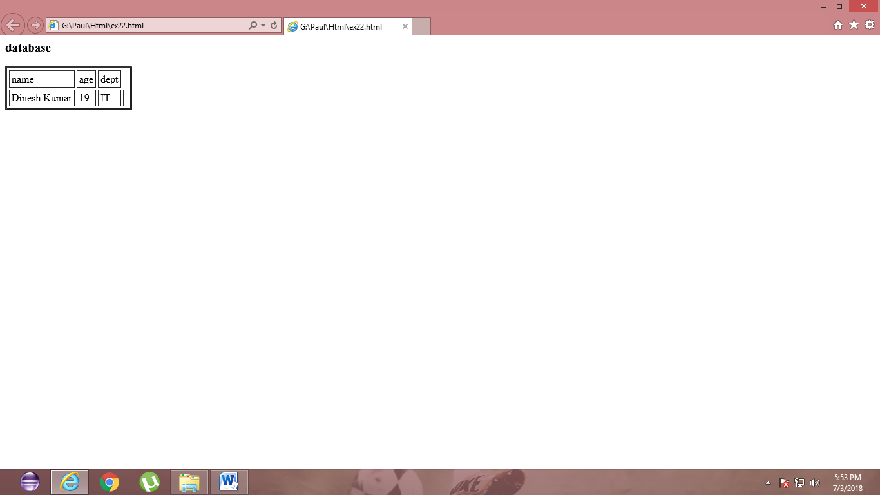

<html>

<body bgcolor="Green">

<h1>The Background color is Green</h1>

</body>

</html>

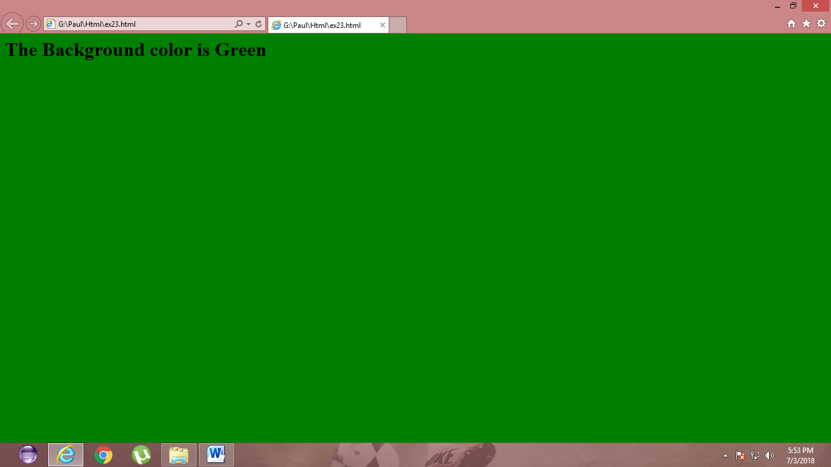

<html>

<body background="C:\Users\admin\Desktop\Harley.jpg" height="20" width="18">

<h1>Harley Owners Group</h1>

</body>

</html>

