<html>

<body>

<p>Javascript program</p>

</body>

</html>

Output:

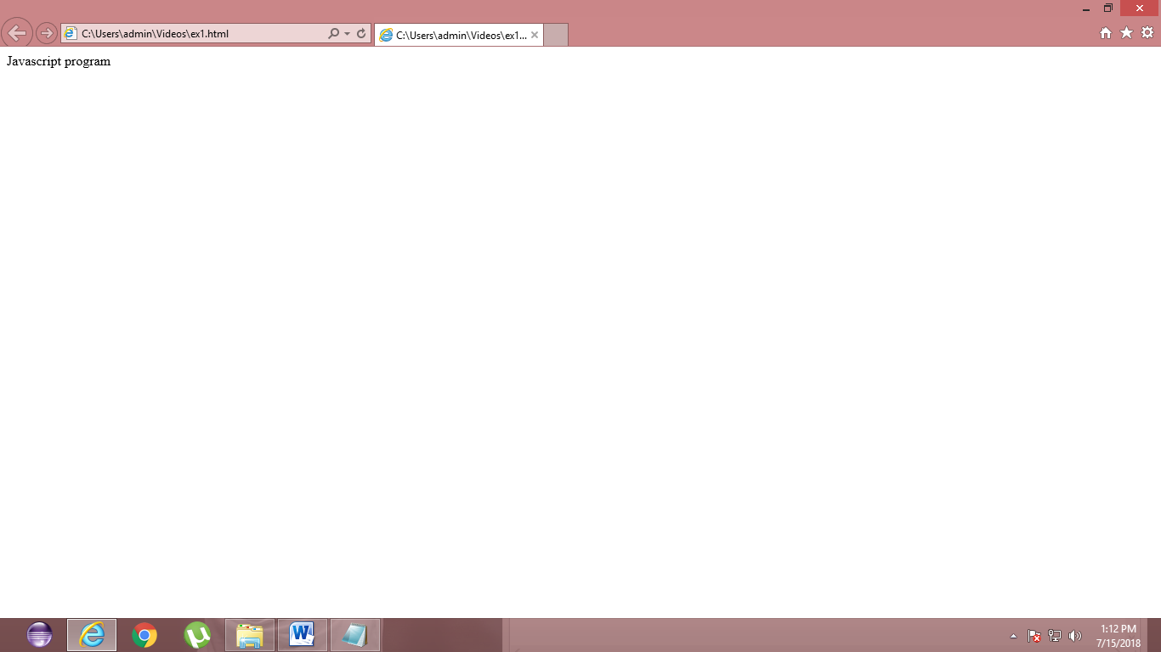

<!DOCTYPE html>

<html>

<body>

<h2>JavaScript Alert</h2>

<button onclick="myFunction()">Try it</button>

<script>

function myFunction() {

alert("I am an alert box!");}

</script>

</body>

</html>

Output:

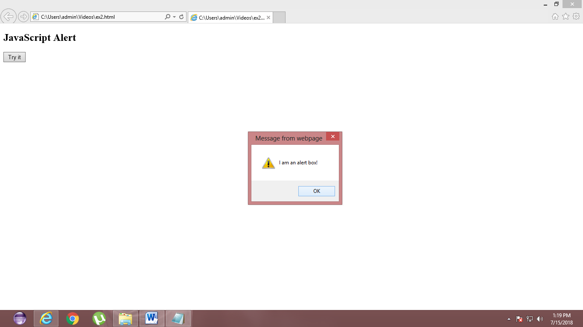

<!DOCTYPE html>

<html>

<body>

<h2>JavaScript Alert</h2>

<button onclick="myFunction()">Click Me</button>

<script>

function myFunction() {

alert("Hello World");}

</script>

</body>

</html>

Output:

