

# **September 30, 2023**

RELIEVING CERTIFICATE

This is to certify that **Mr. Dinesh Laxminarayan Paradeshi** was employed with us from

**September 13, 2023 to September 30, 2023.** His last designation in the organization was **Lead Consultant (Grade IS4).**

He has tendered his resignation on his own accord. His professional conduct during his tenure with us was good.

We wish him every success in his future endeavors.

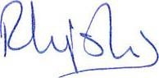For ITC INFOTECH INDIA LIMITED

# **Reshama Hemant Joshi**

**General Manager - Business HR**