

|  |  |  |  |
| --- | --- | --- | --- |
| DEPARTMENT | **MCA** | SEMESTER | **SUMMER SEM. I 2021-2022** |
| COURSE | **MOBILE APPLICATION DEVELOPMENT** | CODE | **ITA-6001** |
| FACULTY | **PROF. JANI ANBASARI** | SLOT | **A1/A2** |
| STUDENT NAME **:** | **DINESH YOGESH PAREKH** | REG NO | **20MCA1013** |

**Javascript Assignment**

**1.**

<!DOCTYPE html>

<html>

<head>

<style>

<body>

<h2>Date and Time</h2>

<button type="button" onclick="document.getElementById('Demo').innerHTML=Date()">Click here</button>

<p id="Demo">Fri Jul 02 2021 23:04:15 GMT+0530 (India Standard Time)</p>

</body>

</style>

</head>

</html>

**OUTPUT:**

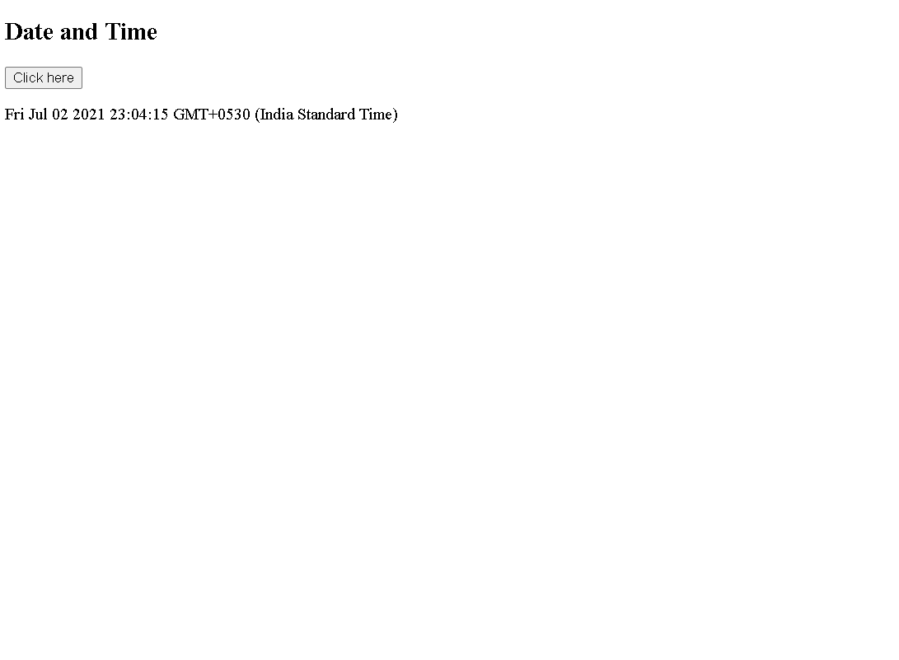

**2.**

<!DOCTYPE html>

<html>

<head>

<style>

<body>

<p id="demo">Hello !</p>

<button type="button" onclick="document.getElementById(&quot;demo&quot;).innerHTML = &quot;Hello !&quot;">Click !</button>

</body>

</style>

</head>

</html>

**OUTPUT:**

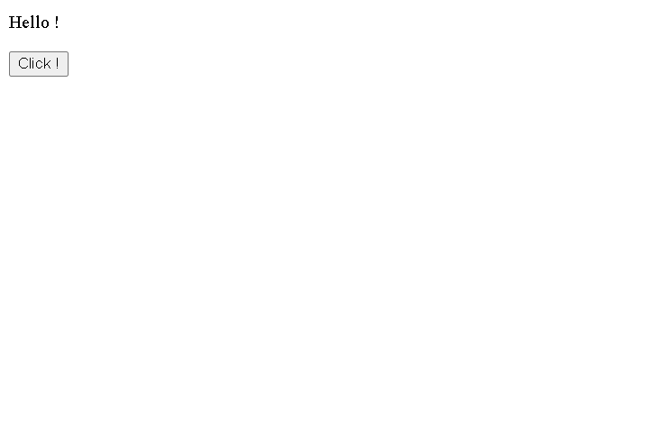

**3.**

<html>

<head>

</head>

<body>

<p id="demo"> Hide the HTML content.</p>

<button type="button" onclick="document.getElementById(&quot;demo&quot;).style.display=&quot;none&quot;">Click !</button>

</body>

</html>

**OUTPUT:**

1. 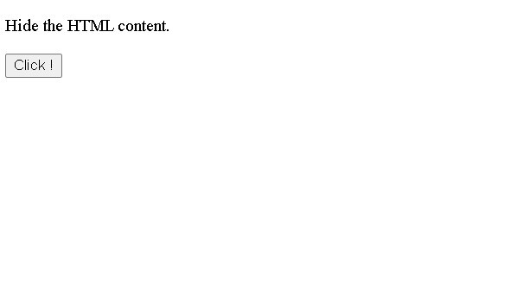

2



**4.**

<html>

<head>

</head>

<body>

<p>JavaScript can show hidden HTML elements.</p>

<p id="demo" style="display:none">Hello JavaScript!</p>

<button type="button" onclick="document.getElementById('demo').style.display='block'">Click !</button>

</body>

</html>

**OUTPUT:**

**1.**

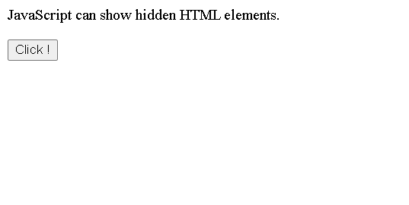

**2.**

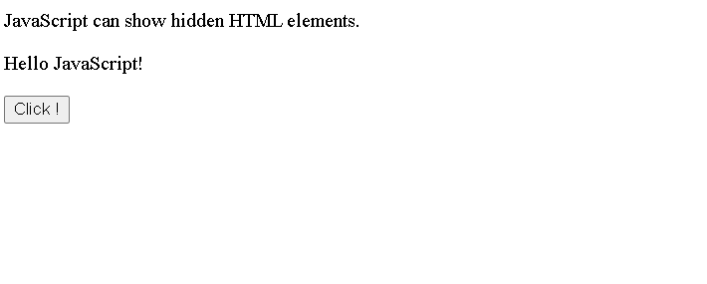

**5.**

<html>

<head>

<script>

function funct()

{

document.getElementById("demo").innerHTML="Paragraph Changed";

}

</script>

</head>

<body>

<p id="demo">Paragraph</p>

<button type="button" onclick="funct()">click</button>

</body>

</html>

**OUTPUT:**

**1.**

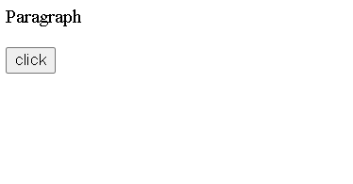

**2.**

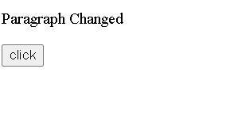

**6.**

<html>

<head>

<script src="D:\VIT Cources\COURCES\WINTER2018-2019\CSE4027\Code\myScript.js"></script>

</head>

<body>

<h2>External JavaScript</h2>

<p id="demo">A Paragraph.</p>

<button type="button" onclick="myFunction()">Try it</button>

<p>(myFunction is stored in an external file called "myScript.js")</p>

</body>

</html>

**OUTPUT:**

**1.**

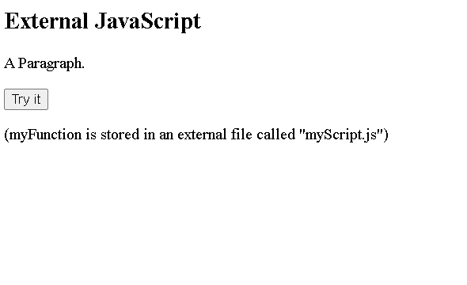

**7.**

<html>

<head>

</head>

<body>

<h1>My First Web Page</h1>

<p id="demo">16</p>

<script>

document.getElementById("demo").innerHTML = 5 + 11;

</script>

</body>

</html>

**OUTPUT:**

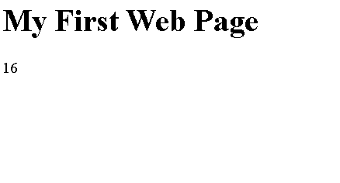

**Thank you.**