

|  |  |  |  |
| --- | --- | --- | --- |
| DEPARTMENT | **MCA** | SEMESTER | **SUMMER SEM. I 2021-2022** |
| COURSE | **MOBILE APPLICATION DEVELOPMENT** | CODE | **ITA-6001** |
| FACULTY | **PROF. JANI ANBASARI** | SLOT | **A1/A2** |
| STUDENT NAME **:** | **DINESH YOGESH PAREKH** | REG NO | **20MCA1013** |

**DIGITAL ASSIGNMENT - 2**

**Develop an Android application to perform the following**

**1. Design a calculator App to perform the following operations;**

* **Addition**
* **Subtraction**
* **Multiplication**
* **Division.**

**The user will enter two inputs and on clicking calculate button with operation type, the result will be calculated, and result would be presented using a Toast message.**

**CODE:**

**MainActivity.java**

package com.example.mycalculator;  
  
import androidx.appcompat.app.AppCompatActivity;  
  
import android.os.Bundle;  
import android.view.View;  
import android.widget.Button;  
import android.widget.EditText;  
import android.widget.TextView;  
import android.widget.Toast;  
  
public class MainActivity extends AppCompatActivity {  
  
 EditText no1 , no2;  
 Button add ,mul ,div , sub,equal;  
 TextView answer;  
 double ans = 0;  
  
 @Override  
 protected void onCreate(Bundle savedInstanceState) {  
 super.onCreate(savedInstanceState);  
 setContentView(R.layout.*activity_main*);  
  
  
  
 // for text views  
 no1 = findViewById(R.id.*first_no*);  
 no2 = findViewById(R.id.*second_no*);  
  
 // for button with operations  
 add = findViewById(R.id.*add*);  
 mul = findViewById(R.id.*mul*);  
 div = findViewById(R.id.*div*);  
 sub = findViewById(R.id.*sub*);  
  
 // for equal to button  
 equal = findViewById(R.id.*equals*);  
  
 // for answer field  
 answer = findViewById(R.id.*answer*);  
  
 add.setOnClickListener(new View.OnClickListener() {  
 @Override  
 public void onClick(View v) {  
 String num1 = no1.getText().toString();  
 String num2 = no2.getText().toString();  
  
 if (num1.isEmpty() || num2.isEmpty()) {  
 Toast.*makeText*(getApplicationContext(),"Enter Numbers",Toast.*LENGTH_SHORT*).show();  
 }  
 else {  
 double a = Double.*parseDouble*(no1.getText().toString());  
 double b = Double.*parseDouble*(no2.getText().toString());  
 ans = a + b;  
 }  
 }  
 });  
  
 sub.setOnClickListener(new View.OnClickListener() {  
 @Override  
 public void onClick(View v) {  
 String num1 = no1.getText().toString();  
 String num2 = no2.getText().toString();  
  
 if (num1.isEmpty() || num2.isEmpty()) {  
 Toast.*makeText*(getApplicationContext(),"Enter Numbers",Toast.*LENGTH_SHORT*).show();  
 }  
 else {  
 double a = Double.*parseDouble*(no1.getText().toString());  
 double b = Double.*parseDouble*(no2.getText().toString());  
 ans = a - b;  
 }  
 }  
 });  
  
 mul.setOnClickListener(new View.OnClickListener() {  
 @Override  
 public void onClick(View v) {  
 String num1 = no1.getText().toString();  
 String num2 = no2.getText().toString();  
  
 if (num1.isEmpty() || num2.isEmpty()) {  
 Toast.*makeText*(getApplicationContext(),"Enter Numbers",Toast.*LENGTH_SHORT*).show();  
 }  
 else {  
 double a = Double.*parseDouble*(no1.getText().toString());  
 double b = Double.*parseDouble*(no2.getText().toString());  
 ans = a * b;  
 }  
 }  
 });  
  
 div.setOnClickListener(new View.OnClickListener() {  
 @Override  
 public void onClick(View v) {  
 String num1 = no1.getText().toString();  
 String num2 = no2.getText().toString();  
  
 if (num1.isEmpty() || num2.isEmpty()) {  
 Toast.*makeText*(getApplicationContext(), "Enter Numbers", Toast.*LENGTH_SHORT*).show();  
 } else {  
 double a = Double.*parseDouble*(no1.getText().toString());  
 double b = Double.*parseDouble*(no2.getText().toString());  
 if (b != 0)  
 ans = a / b;  
 else  
 Toast.*makeText*(getApplicationContext(), "Enter Valid Numbers", Toast.*LENGTH_SHORT*).show();  
 }  
 }  
 });  
  
 equal.setOnClickListener(new View.OnClickListener() {  
 @Override  
 public void onClick(View v) {  
 String ans1 = String.*valueOf*(ans);  
 answer.setText(ans1);  
 ans= 0;  
 }  
 });  
  
 }

**Activity_main.xml**

<?xml version="1.0" encoding="utf-8"?>  
<LinearLayout xmlns:android="http://schemas.android.com/apk/res/android"  
 xmlns:app="http://schemas.android.com/apk/res-auto"  
 xmlns:tools="http://schemas.android.com/tools"  
 android:layout_width="match_parent"  
 android:layout_height="match_parent"  
 tools:context=".MainActivity"  
 android:padding="20dp"  
 android:orientation="vertical"  
 android:background="lighted">  
  
 <TextView  
 android:layout_width="wrap_content"  
 android:layout_height="wrap_content"  
 android:text="MY CALCULATOR"  
 android:textSize="25sp"  
 android:layout_marginBottom="16dp"  
 android:textColor="@color/purple_500" />  
  
 <LinearLayout  
 android:layout_width="match_parent"  
 android:layout_height="wrap_content"  
 android:layout_marginBottom="20dp"  
 android:orientation="horizontal">  
  
 <EditText  
 android:id="@+id/first_no"  
 android:layout_width="102dp"  
 android:layout_height="59dp"  
 android:layout_marginHorizontal="50dp"  
 android:ems="10"  
 android:hint="Enter" />  
  
 <EditText  
 android:id="@+id/second_no"  
 android:layout_width="102dp"  
 android:layout_height="59dp"  
 android:ems="10"  
 android:hint="Enter" />  
  
 </LinearLayout>  
  
 <LinearLayout  
 android:layout_width="wrap_content"  
 android:layout_height="wrap_content"  
 android:orientation="horizontal"  
 android:layout_marginBottom="20dp">  
  
 </LinearLayout>  
  
 <LinearLayout  
 android:orientation="vertical"  
 android:layout_marginLeft="250dp"  
 android:layout_width="wrap_content"  
 android:layout_height="wrap_content"  
 android:layout_marginBottom="30dp">  
  
 <Button  
 android:id="@+id/sub"  
 android:layout_width="wrap_content"  
 android:layout_height="wrap_content"  
 android:layout_marginBottom="16dp"  
 android:text="-"  
 android:textSize="25sp" />  
  
 <Button  
 android:id="@+id/add"  
 android:layout_width="wrap_content"  
 android:layout_height="wrap_content"  
 android:layout_marginBottom="16dp"  
 android:text="+"  
 android:textSize="25sp"  
 tools:ignore="OnClick" />  
  
 <Button  
 android:id="@+id/div"  
 android:layout_width="wrap_content"  
 android:layout_height="wrap_content"  
 android:text="/"  
 android:textSize="25sp"  
 android:layout_marginBottom="16dp" />  
  
 <Button  
 android:id="@+id/mul"  
 android:layout_width="wrap_content"  
 android:layout_height="wrap_content"  
 android:layout_marginBottom="16dp"  
 android:text="X"  
 android:textSize="25sp"/>  
  
 <Button  
 android:id="@+id/equals"  
 android:layout_width="wrap_content"  
 android:layout_height="wrap_content"  
 android:layout_marginBottom="16dp"  
 android:text="="  
 android:textSize="35sp"/>  
 </LinearLayout>  
  
 <TextView  
 android:id="@+id/answer"  
 android:layout_width="102dp"  
 android:layout_height="59dp"  
 android:layout_marginHorizontal="50dp"  
 android:hint="ans"  
 android:textSize="35sp" />  
  
  
</LinearLayout>

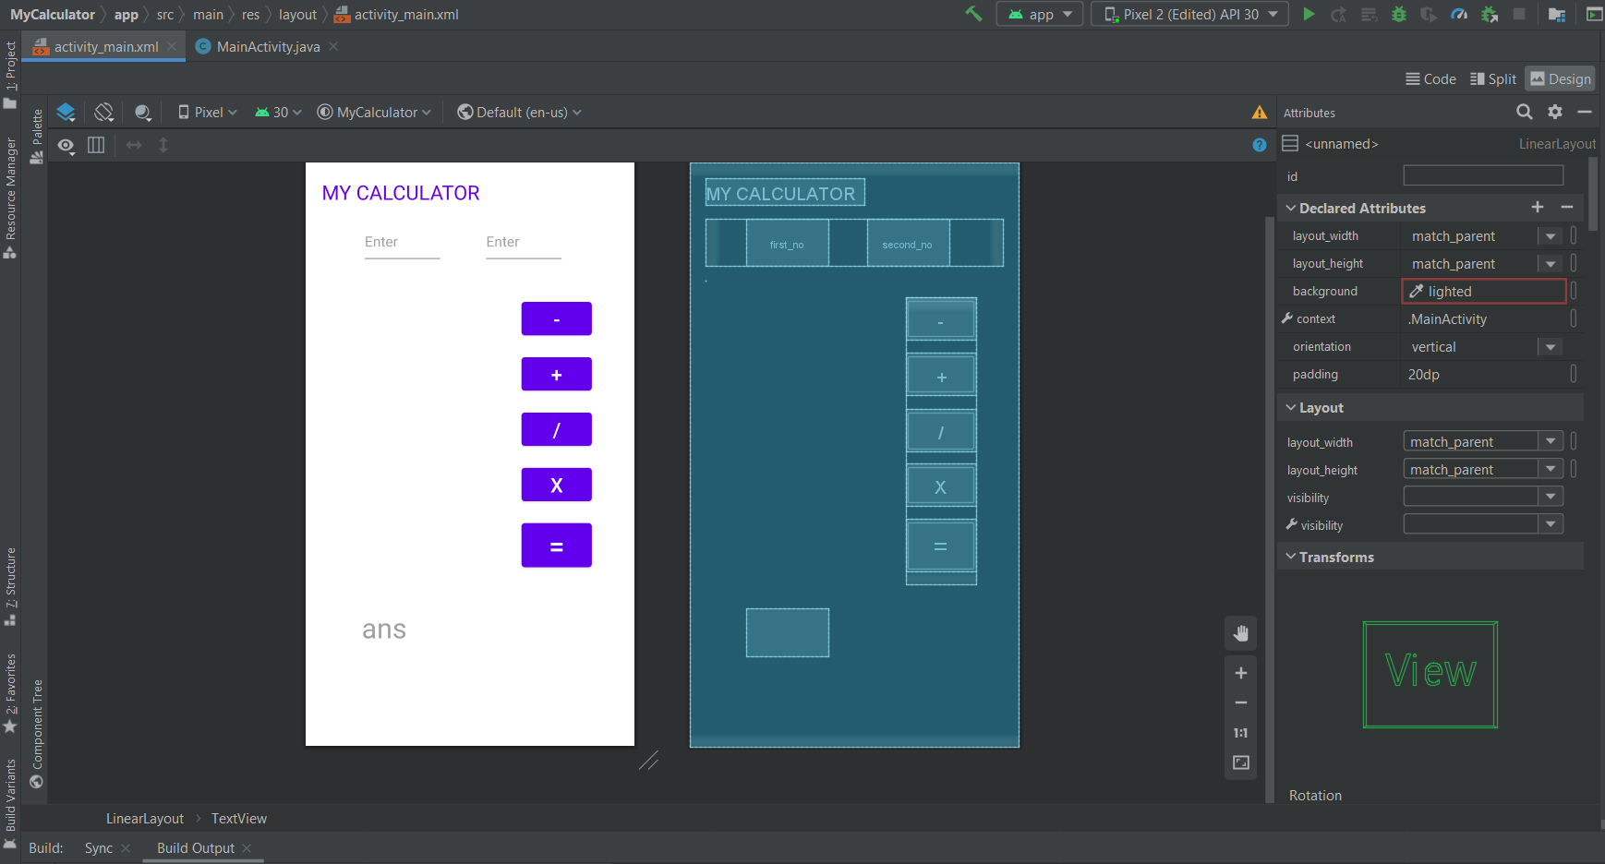

1. **Design an Android App to adjust the intensity of the image. The App should include an image and a Transparency slider in the Activity layout. Sliding the Transparency slider to the right will reduce the element’s transparency while sliding it to the left will increase it.**

**Activity_main.xml**

<?xml version="1.0" encoding="utf-8"?>  
<androidx.coordinatorlayout.widget.CoordinatorLayout xmlns:android="http://schemas.android.com/apk/res/android"  
 xmlns:app="http://schemas.android.com/apk/res-auto"  
 xmlns:tools="http://schemas.android.com/tools"  
 android:layout_width="match_parent"  
 android:layout_height="match_parent"  
 tools:context=".MainActivity">  
  
 <com.google.android.material.appbar.AppBarLayout  
 android:layout_width="match_parent"  
 android:layout_height="wrap_content"  
 android:theme="@style/Theme.MyDemoApp.AppBarOverlay">  
  
 <androidx.appcompat.widget.Toolbar  
 android:id="@+id/toolbar"  
 android:layout_width="match_parent"  
 android:layout_height="?attr/actionBarSize"  
 android:background="?attr/colorPrimary"  
 app:popupTheme="@style/Theme.MyDemoApp.PopupOverlay" />  
  
 <EditText  
 android:id="@+id/editTextTime"  
 android:layout_width="match_parent"  
 android:layout_height="wrap_content"  
 android:ems="10"  
 android:inputType="time" />  
  
 </com.google.android.material.appbar.AppBarLayout>  
  
 <include  
 android:id="@+id/include"  
 layout="@layout/content_main" />  
  
 <com.google.android.material.floatingactionbutton.FloatingActionButton  
 android:id="@+id/fab"  
 android:layout_width="wrap_content"  
 android:layout_height="wrap_content"  
 android:layout_gravity="bottom|end"  
 android:layout_margin="@dimen/fab_margin"  
 app:srcCompat="@android:drawable/ic_dialog_email" />  
  
 <androidx.constraintlayout.widget.ConstraintLayout  
 android:id="@+id/constraintLayout"  
 android:layout_width="match_parent"  
 android:layout_height="match_parent"  
 app:layout_anchor="@+id/include"  
 app:layout_anchorGravity="center">  
  
 <TextView  
 android:id="@+id/textView"  
 android:layout_width="wrap_content"  
 android:layout_height="wrap_content"  
 android:text="Hello Android World"  
 tools:layout_editor_absoluteX="134dp"  
 tools:layout_editor_absoluteY="105dp" />  
  
 <EditText  
 android:id="@+id/editTextTextPassword"  
 android:layout_width="wrap_content"  
 android:layout_height="wrap_content"  
 android:ems="10"  
 android:inputType="textPassword"  
 tools:layout_editor_absoluteX="100dp"  
 tools:layout_editor_absoluteY="302dp" />  
  
 <Button  
 android:id="@+id/button"  
 android:layout_width="wrap_content"  
 android:layout_height="wrap_content"  
 android:text="Submit"  
 tools:layout_editor_absoluteX="160dp"  
 tools:layout_editor_absoluteY="607dp" />  
  
 <RadioGroup  
 android:layout_width="wrap_content"  
 android:layout_height="wrap_content"  
 tools:layout_editor_absoluteX="108dp"  
 tools:layout_editor_absoluteY="428dp" />  
  
 <com.google.android.material.chip.Chip  
 android:id="@+id/chip4"  
 android:layout_width="wrap_content"  
 android:layout_height="wrap_content"  
 tools:layout_editor_absoluteX="76dp"  
 tools:layout_editor_absoluteY="178dp" />  
 </androidx.constraintlayout.widget.ConstraintLayout>  
  
</androidx.coordinatorlayout.widget.CoordinatorLayout>

**Main_Activity.java**

package com.example.mydemoapp;  
  
import android.content.Intent;  
import android.os.Bundle;  
  
import com.google.android.material.snackbar.Snackbar;  
  
import androidx.appcompat.app.AppCompatActivity;  
  
import android.view.View;  
import android.widget.TextView;  
  
import androidx.navigation.NavController;  
import androidx.navigation.Navigation;  
import androidx.navigation.ui.AppBarConfiguration;  
import androidx.navigation.ui.NavigationUI;  
  
import com.example.mydemoapp.databinding.ActivityMain2Binding;  
  
  
 class Main2Activity extends AppCompatActivity {  
 TextView t1;  
 String name;  
  
 @Override  
  
 protected void onCreate(Bundle savedInstanceState) {  
 super.onCreate(savedInstanceState);  
 setContentView(R.layout.*activity_main2*);  
 t1 = (TextView) findViewById(R.id.*textView2*);  
 Intent i = getIntent();  
 name = i.getStringExtra("name_key");  
 t1.setText(name);  
  
 }  
 }

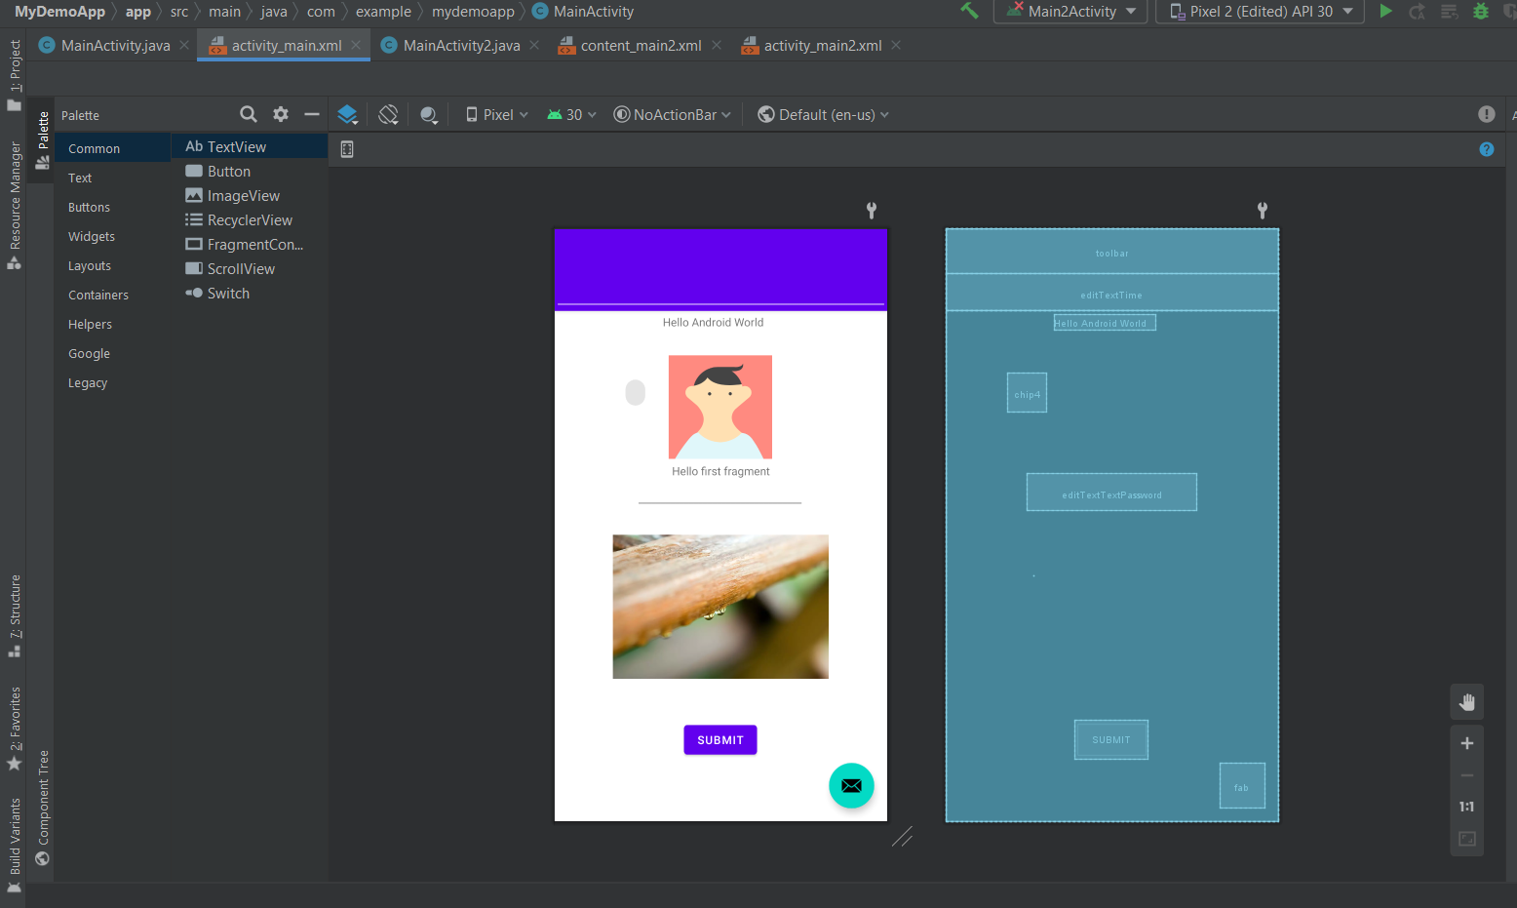

1. **Attendance Manager APP helps to keep track of student daily attendance in the class. It maintains the attendance of students for any number of subjects. The students can view whether he/she was present or absent in a particular class from the APP. It also calculates the attendance percentage and displays the same using toast message. Design the APP for the given scenario.**

**LoginActivity.java**

package com.android.attendance.activity;  
  
import android.app.Activity;  
import android.content.Intent;  
import android.graphics.Color;  
import android.os.Bundle;  
import android.text.TextUtils;  
import android.view.Menu;  
import android.view.View;  
import android.view.View.OnClickListener;  
import android.widget.AdapterView;  
import android.widget.AdapterView.OnItemSelectedListener;  
import android.widget.ArrayAdapter;  
import android.widget.Button;  
import android.widget.EditText;  
import android.widget.Spinner;  
import android.widget.TextView;  
import android.widget.Toast;  
  
import com.android.attendance.bean.FacultyBean;  
import com.android.attendance.context.ApplicationContext;  
import com.android.attendance.db.DBAdapter;  
import com.example.androidattendancesystem.R;  
  
public class LoginActivity extends Activity {  
  
 Button login;  
 EditText username,password;  
 Spinner spinnerloginas;  
 String userrole;  
 private String[] userRoleString = new String[] { "admin", "faculty"};  
  
 @Override  
 protected void onCreate(Bundle savedInstanceState) {  
 super.onCreate(savedInstanceState);  
 setContentView(R.layout.*login*);  
  
 login =(Button)findViewById(R.id.*buttonlogin*);  
 username=(EditText)findViewById(R.id.*editTextusername*);  
 password=(EditText)findViewById(R.id.*editTextpassword*);  
 spinnerloginas=(Spinner)findViewById(R.id.*spinnerloginas*);  
  
 spinnerloginas.setOnItemSelectedListener(new OnItemSelectedListener() {  
 @Override  
 public void onItemSelected(AdapterView<?> arg0, View view,  
 int arg2, long arg3) {  
 // *TODO Auto-generated method stub* ((TextView) arg0.getChildAt(0)).setTextColor(Color.*WHITE*);  
 userrole =(String) spinnerloginas.getSelectedItem();  
  
 }  
  
 @Override  
 public void onNothingSelected(AdapterView<?> arg0) {  
 // *TODO Auto-generated method stub* }  
 });  
  
 ArrayAdapter<String> adapter_role = new ArrayAdapter<String>(this,  
 android.R.layout.*simple_spinner_item*, userRoleString);  
 adapter_role  
 .setDropDownViewResource(android.R.layout.*simple_spinner_dropdown_item*);  
 spinnerloginas.setAdapter(adapter_role);  
  
 login.setOnClickListener(new OnClickListener() {  
  
 @Override  
 public void onClick(View v) {  
 // *TODO Auto-generated method stub* if(userrole.equals("admin"))  
 {  
  
 String user_name = username.getText().toString();  
 String pass_word = password.getText().toString();  
  
 if (TextUtils.*isEmpty*(user_name))   
 {  
 username.setError("Invalid User Name");  
 }  
 else if(TextUtils.*isEmpty*(pass_word))  
 {  
 password.setError("enter password");  
 }  
 else  
 {  
 if(user_name.equals("admin") & pass_word.equals("admin123")){  
 Intent intent =new Intent(LoginActivity.this,MenuActivity.class);  
 startActivity(intent);  
 Toast.*makeText*(getApplicationContext(), "Login successful", Toast.*LENGTH_SHORT*).show();  
 }else{  
 Toast.*makeText*(getApplicationContext(), "Login failed", Toast.*LENGTH_SHORT*).show();  
 }  
 }  
 }  
   
 else  
 {  
 String user_name = username.getText().toString();  
 String pass_word = password.getText().toString();  
  
 if (TextUtils.*isEmpty*(user_name))   
 {  
 username.setError("Invalid User Name");  
 }  
 else if(TextUtils.*isEmpty*(pass_word))  
 {  
 password.setError("enter password");  
 }  
 DBAdapter dbAdapter = new DBAdapter(LoginActivity.this);  
 FacultyBean facultyBean = dbAdapter.validateFaculty(user_name, pass_word);  
   
 if(facultyBean!=null)  
 {  
 Intent intent = new Intent(LoginActivity.this,AddAttandanceSessionActivity.class);  
 startActivity(intent);  
 ((ApplicationContext)LoginActivity.this.getApplicationContext()).setFacultyBean(facultyBean);  
 Toast.*makeText*(getApplicationContext(), "Login successful", Toast.*LENGTH_SHORT*).show();  
 }  
 else  
 {  
 Toast.*makeText*(getApplicationContext(), "Login failed", Toast.*LENGTH_SHORT*).show();  
 }  
 }  
  
  
 }  
 });  
  
  
  
 }  
  
 @Override  
 public boolean onCreateOptionsMenu(Menu menu) {  
 // Inflate the menu; this adds items to the action bar if it is present.  
 getMenuInflater().inflate(R.menu.*main*, menu);  
 return true;  
 }  
  
}

**Activity_main.xml**

<RelativeLayout xmlns:android="http://schemas.android.com/apk/res/android"  
 xmlns:tools="http://schemas.android.com/tools"  
 android:layout_width="match_parent"  
 android:layout_height="match_parent"  
 android:paddingBottom="@dimen/activity_vertical_margin"  
 android:paddingLeft="@dimen/activity_horizontal_margin"  
 android:paddingRight="@dimen/activity_horizontal_margin"  
 android:paddingTop="@dimen/activity_vertical_margin"  
 android:background="@drawable/clg"  
 tools:context=".MainActivity" >  
  
 <TextView  
 android:id="@+id/textView1"  
 android:layout_width="395dp"  
 android:layout_height="wrap_content"  
 android:layout_alignParentLeft="true"  
 android:layout_alignParentTop="true"  
 android:layout_marginLeft="0dp"  
 android:layout_marginTop="188dp"  
 android:text="Attendance Manager APP"  
 android:textAlignment="center"  
 android:textAppearance="?android:attr/textAppearanceLarge"  
 android:textColor="@android:color/holo_red_dark"  
 android:textSize="25dp"  
 android:textStyle="bold"  
 android:gravity="center_horizontal" />  
  
 <Button  
 android:id="@+id/buttonstart"  
 android:layout_width="match_parent"  
 android:layout_height="wrap_content"  
 android:layout_centerHorizontal="true"  
 android:layout_centerVertical="true"  
 android:background="@drawable/roundedbutton"  
 android:text="Begin" />  
  
 <TextView  
 android:id="@+id/textView"  
 android:layout_width="174dp"  
 android:layout_height="wrap_content"  
 android:layout_alignParentLeft="true"  
 android:layout_alignParentTop="true"  
 android:layout_marginLeft="115dp"  
 android:layout_marginTop="157dp"  
 android:text="HOME"  
 android:textAlignment="center"  
 android:textAppearance="?android:attr/textAppearanceLarge"  
 android:textColor="@android:color/holo_red_dark"  
 android:textSize="25dp"  
 android:textStyle="bold"  
 android:gravity="center_horizontal" />  
  
</RelativeLayout>

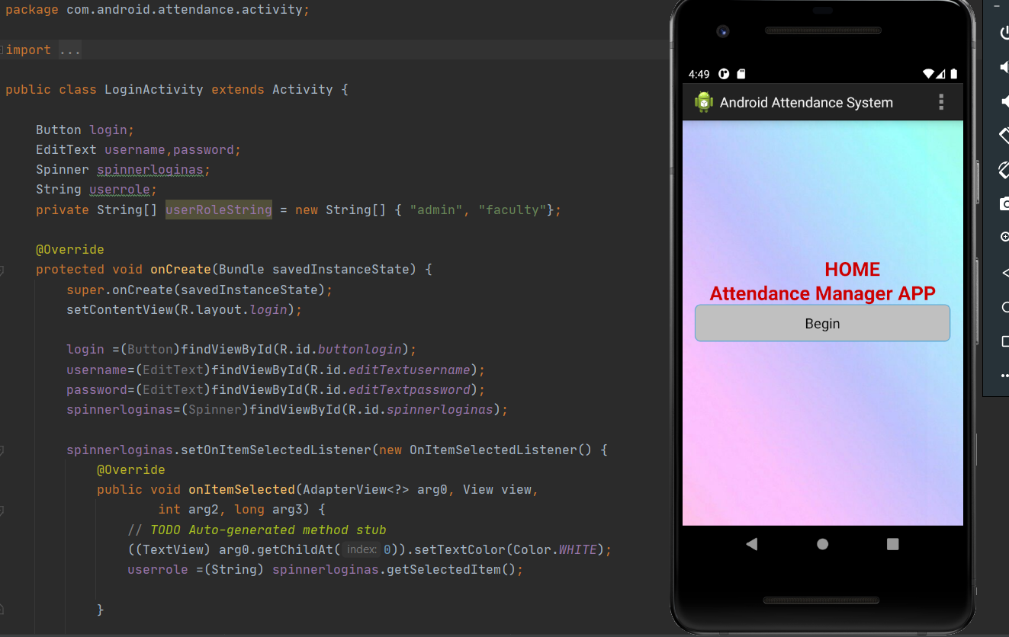

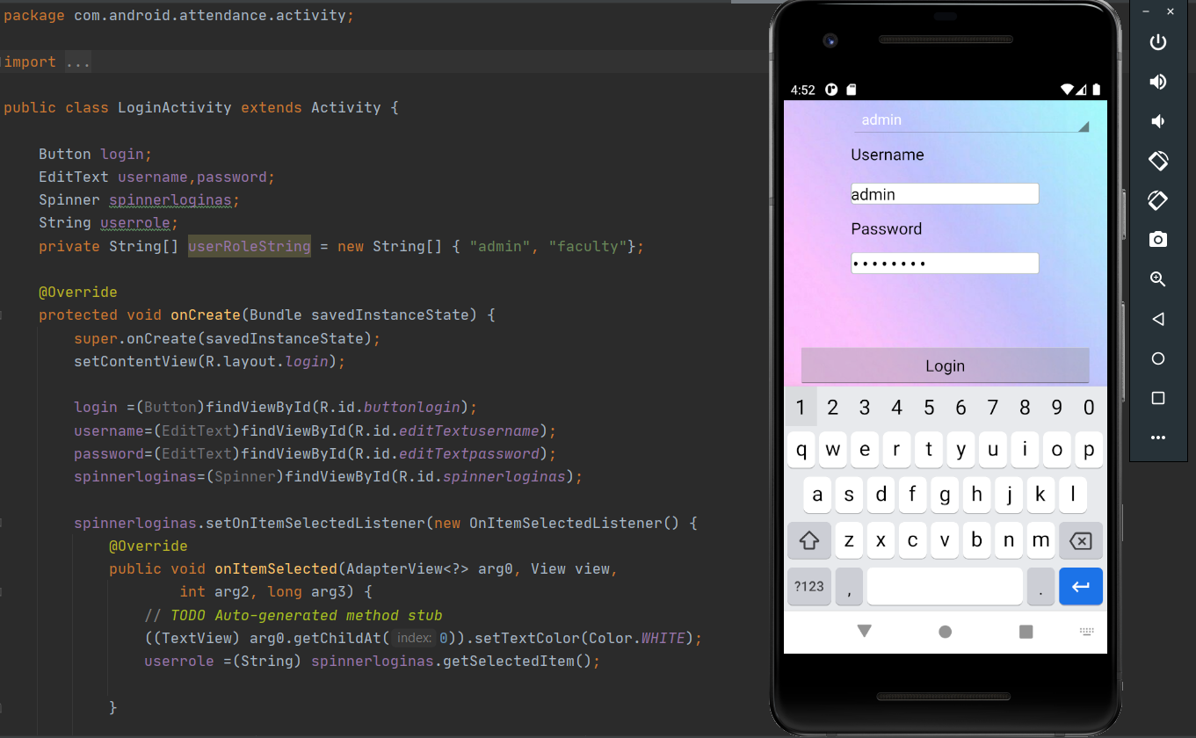

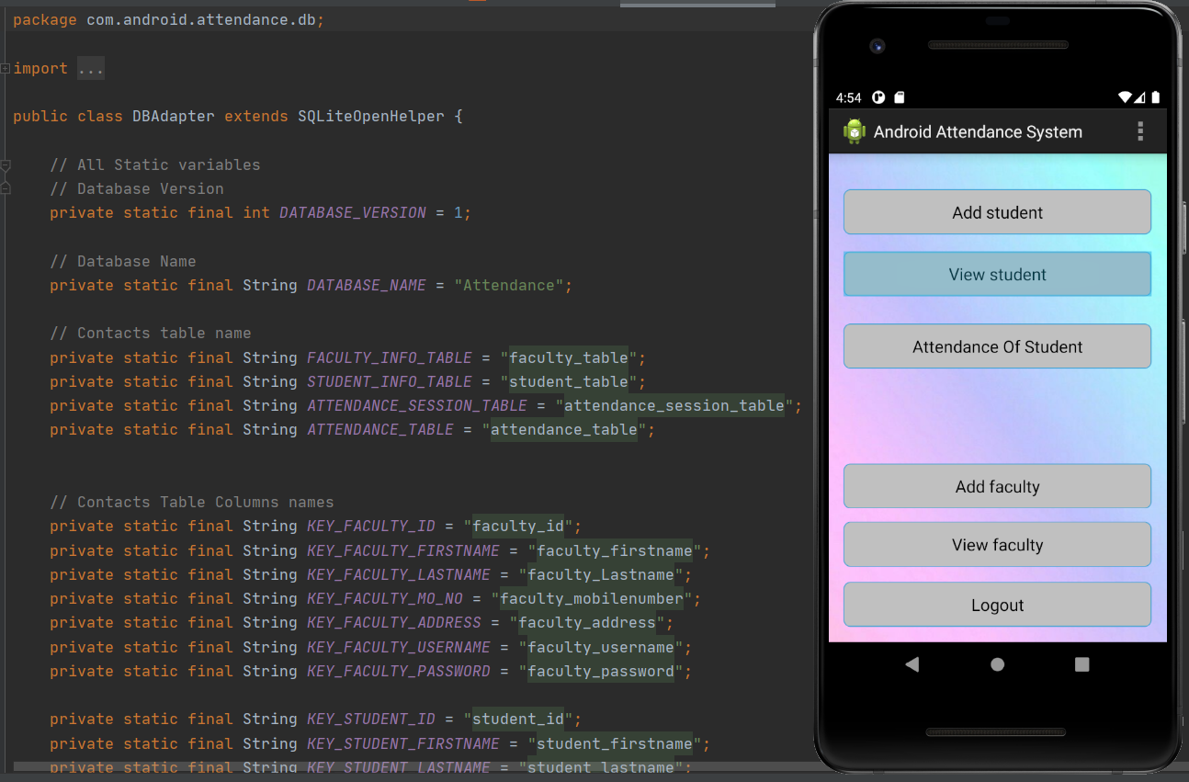

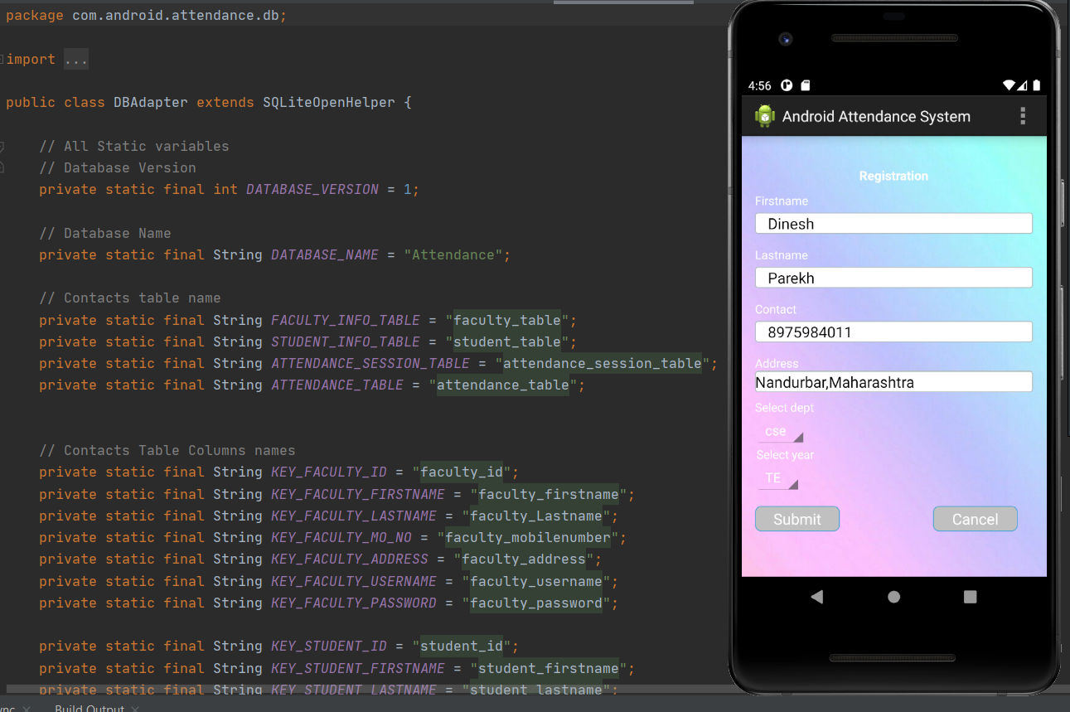

***Thank you.***