

|  |  |  |  |
| --- | --- | --- | --- |
| DEPARTMENT | **MCA** | SEMESTER | **SUMMER SEM. I 2021-2022** |
| COURSE | **PYTHON** | CODE | **ITA-6017** |
| FACULTY | **PROF. RAJRAJESWARI S.** | SLOT | **D1/D2 / L11/L12** |
| STUDENT NAME **:** | **DINESH YOGESH PAREKH** | REG NO | **20MCA1013** |

**Lab Assignment1 (29.6.21)**

 Read   a complex number A from a user and  create another  complex number B by exchanging the real part and imaginary part. Then perform the following operations and the result :

A2+2AB+B2

A/B

A//B (Perform  integer division for real and imaginary part separately )

**CODE:**

a=int(input("Enter number"))

b=complex(a)

b

c=(a*a)+(b*b)+(2*a*b);

c

d=a/b

d

**OUTPUT:**

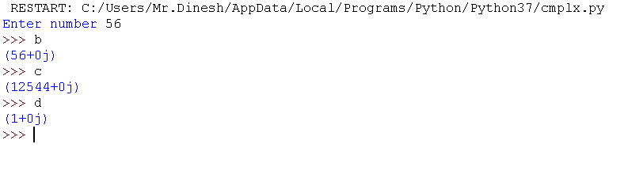

**2.**

**Accept three digit number from user and print them in the same order how it appears in the number.**

**Eg : 427 à**

**4**

**2**

**7**

**CODE:**

a=int(input("Enter number a "))

b=int(input("Enter number b "))

c=int(input("Enter number c "))

print('\n',a,'\n',b,'\n',c)

**OUTPUT:**

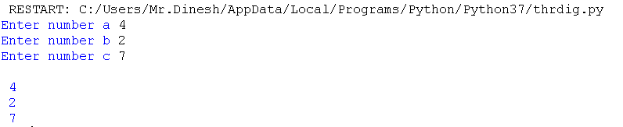

**3.**

Accept the seconds from the user and print in the format hh:mm:ss

Eg :

 3699

1:1:39

CODE:

# SAMPLE CODE

time = float(input("Input time in seconds: "))

hour = time // 3600

minutes = time // 60

time %= 60

seconds = time

print("h:m:s-> %d:%d:%d" % (hour, minutes, seconds))

**OUTPUT:**



**4.**

In this challenge, a farmer is asking you to tell him how many legs can be counted among all his animals. The farmer breeds three species:

chickens = 2 legs

cows = 4 legs

pigs = 4 legs

The farmer has counted his animals and he gives you a subtotal for each species. You have to implement a function that returns the total number of legs of all the animals. Accwpt number of chickens  and number of cows and number of pigs.

**CODE:**

# SAMPLE CODE

print("returns the total number of legs of all the animals")

print("chickens = 2 legs\ncows = 4 legs\npigs = 4 legs")

chickens=2

cows=4

pigs=4

print("enter the no of chickens")

chic=int(input())

print("enter the no of cows")

cows1=int(input())

print("enter the no of pigs")

pigs1=int(input())

def animals(chickens,cows,pigs):

return chic*chickens+cows1*cows+pigs1*pigs

print(animals(chickens,cows,pigs))

**OUTPUT:**

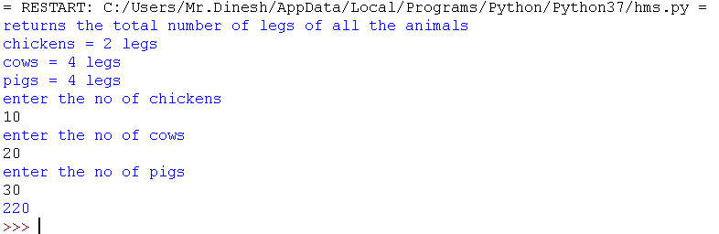

**5.**

Accept two three digit number from user and form a new number by taking each digit from the two number alternatively:

N1=356, N2=294

Result =325964

**CODE:**

a=str(input("Enter A values:"))

b=str(input("Enter B values:"))

result = ''

for i in range(len(a)):

result = result + a[i] + b[i]

print("Result :",result)

**OUTPUT:**

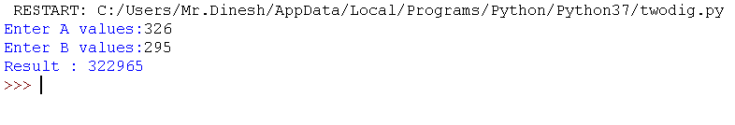

***Thank you.***