

|  |  |  |  |
| --- | --- | --- | --- |
| DEPARTMENT | **MCA** | SEMESTER | **SUMMER SEM. I 2021-2022** |
| COURSE | **PYTHON** | CODE | **ITA-6017** |
| FACULTY | **PROF. RAJRAJESWARI S.** | SLOT | **D1/D2 / L11/L12** |
| STUDENT NAME **:** | **DINESH YOGESH PAREKH** | REG NO | **20MCA1013** |

**Lab Assignment 2( 6.7.21) Morning**

1. Write a program that read a group ‘g’ of five numbers and another number ‘n’ and print a number in ‘g’ if it is a factor for a given number n?

**CODE:**

**OUTPUT:**

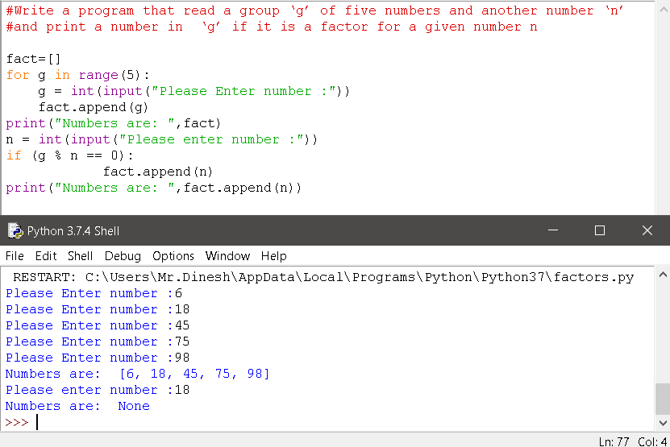

1. Write a program to find the factorial of a number n?

**CODE:**

# find the factorial of a number

n = int(input("Enter a number: "))

fact = 1

if n < 0:

print("Sorry, factorial does not exist for negative numbers")

elif n == 0:

print("The factorial of 0 is 1")

else:

for i in range(1,n + 1):

fact = fact*i

print("The factorial of",n,"is",fact)

**OUTPUT:**

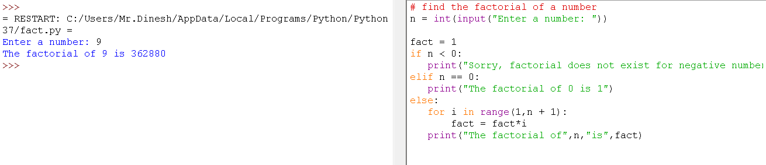

1. Write a menu driven program which get user choice to perform add/sub/mul/div with the obtained two input?

**CODE:**

n1 = int(input("Enter First Number: "))

n2 = int(input("Enter Second Number: "))

print("Select Operation + - * / ")

op = input("Enter any of these operation +,-,*,/: ")

result = 0

if op == '+':

result = n1 + n2

elif op == '-':

result = n1 - n2

elif op == '*':

result = n1 * n2

elif op == '/':

result = n1 / n2

else:

print("Invalid input!")

print(n1, op , n2, ":", result)

**OUTPUT:**

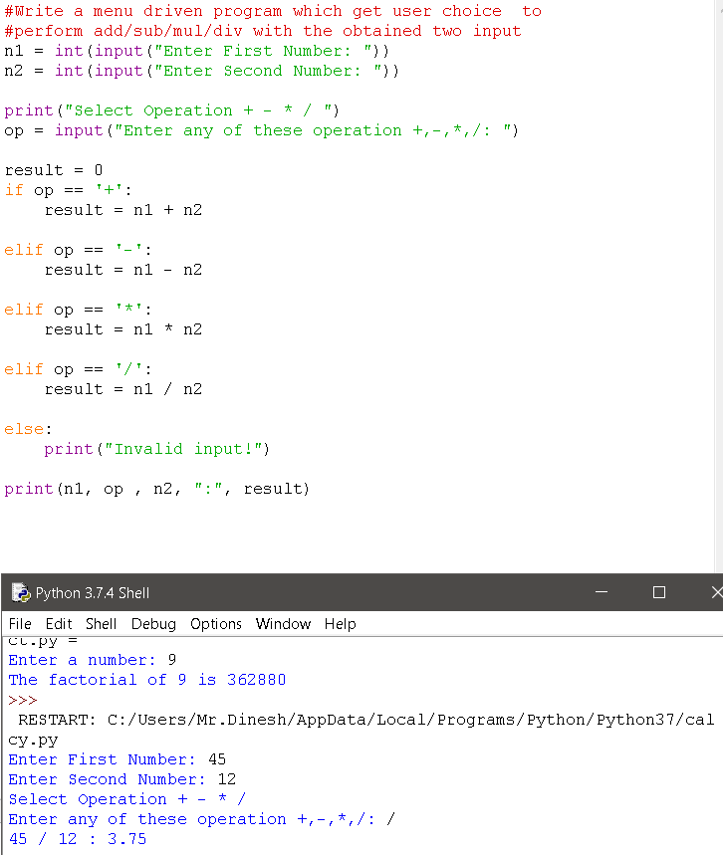

1. Write a program to display few odd multiples of a odd number n

CODE:

#Write a program to display few odd multiples of a odd number n

num=int(input("Enter the odd number"))

i=1

a=0

n=int(input("Enter the n value"))

if n%2==0:

print("The number is Even")

else:

print("The number is odd")

while(a<n):

print(num*i)

i=i*2+1

a=a+1

OUTPUT:

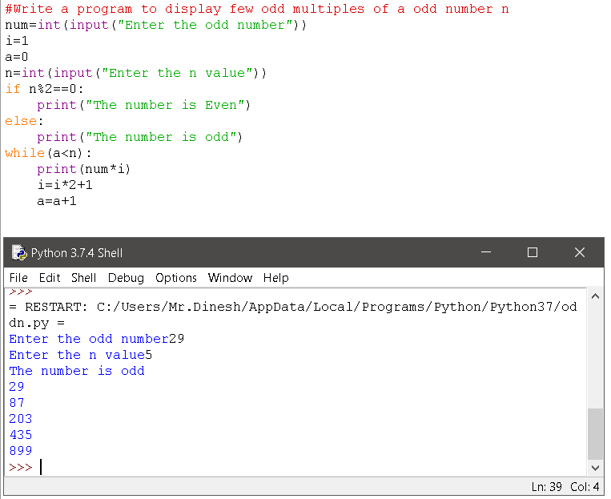

1. 5.The Head Librarian at a library wants you to make a program that calculates the fine for returning the book after the return date. You are given the actual and the expected return dates. Calculate the fine as follows:

a. If the book is returned on or before the expected return date, no fine will be charged, in other words fine is 0.

b. If the book is returned in the same month as the expected return date, Fine = 15 Rupees × Number of late days

c. If the book is not returned in the same month but in the same year as the expected return date, Fine = 500 Rupees × Number of late months

d. If the book is not returned in the same year, the fine is fixed at 10000 Rupees.

**CODE:**

adt,amt,ayr = map(int,input("Enter the Actual date (dt-mt-yr): ").split())

edt,emt,eyr = map(int,input("Enter the Expected date (dt-mt-yr): ").split())

fine=0

if ayr<eyr:

fine=0

elif ayr > eyr:

fine=10000

elif ayr==eyr:

if amt < emt:

fine=0

elif amt > emt:

fine=500*(amt-emt)

elif amt == emt:

if adt <= edt:

fine =0

elif adt > edt:

fine = 15 * (adt - edt)

print("Total Fine is :",fine)

**OUTPUT:**

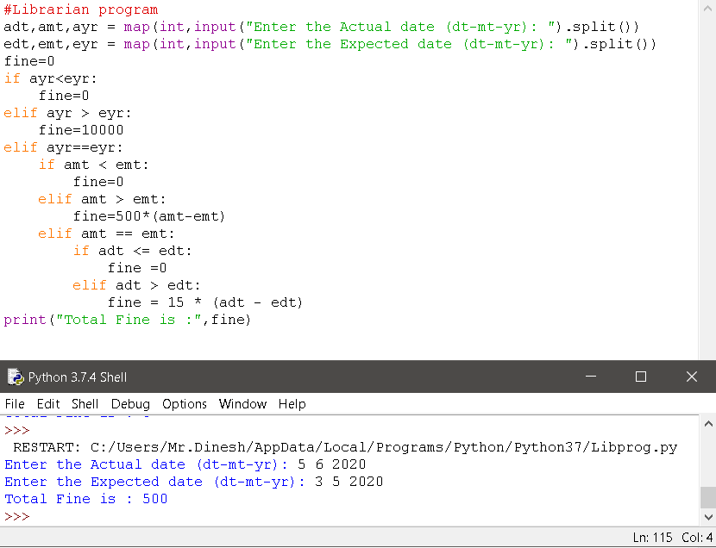

***THANK YOU.***