

|  |  |  |  |
| --- | --- | --- | --- |
| DEPARTMENT | **MCA** | SEMESTER | **SUMMER SEM. I 2021-2022** |
| COURSE | **PYTHON** | CODE | **ITA-6017** |
| FACULTY | **PROF. RAJRAJESWARI S.** | SLOT | **D1/D2 / L11/L12** |
| STUDENT NAME **:** | **DINESH YOGESH PAREKH** | REG NO | **20MCA1013** |

**Lab Assignment 2( 6.7.21) Afternoon**

1. **Accept the number from user and print in the ladder format**

**Eg: 45321**

**4**

**45**

**453**

**4532**

**45321**

**CODE:**

#1.Accept the number from user and print in the ladder format

#Eg: 45321

str= str(input("Enter a number: "))

x = ""

for i in str:

x += i

print(x)

**OUTPUT:**

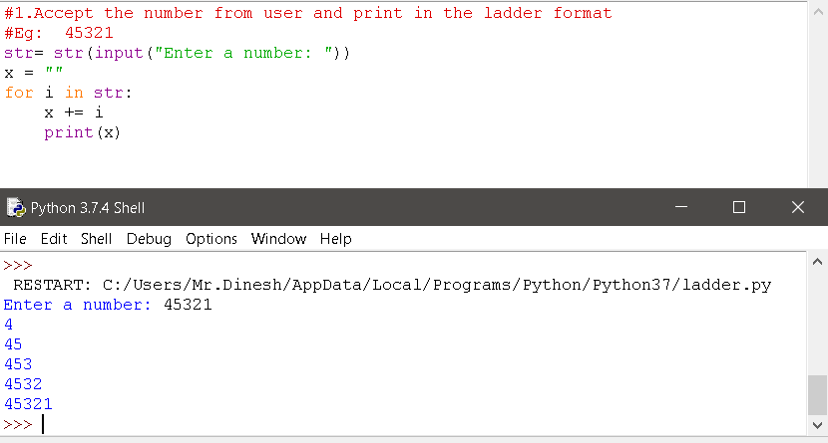

1. **Accept N numbers from user count and display how many numbers are begin with odd numbers and how many numbers are begin with even numbers.**

**CODE:**

#Check odd/even starting no.

n1=int(input("enter the range you want to print : "))

count_odd = 0

count_even = 0

while(n1!=0):

x = int(input("enter the number "))

if not x % 2:

count_even+=1

n1=n1-1

else:

count_odd+=1

n1=n1-1

print("Number of even numbers :",count_even)

print("Number of odd numbers :",count_odd)

**OUTPUT:**

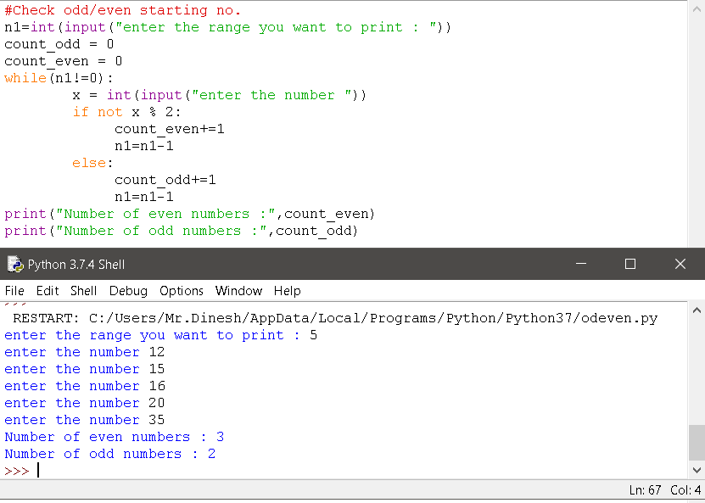

1. **Accept two numbers from the user and remove the common digits among both the numbers and print the numbers after modification.**

**Eg:**

**Input : N1=436784 , N2= 67912**

**Output: N1=4384, N2=912**

**CODE:**

***THANK YOU.***