

|  |  |  |  |
| --- | --- | --- | --- |
| DEPARTMENT | **MCA** | SEMESTER | **SUMMER SEM. I 2021-2022** |
| COURSE | **PYTHON** | CODE | **ITA-6017** |
| FACULTY | **PROF. RAJRAJESWARI S.** | SLOT | **D1/D2 / L11/L12** |
| STUDENT NAME **:** | **DINESH YOGESH PAREKH** | REG NO | **20MCA1013** |

**Lab Assignment 3( 13.7.21) Morning**

1. **Accept a string and number from the user and perform the wrap around process.**

**Eg**

**S= “This is a best practice” N=3 Answer = “s is a best practiceTHi”**

**S= “This is a best practice” N= -4 Answer = “ticeThis is a best prac”**

**CODE:**

s=input("Enter the string")

n=int(input("Enter number"))

if n<0:

s1=s[n:]

s2=s[:n]

print("".join([s1,s2]))

else:

s1=s[n:]

s2=s[:n]

a=s2[::-1]

print("".join([s1,a]))

**OUTPUT:**

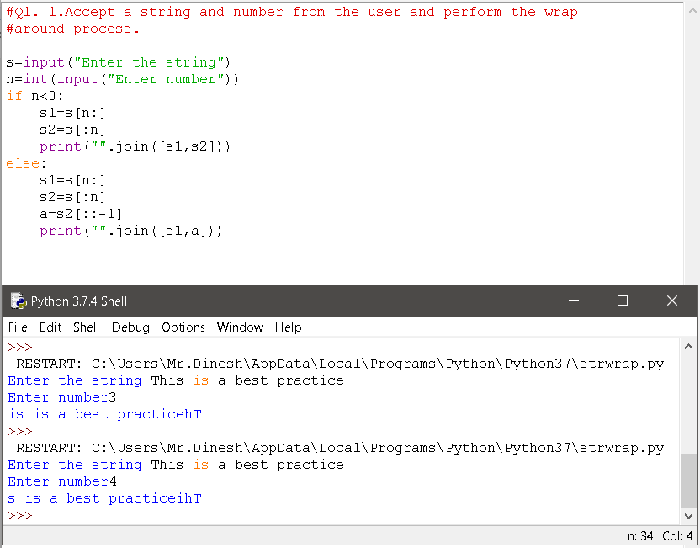

1. **Accept a string which consists of list of math equations Display total number of math fucntions and number of correct fucntions.**

**Eg:**

**"2+2=4,3+2=5,10-3=-3,5+5=10"**

**Total number=4**

**Correct=3**

**CODE:**

#Q1.

n=int(input("Enter total number of equations you want to enter-"))

print("\nEnter Math equations....\n")

i=0

math_list=[]

while(i<n):

eqn=str(input("Enter Equation-"))

math_list.append(equn)

i+=1

i=0

j=0

k=0

correct=0

while(i<n):

sp=str(math_list[i]).split("=")

print(sp)

newsp=sp[0]

newspr=sp[1]

lensp=len(newsp)

while(k<n):

if(newsp[k]=='+'):

final=str(newsp).split("+")

res=int(final[0]+int(final[1])

if(int(newspr==res):

print("correct")

correct+=1

break

else:

print("wrong")

break

if(newsp[k]=='-'):

final=str(newsp).split("-")

res=int(final[0]-int(final[1])

if(int(newspr)==res):

print("correct")

correct+=1

break

else:

print("wrong")

break

if(newsp[k]=='*'):

final=str(newsp).split("*")

res=int(final[0]*int(final[1])

if(int(newspr)==res):

print("correct")

correct+=1

break

else:

print("wrong")

break

if(newsp[k]=='/'):

final=str(newsp).split("/")

res=int(final[0]/int(final[1])

if(int(newspr)==res):

print("correct")

correct+=1

break

else:

print("wrong")

break

k+=1

i+=1

print("\nTotal correct=",correct)

**OUTPUT:**

**"2+2=4,3+2=5,10-3=-3,5+5=10"**

**Total number=4**

**Correct=3**

1. **Accept a string and exchange every pair of characters:**

**Eg**

**“Sample program” => “aSpmelp orrgma”**

**“vivah”=>”ivavh”**

**CODE:**

#Q 3.Accept a string and exchange every pair of characters:

s = "Sample program"

t = list(s)

t[::2], t[1::2] = t[1::2], t[::2]

"".join(t)

**OUTPUT:**

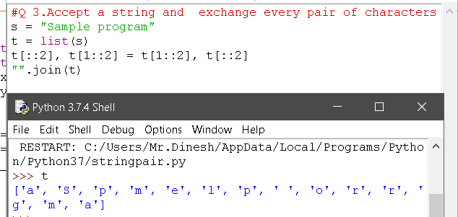

1. **Accept two strings and delete the common characters of them and display both strings after removal and display which string got more deletions.**

**CODE:**

#Q4.

x= input("String 1: \t")

y= input("String 2: \t")

a= set(x)

b= set(y)

only_x= a-b

only_y= b-a

x_final= str("".join([i for i in x if i in only_x]))

y_final= str("".join([i for i in y if i in only_y]))

print(x_final,y_final)

**OUTPUT:**

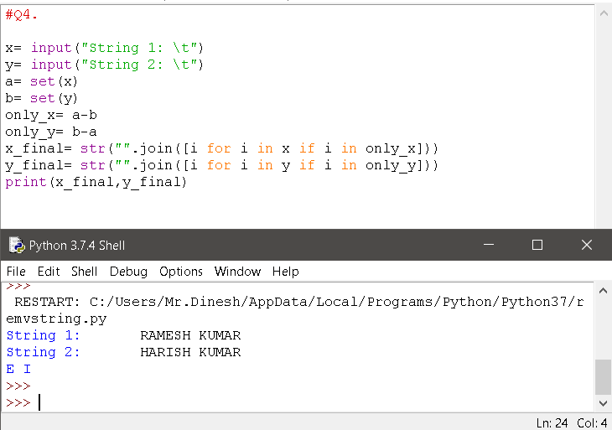

***Thank you.***