

|  |  |  |  |
| --- | --- | --- | --- |
| DEPARTMENT | **MCA** | SEMESTER | **SUMMER SEM. I 2021-2022** |
| COURSE | **PYTHON** | CODE | **ITA-6017** |
| FACULTY | **PROF. RAJRAJESWARI S.** | SLOT | **D1/D2 / L11/L12** |
| STUDENT NAME **:** | **DINESH YOGESH PAREKH** | REG NO | **20MCA1013** |

**Lab Assignment 3.2( 13.7.21) Afternoon**

1. **Create two integer matrix of same size MX N ( M rows and M columns). Write a program to find how many common elements are there between them and print the elements also.**

**CODE:**

#Q1

x=[2,-3,8,-5,6,1]

y=[1,-2,7,-4,8,6]

x_set=set(x)

y_set=set(y)

if(x_set & y_set):

print(x_set & y_set)

else:

print("Here is not common elements")

**OUTPUT:**

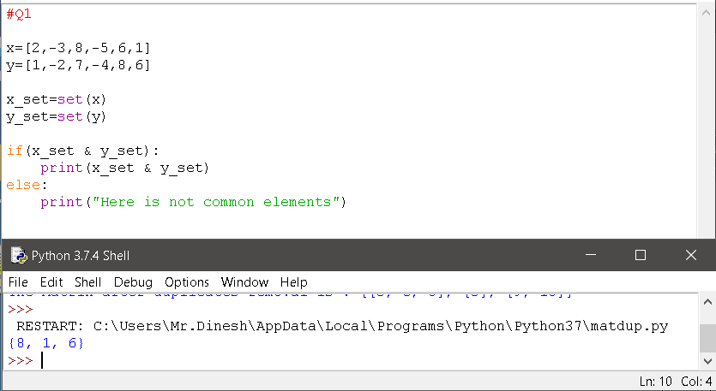

1. **Write a program to replace the duplicate elements in an matrix into zero.**

**Eg:**

**3 4 6**

**2 6 8**

**4 3 7**

**Output :**

**3 4 6**

**2 0 8**

**0 0 7**

**CODE:**

#Q2.

l=[3,4,6,2,6,8,4,3,7]

print(l)

out=[]

already_appended=set()

for n in l:

if n in already_appended:

out.append(0)

else:

out.append(n)

already_appended.add(n)

print(out)

**OUTPUT:**

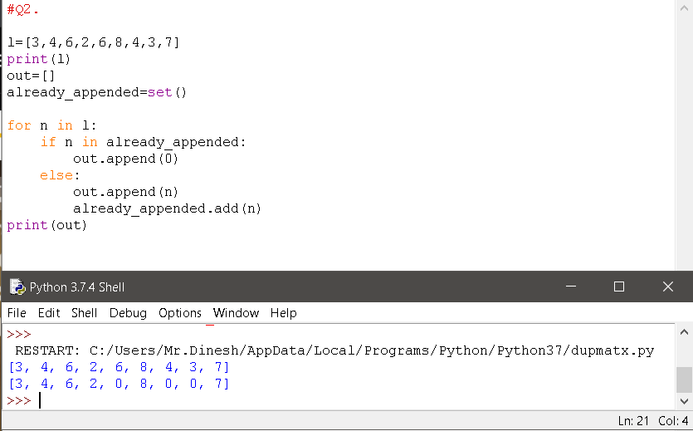

1. **Create two String matrix of same size MX N ( M rows and M columns) where one matrix comprised of first name of four year students ( N=4 columns) and the second matrix comprised of last Name of the four year students ( N=4 columns) . Form a new list which comprised of name ( first name +last name with the space between them). TO differentiate between the years. First year student names should contain all their last names in Uppercase. Second year Students should contain all their First names upper case, third year Students should contains Title case for both first name and last name. Fourth year student should have All uppercase.**

**Print the final list.**

**Eg:**

**N=3, M=4 ( constant)**

**First name = “sam” “sundar” “rishi” “ Mukesh”**

**“srija” “sruthi” “hima” “Rakshi”**

**“anshul” “ankit” “arya” “sakshi”**

**Last name = “ ganesh” “ ram” “agarwal” “ raj”**

**“ Krishnan” “rajesh” “ priyan” ,”guptha”**

**“umesh” “rahul” “ tej” “ suman”**

**Output = “sam GANESH” “SUNDAR ram” “Rishi Agarwal” “MUKESH RAJ”**

**“srija KRISHNAN” “SRUTHI rajesh” “Hima Priyan” “RAKSHI GUPTHA”**

**“anshul UMESH” “ANKIT rahul” “Arya Tej” “SAKSHI SUMAN”**

**CODE:**

#Q3.

A=[["Sam","Sundar","Rishi","Mukesh"],

["Srija","Sruthi","Hima","Rakhi"],

["Anshul","Ankit","Arya","Sakshi"]]

B=[["Ganesh","Ram","Agrawal","Raj"],

["Krishan","Rajesh","Priyan","Gupta"],

["Umesh","Rahul","Tej","Suman"]]

result =[[0,0,0,0],

[0,0,0,0],

[0,0,0,0]]

for x in range(len(A)):

for y in range(len(B[0])):

result[x][y]=A[x][y] + B [x][y]

for r in result:

print(r)

**OUTPUT:**

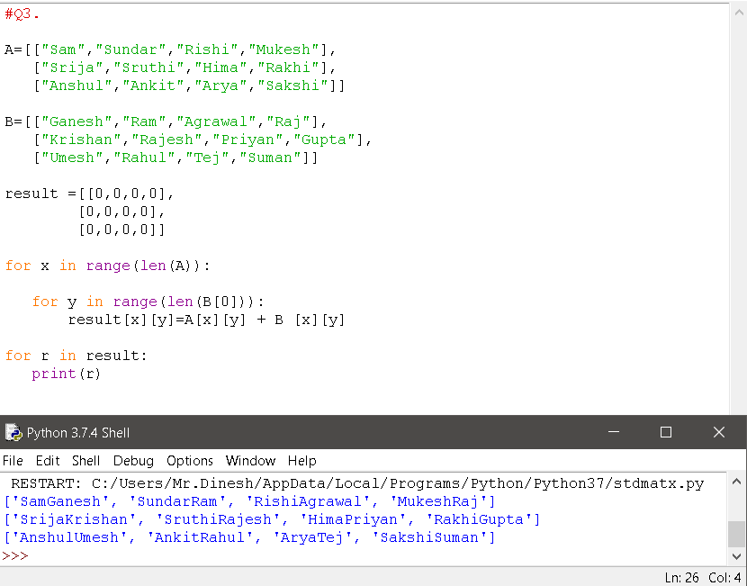

***Thank you.***