

|  |  |  |  |
| --- | --- | --- | --- |
| DEPARTMENT | **MCA** | SEMESTER | **SUMMER SEM. I 2021-2022** |
| COURSE | **PYTHON** | CODE | **ITA-6017** |
| FACULTY | **PROF. RAJRAJESWARI S.** | SLOT | **D1/D2 / L11/L12** |
| STUDENT NAME **:** | **DINESH YOGESH PAREKH** | REG NO | **20MCA1013** |

**Lab Assignment 4.2( 20.7.21) Afternoon**

1. **Write a program which reads a string from a user and the string comprised of eyes of three dies :**

**Eg S= “O-O/O-O/O-O, O--/---/--O, ---/-0-/---“.**

**‘O’ represents the eyes of the dies. Three rows separated by / .**

**Three dies values are separated by comma. Print the value of each die**

**For the above example the values of three dies are V=[6,2,1].**

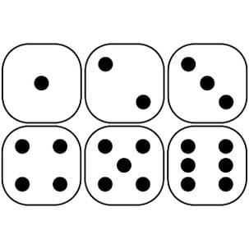

**CODE:**

#4.2_Q.1

ludomaster=list(input("Enter 3 input by ludo(O-O/O-O/O-O, O--/---/--O, ---/-O-/---)(6,2,1) format: "))

reslt = []

cntO = 0

for i in ludomaster:

if i == 'O':

cntO += 1

if i == ',':

result.append(cntO)

cntO = 0

result.append(cntO)

print(reslt)

**OUTPUT:**

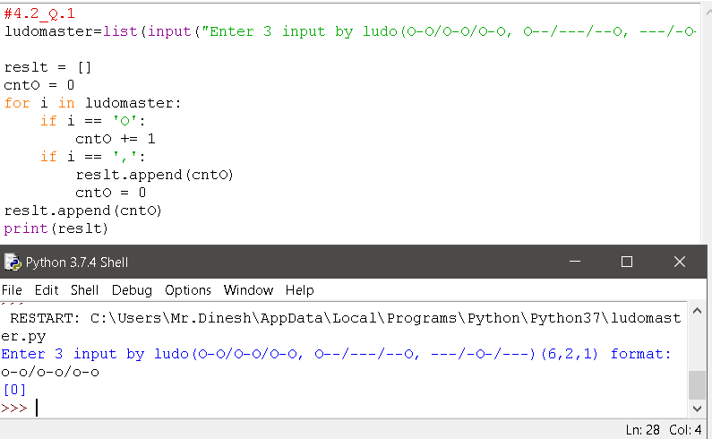

1. **Write a program that takes a list of register numbers of VIT university.All valid register numbers are formed into three sets for each branch like ( MTech software engineering(MIS) , MCA(MCA), Btech(BCE)). Count and display how many students are there in each category and display how many invalid register numbers are there.**

**CODE:**

class Student:

marks=[]

def getData(self,rgn,name,s1,s2,s3):

Student.rgn=rgn

Student.name=name

Student.marks.append(s1)

Student.marks.append(s2)

Student.marks.append(s3)

def displayData(self):

print("Reg. Number is: ", Student.rgn)

print("Name is: ", Student.name)

print("Marks are: ", Student.marks)

print("Total Marks are: ", self.total())

print("Average Marks are: ", self.average())

def total(self):

return(Student.marks[0] + Student.marks[1] + Student.marks[2])

def average(self):

return((Student.marks[0] + Student.marks[1] + Student.marks[2])/3)

r=int(input("Enter the roll number: "))

name=input("Enter the name: ")

s1=int(input("Enter the marks in 1st subject : "))

s2=int(input("Enter the marks in 2nd subject : "))

s3=int(input("Enter the marks in 3rd subject : "))

m1=Student()

m1.getData(r,name,s1,s2,s3)

m1.displayData()

**OUTPUT:**

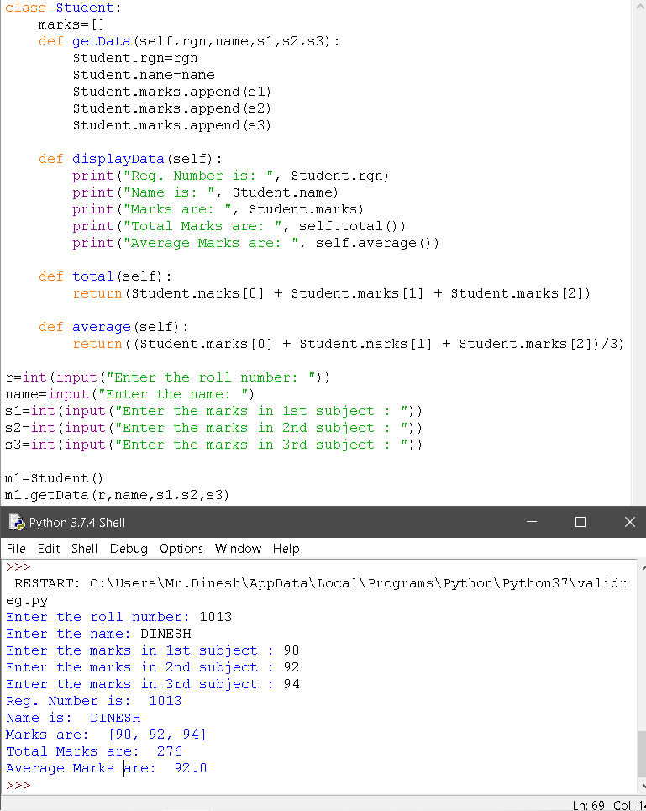

1. **Write a program that takes list of land line phone numbers ( with the std code) from user . count and display how many are numbers are in each state ( take any five state of your choice). Create a tuple for each state and combine all tuples into a list and print.**

**CODE:**

landline= input("Eneter Landline Number:")

if len(landline)==12:

if landline[3]=='-':

if(landline[:3]+landline[4:].isdigit()):

print("landline number is valid")

else:

print("invalid")

**OUTPUT:**

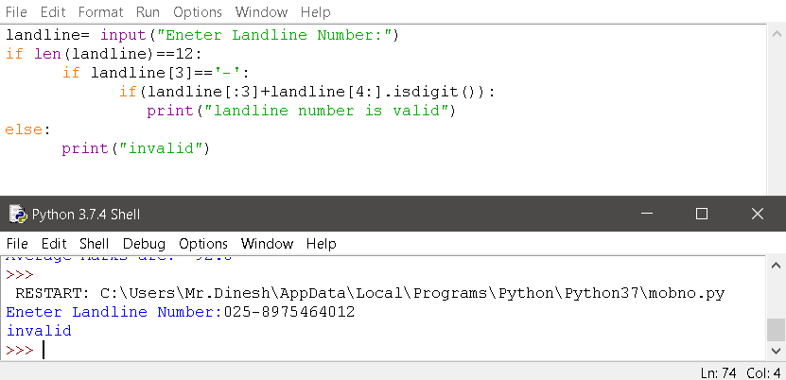

***Thank you.***