IOT Class Test 26/03/2021

DINESH YOGESH PAREKH 20MCA1013

**Instructions**

1. Explain in detail about IEEE802.15.4 protocol along with role of ZIGBEE in IoT.

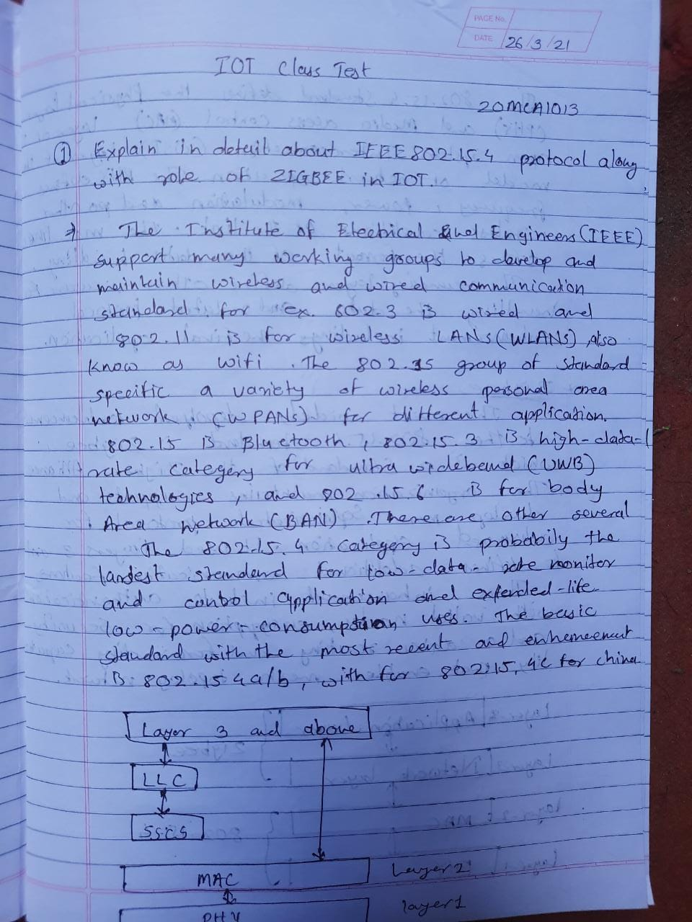

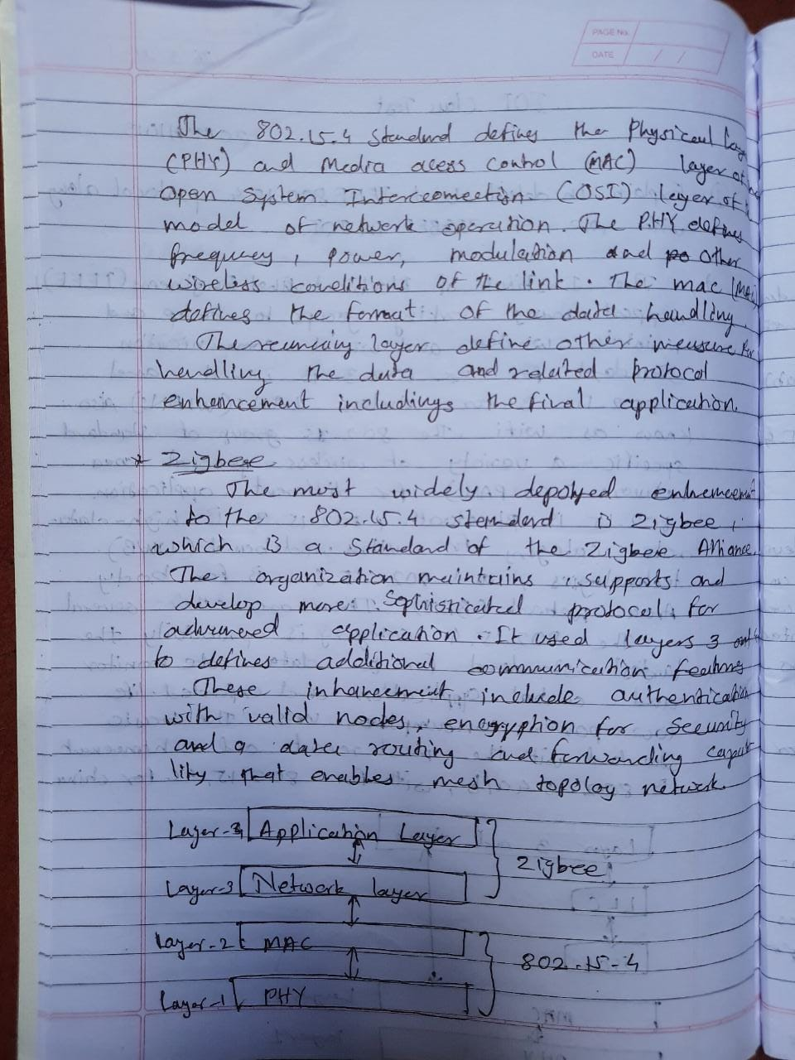

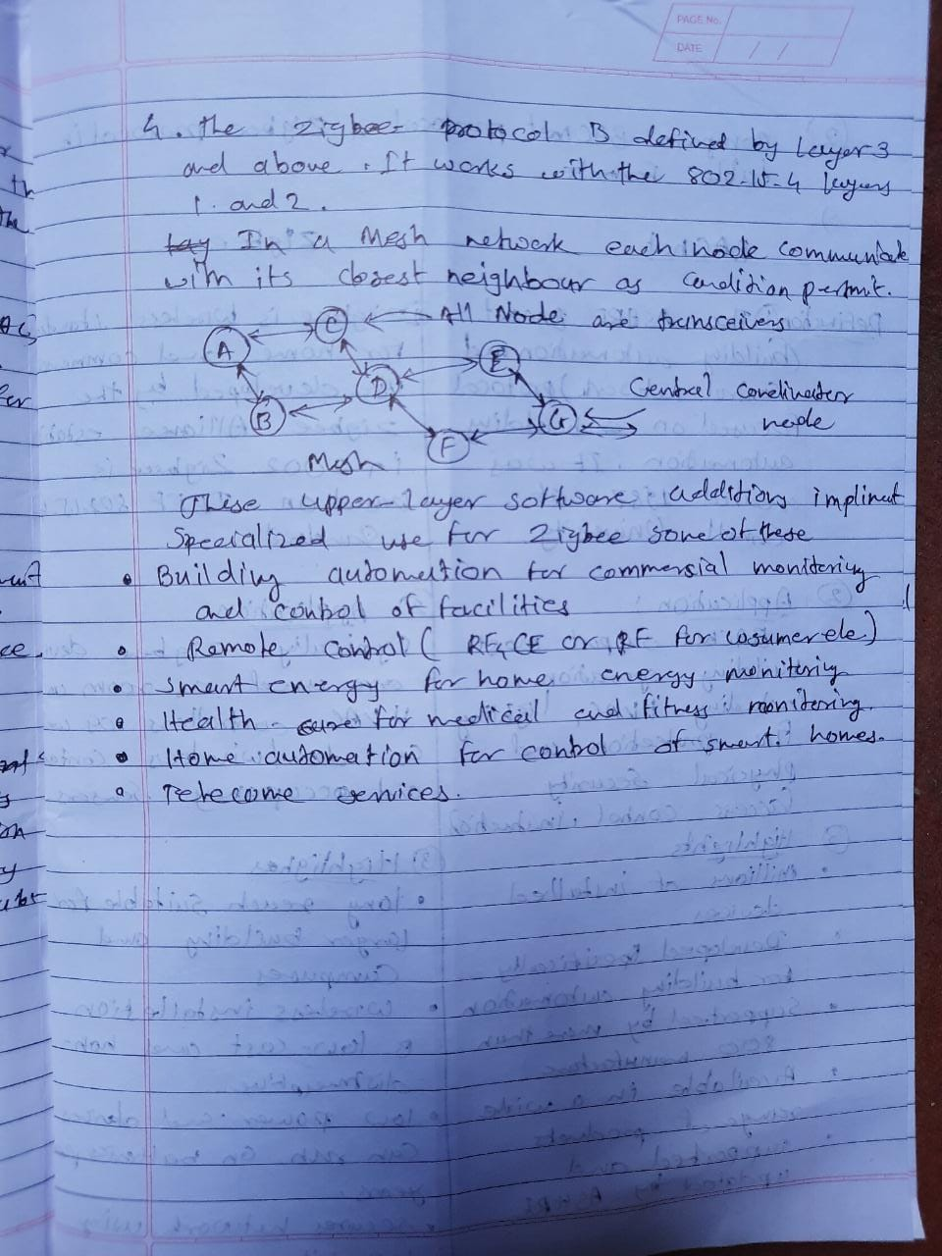

1. Compare BACnet protocol and ZIGBEE protocol in a table format.

