|  |  |  |  |
| --- | --- | --- | --- |
| DEPARTMENT | **MCA** | SEMESTER | **WINTER 2021-2022** |
| COURSE | **ADVANCED SOFTWARE TESTING** | CODE | **ITA-6013** |
| FACULTY | **PROF. KAVYA ALLURU** | SLOT | **L9+L10** |
| STUDENT NAME **:** | **DINESH YOGESH PAREKH** | REG NO | **20MCA1013** |

**12/05/2021**

1. **Write a web driver program , to open <https://lms.vit.ac.in/login/index.php> , login to your account, once you login go to course Advanced Software Testing (ITA6013) , and click on ‘May’ month.**

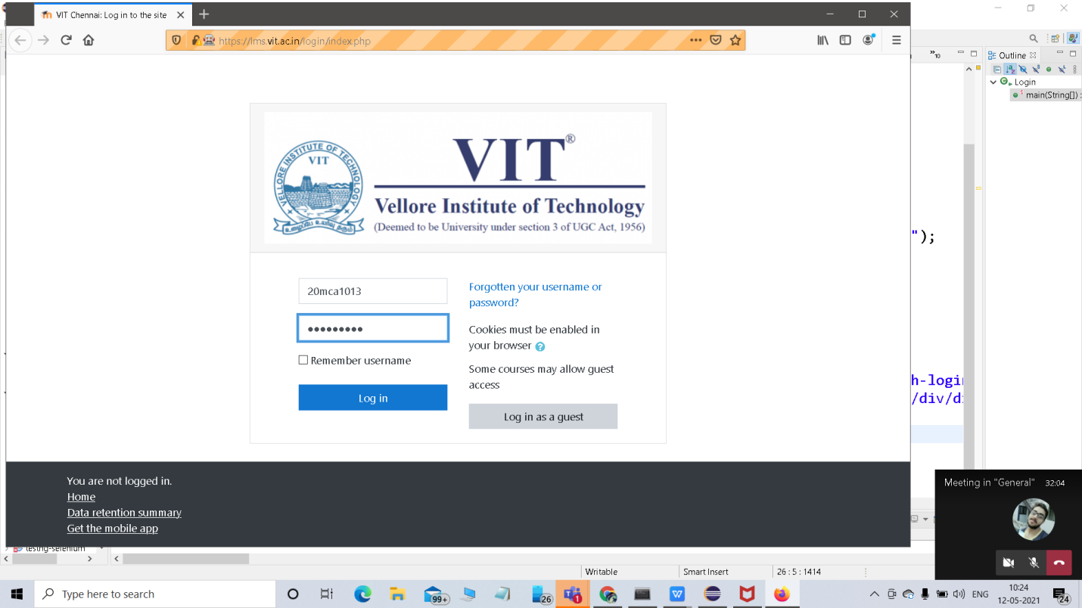

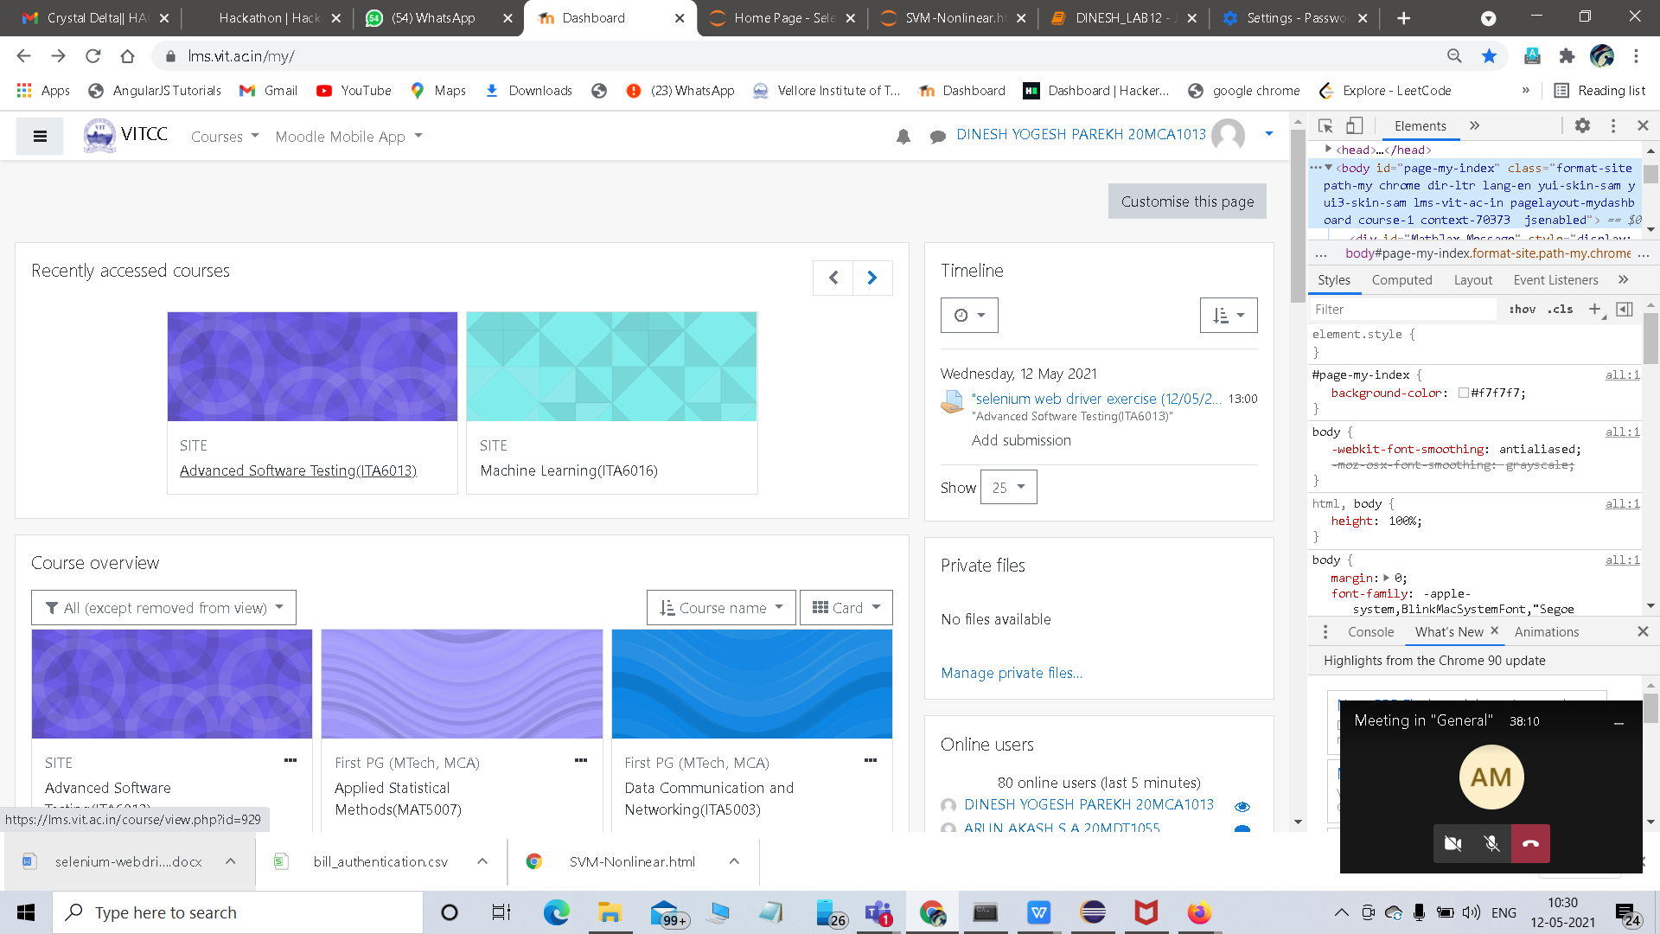

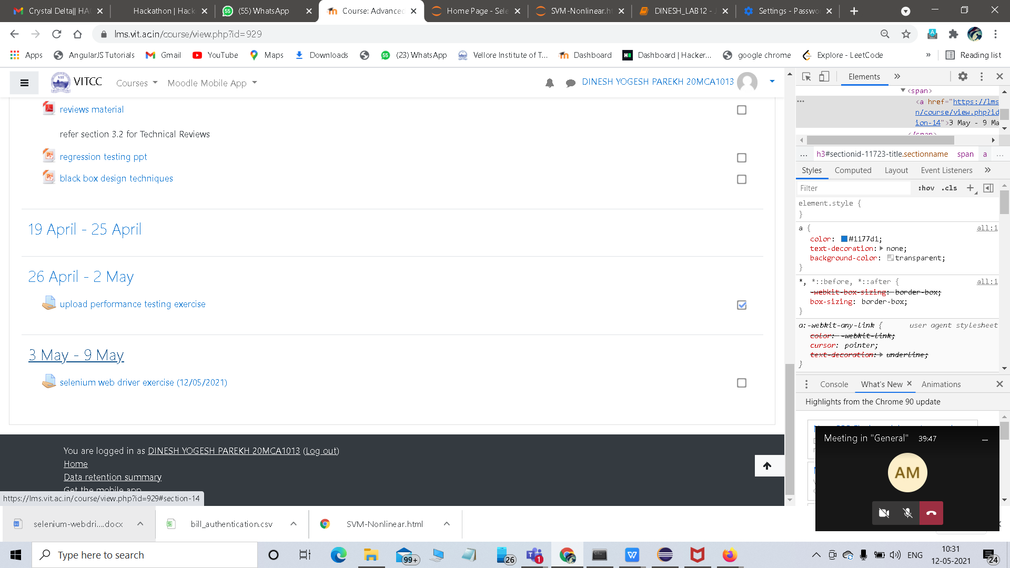

**SOURCE CODE**

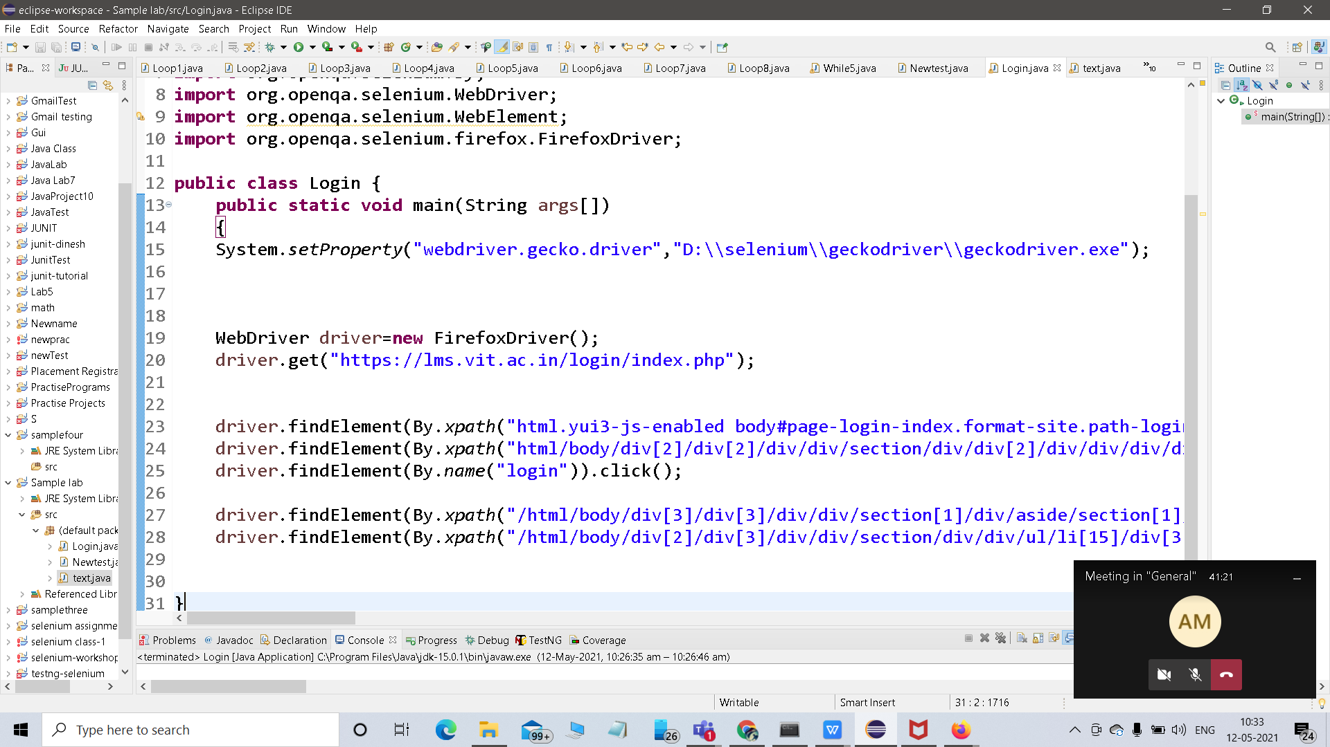

1. **Write a selenium web driver program demonstrating cross browser testing.**

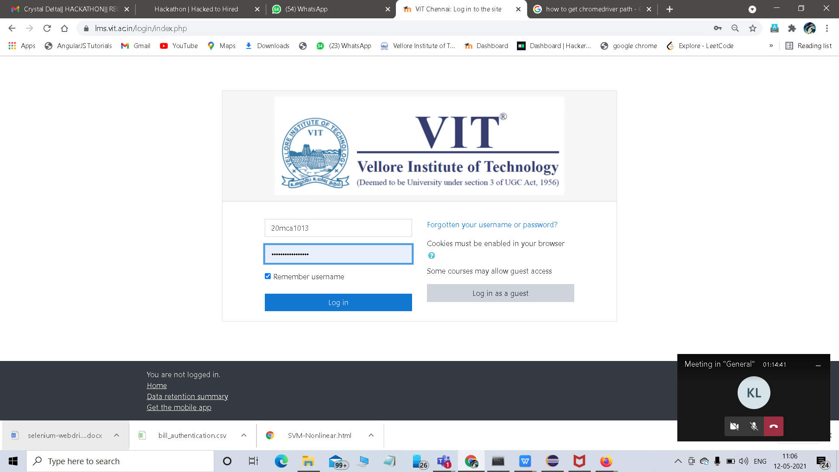

**SOURCE CODE:**

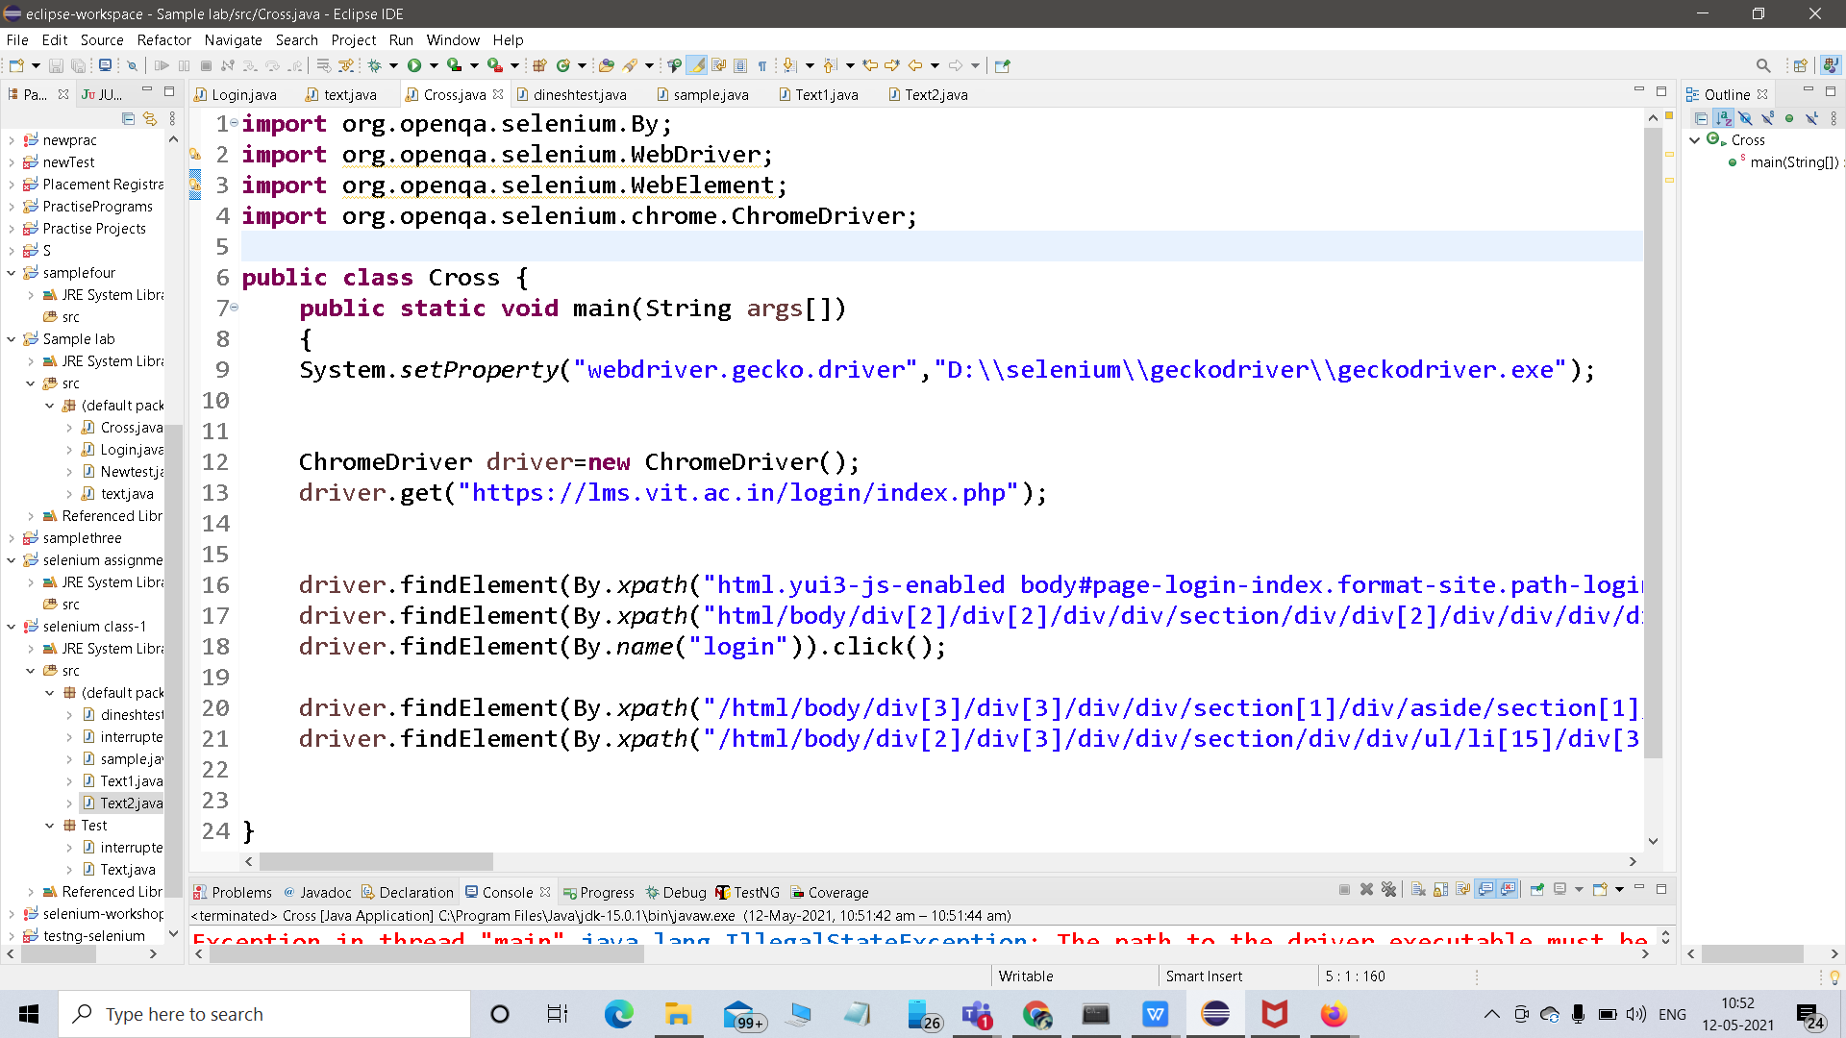

1. **Using the link given, write a selenium program on how to upload and download a file.**

<https://www.guru99.com/upload-download-file-selenium-webdriver.html>

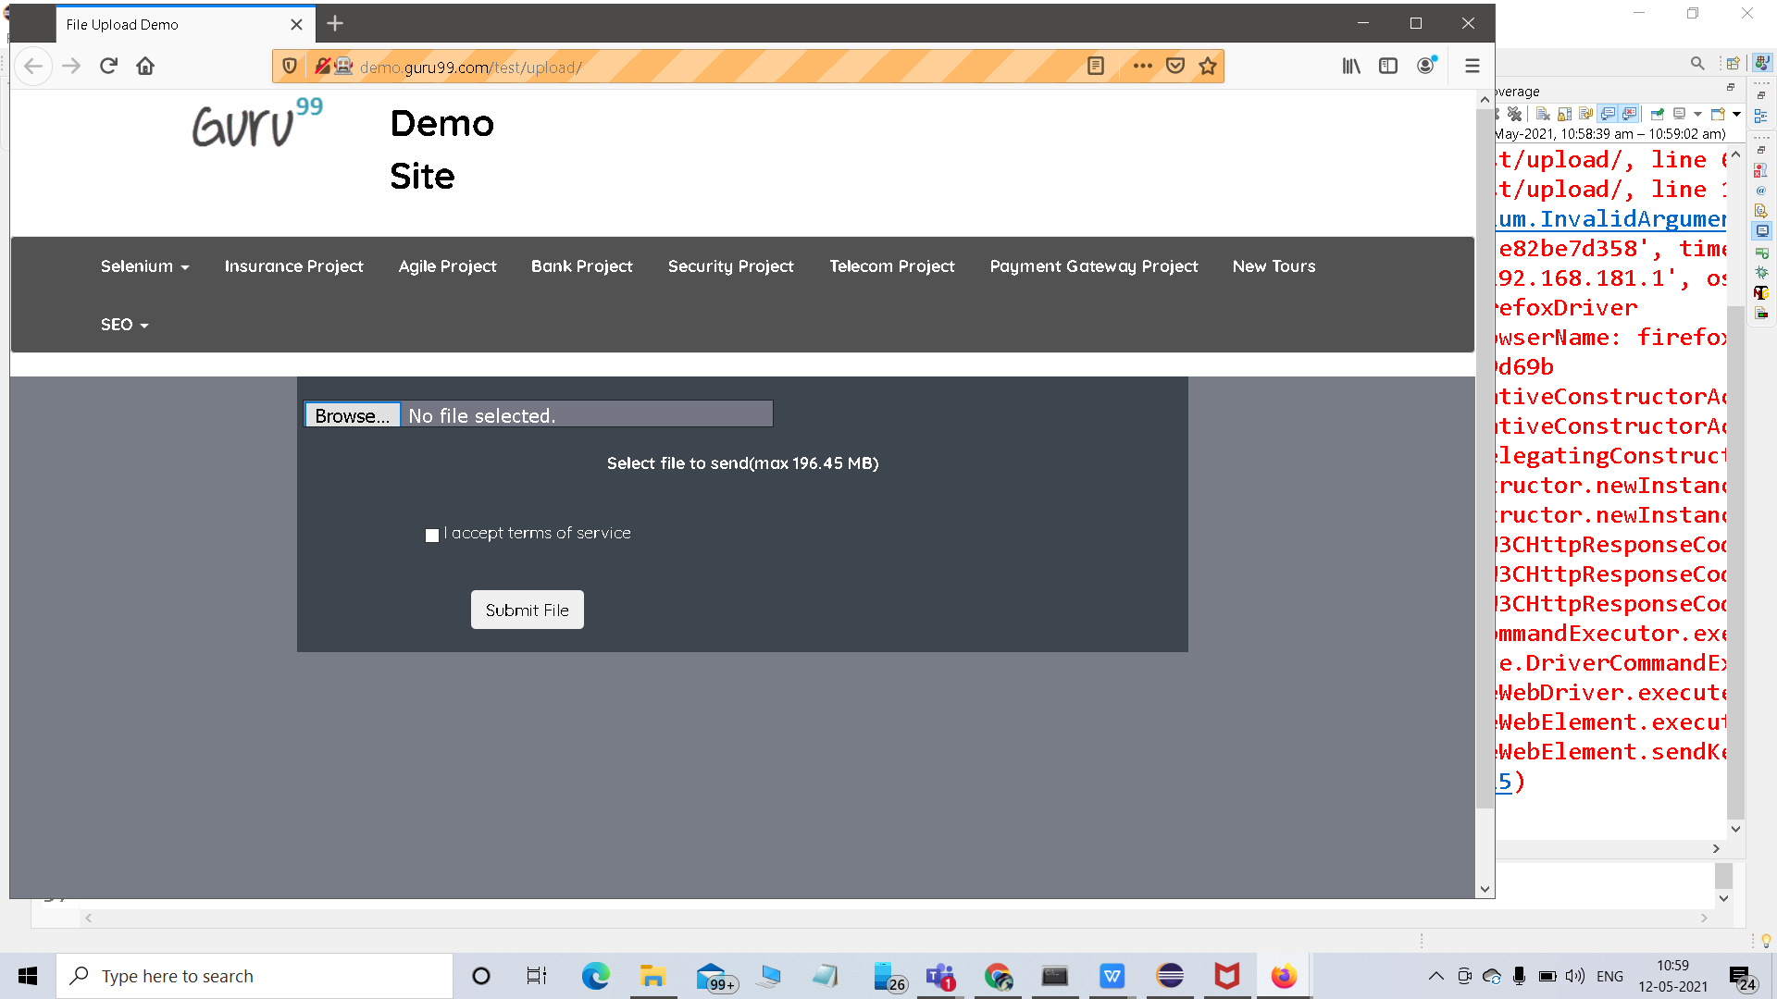

**SOURCE CODE:**

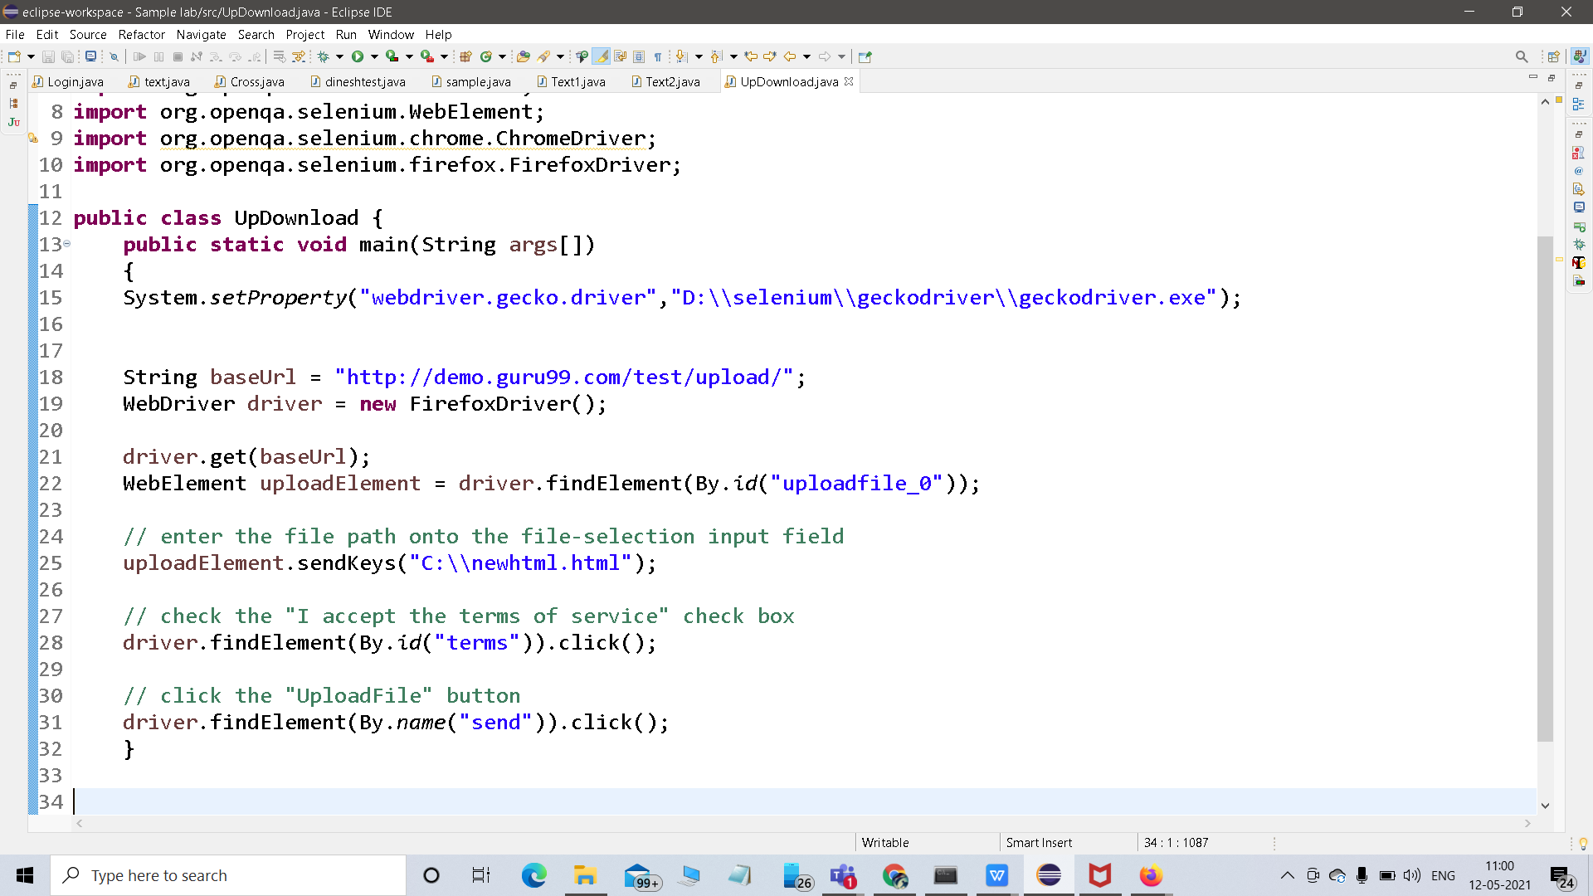

**THANK YOU…**