

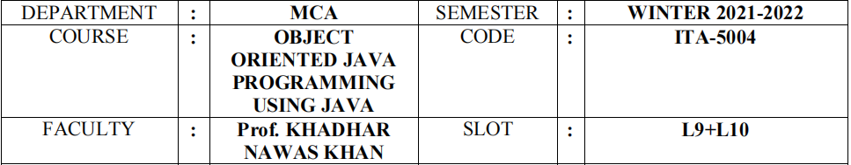

|  |  |  |  |
| --- | --- | --- | --- |
| STUDENT NAME | **DINESH YOGESH PAREKH** | REG NO | **20MCA1013** |

**LAB: 5**

**Date: 22/03/2021**

A Travel Agent want to develop a program that can be used by the user to book the bus

tickets. The “Bluebus.in” company was responsible for the program to book tickets.

Assume that you are a member of development team in that company. The task

assigned to you is to create a program which contains the all the possible stops in a

state for ex: Tamil Nadu.(Stops are the district name).You are requested to handle any

two states in south region as two packages that should be used for ticket booking.

Sample output:

Welcome to blusbus.in

1. Tamil Nadu 2.Kerala 3.Karnataka 4.Puducherry

Choose the Source state: 1

1. **Ariyalur**. 2. Chengalpattu. 3. **Chennai**. 4. **Coimbatore**. 5. **Cuddalore**. 6. **Dharmapuri**.

7. **Dindigul**. 8. Erode.

Enter the source: Chennai

1. Tamil Nadu 2.Kerala 3.Karnataka 4.Puducherry

Choose the Destination State: 3

1 Bagalkot. 2. Ballari (Bellary) 3. Belagavi (Belgaum) 4. Bengaluru (Bangalore) Rural. 5.

Bengaluru (Bangalore) Urban. 6. Bidar. 7. Chamarajanagar. 8. Chikballapur.

Enter the destination: Bengaluru

Enter the Date: dd/mm/yyyy

05/04/2021

Enter the seat count: 2

Ticket booking confirmed

**SOURCE CODE:**

**Tamilnadu.java:**

**package** states;

**public class** tamilnadu {

**public** tamilnadu(){

System.***out***.println("\n1.Ariyalur \n2.Chengalpattu \n3.Chennai

\n4.Coimbatore\n5.Cuddalore \n6.Dharmapuri \n7.Dindigul \n8.Erode");

}

}

**Pudhucherry.java:**

**package** states;

**public class** pudhucherry {

**public** pudhucherry(){

System.***out***.println("\n1.Oulgaret \n2.Villanur \n3.Ariyankuppam");

}

}

**Kerala.java:**

**package** states2;

**public class** kerala {

**public** kerala(){

System.***out***.println("\n1.Calicut \n2.Cochin \n3.Trivandrum \n4.Kannur

\n5.Idukki\n6.Malappuram \n7.Wayanad \n8.Kazargode");

}

}

**Karnataka.java:**

**package** states2;

**public class** karnataka {

**public** karnataka(){

System.***out***.println("\n1.Bagalkot \n2.Ballari \n3.Belagavi

\n4.Bengaloru Rural\n5.Bengaloru Urban \n6.Bidar \n7.Chamarajanagar

\n8.Chikballur");

}

}

**Ticket booking.java:**

**import** java.util.Scanner;

**import** states.*;

**import** states2.*;

**public class** ticketbooking {

**public void** method(){

String choice;

Scanner sc=**new** Scanner(System.***in***);

System.***out***.print("1.Tamil Nadu 2.Kerala 3.Karnataka 4.Puducherry\n");

System.***out***.print("Enter the Source state:");

**int** c=sc.nextInt();

**switch**(c){

**case** 1:

**new** tamilnadu();

System.***out***.print("Enter the source :");

choice=sc.next();**break**;

**case** 2:

**new** kerala();

System.***out***.print("Enter the source :");

choice=sc.next();

**break**;

**case** 3:

**new** karnataka();

System.***out***.print("Enter the source :");

choice=sc.next();

**break**;

**case** 4:

**new** pudhucherry();

System.***out***.print("Enter the source :");

choice=sc.next();

**break**;

}

System.***out***.println("\n1.Tamil Nadu 2.Kerala 3.Karnataka 4.Puducherry\n");

System.***out***.print("Enter the destination state:");

c=sc.nextInt();

**switch**(c){

**case** 1:

**new** tamilnadu();

System.***out***.print("Enter the destination :");choice=sc.next();

**break**;

**case** 2:

**new** kerala();

System.***out***.print("Enter the destination :");

choice=sc.next();

**break**;

**case** 3:

**new** karnataka();

System.***out***.print("Enter the destination:");

choice=sc.next();

**break**;

**case** 4:

**new** pudhucherry();

System.***out***.print("Enter the destination:");

choice=sc.next();

**break**;

}

System.***out***.print("Enter the Date :");

String date=sc.next();

System.***out***.print("Enter the seat count :");

**int** seat=sc.nextInt();

System.***out***.println("\nTicket Booking Confirmed");

}

}

**BLUEBUS.JAVA:**

**import** java.util.Scanner;

**public class** Bluebus {

**public static void** main(String args[]){

System.***out***.println("\nWelcome to bluebus.in\n");

ticketbooking e=**new** ticketbooking();

e.method();

}

}

OUTPUT

