

BANNARI AMMAN INSTITUTE OF TECHNOLOGY
Sathyamangalam, Erode – 638 401
CHRONOBITS’26

24-HOUR DIGITAL CLOCK
Using IC 555 Timer and CD4026 Counter ICs
Submitted by
TEAM CIRCUIT BREAKERS
Dinesh P (7376251EC154)
Poovitha S (7376251EC258)
Harish P (7376251EC170)
Department of Electronics and Communication Engineering
July 2026

1. Abstract
This project presents the design and implementation of a 24-hour digital clock built entirely from discrete integrated circuits, without any microcontroller or pre-programmed device. A 555 timer IC configured in astable mode generates a 1 Hz clock pulse, which drives a cascaded chain of six CD4026 decade counter ICs. Each CD4026 combines a decade counter and a seven-segment decoder in a single package, allowing it to directly drive a common-cathode seven-segment display.
Time is displayed in HH:MM:SS format across six displays. Rollover at 60 seconds, 60 minutes, and 24 hours is achieved using segment-level decoding: instead of BCD comparison (which the CD4026 does not support), specific segment output patterns unique to the digits 6, 6, and 24 are detected using NOT and AND gates, generating asynchronous reset pulses at the correct instants.
The complete clock was assembled and validated on a breadboard. The project demonstrates fundamental digital electronics concepts — astable multivibrators, counter cascading, combinational decoding, and asynchronous reset — using components costing under ₹500, making it an ideal instructional build for second-year ECE students.
Keywords: 555 timer, CD4026, decade counter, seven-segment display, segment decoding, asynchronous reset, 24-hour clock.

2. Introduction
Digital clocks are among the most recognisable applications of digital electronics. While modern clocks are almost always built around microcontrollers or dedicated RTC chips, building one from discrete logic remains one of the best exercises for understanding how counting, decoding, and display driving actually work at the hardware level.
In this project, every function of the clock is visible on the breadboard: a 555 timer produces the heartbeat, decade counters accumulate the count, and simple logic gates decide when each digit group must roll over. Nothing is hidden inside firmware. When the clock counts from 09:59:59 to 10:00:00, the student can trace exactly which gate fired and which reset line pulsed.
The design intentionally uses the CD4026, a slightly unusual counter IC that outputs seven-segment drive signals directly rather than BCD. This removes the need for separate BCD-to-seven-segment decoder ICs (such as the CD4511), reducing chip count — but it introduces an interesting design challenge: rollover detection must be done by decoding segment patterns instead of comparing BCD values. Solving this challenge is the intellectual core of the project.

3. Problem Statement
Design and build a digital clock that displays time in 24-hour format (00:00:00 to 23:59:59) subject to the following constraints:
- Only discrete ICs may be used — no microcontrollers, no pre-programmed chips, and no ready-made clock modules.
- The timebase must be generated on-board using an IC 555 timer.
- The counting and display-driving stages must use CD4026 decade counter ICs feeding seven-segment displays.
- The clock must roll over correctly: seconds and minutes reset at 60, and hours reset at 24.
- The complete circuit must operate from a single +5 V supply and be demonstrable on a breadboard.
The central technical problem is rollover detection. The CD4026 provides no BCD outputs, so the standard approach of AND-ing BCD bits (for example, detecting binary 0110 for six) is impossible. The design must instead identify each rollover digit purely from the seven-segment drive lines.

4. Objectives
- To design a stable 1 Hz timebase using the IC 555 in astable mode and verify its frequency through calculation and measurement.
- To cascade six CD4026 decade counters into seconds, minutes, and hours stages driving six seven-segment displays.
- To design segment-pattern decoding logic that detects the digit 6 (for seconds/minutes rollover) and the count 24 (for hours rollover).
- To implement clean asynchronous reset of each counter group using NOT and AND gates.
- To assemble, debug, and validate the complete clock on a breadboard, documenting every fault found and its resolution.
- To present the design in a form reproducible by any second-year ECE student.

5. Components Used
All components are through-hole parts, readily available and breadboard-friendly. Total cost is approximately ₹400–₹500.
S.No | Component | Qty | Purpose in this Project
1 | IC 555 (LM/NE555) | 1 | Astable multivibrator generating the 1 Hz clock pulse — the timebase of the entire clock.
2 | CD4026BE decade counter | 6 | Counts pulses and directly drives seven-segment displays. One per digit: SEC-1, SEC-10, MIN-1, MIN-10, HOUR-1, HOUR-10.
3 | Seven-segment display (common cathode) | 6 | Displays the digits. Must be common cathode because the CD4026 drives segments HIGH.
4 | 74HC04 / hex inverter | 1 | NOT gates used in rollover decoding (inverting segment lines B and A).
5 | 74HC08 | 1 | AND gates combining decoded segment conditions into reset pulses for seconds and minutes.
6 | 74HC11 | 1 | Forms the 3-input hour-reset condition (detecting the count 24).
7 | Resistor 10 kΩ | 1 | R1 of the 555 timing network.
8 | Resistor 68 kΩ | 1 | R2 of the 555 timing network.
9 | Capacitor 10 µF electrolytic | 1 | C of the 555 timing network (sets the ~1 s period with R1, R2).
10 | Push buttons + 10 kΩ resistors | 2 | Time-setting: manually pulse the MIN-1 and HOUR-1 clock inputs.
11 | Breadboards, +5 V supply, jumper wires | --- | Assembly and power.

5.1 Why the CD4026?
A conventional design uses a CD4029/74LS90 counter plus a CD4511 BCD-to-seven-segment decoder — two chips per digit. The CD4026 merges both functions, halving the chip count to one per digit. The trade-off is that no BCD count value is available externally, which forces the segment-decoding approach described in Section 8.

6. Block Diagram
The clock is organised as a pulse chain. Each stage divides the incoming pulse rate and passes a carry to the next stage.
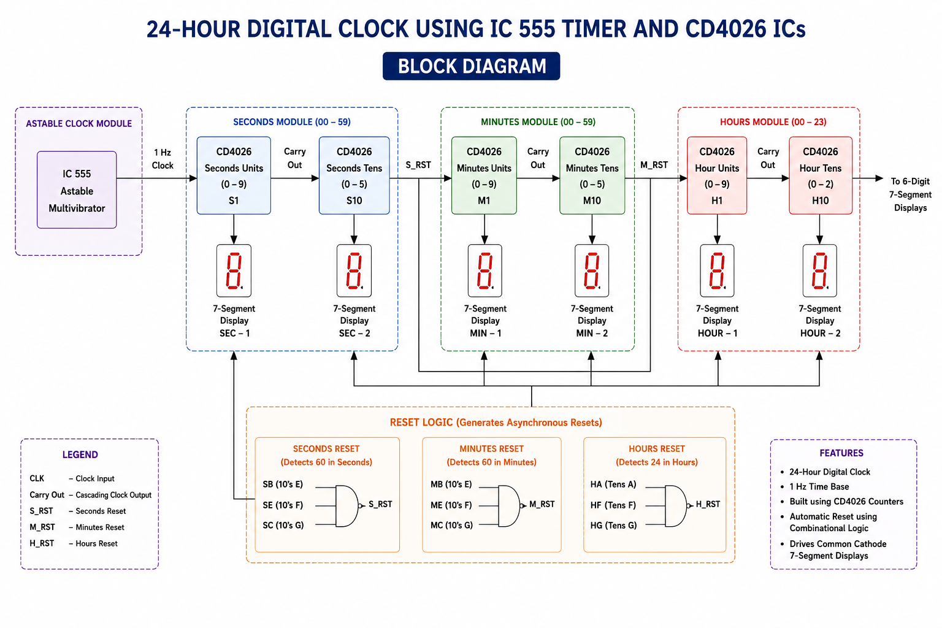

Signal flow summary:
- Timebase: 555 astable output (1 Hz)
- Seconds stage: SEC-1 counts 0–9; its CARRY OUT clocks SEC-10. The seconds decode detects '6' on SEC-10 and resets both, so the pair counts 00–59.
- Minutes stage: The seconds reset pulse clocks MIN-1. The identical decode scheme makes the minutes pair count 00–59.
- Hours stage: The minutes reset pulse clocks HOUR-1. A three-input decode detects the display value 24 and resets both hour counters, giving 00–23.

7. Circuit Diagram
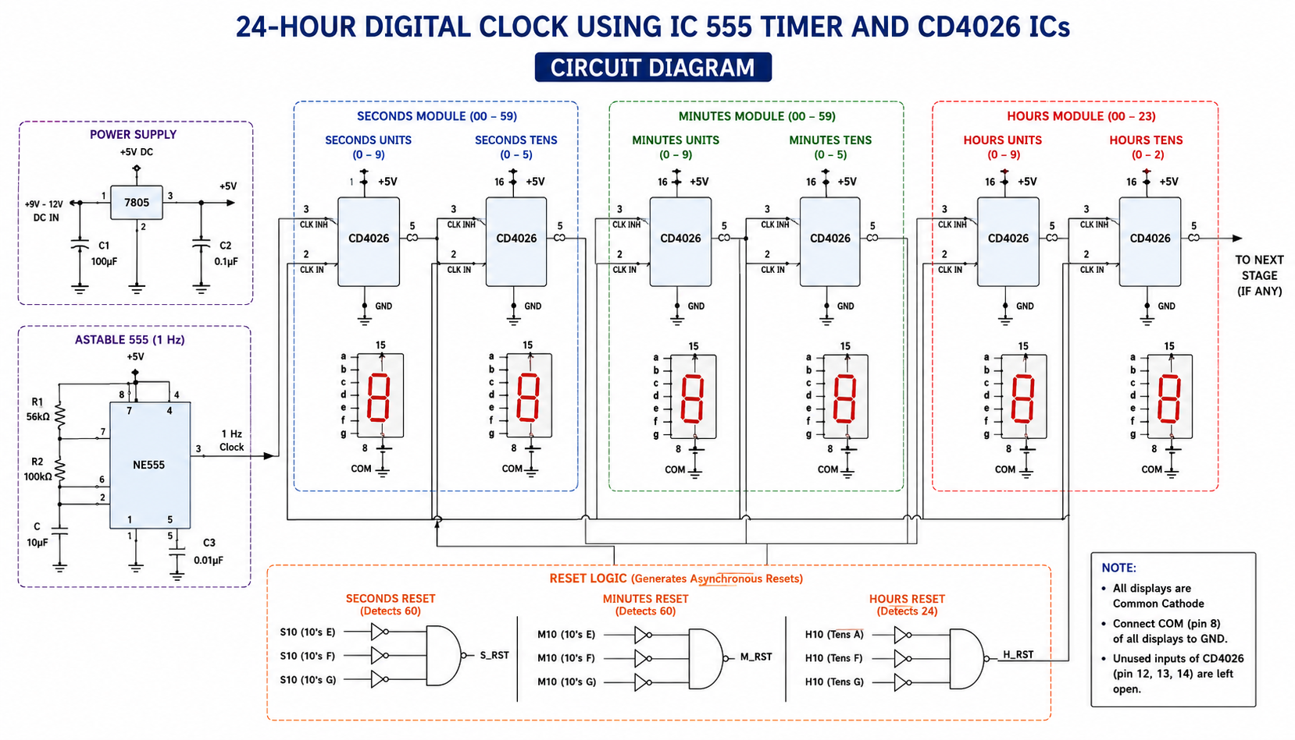

7.1 Key Connections per CD4026
Pin | Name | Connection
16 | VDD | +5 V (with 0.1 µF decoupling to GND)
8 | VSS | GND
1 | CLOCK | Previous stage carry / reset pulse (555 output for SEC-1)
2 | CLOCK INHIBIT | GND (must be tied low for normal counting)
3 | DISPLAY ENABLE IN | +5 V (segments enabled)
15 | RESET | Decode logic output for its group; active HIGH
5 | CARRY OUT | Clock input of the next decade (÷10 output)
a–g (10,12,13,9,11,6,7) | Segment outputs | Through 330 Ω resistors to the display segment pins

Every seven-segment display is common cathode with its common pin to GND. Decode taps (SB, SE, MB, ME, H1A, H1F, H1G, HG) are taken on the IC side of the segment resistors — see Section 13 for why this matters.

8. Working Principle

8.1 Timebase — 555 in Astable Mode
The 555 runs as a free-running oscillator. The capacitor C charges through R1 + R2 and discharges through R2 alone, producing a square wave at pin 3 with a period close to one second (calculation in Section 9). This output clocks the first counter, SEC-1. Pin 4 (RESET) is tied to +5 V, and pin 5 is decoupled with 10 nF for stability.

8.2 Counting and Cascading
Each CD4026 advances on the rising edge of its clock. Its CARRY OUT pin produces one pulse per ten input pulses, which clocks the next digit. This cascading alone would count 00–99 in every pair — the reset decoding below is what turns 00–99 counters into 00–59 and 00–23 counters.

8.3 Rollover by Segment Decoding
Because the CD4026 exposes no BCD outputs, the design detects rollover digits by their unique segment patterns.
Seconds and minutes (detect '6' on the tens digit): comparing the segment patterns of 5 and 6 — the only candidates once segment b is OFF — shows that segment e is the discriminator: e is OFF for 5 but ON for 6. Therefore:
RESET = (NOT b) AND e
is true only when the tens digit shows 6. The instant SEC-10 reaches 6, this expression goes HIGH, resetting SEC-1 and SEC-10 to zero. The '6' exists for only a few hundred nanoseconds — invisible to the eye — so the display appears to count 00–59 and roll to 00. The same falling/rising transition serves as the clock for the minutes stage. An identical circuit (MB, ME) handles the minutes group.
Hours (detect the display value 24): here two digits must be decoded together.
- HOUR-10 = 2: since the tens-of-hours digit only ever shows 0, 1 or 2, segment g alone identifies it — g is OFF for 0 and 1 but ON for 2. The tap is named HG.
- HOUR-1 = 4: among all ten digits, the combination (NOT a) AND f AND g is unique to 4. Segments f AND g together match 4, 5, 6, 8, 9 — adding NOT a eliminates everything except 4.
The full hour reset is therefore a three-input AND:
HRS RESET = HG AND (NOT H1A) AND H1F [with H1G folded into the decode]
The moment the display reaches 24, both hour counters reset to 00, giving true 24-hour operation.

8.4 The CD4026 RESET Pin
Pin 15 is active-HIGH and asynchronous: the counter jumps to zero immediately, without waiting for a clock edge, and stays at zero while RESET is held HIGH. The reset pulses generated above are self-terminating — resetting the counter removes the very digit pattern that caused the reset — so each pulse is a narrow glitch, which CMOS logic handles reliably. Any RESET pin not driven by decode logic must be tied to GND, never left floating.

9. Design Calculations

9.1 555 Astable Frequency
Component values: R1 = 10 kΩ, R2 = 68 kΩ, C = 10 µF.
f = 1.44 / ((R1 + 2·R2) × C)
f = 1.44 / ((10,000 + 136,000) × 10×10⁻⁶) = 1.44 / 1.46 ≈ 0.986 Hz
Period T ≈ 1.014 s — within about 1.4 % of the ideal one-second tick before component tolerances.

9.2 Duty Cycle
Duty = (R1 + R2) / (R1 + 2·R2) = 78k / 146k ≈ 53.4 %. The CD4026 triggers on rising edges only, so duty cycle does not affect timekeeping.

9.3 Segment Current
With a 330 Ω resistor, segment current ≈ (5 V − 2 V LED drop − output drop) / 330 Ω ≈ 7–8 mA per segment — bright enough for a demo while staying near the CD4026's comfortable drive capability.

9.4 Expected Accuracy
An RC oscillator drifts with temperature and capacitor tolerance; a few minutes of error per day is normal. This is acceptable for demonstration. Section 17 describes the crystal-based upgrade path for real accuracy.

10. Implementation
The build proceeded in verified stages — each stage was proven working before the next was added. This discipline made faults easy to localise.
- Power rails: +5 V and GND distributed across breadboards; rail-gap jumpers added; 0.1 µF decoupling placed at every IC.
- 555 stage: wired astable (R1 from +5 V to pin 7, R2 from pin 7 to pins 2+6, C from pins 2+6 to GND, pin 4 to +5 V) and verified a ~1 Hz square wave at pin 3.
- First counter: SEC-1 wired with pin 2 to GND, pin 3 to +5 V, pin 15 temporarily to GND; confirmed 0–9 counting on the display through 330 Ω segment resistors.
- Seconds pair: SEC-10 cascaded from CARRY OUT; decode taps SB (segment b) and SE (segment e) taken on the IC side of the resistors; NOT/AND decode wired; verified 00→59→00 rollover.
- Minutes pair: duplicated the seconds scheme, clocked by the seconds reset pulse.
- Hours pair: three-input decode wired (HG, NOT-H1A, H1F/H1G); verified reset at 24 by manually clocking the hour stage.
- Time-set buttons: push buttons with pull-down resistors pulse the MIN-1 and HOUR-1 clock inputs for setting the time.
[ INSERT BREADBOARD PHOTOGRAPHS HERE — full build + close-up of decode gates ]

11. Testing and Validation
Test | Method | Result
Timebase frequency | Measured pin 3 of 555 over 60 ticks against a phone stopwatch | ≈ 0.99 Hz — matches calculation
Digit counting 0–9 | Observed each display through a full decade | All six digits count correctly
Seconds rollover | Watched transition at 59 s | 59 → 00 with carry to minutes; no visible '6' flicker
Minutes rollover | Fast-clocked via set button | 59 → 00 with carry to hours
24-hour rollover | Set 23:59, waited across the minute | 23:59:59 → 00:00:00 confirmed
Gate logic levels | Multimeter on decode taps | Clean 0 V / ~4.5 V swing after resistor fix (see Section 12.3)
Reset pin behaviour | Pin 15 forced HIGH manually | Counter snaps to 0 and holds — as per datasheet

12. Results
The completed clock counts continuously from 00:00:00 to 23:59:59 and rolls over to 00:00:00, displayed across six seven-segment digits. All three rollover mechanisms (60 s, 60 min, 24 h) operate reliably. Measured timebase error was under 2 % before trimming, consistent with RC-oscillator expectations.
The final build uses 9 ICs (one 555, six CD4026, and the gate packages), consumes roughly 150–250 mA at 5 V depending on displayed digits, and cost under ₹500 in components.
[ INSERT PHOTO OF FINISHED CLOCK SHOWING A TIME, e.g. 12:45:37 ]

13. Challenges Faced
These are the actual faults encountered during the build and how each was diagnosed — arguably the most instructive part of the project.

13.1 The 555 Would Not Oscillate
In the first schematic revision, the discharge pin (7) was shorted directly to the threshold/trigger node and R1 was wired to the RESET pin, leaving no charging path from +5 V to the capacitor. Rewiring to the standard astable topology (R1: +5 V → pin 7; R2: pin 7 → pins 2+6; C to GND; pin 4 to +5 V) fixed it immediately. Lesson: verify the oscillator standalone before connecting anything downstream.

13.2 Hour Reset Fired at the Wrong Count
An early decode detected HOUR-10 using segment a, which identifies the digit 1 — making the clock reset near 12 instead of 24. Re-deriving the segment truth table produced the correct discriminators: segment g for '2' on the tens digit, and (NOT a)·f·g for '4' on the units digit. Lesson: with the CD4026, every decode must be proven against the full 0–9 segment truth table, not assumed.

13.3 Floating CMOS Inputs
Unused inverter and AND inputs left floating caused erratic behaviour and chip heating. All unused CMOS inputs were tied to GND. Lesson: CMOS inputs must never float.

13.4 A Rejected 'Simplification'
During debugging, the decode (NOT b)·c was considered as an alternative to (NOT b)·e for detecting 6. The truth table shows it also matches 5 — the clock would have counted only 0–4 in the tens position. It was rejected before wiring. Lesson: candidate decodes must be checked against every digit, not just the target.

14. Applications
- Teaching platform for digital electronics labs — every concept (astable timing, cascaded counting, combinational decoding, asynchronous reset) is physically observable.
- Low-cost wall/desk clock where absolute accuracy is not critical.
- Timer/sequencer core: the same 555 + CD4026 chain, with different decode points, becomes a countdown timer, event counter, or industrial cycle counter.
- Scoreboards and token-number displays using the counting/display sections alone.
- Foundation for interval-based control (bell timers, irrigation timers) by decoding specific times.

15. Future Scope
- Crystal timebase: Replace the 555 with a 32.768 kHz crystal and CD4060 divider chain for quartz accuracy (seconds/day instead of minutes/day) — the single most valuable upgrade.
- Backup: Add battery backup with a supervisor circuit so the clock survives power cuts.
- Alarm: Add an alarm by decoding a chosen time and driving a buzzer through a transistor.
- 12-hour mode: Detect 12/24 display value and add an AM/PM indicator using additional decode gates.
- PCB: Move from breadboard to a soldered PCB for reliability and presentation.
- Modern comparison: As a contrast study, implement the same specification on an ESP32 with NTP synchronisation and compare cost, accuracy, and complexity.

16. Conclusion
A fully functional 24-hour digital clock was designed, built, and validated using only discrete ICs: one 555 timer, six CD4026 decade counters, and three small gate packages. The project met every stated constraint — 24-hour format, on-board timebase, direct display driving, and correct rollover at 60 seconds, 60 minutes, and 24 hours.
The distinctive contribution of the design is its segment-pattern rollover decoding, made necessary by the CD4026's lack of BCD outputs. Deriving minimal, provably unique decodes — (NOT b)·e for the digit 6, and g with (NOT a)·f·g for the value 24 — required working directly from the seven-segment truth table, and rejecting plausible-looking but incorrect alternatives.
Equally valuable were the faults: a mis-wired oscillator, a wrong decode, LED-clamped logic lines, unpowered gate packages, and floating inputs. Each produced a concrete lesson in debugging methodology. The result is a project that is inexpensive, reproducible, and genuinely educational for second-year ECE students.

17. References
- Texas Instruments, 'LM555 Timer' datasheet, SNAS548D.
- Texas Instruments, 'CD4026B CMOS Decade Counter/Divider with Decoded 7-Segment Display Outputs' datasheet, SCHS054C.
- Texas Instruments, 'CD4073B Triple 3-Input AND Gate' datasheet.
- R. P. Jain, Modern Digital Electronics, 4th ed., McGraw-Hill Education.
- A. P. Malvino and D. P. Leach, Digital Principles and Applications, 8th ed., McGraw-Hill.
- P. Horowitz and W. Hill, The Art of Electronics, 3rd ed., Cambridge University Press — Ch. 7, Oscillators and Timers.

