IrisMDS

User guide

# 

# Introduction

This document describes how to install IrisMDS that can work with CIS202

And MOSIP ecosystem for Registration of an individual’s Iris in MOSIP database.

This installer is just a prototype that can be taken as POC for the integration of CIS202 device and can be used as a reference to develop a Production level IrisMDS.

Please refer the following link for detail information on MDS:

https://docs.mosip.io/platform/biometrics/mosip-device-service-specification

# System Requirements

* Windows 7 and above.
* Microsoft Visual C++ Redistributable 2010, 2013 and 2015(All x86 and x64)

# Installation Steps:

1. Double click the installer file (Thales_Iris_MDS v1.0.0.0 Setup.exe), following screen will appear.

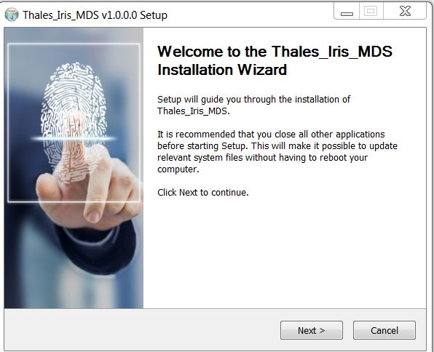

1. Click on “Next”, then following screen will appear.

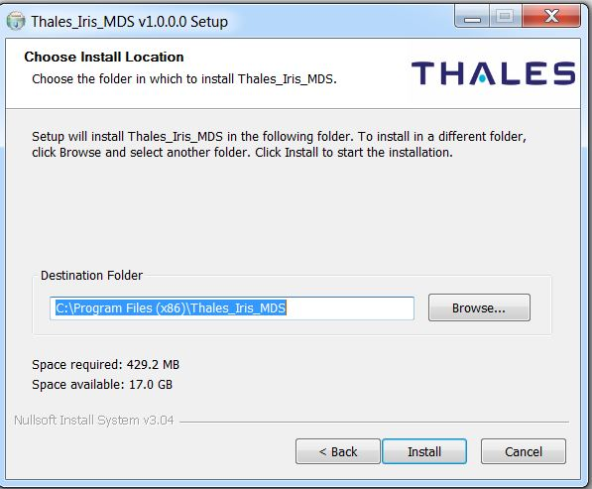

1. Click on “Install”, after completion of installation following screen will appear.

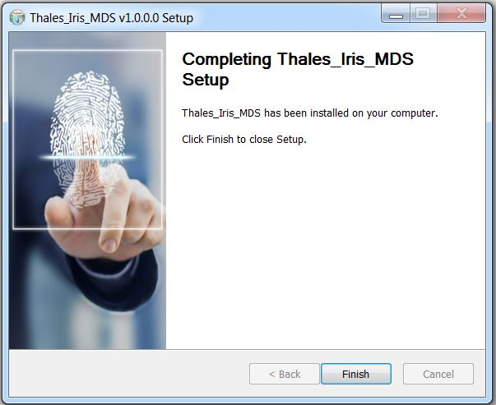

1. Click on finish, and a windows service named as Thales Iris MDSService will start running and CIS202 device drivers will get installed.

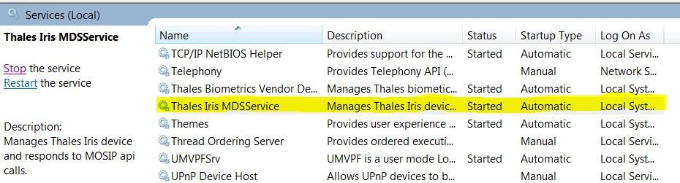

All the required libraries and folders will be installed in “C:\Program Files (x86)\ Thales_Iris_MDS” folder.

1. **Usage**

The IrisMDS service runs as server on one of the port in port range (4501-4600).

To test this server one needs to have registration client application provided by MOSIP.

The server implements four http apis, and can be accessed using following urls and these apis need to be accessed sequentially.

Detailed information about these apis can be found on the MDS specification link provided above.

**Device Discovery**

URL: http://127.0.0.1:port/device

METHOD NAME: MOSIPDISC

REQUEST BODY should be as follows or can refer from Mosip Specification from above mentioned URL.

{

   "type": "Iris"

}

**Device info**

URL: <http://127.0.0.1:port/info>

METHOD NAME: MOSIPDINFO

**Streaming**

URL: <http://127.0.0.1:port/stream>

METHOD NAME: STREAM

**Capture**

URL: <http://127.0.0.1:port/capture>

METHOD NAME: RCAPTURE

**Caliberate**

URL: <http://127.0.0.1:port/caliberate>

METHOD NAME: GET

Note: This api is device specific to caliberate the device. It is required when images returned by device are not clear.

To caliberate, first we need to cover the eye lids, and then only call this api.