Finger MDS

User guide

# 

# Introduction

This document describes how to install MDSService that can work with CS500F or DactyScan84C and MOSIP ecosystem for Registration of an individual’s fingerprints in MOSIP database.

This installer is just a prototype that can be taken as POC for the integration of CS500F or DactyScan84C device and can be used as a reference to develop a Production level MDService.

Please refer the following link for detail information on MDS.

<https://docs.mosip.io/platform/biometrics/mosip-device-service-specification>

* To make the MDS work with CS500F or DactyScan84C, one need to make changes to the config file in

“C:\Program Files (x86)\Thales_Iris_MDS\App_Data\Config.cfg” folder.

In this file need to change the value of “DEVICE_TYPE” key. Its values can be CS500F OR DS84C.

# System Requirements

* Windows 7 and above.
* Microsoft Visual C++ Redistributable 2013 and 2015(both x86 and x64)

# Installation

After completion of installation, windows service named as Thales Finger MDSService will start running and CS500F/ DactyScan84C device drivers will get installed.

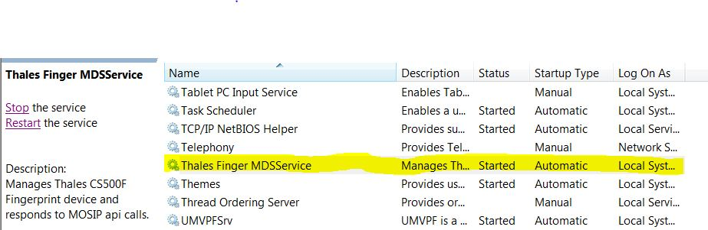

All the required libraries and folders will be installed in “C:\Program Files (x86)\ Thales_Finger_MDS” folder

1. **Usage**

The windows service runs as server on one of the port in port range (4501-4600).

To test this server one needs to have registration client application provided by MOSIP.

The server implements four http apis, and can be accessed using following urls and these apis need to be accessed sequentially.

Detailed information about these apis can be found on the MDS specification link provided above.

**Device Discovery**

URL: http://127.0.0.1:port/device

METHOD NAME: MOSIPDISC

REQUEST BODY should be as follows or can refer from Mosip Specification from above mentioned URL.

{

   "type": "Finger"

}

**Device info**

URL: <http://127.0.0.1:port/info>

METHOD NAME: MOSIPDINFO

**Streaming**

URL: <http://127.0.0.1:port/stream>

METHOD NAME: STREAM

**Capture**

URL: <http://127.0.0.1:port/capture>

METHOD NAME: RCAPTURE