What is Terraform ?
Terraform is an infrastructure as code tool that allows you to build, change and version infrastructure safely and efficiently.

It uses HashiCorp language.

Installation of Terraform

- Open link https://developer.hashicorp.com/terraform/install#windows
- Download it for windows.
- Extract all the files and run terraform.exe file.
- Configure environmental variable using below link in-order to execute terraform any where
Link :- https://www.youtube.com/watch?v=8096cAY1JPc
- Testing :-
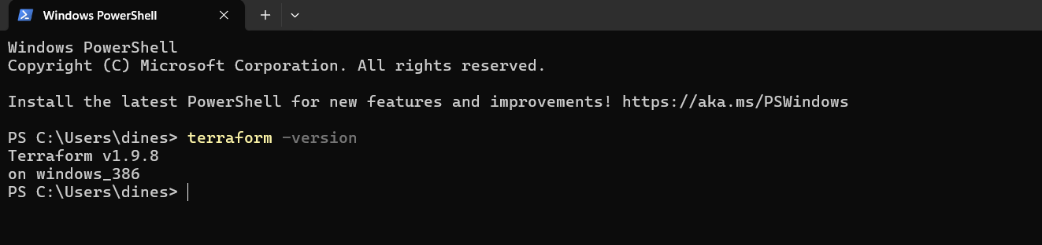

All terraform files will be with .tf extension.

