VK7SPORTS Prototype Description Report
Client Demonstration Prototype Package

1. Submission Overview
This submission contains four HTML prototype files selected to demonstrate the main customer-facing and administrative capabilities proposed for the VK7SPORTS platform. The prototype covers the website home experience, product browsing, custom teamwear configuration, and the administrative dashboard.

2. Prototype Files Included
- HomePage.html: Brand landing page with sports categories, featured collections, customer segments, promotional sections, and value propositions.
- ShopPage.html: Product listing experience with product cards, filters, sorting options, pricing, ratings, and responsive layouts.
- CustomTeamwear.html: Interactive teamwear configuration experience with jersey preview, colour selection, team name, logo upload, size/quantity inputs, and bulk enquiry.
- AdminDashboardPage.html: Administrative dashboard with KPI cards, navigation, sales/order/enquiry indicators, and a visual chart area.

3. Images and Visual Assets Used in the Prototype
The following section documents the actual image assets and visual elements included in the prototype. The Home page uses externally hosted sports and institutional photographs. The Shop page contains embedded product images. The Custom Teamwear page and Admin Dashboard primarily use SVG, CSS, icons, and generated interface visuals.

3.1 Home Page Image Assets
No. | Image usage | Image source included in HTML
1 | Cricket category image | https://images.unsplash.com/photo-1531415074968-036ba1b575da?auto=format&fit=crop&w=600&q=80
2 | Football category image | https://images.unsplash.com/photo-1579952363873-27f3bade9f55?auto=format&fit=crop&w=600&q=80
3 | Basketball category image | https://images.unsplash.com/photo-1546519638-68e109498ffc?auto=format&fit=crop&w=600&q=80
4 | Volleyball category image | https://images.unsplash.com/photo-1612872087720-bb876e2e67d1?auto=format&fit=crop&w=600&q=80
5 | Running/Athletics category image | https://images.unsplash.com/photo-1461896836934-ffe607ba8211?auto=format&fit=crop&w=600&q=80
6 | Gaming category image | https://images.unsplash.com/photo-1511512578047-dfb367046420?auto=format&fit=crop&w=600&q=80
7 | Football collection image | https://images.unsplash.com/photo-1574629810360-7efbbe195018?auto=format&fit=crop&w=600&q=80
8 | Fitness collection image | https://images.unsplash.com/photo-1517838277536-f5f99be501cd?auto=format&fit=crop&w=600&q=80
9 | School/Institution image 1 | https://images.unsplash.com/photo-1580582932707-520aed937b7b?auto=format&fit=crop&w=400&q=80
10 | School/Institution image 2 | https://images.unsplash.com/photo-1562774053-701939374585?auto=format&fit=crop&w=400&q=80
11 | School/Institution image 3 | https://images.unsplash.com/photo-1577223625816-7546f13df25d?auto=format&fit=crop&w=400&q=80
12 | Team/Institution image 4 | https://images.unsplash.com/photo-1526232761682-d26e03ac148e?auto=format&fit=crop&w=400&q=80
13 | Corporate/Building image | https://images.unsplash.com/photo-1486406146926-c627a92ad1ab?auto=format&fit=crop&w=400&q=80
14 | Main hero banner image | https://images.unsplash.com/photo-1518091043644-c1d4457512c6?q=80&w=1600&auto=format&fit=crop
Note: These photographs are loaded through external Unsplash URLs when the prototype is opened with an internet connection.

3.2 Shop Page Product Images
Seven product photographs are embedded directly inside the Shop page HTML. The images below are the same embedded assets used in the product cards.
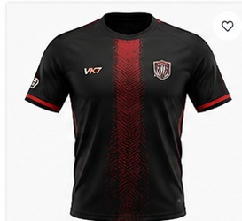  Embedded product image 1 | 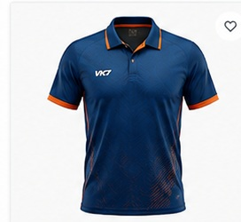  Embedded product image 2
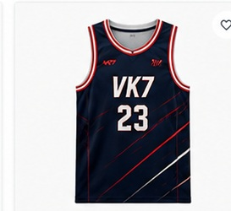  Embedded product image 3 | 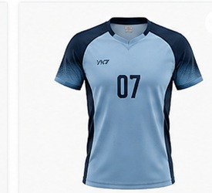  Embedded product image 4
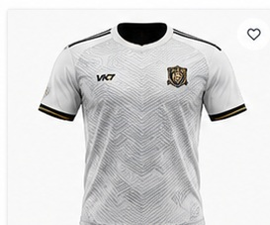  Embedded product image 5 | 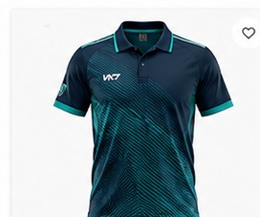  Embedded product image 6
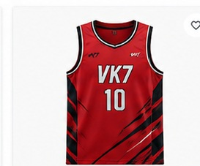
Embedded product image 7

3.3 Custom Teamwear Visuals
The Custom Teamwear prototype does not rely on a separate static jersey photograph. The jersey previews are created using inline SVG graphics and CSS. This allows the jersey colour to update dynamically and supports live placement of the uploaded team logo and team name. The page also includes interface icons and colour swatches.

3.4 Admin Dashboard Visuals
The Admin Dashboard contains no external photographic assets. Its visuals are created through interface icons, styled KPI cards, CSS components, and an inline SVG bar chart. This keeps the dashboard lightweight and suitable for responsive display.

4. Key Capabilities Demonstrated
- Responsive desktop and mobile layouts
- Consistent navy, white, and red VK7SPORTS branding
- Sports and collection discovery
- Product browsing with filters and sorting
- Interactive teamwear customization and bulk enquiry
- Administrative KPI monitoring and visual reporting

5. Conclusion
The four selected files are sufficient for an initial client prototype demonstration because they represent the major customer journey and the supporting administrative experience. Together, they show the proposed interface direction, product discovery flow, customization capability, and dashboard structure.

