VK7SPORTS
Task 1 — Revised Prototype Walkthrough
Customer Website • Simplified Admin Dashboard • Backend Integration Overview
PURPOSE Show how the website and dashboard should look, what each must include, and how the backend will support the main B2B ordering flow.

1. Required Revision Summary
Area | Approved update
Website browsing | Remove Shop by Customer Type and Shop by Sports Category. The audience is already fixed: shopkeepers and retailers.
Product structure | Use Jerseys, Pants/Track Pants, Shorts, and T-Shirts/Training Tops. Size and Color are product attributes and filters.
Admin Dashboard | Use fewer, clearer modules for easy daily management.
Backend | Plan the Admin Portal, Customer Website APIs, products/variants/pricing/inventory, orders/payments, and tracking/status updates.

RULES RETAINED Minimum 24 pieces per product; combined sizes/colors; no design customization; tier pricing; stock validation; full online or 10% advance + 90% COD only.

2. Customer Website — Updated Prototype

2.1 Home Page
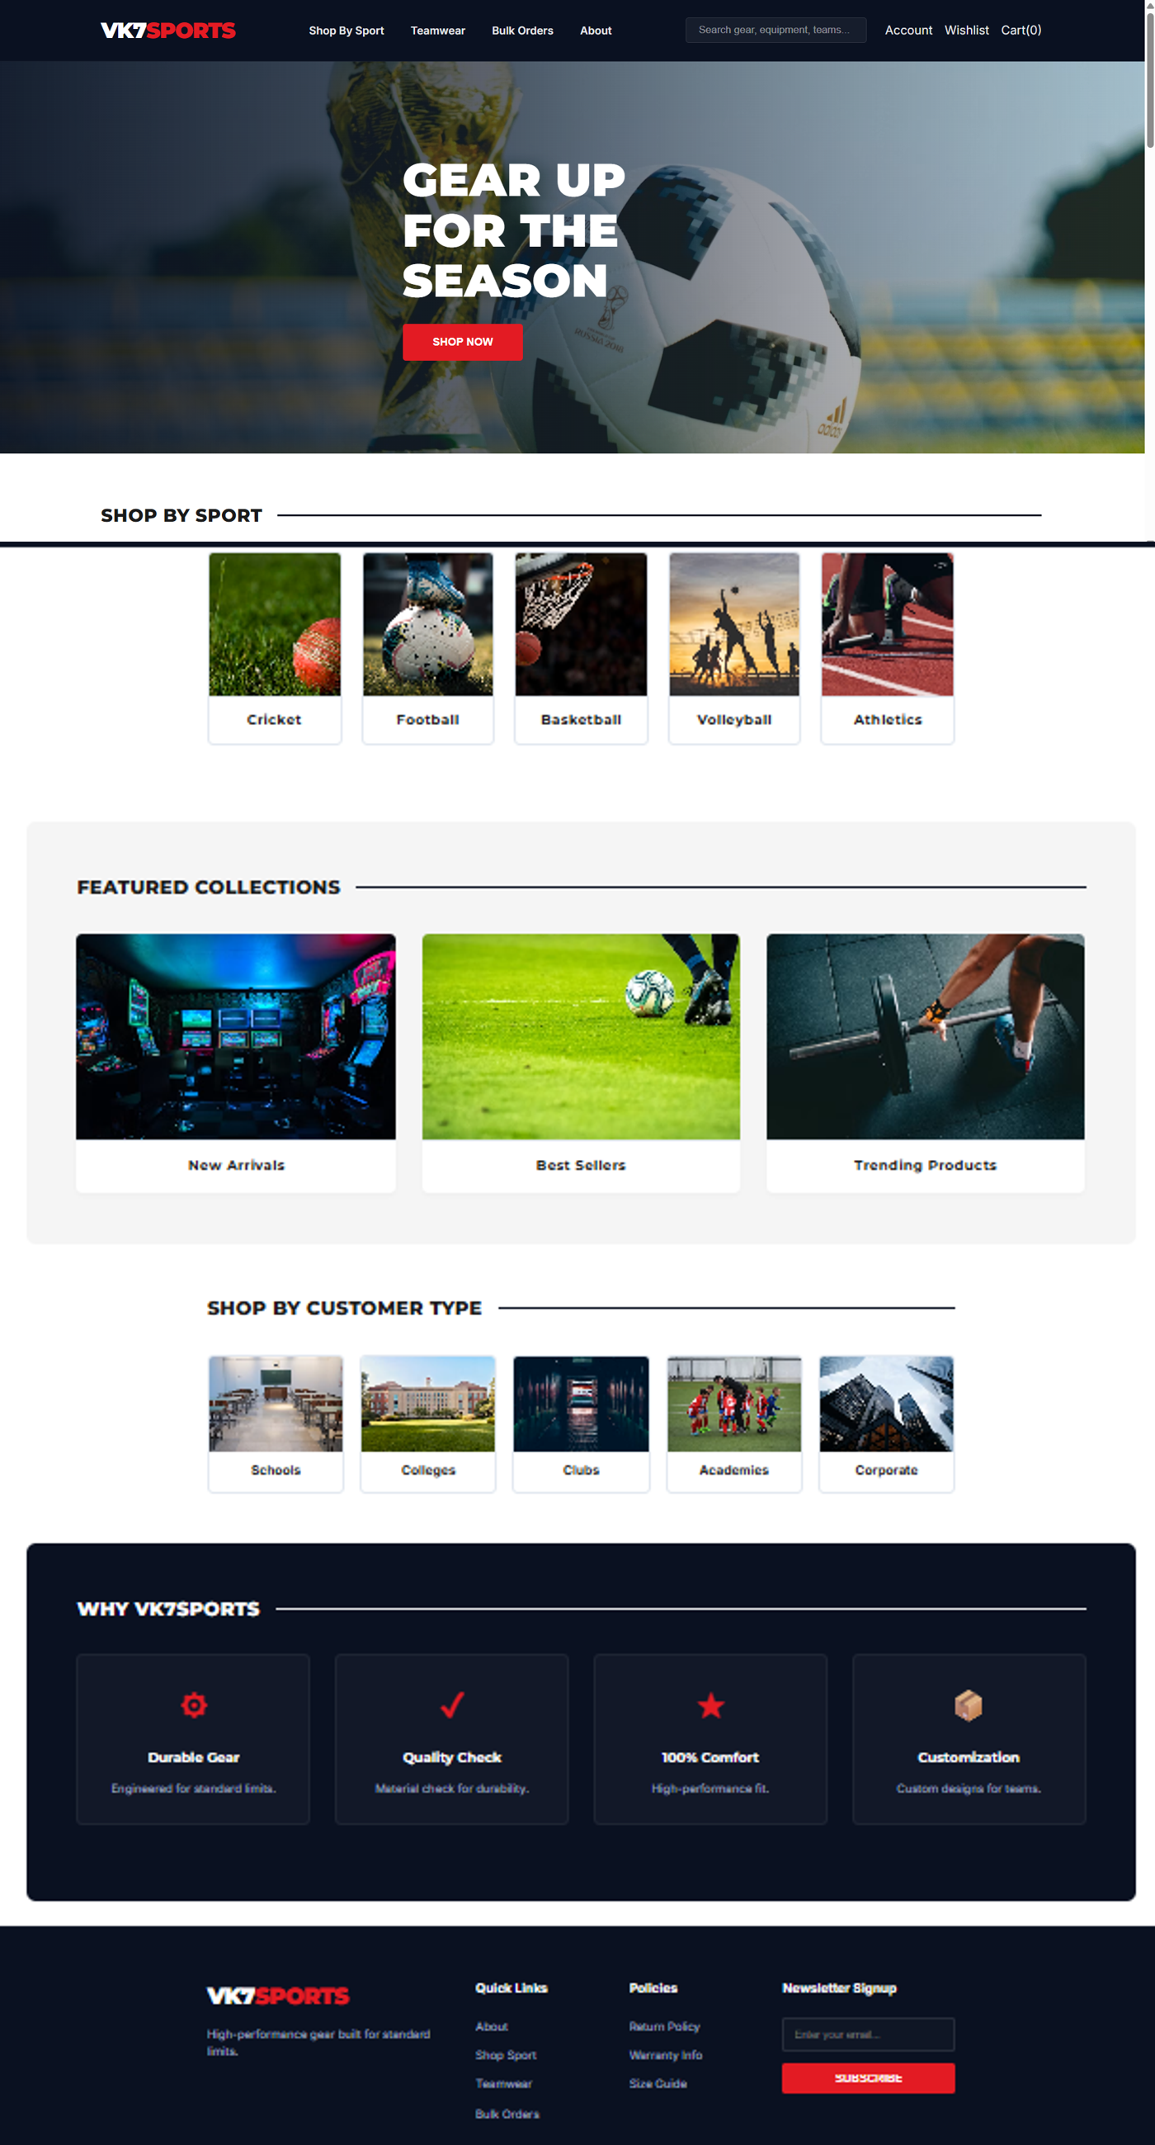
Existing Home Page prototype — retained as the visual reference.
REQUIRED UPDATE Replace “Shop by Sport” and “Shop by Customer Type” with one “Shop by Product Category” section: Jerseys, Pants/Track Pants, Shorts, and T-Shirts/Training Tops. Update header/footer links the same way. Remove the Customization claim because customers cannot change designs.
• Keep: VK7SPORTS branding, hero banner, search, account, cart, featured/new products, wholesale information, and 24-piece MOQ message.
• Primary navigation: Home, Shop, Categories, Wholesale Guide, About, Account, Cart.

2.2 Product Catalogue
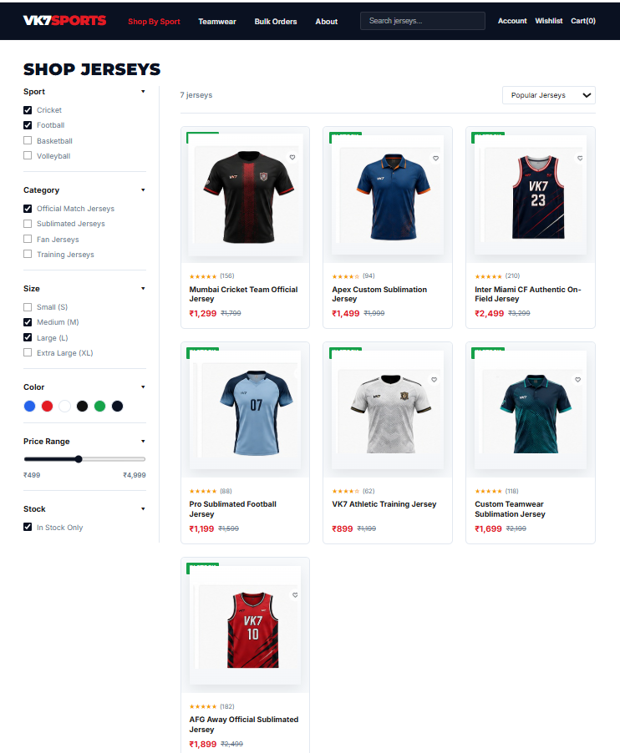
Existing Catalogue prototype — product-card and filter layout remain useful.
REQUIRED UPDATE Remove the Sport filter. Use Category, Size, Color, Price Range, and Stock Availability. Product cards should show image, name, SKU, starting wholesale price, colors, sizes, and stock status.
• Categories: Jerseys, Pants/Track Pants, Shorts, T-Shirts/Training Tops.
• Size and Color are attributes/filters, not standalone product categories.

2.3 Product Details and Wholesale Selection
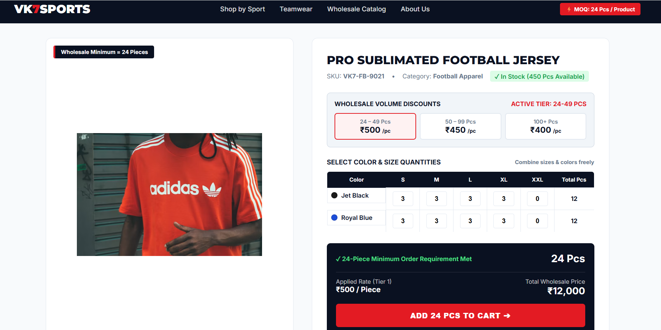
Product Details prototype — approved direction for combined Color × Size quantities and tier pricing.
• Show product images, name, description, SKU, category, available colors, sizes, stock, pricing tiers, and quantity matrix.
• Customer combines size/color quantities for the same product. Total below 24 disables Add to Cart; total of 24 or more enables it after stock validation.
• No logo, text, color-design, or other customization tools are included.

2.4 Remaining Customer Flow
Screen | Must include
Cart / Checkout | Selected color-size quantities, tier price, totals, stock/price recheck, business/address details.
Payment | Full online payment OR 10% online advance + 90% COD. No 100% COD.
Orders | Order history, payment state, product/variant quantities, current status, and shipment details.
Tracking | Order Placed → Payment Confirmed → Processing → Packed → Shipped → Out for Delivery → Delivered.
Notifications | Order/payment/status/shipment/delivery and back-in-stock updates.

3. Simplified Admin Dashboard
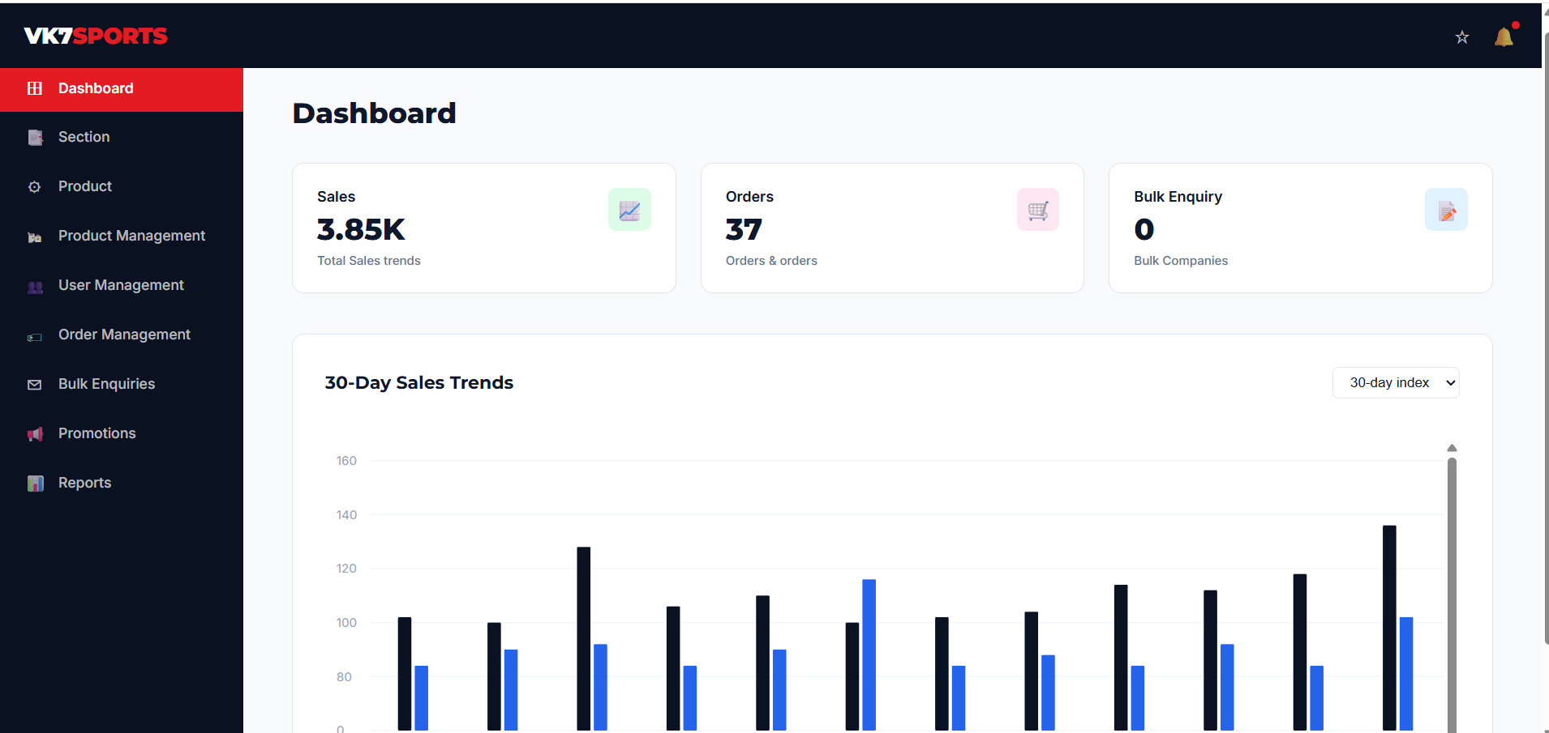
Existing Admin Dashboard prototype — visual style retained; navigation should be simplified.
REQUIRED UPDATE Replace the overlapping menu with: Dashboard, Products, Inventory, Orders, Customers, Notifications, and Settings.
Module | Simple day-to-day contents
Dashboard | Products, orders, pending orders, sales/order value, low/out-of-stock variants, and recent orders.
Products | Products, categories, images, SKU, sizes, colors, variants, pricing tiers, and active/inactive status.
Inventory | Stock by Product → Color → Size; add/adjust stock; low/out-of-stock; back-in-stock action and history.
Orders | Search/filter, order detail, payment split/status, approved status update, courier and tracking.
Customers | Shop/business profile, contact/GST/address, order history, total purchase value.
Notifications | Order and stock notification log, failed delivery/retry, back-in-stock requests.
Settings | Admin users/roles, payment/shipping and basic store settings.

• Use one clear sidebar, one page title, search/filters, one primary action, and simple tables/forms.
• Do not keep separate “Product” and “Product Management” modules; combine them under Products.

4. Backend Integration Overview
TASK BOUNDARY This section explains how the prototype connects to the backend. The detailed database schema, API endpoints, middleware, and order-tracking implementation are maintained in the separate Task 2 Backend Implementation Blueprint.
Recommended stack: Next.js/React with TypeScript for the Customer Website and Admin Portal, a Node.js/NestJS REST API, and PostgreSQL for products, variants, pricing, inventory, customers, orders, payments, and tracking. The final framework can be confirmed by the development team; PostgreSQL and the API responsibilities align with Task 2.
Backend area | Task 1 integration requirement
Admin Portal APIs | Create/edit products, categories, Product + Color + Size variants, pricing tiers and inventory; view orders; update status and tracking.
Customer Website APIs | Load catalogue/product details, search/filter, validate cart, checkout, payment, order history and tracking.
Product & inventory | Store valid variants and SKU; stock is managed by Product → Color → Size and revalidated before order creation.
Pricing & checkout | Backend sums combined sizes/colors per product, enforces 24 pieces, selects the correct tier, and rejects client-edited prices.
Payments & orders | Support full online or 10% advance + 90% COD; reject 100% COD; verify payment result before fulfilment.
Tracking & notifications | Store courier/tracking data, control valid status transitions, expose the customer timeline, and trigger updates.

4.1 Main Integration Flow
Step | System behavior
1. Browse | Customer Website requests active categories, products, sizes, colors, starting prices and stock availability.
2. Select | Cart API validates the Product + Color + Size entries and combined quantity for that product.
3. Checkout | Backend rechecks MOQ, stock and tier pricing, then creates the order and approved payment request.
4. Manage | Admin Portal shows the order, payment split, customer and variant quantities for fulfilment.
5. Track | Admin advances the approved status sequence and adds courier details when shipped.
6. Notify | Customer order timeline is updated and a website/email/SMS/WhatsApp notification is triggered as configured.

4.2 Non-Negotiable Backend Validation
• Minimum 24 pieces per product, using combined sizes and colors.
• Valid active Product + Color + Size combination and sufficient stock.
• Correct server-calculated pricing tier and total.
• Full online or exactly 10% advance + 90% COD; no 100% COD.
• Customer/admin authentication, role authorization, and valid next order-status transitions.
EXACT STATUS FLOW Order Placed → Payment Confirmed → Processing → Packed → Shipped → Out for Delivery → Delivered.

5. Final Review Checklist
Check | Expected result
Home and catalogue | No customer-type or sports-category shopping; product categories are visible.
Product selection | Sizes and colors are supported as attributes/filters and combined in the quantity matrix.
Admin | Seven simple modules cover daily product, inventory, order and customer work.
Backend | Both interfaces use secured APIs and server-side validation.
Orders | Pricing, stock, payment, order status, tracking and notifications are fully planned.
Scope | Prototype screenshots remain as visual references, with required changes clearly identified.

DEVELOPMENT PRIORITY Product → Variant → Quantity → Pricing → Inventory → Order must be correct before secondary reports or promotional features.

