VK7SPORTS: Task 2 Backend Implementation Blueprint
Here is the complete, structured backend implementation blueprint for Task 2, designed specifically to support both the Customer Website and the Admin Dashboard while enforcing all core business rules and validation mechanisms.

1. Database Schema Design & Relational Models
To manage the product-variant-pricing hierarchy (Product $\rightarrow$ Color $\rightarrow$ Size), the PostgreSQL database schema is structured as follows:
- Users Table: Stores user accounts, distinguishing between customer (shopkeepers/retailers) and admin roles, along with business/shop details and GST numbers.
- Categories Table: Organizes products into searchable categories.
- Products Table: Holds primary product metadata, titles, base descriptions, and category foreign keys.
- ProductVariants Table: Maps specific color and size permutations to parent products, complete with unique SKUs.
- Inventory Table: Tracks precise stock levels mapped directly to each ProductVariant.
- PricingTiers Table: Stores quantity-based pricing structures (min_qty, max_qty, price_per_piece) for each product.
- Orders & OrderItems Tables: Capture finalized purchases, selected payment methods (100% Online or 10% Advance + 90% COD), transaction references, and fulfillment states.

2. Admin Portal Backend Services
The admin backend provides complete operational control over inventory, pricing, and fulfillment:
- Product & Variant Management Endpoints:
  - POST /api/admin/products: Create products, upload media references, and assign categories.
  - POST /api/admin/products/:id/variants: Define available colors, sizes, and generate SKUs.
- Dynamic Pricing Tier Management:
  - POST /api/admin/products/:id/pricing-tiers: Establish or modify bulk pricing brackets (e.g., 24–49 pcs, 50–99 pcs, 100+ pcs).
- Granular Inventory Control:
  - PATCH /api/admin/inventory: Directly add, reduce, or update stock counts mapped to Product $\rightarrow$ Color $\rightarrow$ Size. Automatically flags variants as available or out-of-stock.
- Order & Fulfillment Management:
  - GET /api/admin/orders: Inspect all incoming wholesale orders, customer shop credentials, and GST details.
  - PATCH /api/admin/orders/:id/status: Advance the order lifecycle (Processing $\rightarrow$ Packed $\rightarrow$ Shipped, etc.), automatically triggering customer notification alerts.
  - PATCH /api/admin/orders/:id/tracking: Attach courier partner names, tracking numbers, and tracking URLs to shipped orders.

3. Customer Website Backend Integration
The customer backend ensures secure browsing, strict rule validation, and seamless wholesale checkout:
- Catalogue & Discovery APIs:
  - GET /api/customer/products: Fetch active products with filtering, search parameters, and starting wholesale prices.
  - GET /api/customer/products/:id: Retrieve full product details, available color/size matrices, and active pricing tier tables.
- Cart & 24-Piece Enforcement Middleware:
  - POST /api/customer/cart/add: Validates that the cumulative quantity across selected variant matrices is $\ge 24$ pieces. Requests failing this rule are rejected with an explicit validation error.
  - Dynamic pricing calculator middleware evaluates aggregate quantities against tiers to automatically compute accurate per-piece prices and line totals.
- Checkout & Split-Payment Processing:
  - POST /api/customer/checkout: Re-validates current stock availability and final backend pricing right before order creation.
  - Enforces payment rules by rejecting 100% Cash on Delivery (COD) while fully supporting 100% online payments or the 10% advance + 90% COD split structure.

4. Order Tracking System & Status Updates
A robust state machine engine tracks and exposes the complete lifecycle of wholesale orders:
- Sequential Order Lifecycle:
- 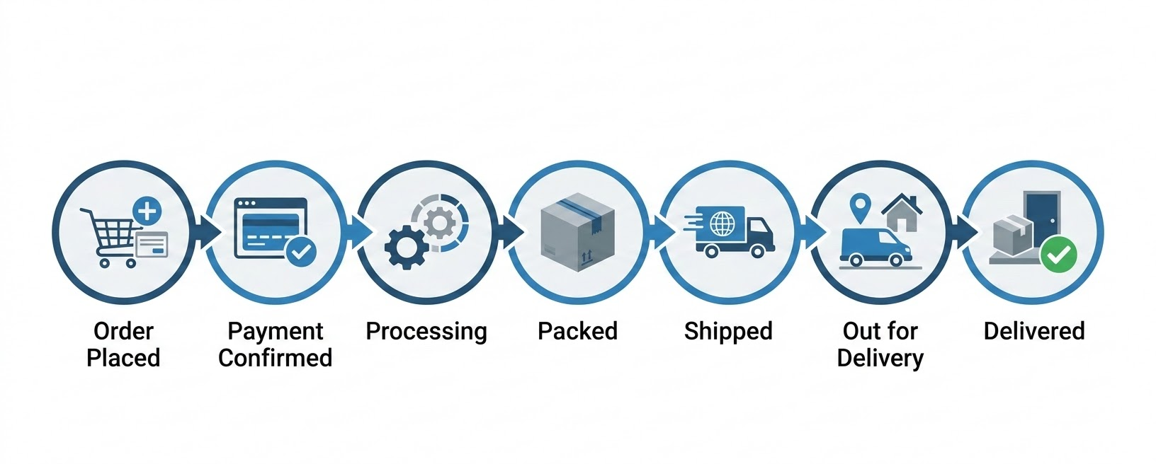
- Customer Visibility Endpoint:
  - GET /api/customer/orders: Returns customer order history with live status checkpoints and attached courier tracking details.
- Automated Notification Triggers:
  - Event-driven triggers dispatch notifications via Email, SMS, or WhatsApp whenever an order status changes or an out-of-stock product becomes available again for customers on the "Notify Me" list.
How would you like to structure the initial folder layout or database migration scripts for these backend services?

