TaskMaster — Personal To-Do App
React.js Course Project DocumentationReact.js Course Project Documentation

1. Project Overview and Objective
TaskMaster is a single-page task management application built with React.js. It allows users to create, edit, delete, and organize daily tasks with categories, due dates, and theme preferences. The objective of this project was to apply core React concepts including components, props, state management with hooks, event handling, and conditional rendering in a real-world application.

2. Modules and Features Implemented

2.1 Core Features
• Add Tasks — Users can create new tasks with a title, category (Work, Personal, Urgent), and optional due date using a controlled form with onChange and onSubmit handlers.
• Edit Tasks — Each task can be edited inline, allowing users to modify the title, category, and due date.
• Delete Tasks — Tasks can be removed from the list with a single click.
• Mark as Complete — A custom checkbox toggles task completion status with visual feedback (strikethrough and opacity).
• Filter by Status — Three filter buttons (All, Active, Completed) allow users to view tasks by their completion status.
• Category Organization — Tasks are organized into three categories: Work, Personal, and Urgent, each with a distinct color badge.
• localStorage Persistence — All tasks and theme preferences are stored in the browser localStorage, so data survives page refreshes.
• Live Task Counts — A stats bar displays the count of remaining and completed tasks in real time.

2.2 Stretch Goals (Bonus Features)
• Due Dates with Overdue Indicators — Tasks can have due dates. Overdue tasks are highlighted with a red border and warning icon.
• Dark/Light Theme Toggle — Users can switch between light and dark themes. The preference is persisted in localStorage.
• Responsive Design — The layout adapts to mobile screens with a responsive design using CSS media queries.

3. Technology and Tools Used
• React 18 — JavaScript library for building user interfaces using functional components and hooks (useState, useEffect).
• Vite — Next-generation frontend tooling providing fast dev server and optimized builds.
• CSS3 — Custom properties (CSS variables) for theming, Flexbox for layout, and media queries for responsiveness.
• localStorage API — Web storage API for persisting tasks and theme data on the client side.
• Git & GitHub — Version control system for tracking project progress with incremental commits.

4. Project Structure
The project follows a clean, organized folder structure:
src/components/ — Reusable UI components (TaskInput, TaskList, TaskItem, FilterBar, ThemeToggle)
src/hooks/ — Custom React hooks (useLocalStorage for persistent state)
src/App.jsx — Main application component managing state and data flow
src/App.css — Component styles with CSS variables for theming
src/index.css — Global styles and theme variable definitions

5. Screenshots
The following screenshots show the application running in different modes:

Screenshot 1: Light Mode — Main View with Tasks
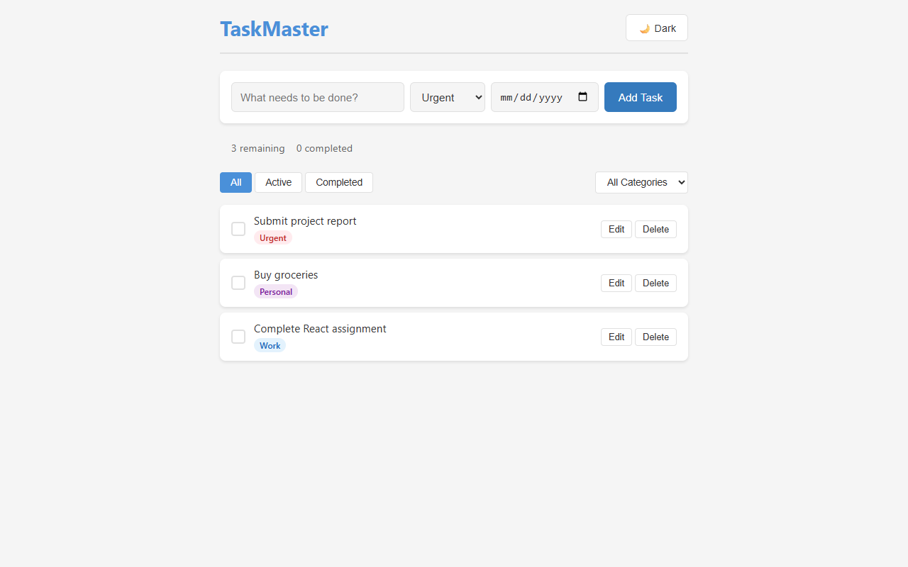

Screenshot 2: Dark Mode — Theme Toggle
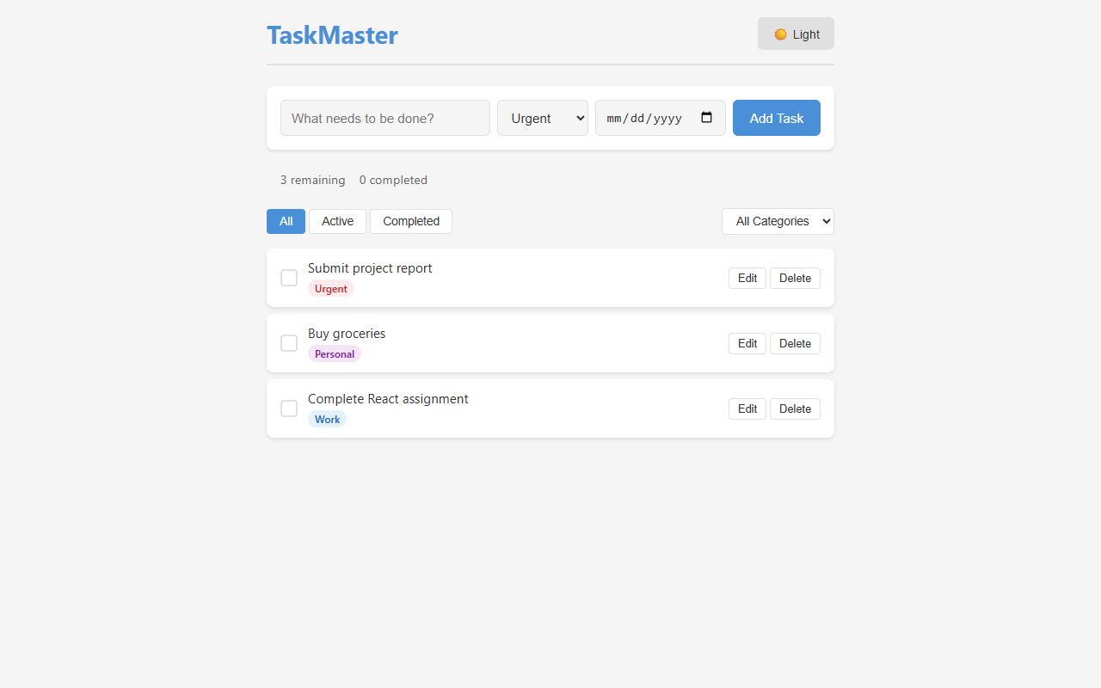

Screenshot 3: Mobile Responsive View
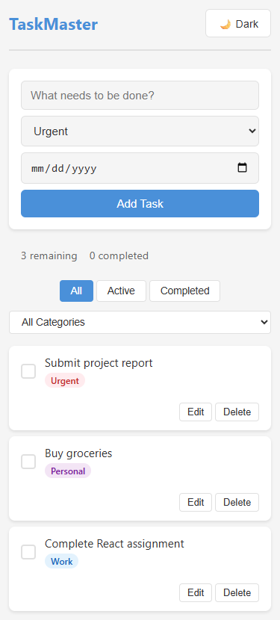

Screenshot 4: Empty State — No Tasks
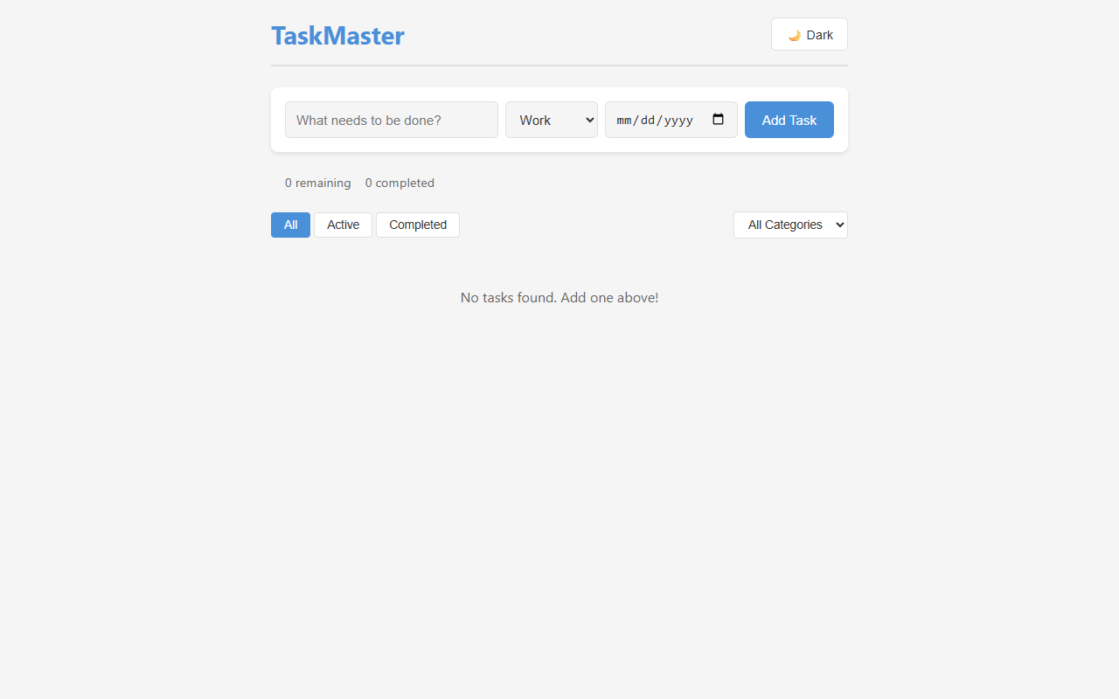

6. Setup Instructions
Prerequisites: Node.js (v16 or higher) and npm installed on your system.
1. Clone the repository to your local machine.
2. Navigate to the project folder: cd react-todo-app
3. Install dependencies: npm install
4. Start the development server: npm run dev
5. Open your browser and go to http://localhost:5173

7. Known Limitations
• No drag-and-drop reordering — Tasks appear in the order they were added.
• No backend database — All data is stored in the browser localStorage and is not synced across devices.
• No user authentication — The app does not support multiple user accounts.
• Edit mode is inline — Editing replaces the task card content rather than using a modal dialog.

8. Appendix — References and Notes
• React Documentation: https://react.dev
• Vite Documentation: https://vitejs.dev
• MDN Web Docs — localStorage: https://developer.mozilla.org/en-US/docs/Web/API/Window/localStorage
• CSS Custom Properties: https://developer.mozilla.org/en-US/docs/Web/CSS/Using_CSS_custom_properties
This project was developed as part of the React.js course curriculum. All code is original and written for learning purposes.

