**Observations:**

**Latitude VS Temperature:**

There is no significant difference in the temperatures of the cities close to the equator i.e. till 20 degrees toward south & north.

However, as we move far away from the equator, the figure clearly shows that the southern hemisphere has slightly higher temperatures than the northern hemisphere.

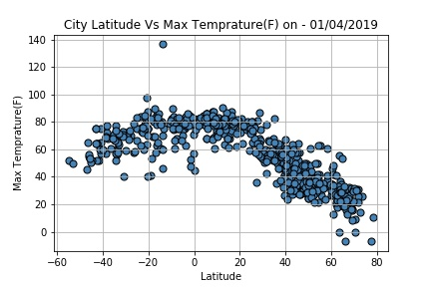

* The figure shows that more cities in northern hemisphere are less humid when compared to northern couther parts as we move away from the equator.

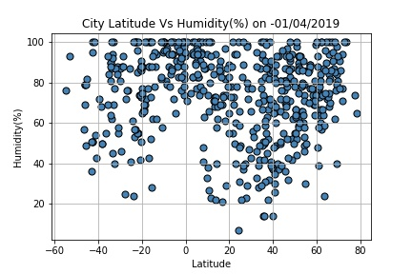

* The figure shows that the Cities in the northern hemisphere are more windy.

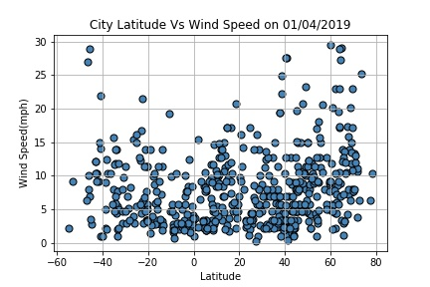

* Looking at the figure , it can be observed that more cities in the northern region are cloudy then in southern hemisphere.

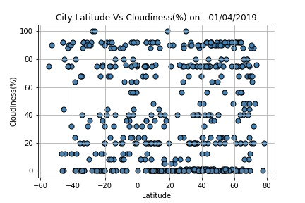

**Conclusion:**

Cities in north are

1. More Windy
2. More Cloudy
3. Less humid

Which makes northern hemisphere cooler than the southern hemisphere.