Observations:

1. **Tumour Response to the Treatment:**

Following graph clearly indicates that the tumour volume is reducing over time when mice received **“Capomulin”** treatment

In case of other treatments, tumour volume appears to be continuously increasing with time, so the treatments show no impact.

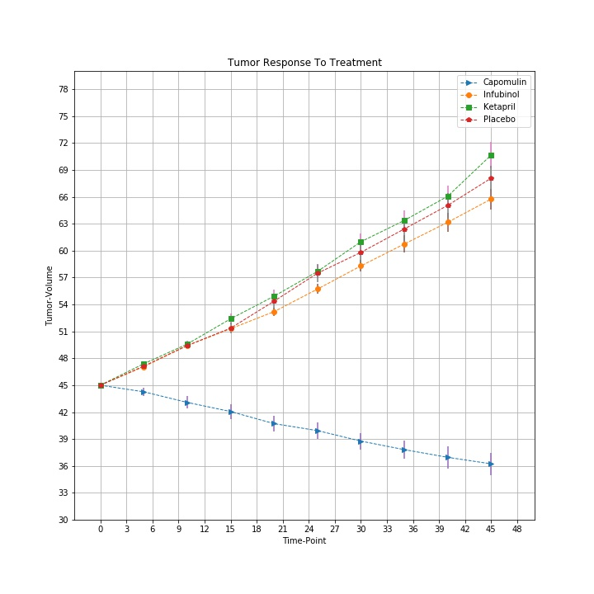

1. **Metastasis Response**

From the following graph, “Capomulin” shows significantly low or gradual metastatic response.

Tumour appears to spread to more than 3 sites , in case of Placebo , where “Capomulin” managed to limit it to 1.5

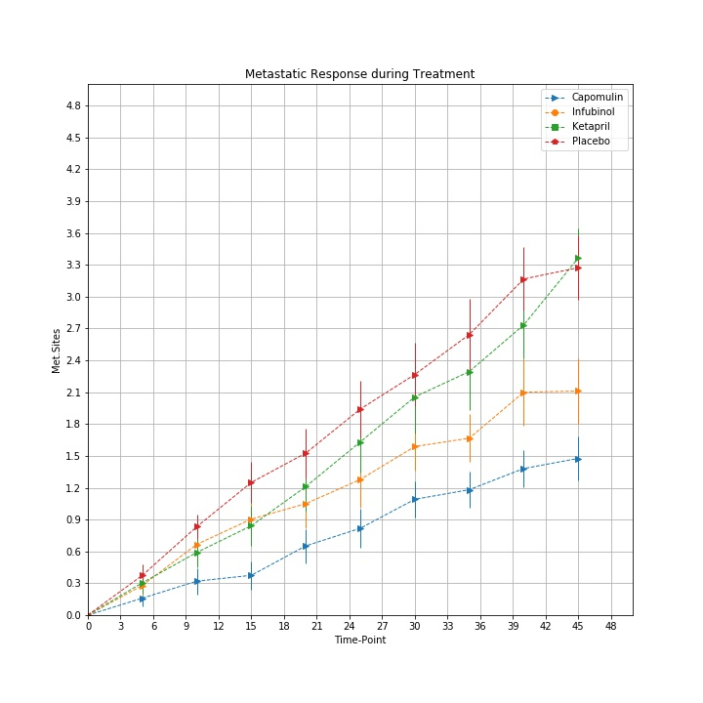

**3.Survival Percentage**

About 85% of the mice survived by the end of 45th day, when treated by “Capomulin” when compared to other treatments where the survival percentage is just over 40%.

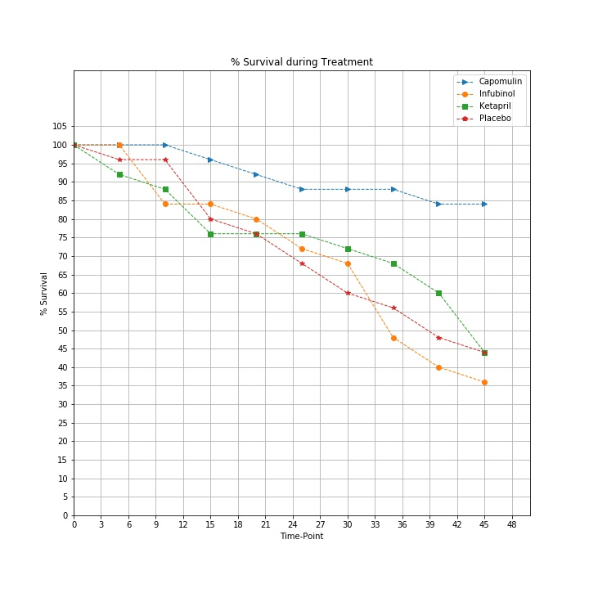

**4.Change in Tumour Volume**

