ISEM 505 · Intelligent System Lifecycle Management & Human Factors
Project #2
Lifecycle Management, Operational Governance, and Agentic AI Stress-Testing
for the LineWatch Predictive-Maintenance System
Prepared by: Oghenegare Aganbi & Dinesh Pratap Singh
Harrisburg University of Science and Technology · September 2026

Executive Summary
This report carries the LineWatch system from Project 1 forward from concept design into a complete operational lifecycle: how it is prototyped, integrated, validated, run, updated, and eventually retired, and how the people who use and oversee it stay in control. LineWatch is an advisory predictive-maintenance tool for discrete manufacturing. It ranks machines by failure risk, but a human always decides whether to act.
Three design ideas run through the report. First, capacity is a requirement, not an afterthought: every threshold is set against how many inspections technicians can actually perform per shift. Second, every human override is data: dismissals are captured with reason codes, reviewed, and only then allowed to influence retraining. Third, the governance model was itself tested. We gave it to an AI system (Claude) to red-team; the critique exposed a genuine blind spot in our alert-budget rule, and Section 2.3 shows the revised model (v1.1). The full AI transcripts and our analysis are in Appendix A.
Methodologically, the design integrates systems engineering lifecycle practice (Kossiakoff), ML systems engineering for train/serve separation, drift, and champion–challenger release (Huyen), Lean/TPM capacity discipline on the floor, and the NIST AI RMF (govern–map–measure–manage) for oversight—using historian, MES, CMMS, and verified technician outcomes as the operational data sources.

Team Roles and Coordination
The project was divided so that each author owned complete sections, with a shared review gate before submission. Dependencies are shown so that later sections were not drafted on unstable inputs. Each author finished assigned work packages by the target date and proactively peer-reviewed the other’s sections against the rubric to raise quality before submit.
Table 1. Work-package RACI, dependencies, and target dates.
Work package | Oghenegare Aganbi | Dinesh Pratap Singh | Depends on | Target date
Part 1: Lifecycle, update & rollback strategy | A / R | C | Project 1 model results | Week 1
Part 2: UX, feedback loop, governance | C | A / R | Stage 4 monitoring metrics (Part 1) | Week 2
Part 3: Stakeholders & figures | R | A / R | Parts 1–2 terminology frozen | Week 2
Part 4: AI stress-test & appendix | A / R | R | Governance model v1.0 (2.3) | Week 3
Part 5, editing, references, final QA | R | A / R | All sections complete | Week 3

R = Responsible, A = Accountable, C = Consulted. Coordination: weekly 30-minute sync, shared task tracker, and a peer-review pass in which each author checked the other’s sections against the rubric before submission.

Part 1: Lifecycle & Deployment Strategy

1.1 System Recap
LineWatch is a human-in-the-loop predictive-maintenance decision-support system for high-duty assets in discrete manufacturing: CNC milling spindles, stamping presses, and assembly transfer lines. Plants today tend to swing between calendar-based preventive maintenance, which services healthy machines and wastes scarce labor, and run-to-failure, which causes unplanned downtime, scrap, and missed shipments. LineWatch reads machine telemetry (process temperature, rotational speed, torque, vibration, and cumulative tool wear) together with maintenance history, and automates one decision: estimating each asset’s probability of failure and placing it in a HIGH / MEDIUM / LOW inspection queue. Its users are maintenance supervisors, who triage the queue and dispatch work; floor technicians, who carry out inspections; and reliability engineers, who own the model’s health. LineWatch is deliberately advisory. It never writes to programmable logic controllers (PLCs), and no work order is created without a supervisor’s approval, so lockout/tagout (LOTO) and operator authority remain fully in human hands.

Requirements and traceability
The requirements below come from Project 1. Each one is traced to the part of this design that satisfies it and to the metric that proves it, so a reviewer can follow any requirement from statement to evidence.
Table 2. Functional and non-functional requirements with traceability and verification metrics.
ID | Requirement | Where addressed | Verification metric
FR-1 | Score every monitored asset and assign HIGH / MEDIUM / LOW | Stage 2 scoring service | Gate 1: failure recall ≥ 92% on a temporal hold-out
FR-2 | Explain each HIGH alert in plain physical terms | 2.1 transparency (top-3 drivers) | Shadow-mode usability check: ≥ 80% of technicians correctly restate the reason
FR-3 | Require a human decision, with a reason code for every dismissal | 2.2 feedback loop | 100% of dismissals carry a reason code (audit log)
FR-4 | Read-only access to plant equipment | Stage 2 edge gateway | Security test finds zero write paths to PLCs
NFR-1 | Stay within inspection capacity | Gate 1; Risk 2 alert budget | ≤ 1.5 HIGH alerts per technician per 8-h shift
NFR-2 | Timeliness | Gate 2; rollback trigger | Sensor-to-score latency ≤ 10 min for 99% of batches
NFR-3 | Availability | Gate 2 | Pipeline availability ≥ 99.5% over 30 days
NFR-4 | Recoverability | 1.3 rollback plan | Revert to previous model in < 60 s
NFR-5 | Accessibility | 2.1 accessibility | WCAG 2.1 AA; 48 px touch targets for gloved use
NFR-6 | Auditability | 2.2, Stage 5 | Immutable decision logs retained 7 years

1.2 Lifecycle Stages

Stage 1: Prototyping (proof of concept)
The proof of concept was an offline sandbox built on the UCI AI4I 2020 predictive-maintenance dataset (Matzka, 2020), which reflects the severe class imbalance of real plants: failures are only about 3.4% of operating cycles. Temperature, speed, torque, and tool-wear features were normalized and three candidate models were compared: logistic regression, random forest, and gradient-boosted trees.
The key finding was that headline accuracy is misleading. A model that always predicts “healthy” scores 96.6% accuracy while catching no failures at all. We therefore evaluated models with a cost matrix that weighs a missed failure far more heavily than an unnecessary inspection. Moving the decision threshold from the default 0.50 to an operational 0.10 raised failure recall from 69% to 96%. Reflection from this executed experiment: the first design (default 0.50 + accuracy KPI) would have failed the plant, so the lifecycle gates below track recall, false-inspect burden, and cost. The prototype also set data-hygiene rules against leakage (Huyen, 2022): post-failure diagnostic codes and teardown notes from the maintenance system were excluded from the feature set, so the model only uses information available while the machine is running.

Stage 2: Integration
Integration turns the model into a live pipeline that crosses the boundary between operational technology (OT) on the plant floor and enterprise IT. LineWatch connects to three environments:
- Plant-floor OT (historian and SCADA): an edge gateway reads PLC tags over read-only OPC UA or Modbus and sends five-minute aggregated snapshots to the cloud.
- Manufacturing Execution System (MES): supplies context such as machine state, part SKU, cycle counts, and shift schedule.
- Computerized Maintenance Management System (CMMS): the presentation layer where priority tiers appear on supervisor dispatch screens and technician tablets.
What could break during integration:
- Network segmentation: OT and enterprise networks are separated by a DMZ (Purdue Model Levels 3 and 4; ISA/IEC 62443). Firewall timeouts or dropped HTTPS egress from the gateway can starve the scoring service and produce stale predictions. Mitigation: store-and-forward buffering on the gateway and a data-freshness timestamp on every score.
- Schema drift in sensor tags: unannounced PLC firmware updates, recalibrations, or renamed tags change the payload and cause parsing failures, or worse, silent nulls fed to the model. Mitigation: schema validation at ingestion and a P2 alert on any unmapped tag.
- Clock skew: differences between PLC, gateway, and cloud clocks misalign rolling-window features such as average torque, creating training-serving skew. Mitigation: NTP synchronization and rejection of out-of-window records.
- CMMS contention: frequent score updates can hit API rate limits or lock legacy database tables. Mitigation: write only priority changes, not every score, and batch updates.

Stage 3: Validation (go / no-go)
LineWatch must pass two gates before any recommendation reaches the floor.
Gate 1: Offline statistical and cost gate. The model is evaluated on a 90-day temporal hold-out; random k-fold cross-validation is not used because it leaks future information into training. To pass, the model must achieve failure recall ≥ 92% for each major failure mode (heat-dissipation, tool-wear, and power failures), a false-discovery rate ≤ 12%, and must produce no more than 1.5 HIGH alerts per technician per 8-hour shift when replayed against historical shift rosters.
Gate 2: 30-day shadow run. The pipeline runs in production alongside existing calendar maintenance, but its recommendations are hidden from technicians. To pass, pipeline availability must be ≥ 99.5% with zero unhandled schema errors, and sensor-to-score latency must be ≤ 10 minutes for 99% of batches (NFR-2).
Decision: Reliability Engineering, Plant Operations, and IT/OT Security jointly review the shadow results, including whether the hidden alerts would have caught the failures that actually occurred during the 30 days. Missing any threshold is a no-go, and the work returns to feature engineering (see the dashed loop in Figure 1).

Stage 4: Operationalization & monitoring
Once live, LineWatch is monitored at three levels. Each has an explicit alert trigger and an owner (Huyen, 2022, Ch. 8).
Table 3. Operational monitoring metrics, triggers, and owners.
What is monitored | Metric | Alert trigger | Routed to
Data and feature drift | Population Stability Index (PSI) and two-sample Kolmogorov–Smirnov test per sensor tag, 72-h window | PSI > 0.20 or K-S p < 0.01 → P3 warning  PSI > 0.25 → out-of-cycle retraining | Reliability Engineering
Pipeline health | Ingestion lag, null-value rate, schema conformance | Lag > 15 min or nulls > 2% on critical tags → P1 incident | Data Engineering
Model outcomes | Rolling 30-day recall; missed failures on LOW/MEDIUM assets | Recall < 92%, or any unplanned failure on an asset scored LOW/MEDIUM in the previous 7 days → P1 review | Reliability Engineering
Human–system interaction | HIGH-alert dismissal rate; Shift 1 vs Shift 2 override gap; deferred HIGH alerts | Dismissals > 20% (7-day), shift gap > 15 points, or any HIGH-deferred alert open for 2 shifts → governance review | Governance board

These operational metrics roll up into the business KPIs that decide whether LineWatch is worth running. Baselines are taken from the 12 months before launch; targets are planning assumptions to be confirmed during the shadow run and reviewed quarterly.
Table 4. Business KPIs with baseline, Year-1 target, and review owner.
Business KPI | Baseline (pre-LineWatch) | Year-1 target | Owner / review
Unplanned downtime, monitored assets | Measured from CMMS history | −25% vs. baseline | Plant Ops Mgr / quarterly
Mean time between failures (MTBF) | Measured per asset class | +15% | Reliability Eng. / quarterly
Inspections that find no defect | Calendar PM teardowns | −30% | Maint. Supervisor / monthly
Overall Equipment Effectiveness (OEE) | Line-level OEE | +3 percentage points | Plant Ops Mgr / quarterly
Maintenance overtime hours | Payroll records | No increase | Plant Ops Mgr / monthly

Stage 5: Decommissioning
What would make LineWatch obsolete: (1) a major retrofit, such as replacing mechanical spindles with direct-drive linear motors, that invalidates the learned feature space; (2) economic inversion, where running costs (compute, data engineering, licenses) exceed the measured savings from avoided downtime for two consecutive quarters; or (3) absorption into a modern SCADA/MES platform with native predictive diagnostics.
How it is retired safely: CMMS widgets are disabled in a planned window, and work-order generation reverts to condition-based thresholds and calendar preventive-maintenance checklists, so the floor never loses maintenance coverage. Model versions, feature pipelines, training data, and the immutable override audit log are moved to cold, write-once storage under the organization’s 7-year records-retention policy, which supports ISO 9001 records control and ISO 55000 asset-management audits. Gateway credentials and network firewall rules are then revoked so no orphaned access path to the OT network remains.

1.3 Update Strategy & Rollback Plan
LineWatch does not learn continuously online, because unreviewed online updates could quietly shift decision boundaries. Instead it uses a scheduled, human-gated champion–challenger cycle.
- Cadence: retraining every 60 days, or earlier if any critical tag exceeds PSI 0.25. The two PSI levels are tiered on purpose: 0.20 prompts investigation, 0.25 prompts retraining.
- Clean labels: only inspection outcomes verified by a technician enter the training set. Unverified dismissals and uninspected flags are excluded, so supervisors’ opinions are not mistaken for ground truth.
- Release: a challenger must first pass Gate 1, then run in shadow beside the champion for 14 days with equal or better recall (≥ 92%) and an equal or lower false-alarm rate. It is then released as a canary to 10% of asset lines on day 15 and expanded to 100% by day 21 if stable.
Rollback. Model versions are stored as containerized artifacts in a model registry. Rollback means changing one configuration flag (ACTIVE_MODEL_VERSION), which routes scoring back to the previous certified champion in under 60 seconds, with no redeployment and no schema migration (NFR-4). Rollback happens automatically if any of these occur during or after a release:
- HIGH-alert volume rises ≥ 30% above the 30-day baseline in any 48-hour window (false-positive surge);
- end-to-end latency exceeds 15 minutes for two consecutive cycles (NFR-2 breach);
- an asset scored LOW in the previous 24 hours suffers a major breakdown (missed failure).
Quantified benefit of the re-engineered process. Compared with the calendar-only process it replaces, the design targets roughly 30% fewer no-defect teardowns and 25% less unplanned downtime (Stage 4 KPIs), while the 60-second rollback limits the exposure from a bad release to at most one scoring cycle. Shadow-first release means a failed model never reaches technicians. If evidence later shows cloud batch lag misses failures, a frozen approved model can move to an industrial PC at the gateway (target 2–5 second local scores, about 40% less tag-stream egress, roughly $4k–$6k packaging), with the same feature-flag rollback to cloud scoring.

1.4 Lifecycle Flow Diagram
Figure 1 shows the five stages and the loops that connect them: a no-go decision returns to feature engineering; supervisor dismissals pass through a review queue before they can become training labels; drift or schedule triggers send a challenger back through Gate 1; and a sunset trigger moves the system into decommissioning.
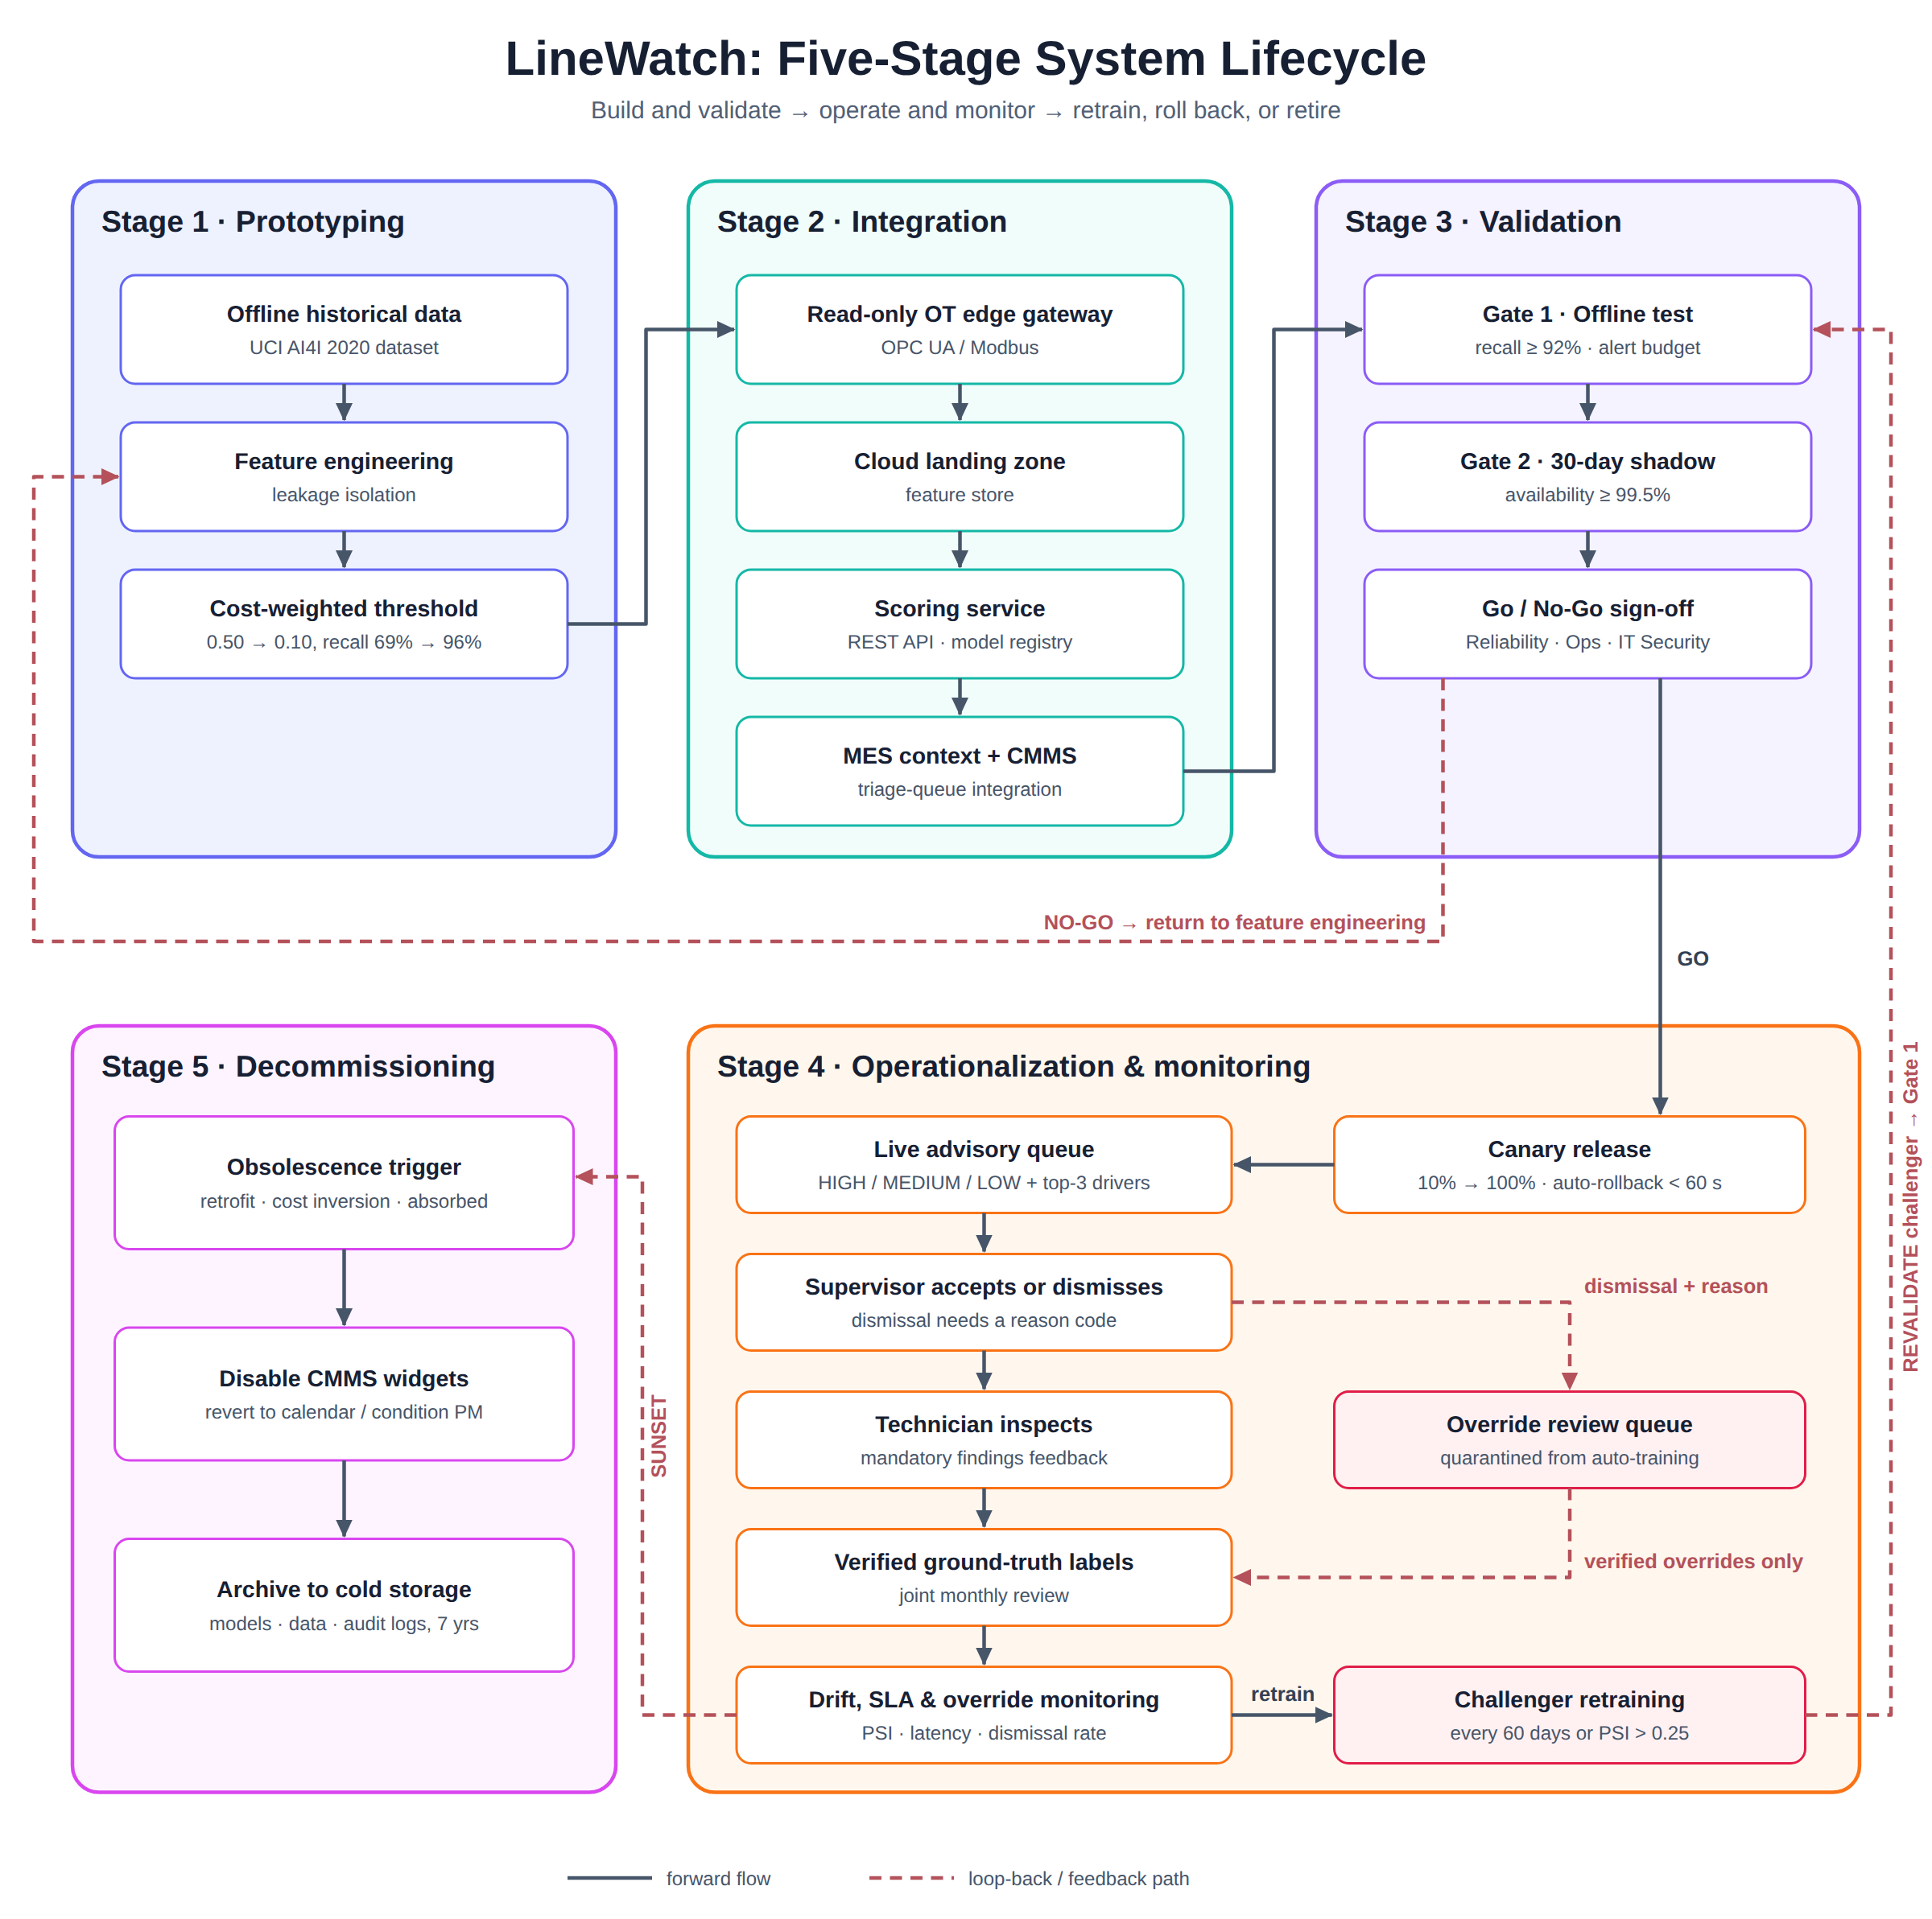
Figure 1. LineWatch five-stage lifecycle, showing forward flow (solid) and loop-back paths for no-go decisions, override review, retraining, and retirement (dashed).

Part 2: Human-Centric Design & Governance

2.1 User Interaction Analysis
What the user sees. Recommendations appear inside the existing CMMS, so no one has to learn a new tool. The supervisor’s triage queue pins HIGH assets to the top, each showing the asset ID, line, and shift; a predicted failure horizon (for example, “elevated risk of bearing seizure within 24–48 operating hours”); the top three contributing factors; and two buttons, Accept & create work order and Dismiss (reason required). Once a work order exists, the technician’s rugged tablet shows a task card with no probability figures: the subsystem to inspect (“Check spindle tool holder and collet assembly”), the physical symptoms to look for, and mandatory findings fields that must be completed to close the task.
Transparency. Every alert explains why in physical terms, using SHAP-based feature attributions translated into plain language rather than log-odds or z-scores (Huyen, 2022):
- “Torque: 58.4 Nm, 26% above the SKU-340 baseline.”
- “Spindle bearing: 8.2 °C above the cooling threshold.”
- “Tool wear: 214 cutting minutes, past the 190-minute regrind interval.”
Each card also shows data freshness and model version (“Evaluated 4 min ago · model v2.4-champion”). The standard we set: a user should be able to state what was flagged, why in physical terms, how current the data is, and what to check, without seeing a raw probability. Appendix A tests an AI system against this standard.
Accessibility: two user groups and their barriers.
Table 5. Accessibility barriers and design responses.
User group | Barrier | Design response
Floor technicians in PPE | High noise makes audio alerts useless; gloves make small touch targets unusable | Visual and vibration (haptic) alerts, minimum 48 px touch targets, hardware buttons mapped on rugged tablets, high-contrast cards
Supervisors with color-vision deficiency; contract crews with limited English | Red/amber/green priority coding is ambiguous; technical text is hard to follow | Shape + text encoding (octagon = HIGH, triangle = MEDIUM, circle = LOW) meeting WCAG 2.1 AA (W3C, 2018); language toggle and ISO 7000 maintenance symbols on task cards

2.2 Feedback Loops: Tracing One Override
Scenario. LineWatch flags CNC Spindle #04 as HIGH. The supervisor knows a tooling change is already scheduled and dismisses the alert. The signal travels as follows:
- The supervisor clicks Dismiss, and the CMMS requires a reason code: (a) planned tooling change within 12 h, (b) known sensor fault, (c) light-duty SKU running, or (d) model false alarm. Here the supervisor selects (a).
- The dismissal, supervisor ID, timestamp, reason code, and the model’s drivers at that moment are written to an immutable audit log.
- LineWatch suppresses repeat alerts on Spindle #04 for 24 hours to avoid nagging, unless the risk score rises further, in which case the alert is re-raised.
- The event enters the override review queue (Figure 1) and is quarantined from automated training.
- Outcome check: if Spindle #04 fails within 72 hours despite the dismissal, the event is automatically raised as a safety review. It counts as a correct model prediction and a missed human intervention.
- At the monthly joint review, Plant Operations and Reliability Engineering confirm what actually happened (in this case, the tooling change took place and the post-change readings were normal). Only these verified outcomes become training labels.
Does it change the system? Yes, but only through review. Verified overrides enter the next champion–challenger training set; repeated reason (b) on one asset opens a data-engineering ticket for that sensor; and repeated reason (c) prompts adding SKU duty level as a model feature. Dismissals never update the model directly, which prevents a biased or rushed override from teaching the model to ignore real risk.

2.3 Governance & Risk
The governance model follows the four functions of the NIST AI Risk Management Framework (NIST, 2023): govern (roles below), map (stakeholders, Part 3), measure (Stage 4 monitoring), and manage (mitigations and escalation). Version 1.1 below includes changes made after the AI red-team in Appendix A; they are marked ▲.
Table 6. Operational RACI for LineWatch oversight.
Activity | Maint. Supervisor | Floor Technician | Reliability Engineer | Data / ML Engineer | IT/OT Security
Gateway and tag-ingestion security | I | I | C | R | A
Go / no-go production approval | C | I | A | R | C
Daily queue triage | A / R | I | I | I | I
Work-order execution and sign-off | I | A / R | I | I | I
Drift and override audit review | C | I | A | R | I
Retraining promotion and canary release | I | I | A | R | C
Incident escalation and rollback | C | I | A | R | I

▲ Independent oversight. Because the Reliability Engineer is accountable for both approving releases and auditing them, a quarterly independent review by the Safety & Quality Lead samples overrides, deferred alerts, and missed failures. This separates the person who approves the model from the person who checks it.
Risk 1: Complacent dismissal under production pressure. During peak runs, supervisors may dismiss HIGH alerts to avoid stopping a machine, which can lead to spindle seizure, ejected tool fragments, or injury. Mitigation: dual-key dismissal. A HIGH alert showing a critical signature (for example, concurrent thermal runaway and high vibration) cannot be dismissed by one person; it needs a second sign-off from the Reliability Engineer. Off-shift, the on-call engineer is paged; if there is no response within 45 minutes, an inspection work order is created automatically and the Plant Operations Manager is informed.
Risk 2: Alert fatigue. A burst of false positives exhausts shift capacity, and technicians begin doing quick walk-bys instead of real inspections, eventually missing a genuine fault. Mitigation (v1.0): hard alert budget. At most three HIGH alerts per manufacturing cell per 8-hour shift (equal to 1.5 per technician for a two-technician cell); excess candidates are ranked by cost-risk and the rest demoted to MEDIUM.
▲ Revision (v1.1). The red-team showed that demotion hides risk from every other safeguard: a demoted alert is no longer HIGH, so it escapes dual-key sign-off and never appears in the dismissal rate. The budget now defers but never downgrades. Overflow alerts keep their HIGH rating with a HIGH-deferred status, are counted on the dashboard (Figure 2), and page the on-call Reliability Engineer. Critical-signature alerts are exempt from the budget entirely. Missed failures on LOW or MEDIUM assets are now monitored directly (Stage 4).
Escalation path if the system causes real harm (for example, a missed catastrophic failure or a recommendation that contributes to a safety incident):
- Hour 0–1, contain: the supervisor or Reliability Engineer switches off the CMMS integration; the plant reverts to manual LOTO-based inspection and calendar preventive maintenance. Open LineWatch-generated work orders are reviewed and re-confirmed by a supervisor.
- Hour 1–4, preserve evidence: Data Engineering freezes a forensic snapshot: 48 hours of telemetry, inference logs, model weights, and the override audit trail.
- Hour 4–24, investigate: a review board (Plant Operations Manager, Reliability Lead, Safety Officer, Lead Systems Engineer) performs root-cause analysis, separating sensor failure, data drift, model error, and procedural error. Reportable injuries follow the plant’s existing OSHA reporting process.
- Reactivation gate: requires an approved corrective plan, a repeat shadow validation, and written sign-off from the Plant Safety Director.

Part 3: Stakeholder Alignment & Visual Communication

3.1 Stakeholder Map
Table 7. Stakeholder needs, LineWatch offers, and distrust risks.
Stakeholder | What they need | What LineWatch offers | What would make them distrust it
Maintenance Supervisor | A manageable, credible daily queue that fits technician hours | Pre-sorted queue; fewer off-shift emergencies | False positives flooding the queue during peak production
Floor Technician | Clear, specific inspection cues and safe procedures | Named subsystem and physical symptoms; no pointless teardowns | "Black-box" alerts that send them to machines with nothing wrong
Reliability Engineer | Valid, auditable models and rising MTBF | Fleet-wide failure patterns; drift monitoring | Silent degradation, hidden leakage, or unexplained missed failures
IT/OT Security Officer | Network segmentation and no write path to PLCs | Read-only gateway in the DMZ; least-privilege access | Any bidirectional path that could let outsiders affect machinery
Safety & Quality Lead | Strict LOTO compliance; no quality escapes from worn tooling | Early warning of tool wear before tolerances drift | The system prompting unsafe troubleshooting or bypassing safety gates
Plant Operations Manager | Higher OEE and less unplanned downtime within budget | Measured downtime reduction; better spare-parts planning | Overtime costs rising from unnecessary AI-driven inspections

Alignment tension: the Supervisor and Operations Manager want fewer alerts, while the Safety Lead and Reliability Engineer want fewer missed failures. The alert budget with deferral (2.3, v1.1) is where these interests meet: capacity is protected, but no risk is hidden.

3.2 Diagrams
The lifecycle flow appears as Figure 1 (Section 1.4). Figure 2 sketches the monitoring dashboard used by Reliability Engineering and the governance board. It brings together the Stage 4 triggers, the human-interaction metrics from 2.2, and the v1.1 HIGH-deferred counter, and it uses shape and text as well as color, matching the accessibility commitments in 2.1.
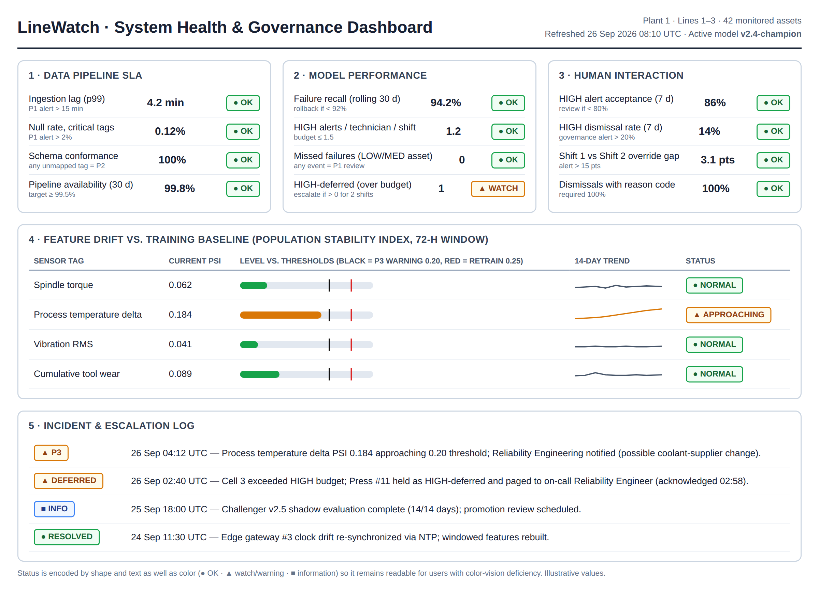
Figure 2. LineWatch system-health and governance dashboard (illustrative values).

Part 5: Synthesis & Self-Review
The hardest tension was between statistical optimization and floor capacity. A model tuned purely for recall keeps lowering its threshold to catch every marginal risk, but technician hours are fixed. Even a 15% rise in marginal alerts can overwhelm a maintenance team, build distrust, and, paradoxically, make it more likely that a real failure is dismissed. We resolved this by treating capacity as a hard requirement (NFR-1) and building a priority budget. The red-team then showed that our first version of that budget created a new blind spot, because demoting alerts made risk invisible. The lesson is that predictive maintenance is a human–machine coordination problem, and that governance rules need the same stress-testing as models.
With one more week, we would make override monitoring context-aware. Today it uses fixed 7-day thresholds. We would correlate dismissals with plant conditions such as end-of-quarter quotas, SKU changeovers, and crew experience. That would separate supervisors making sound calls with context the model lacks from supervisors under schedule pressure. We would also run a short FMEA on the governance process itself, since the v1.0 weakness came from how two controls interacted, not from either control alone.

References
- Anthropic. (2026). Claude (claude-opus-5-5) [Large language model]. https://claude.ai
- Huyen, C. (2022). Designing machine learning systems: An iterative process for production-ready applications. O’Reilly Media.
- International Organization for Standardization. (2015). ISO 9001:2015 Quality management systems — Requirements. ISO.
- International Organization for Standardization. (2024). ISO 55000:2024 Asset management — Vocabulary, overview and principles. ISO.
- International Society of Automation. (n.d.). ISA/IEC 62443 series of standards: Industrial automation and control systems security. ISA.
- Kossiakoff, A., Biemer, S. M., Seymour, S. J., & Flanigan, D. A. (2020). Systems engineering principles and practice (3rd ed.). Wiley.
- Matzka, S. (2020). AI4I 2020 predictive maintenance dataset [Data set]. UCI Machine Learning Repository. https://doi.org/10.24432/C5HS5C
- National Institute of Standards and Technology. (2023). Artificial intelligence risk management framework (AI RMF 1.0) (NIST AI 100-1). https://doi.org/10.6028/NIST.AI.100-1
- World Wide Web Consortium. (2018). Web content accessibility guidelines (WCAG) 2.1. https://www.w3.org/TR/WCAG21/

Appendix A: Agentic AI Stress-Test (Part 4)
AI system used: Claude (Anthropic), model claude-opus-5-5, accessed 26 September 2026 in a fresh session with no prior context. Prompts are reproduced exactly; responses are verbatim, with formatting simplified for print.

4.1 Role-Playing the System

Prompt 1
You are LineWatch, a deployed predictive-maintenance decision-support system in a discrete-manufacturing plant. LineWatch reads telemetry from CNC spindles, stamping presses and transfer lines (process temperature, rotational speed, torque, cumulative tool wear) every five minutes, estimates each asset’s probability of mechanical failure, and places it in a HIGH / MEDIUM / LOW inspection queue inside the plant’s CMMS. It is advisory only: a maintenance supervisor must accept or dismiss each recommendation, and it never writes commands back to machines.
Current data for CNC Milling Spindle #04, Line 2 (Shift 1, data evaluated 4 minutes ago, model v2.4-champion): spindle torque 58.4 Nm (nominal baseline for SKU-340 is 46.3 Nm); spindle bearing temperature 8.2 °C above the cooling threshold; cumulative tool wear 214 cutting minutes against a recommended 190-minute regrind interval; rotational speed within normal range. Model failure probability: 0.41 (HIGH threshold is 0.10).
Produce the decision notification that LineWatch would display to the maintenance supervisor, including a plain-language explanation of why the decision was reached, how current the data is, and the recommended next actions.

Response 1 (Claude)
LINEWATCH: INSPECTION RECOMMENDATION (ADVISORY)
Asset: CNC Milling Spindle #04, Line 2 · Queue: HIGH (supervisor decision required) · Estimated failure probability: 0.41 (HIGH threshold is 0.10) · Model: v2.4-champion
Data freshness: Evaluated 4 minutes ago, Shift 1. Telemetry updates every 5 minutes. Check that the next reading has arrived before you act on this.
Why this was flagged. Three readings are outside their normal range at the same time: (1) Spindle torque is 58.4 Nm, about 26% above the SKU-340 baseline of 46.3 Nm. The spindle is working harder than it should to make the same cut. (2) Bearing temperature is 8.2 °C above the cooling threshold. This can mean extra friction, poor lubrication or a cooling problem. (3) Tool wear is 214 cutting minutes, which is 24 minutes (about 13%) past the recommended 190-minute regrind interval. Rotational speed is normal.
Together these readings fit a worn tool that is putting extra load and heat on the spindle. They could also point to a developing bearing problem. The model can’t tell these causes apart. The 0.41 is a statistical estimate, not a diagnosis, and it doesn’t confirm that failure is imminent.
Recommended next actions. (1) Review within this shift. The combined heat and torque readings don’t support running until the end of the shift without a look. (2) Consider pausing the spindle at a safe point while it’s inspected, following standard LOTO procedure. (3) Change or regrind the cutting tool. It is past its interval regardless of the model’s score. (4) Check the bearing and cooling system: coolant flow, lubrication, and any abnormal noise or play. (5) Re-check torque and temperature after the tool change. If they stay high, escalate to Reliability Engineering as a possible bearing fault.
Limitations. The model has no vibration data for this asset. The probability depends on the model being well calibrated for this SKU and machine. The readings could come from a faulty sensor. If they don’t match what you see on the machine, report a possible sensor fault.
[Accept → create work order] [Dismiss → reason required]

Our evaluation against the Section 2.1 transparency standard
Where it met the standard. The response answered all four of our questions. It named what was flagged, explained each driver in physical terms with its baseline, reported data freshness and model version, and pointed to specific subsystems to check. It went further than our own design by stating its limitations: the model cannot tell tool wear from a bearing fault, and a faulty sensor could explain the readings. We have adopted a one-line “what this alert cannot tell you” field for HIGH cards.
Where it fell short. (1) It displayed the raw probability (0.41) next to the 0.10 threshold, which our standard avoids. A supervisor may read “41%” as a coin flip and wonder why it is HIGH, since the explanation never says that a low threshold is intentional given the cost of a missed failure. (2) It gave no failure horizon (for example, 24–48 hours), which 2.1 requires for triage. (3) It drifted from advisory to prescriptive: “change or regrind the cutting tool” is a maintenance decision, not an inspection cue, although it correctly deferred to LOTO. (4) It stated something untrue about the system: “the model has no vibration data.” Our prompt did not mention vibration, and the AI filled the gap with a confident assumption; the real design ingests vibration RMS. (5) At roughly 300 words it is too long for a glanceable CMMS card. Our design needs a two-line summary with the detail expandable.

4.2 Red-Teaming the Governance Model

Prompt 2
Review the following governance and oversight model for LineWatch, an advisory industrial AI predictive-maintenance system. What’s the weakest part of this oversight model? What failure mode could still slip through?
GOVERNANCE MODEL. Oversight (RACI): Reliability Engineer is Accountable for go/no-go production approval, drift and override audit review, model retraining promotion and canary release, and incident escalation/rollback; Data/ML Engineer is Responsible for those activities. The IT/OT Security Officer is Accountable for sensor-tag ingestion and gateway security. The Maintenance Supervisor is Accountable/Responsible for day-to-day triage of the inspection queue; the Floor Technician is Accountable/Responsible for executing and signing off physical work orders.
Risk 1 – Complacent dismissal of HIGH alerts under production pressure, leading to catastrophic spindle failure or injury. Mitigation: dual-key escalation — a HIGH alert with extreme concurrent readings (e.g., thermal runaway plus high vibration) cannot be dismissed by one supervisor; dismissal needs a second digital sign-off from the on-duty Reliability Engineer, otherwise an automated inspection request escalates to the Plant Operations Manager within two hours.
Risk 2 – Alert fatigue causing technicians to perform perfunctory inspections. Mitigation: a hard capacity budget of at most 3 HIGH alerts per manufacturing cell per 8-hour shift; excess candidates are ranked by cost-risk exposure and borderline ones are demoted to MEDIUM.
Monitoring: a governance alert fires if the 7-day rolling dismissal rate of HIGH alerts exceeds 20% or if Shift 1 vs Shift 2 override rates differ by more than 15 percentage points.
Escalation path if harm occurs: Hour 0–1 the supervisor or reliability engineer disables the CMMS integration and the plant reverts to calendar and manual LOTO-based maintenance; Hour 1–4 data engineering freezes a forensic snapshot (48 h telemetry, inference logs, model weights, override audit trail); Hour 4–24 a review board (Plant Operations Manager, Reliability Lead, Safety Officer, Lead Systems Engineer) performs root-cause analysis; reactivation requires an approved mitigation plan, shadow-mode revalidation and written sign-off from the Plant Safety Director.

Response 2 (Claude)
The weakest part is the Risk 2 capacity cap. It can demote a genuine HIGH alert to MEDIUM, and a demoted alert is invisible to every other safeguard in the model.
Here is how the pieces combine: The dual-key rule doesn’t apply. It only covers dismissals of HIGH alerts, and a demoted alert is no longer HIGH. The dismissal-rate monitor doesn’t see it. It measures dismissals of HIGH alerts. Demotion isn’t a dismissal, so the metric stays clean. No human chose to take the risk. The system hid the alert before any supervisor saw it as urgent, so there is no override to audit.
Failure mode that slips through: During a bad shift, a cell has five spindles with real HIGH-level risk. The cap keeps three and ranks the other two by “cost-risk exposure,” which is an economic score and not a safety score. A spindle with a real bearing fault gets demoted to MEDIUM and waits in the queue. It fails, possibly injuring someone. The dashboards showed low dismissal rates and no governance alerts. The cap hides risk exactly when risk is concentrated, which is when you most need to see it.
Fix: Keep the cap for workload planning, but never let it lower a safety rating. Mark overflow alerts as “HIGH – deferred.” Log and count those deferrals, and have them trigger the same escalation path as dismissals.
Other weaknesses worth noting: (1) The dual-key trigger uses “high vibration,” but the stated telemetry has no vibration channel. As written, the trigger may never fire, or it depends on a signal the system doesn’t collect. (2) The Reliability Engineer audits their own decisions. They approve go/no-go, retraining promotion and releases, and also review drift and overrides. No one independent checks their work before harm happens. (3) Missed failures and stale data aren’t monitored. Nothing detects failures the model never flagged, silent sensor dropouts, or stuck values that keep feeding outdated readings to the model. All the monitoring is built around overrides, not around what the model misses. (4) The Hour 0–1 kill switch relies on someone noticing the harm and connecting it to LineWatch. There is no automatic tripwire, and the rollback plan says nothing about backlogged work orders.

Top critique and our response
Top critique: the alert budget silently demotes real HIGH risks, so they escape dual-key sign-off and never appear in the dismissal metrics.
Our response: We agree. This was a genuine blind spot: we had designed each control correctly in isolation but never checked how they interacted. In v1.1 the budget defers but never downgrades, “HIGH-deferred” alerts are counted and escalated, and critical signatures are exempt from the cap. We also accepted the points on self-audit (a quarterly independent review was added) and on missed-failure monitoring (a new Stage 4 trigger). The vibration point reflected our prompt rather than the design, because vibration RMS is ingested at Stage 2, but it showed that the dual-key rule must name its exact sensor tags.

4.3 Reflection on the AI’s Own Behavior
The AI showed the same issues we analyze in LineWatch. In both responses it filled missing context with confident assumptions: it claimed there was no vibration data because our prompts did not mention it. An operator reading that fluent output would have no cue that it was guessing, which is exactly the automation-bias risk we designed against. Its explanations were transparent about uncertainty, but the quality of its critique depended entirely on what we chose to paste in, so a human still has to own the oversight of the AI’s output, just as supervisors own LineWatch’s.

