ISEM 505 Project 1
Designing an Intelligent System Framework with AI Tool Exploration

“LineWatch”

An AI-Enabled Predictive Maintenance
Intelligent System Framework
Prepared by: Oghenegare Aganbi & Dinesh Pratap Singh
Harrisburg University
September 15, 2026

Project scope.
  - This report develops a no-code, teaching-scale framework for an intelligent predictive-maintenance system for a discrete manufacturing line. It integrates systems engineering, data/ML engineering, lean maintenance operations, human decision-making, and AI-tool exploration, including an executed Colab evaluation that changed the threshold and KPI design.

Introduction: Problem, Significance, and System Vision

When a CNC spindle, conveyor, pump, or press fails without warning, the plant loses more than a machine: throughput, scrap, overtime, and ship dates all move. Calendar-based PM still sends technicians to healthy assets; run-to-fail waits until the line is down. LineWatch addresses that problem and the contextual factors that decide whether AI help is usable: inspect capacity, OT segmentation, lockout/tagout and human authority, rare-event economics, technician-note privacy, and change-management risk if scores appear without trust.
LineWatch is an advisory ranking system. It uses condition signals and maintenance history to estimate failure risk, order inspections, and show why a cycle landed in HIGH, MEDIUM, or LOW. We are not writing to the PLC. A supervisor or technician still decides what gets worked.
A fixed rule such as “inspect after 200 minutes of tool wear” is easy to explain and still misses combined modes, high torque with heat, overstrain, rare random stops. That is why we put a classifier in the middle of the design. It ranks risk. Engineering limits and lockout/tagout stay in charge.
The boundary is wider than a model file. Sensors and PLCs, an edge gateway, historian and CMMS data, a feature layer, a scoring service, the CMMS screen, and the people who accept or dismiss a HIGH flag all sit inside it. Change one interface, for example auto-creating a work order with no human gate, and you have changed labor practice, not only software.

1.1 Need Statement and Objectives
Need statement. While the machine is running, LineWatch should produce a ranked inspection list that catches more failures without overflowing the plant’s inspect capacity. That sentence is the requirement. The rest of the report is how we would meet it.
- Detect elevated failure risk early enough for useful maintenance action.
- Prioritize limited technician time using risk and operational cost rather than raw probability alone.
- Provide understandable evidence behind each recommendation.
- Maintain a human approval gate for maintenance actions and preserve existing safety procedures.
- Learn from validated inspection outcomes while preventing uncontrolled automatic retraining.

1.2 Stakeholders and Success Measures
Stakeholder | Primary concern | Representative success measure
Maintenance supervisor | Useful, manageable inspection queue | HIGH-priority items acted on within agreed response time
Technicians | Trustworthy and explainable recommendations | Low unnecessary-inspection burden
Reliability engineering | Model validity and lifecycle control | Failure recall, false-inspect hours, drift indicators
IT/OT security | Network segmentation and least privilege | No unauthorized PLC write path
Safety / quality | No unsafe automation or quality degradation | Human-gated decisions and auditable actions
Plant management | Downtime and cost performance | Reduced unplanned downtime without excessive maintenance cost

2. Systems Engineering Approach and System Architecture
We started with stakeholders and a hard boundary, then split the system into plant, data, scoring, and work-management layers. Interfaces and trade-offs come before algorithm choice. The model is one service in Figure 1. It is not the whole system.
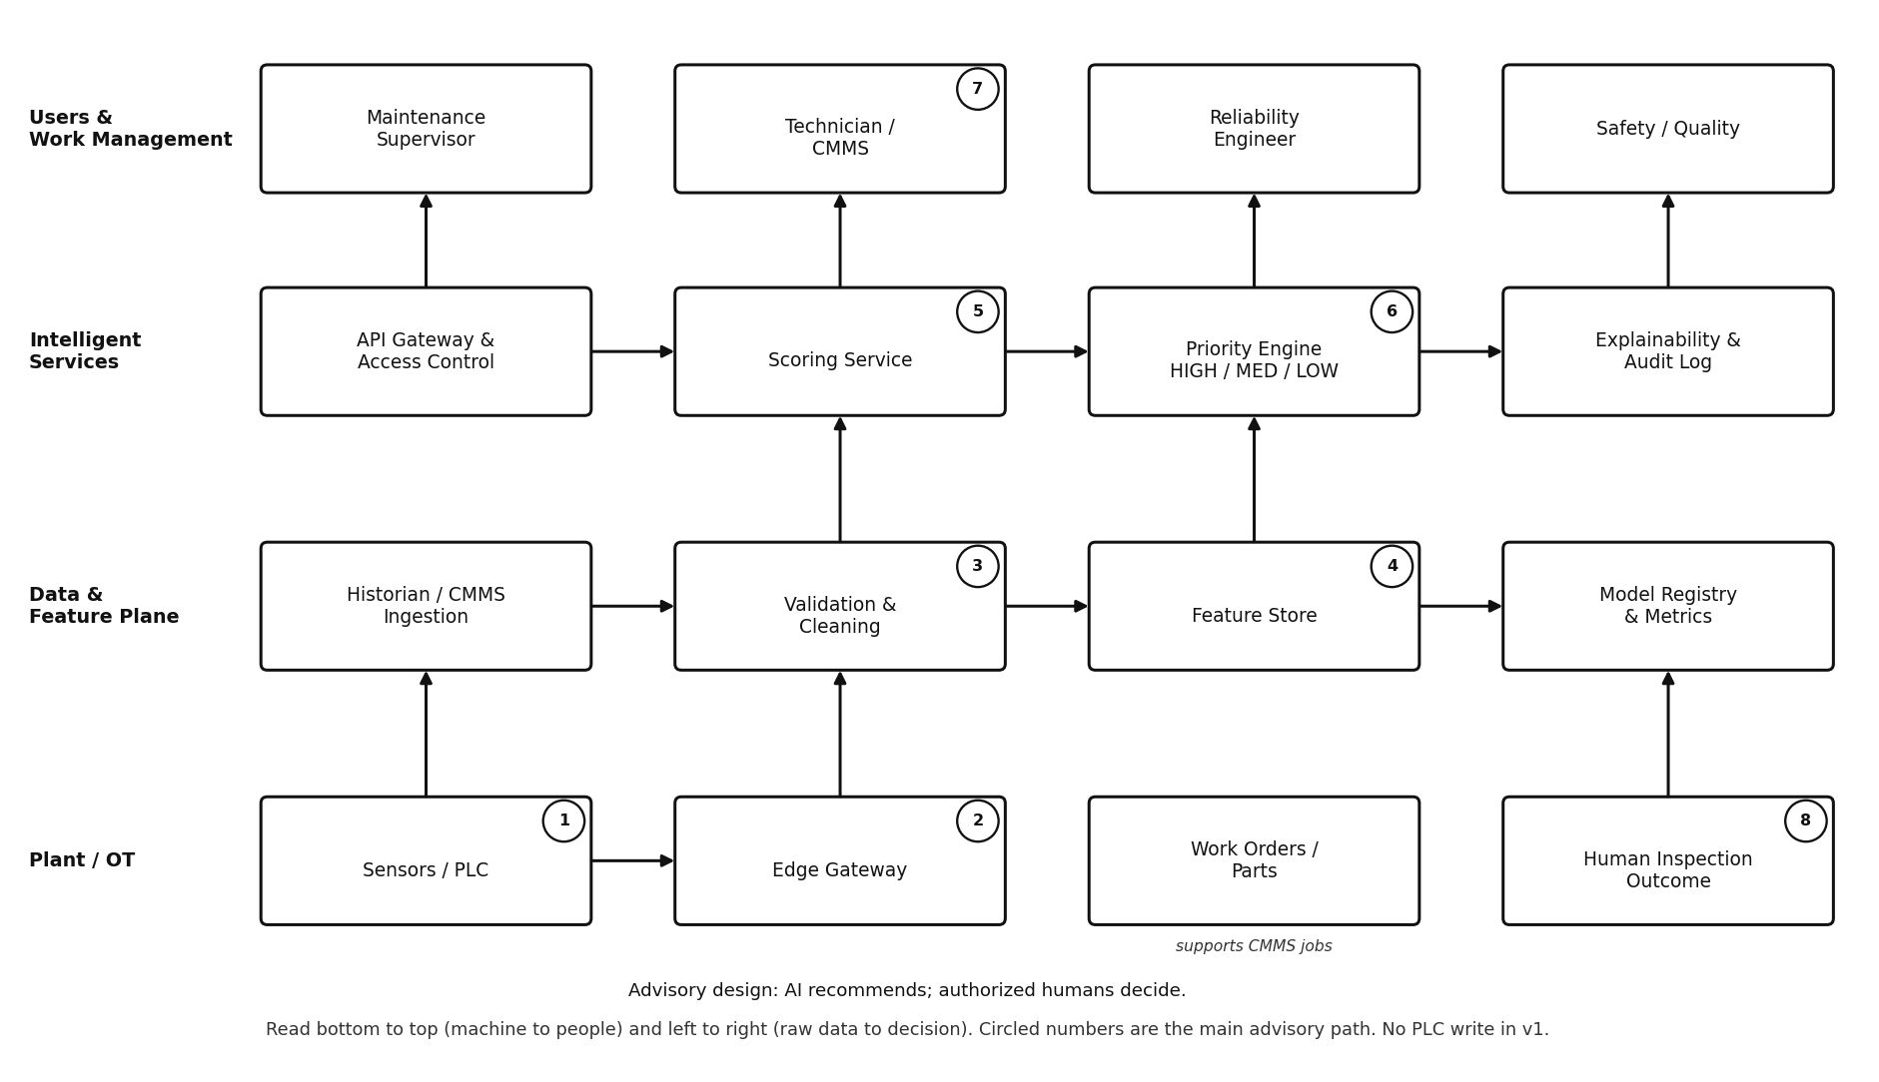
Figure 1. LineWatch system architecture overview.
This is one system drawn as four layers, not four separate tools. Start at the bottom (Plant / OT). Sensors and the edge gateway collect signals while the machine is still running. Those signals move up into the Data & Feature Plane, where historian and CMMS records are ingested, cleaned, stored as features, and tied to a versioned model. Intelligent Services then turn those features into a failure score, a HIGH / MEDIUM / LOW priority, and an explanation in the audit log. The top layer is people: the technician sees the recommendation in the CMMS, the supervisor owns the inspection queue, the reliability engineer owns the model, and safety/quality reviews policy. Circled numbers mark the main advisory path from a live sensor reading (1) to an inspection outcome that can later improve the model (8). Work orders and parts stay on the plant layer because they support jobs; they do not write commands back to the PLC. Version 1 is advisory: the AI recommends, and authorized humans decide.
Operational design integrates three methodologies and multiple data sources. Systems engineering (Kossiakoff life cycle/Vee) structures need → requirements → architecture → verification → operations → retirement. ML systems engineering (Huyen) separates train/serve, blocks leakage, monitors drift, and gates promotion. Lean/TPM protects technician capacity and cuts unplanned downtime rather than chasing accuracy. Historian, CMMS, MES/quality, and validated technician outcomes feed one efficiency target for a pilot cell: about 20–35% fewer unnecessary inspections while holding or improving failure recall, scaled line→cell→plant only after KPI gates.

2.1 Functional and Non-Functional Requirements
ID | Requirement | Verification approach
FR-1 | Ingest selected machine-condition and process tags from read-only OT sources within 5 minutes. | Interface/acceptance test
FR-2 | Generate a failure-risk probability and HIGH/MEDIUM/LOW priority tier for each scored unit. | Interface/acceptance test
FR-3 | Display the principal factors contributing to a recommendation. | Interface/acceptance test
FR-4 | Allow authorized supervisors to accept or dismiss an advisory recommendation. | Interface/acceptance test
FR-5 | Capture inspection outcome and maintenance action for feedback and model evaluation. | Interface/acceptance test
NFR-1 | No direct PLC write or autonomous machine stop in version 1. | Architecture/operations review
NFR-2 | Scoring lag should not exceed 15 minutes for the initial batch design. | Architecture/operations review
NFR-3 | Access shall use role-based permissions and least privilege. | Architecture/operations review
NFR-4 | Scores, model version, inputs, and human decisions shall be auditable. | Architecture/operations review
NFR-5 | The design shall support rollback to a previously approved model. | Architecture/operations review

2.2 Design Constraints and Trade-offs
The constraints that actually drove the drawing are OT security, limited technician hours, messy labels, rare failures, budget, and lockout/tagout. Random Forest versus boosting is a smaller decision than those. If the model flags 30 percent of cycles, the board is unusable, so the threshold is an inspect-capacity choice, not a default of 0.50. Trade-offs are recorded in the decision table and traced to FR/NFR IDs so every architecture choice maps back to a stated requirement (for example, human advisory → NFR-1; batch lag ≤15 minutes → NFR-2; rollback → NFR-5).
Decision | Option A | Option B | Design choice / rationale
Cloud vs. edge scoring | Simpler management and audit | Lower latency and WAN dependence | Begin with cloud/hybrid batch; consider edge after operational evidence
Automation level | Autonomous action | Human advisory | Human advisory in v1 to reduce safety and organizational risk
Threshold | High threshold, fewer inspections | Low threshold, higher failure recall | Set from failure cost and technician capacity, not default 0.50
Model complexity | Deep learning | Tree-based ensemble | Tree ensemble first; deep learning only if richer vibration/audio data justify it

3. Data Engineering and AI Components
The pipeline has to keep “what we knew while the machine was running” apart from “what someone typed after the teardown.” If those mix, the model looks brilliant in training and useless on a live cycle. Train and score have to use the same cleaning rules.
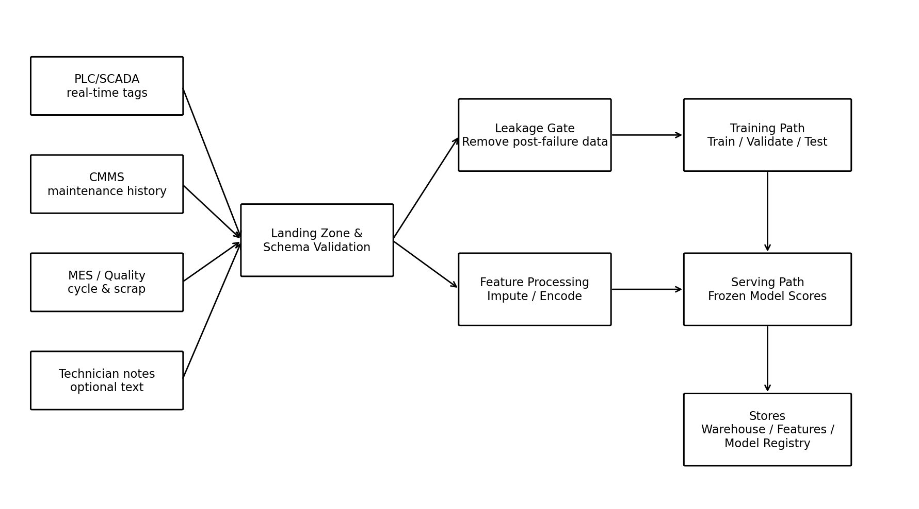
Figure 2. Data processing pipeline.

3.1 Data Sources
Source | Type | Examples | Cadence
PLC / SCADA / historian | Structured | Temperature, speed, torque, vibration, tool wear, machine state | Seconds to minutes
CMMS | Structured + text | Work orders, failure codes, parts, maintenance history | Batch / event
MES / quality | Structured | Cycle count, product type, scrap, quality result | Cycle / batch
Technician input | User-generated, potentially unstructured | Inspection outcome and optional notes | After inspection

3.2 Model Selection and Evaluation
Version 1 is a yes/no failure label on a cycle or asset, with a time horizon the reliability engineer names in advance. We would start with class-weighted Random Forest or gradient-boosted trees on tabular tags, and keep logistic regression as a baseline we can explain. Deep learning waits until the plant actually has dense vibration or audio, not because it sounds more advanced.
Accuracy is a weak headline. We executed a Google Colab check on UCI AI4I 2020 and iterated from the data: always-healthy scored ~96.6% accuracy with 0% recall; a class-weighted tree at threshold 0.50 reached ~69% recall; after pricing misses above wasted inspects and moving to 0.10, recall rose to ~96% with unchanged ROC-AUC. Reflection: default 0.50 + accuracy KPI would fail the plant. The design therefore tracks recall, false-inspect hours, and cost, and freezes the cutoff on validation before any board display.

3.3 Infrastructure
OT tags stay in the historian and leave through a read-only gateway. Cleaned cycles, features, model files, and the audit log live in a cloud or on-prem platform. v1 scoring is a batch job every 5 to 15 minutes. If that delay is later shown to miss failures, we would move a frozen approved model onto an industrial PC at the gateway: target 2 to 5 second local scores, about 40 percent less tag-stream egress, roughly $4k to $6k one-time packaging cost. Rollback is a feature flag. If the edge box fails health checks, scoring returns to the cloud job on the next cycle.

3.4 Feedback Loop and Continual Learning
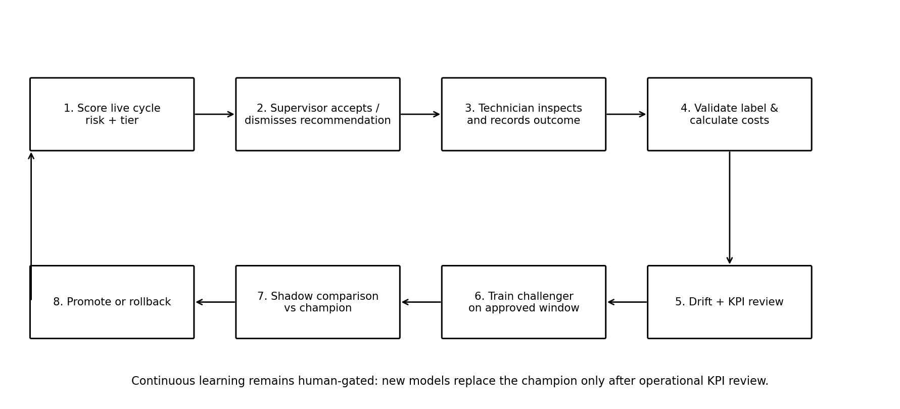
Figure 3. Human-gated feedback and continual-learning loop.
Inspection outcomes become candidate labels only after validation. Challengers train in a controlled window and run in shadow against the champion; promotion requires the KPI gates in Table 7. Freshness, score volume, HIGH-queue age, and drift are reviewed weekly in shadow and daily in advisory. Gate failure triggers rollback to the last approved model (NFR-5).

4. AI Tool Exploration and Contribution to the Design
The prompt asked us to use at least one free AI tool. We used ChatGPT (GPT Astra) to stress-test the stakeholder list and the no-PLC-write rule, diagrams.net for the four figures, and Google Colab on the dataset (UCI AI4I 2020) to see how a rare-failure table behaves. ChatGPT did not get to pick the architecture. We did.
Tool | Purpose | Example use in this project | Design contribution
ChatGPT | Brainstorming and systems-design critique | Generate stakeholder questions, failure scenarios, candidate requirements, trade-offs, and ethical risks | Helped expose the need for a human gate, leakage controls, explainability, and lifecycle governance
diagrams.net (draw.io) | Visual modeling | Recreate the architecture, data pipeline, feedback-loop, and system-lifecycle views | Made subsystem boundaries, interfaces, and lifecycle stages explicit
Google Colab (optional exploration) | ML sandbox / evaluation | Explore the UCI AI4I 2020 dataset and compare simple classifiers | Demonstrates why class imbalance, leakage, threshold choice, and train/test separation matter

4.1 Example AI-Assisted Design Exploration
Example prompt used for brainstorming: “Design an advisory predictive-maintenance system for a discrete manufacturing line. Identify stakeholders, system boundaries, sensor and maintenance data, failure modes, safety constraints, AI/ML components, human decision points, cybersecurity risks, and a feedback loop. Do not assume the AI may directly control the PLC.”
Astra kept offering a closed-loop controller; we cut that and kept prediction-time/post-failure separation plus a human gate before work orders. Dinesh owned the Colab threshold evidence the team adopted; Oghenegare owned requirements tables and diagrams.net redraws for Figures 1–3. Each then improved the other’s work before submit: Dinesh aligned FR/NFR text to Colab evidence; Oghenegare forced the no-PLC-write and human-gate path to be unambiguous in the architecture figure; both co-edited to remove automation overclaim.

5. Implementation Considerations
We would not go live on day one. The plan is dated, owned, and dependency-tracked. Days 1–30: prediction moment, tag inventory, failure label, read-only historian access, security review (exit: approved requirements + usable history). Days 31–60: shadow scoring only (exit: stable pipeline + baseline KPIs). Days 61–90: HIGH items on the board with accept/dismiss (exit: useful within inspect capacity). Auto work orders stay off until KPIs hold for a quarter. Critical-path dependencies: CMMS API before advisory; SSO/RBAC before tablet scores; security sign-off before OT gateway; labeled outcomes before challenger training.
Figure 4 places that same rollout inside a full systems-engineering lifecycle: offline prototyping on historical data, read-only OT integration, shadow validation, monitored operations with human-gated feedback, and controlled decommissioning or retirement when the model no longer earns its keep.
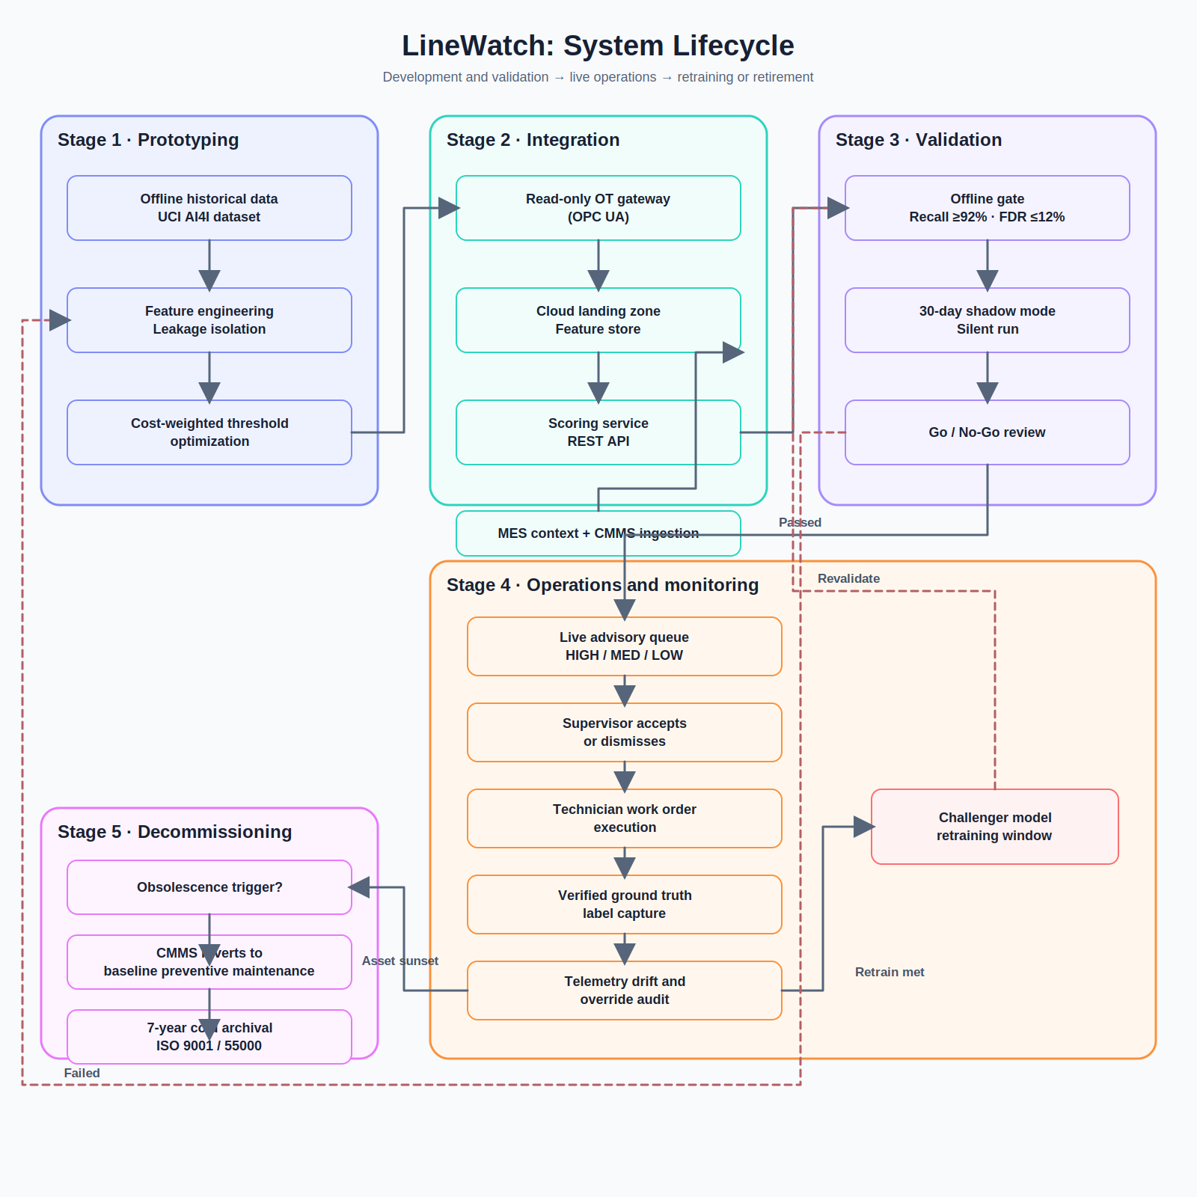
Figure 4. LineWatch system lifecycle.
Phase | Approx. period | Main activities | Exit evidence
1. Need & data | Days 1–30 | Define prediction horizon, inventory tags, validate labels, security and data-use review | Approved requirements and usable historical dataset
2. Shadow mode | Days 31–60 | Score silently, compare with actual maintenance events, tune thresholds | Stable data pipeline and baseline KPI evidence
3. Advisory mode | Days 61–90 | Show ranked inspections with human acceptance/dismissal | Operational usefulness within technician capacity
4. Controlled scale-up | After KPI review | Expand assets; consider edge scoring or CMMS automation | Change-control approval and rollback plan

5.1 Governance and Responsibility
Coordination uses an explicit RACI (Table 6): maintenance supervisor Accountable for which HIGH items are worked; technicians Responsible for outcomes; reliability Accountable for training/threshold/promotion; data engineering Responsible for freshness/schema; IT/OT security Accountable for air gap / no PLC write; safety/quality Consulted before stop-the-line policy; plant manager Informed on downtime and inspect-hours. Vacant A/R blocks promotion. Dependencies map to Day 30/60/90 exits.
Table 6. RACI for LineWatch delivery and operations (R = Responsible, A = Accountable, C = Consulted, I = Informed).
Activity | Maint. supervisor | Technician | Reliability eng. | Data eng. | IT/OT security | Safety/quality | Plant mgr
Approve OT read-only access | C | I | C | C | A/R | C | I
Define failure label & horizon | C | C | A/R | C | I | C | I
Build/score features & model | I | I | A | R | C | I | I
Set/inspect threshold | C | I | A/R | C | I | C | I
Accept/dismiss HIGH item | A/R | C | I | I | I | C | I
Record inspection outcome | C | R | A | C | I | I | I
Promote challenger model | C | I | A/R | C | C | C | I
Rollback / stop advisory | C | I | A | R | C | C | I
Table 7. KPI plan with baseline, target, monitoring, and reflection trigger (executed teaching baseline from Colab; plant targets for pilot).
KPI | Baseline (teaching/pilot start) | Target (Day 90 advisory) | Monitor | Reflection / action if off-target
Failure recall (on labeled set) | ~69% @ thr 0.50 (Colab) | ≥90% @ cost-weighted threshold | Weekly in shadow; daily in advisory | Retune threshold; check leakage; delay promotion
False-inspect rate / hours | Unprioritized PM load (high) | 20–35% reduction vs unprioritized inspects | Weekly queue review | Raise threshold or improve features; protect capacity
HIGH-item age on board | N/A before advisory | Median age within agreed response window | Daily board | Supervisor capacity or alert routing fix
Data freshness (tag→score) | Unknown / batch unset | ≤15 min (NFR-2) | Pipeline health check | Page data eng; fail over / rollback
Human gate compliance | N/A | 100% HIGH items accepted or dismissed (no silent auto WO) | Audit log | Disable automation; retrain users
Model rollback readiness | No prior model | Last approved model restorable <1 hour | Change-control drill | Block promotion until drill passes
We worked as a pair with named owners and shared quality gates. After locking the problem, success measures, and no-PLC-write boundary, Dinesh delivered architecture narrative, Colab experiment, and lifecycle figure integration; Oghenegare delivered stakeholder/requirements/trade-off tables and Figures 1–3 cleanup. Both finished on the internal deadline and proactively raised the other’s sections (peer critique of leakage wording, redraw notes, Colab-to-requirement traceability) until the package was submission-ready.

6. Challenges and Ethical Considerations
Data quality and rare failures need explicit labels, lineage, and review because near misses are underreported and successful maintenance can remove the failure the model is trying to learn. Leakage and drift: post-failure codes never enter prediction features; product, tooling, season, and policy changes require drift monitoring. Safety and authority: false negatives risk damage; false positives waste labor — v1 stays advisory under lockout/tagout. Privacy: optional technician free text is purpose-limited, access-controlled, and excluded from features unless reviewed. Trust: show factors, freshness, model version, and confidence — not only HIGH/LOW. Equity: check performance across product families, shifts, and cells so one area is not systematically over-inspected. Cyber and lock-in: do not weaken OT segmentation; keep models, features, and audit data exportable for migration.

7. Conclusion
LineWatch is a ranked inspection service with a human gate, not a model sitting by itself. The need, the layers, the data rules, and the feedback loop are the design. The classifier is how we rank. Supervisors and technicians still decide.
In a real plant we would start with one line, read-only data, and shadow scores beside the existing board; monitor Table 7 weekly; iterate threshold/features only through the challenger gate; and expand only after the supervisor confirms the HIGH list is usable and RACI owners sign the Day-90 exit.

References
- UCI Machine Learning Repository. AI4I 2020 Predictive Maintenance Dataset. https://archive.ics.uci.edu/dataset/601/ai4i+2020+predictive+maintenance+dataset
- Kossiakoff, A., Seymour, S. J., Flanigan, D. A., & Biemer, S. M. (2020). Systems engineering principles and practice (3rd ed.). Wiley. Chapters 1-3 (needs, structure, life cycle).
- Huyen, C. (2022). Designing machine learning systems. O’Reilly. Chapters 1-3 and 9 (ML systems vs models, data engineering, continual learning / test in production).
- OpenAI. ChatGPT. AI-assisted brainstorming and design exploration used for this project.
- diagrams.net (draw.io). Visual modeling tool for system architecture, data pipeline, feedback-loop, and system-lifecycle diagrams.
- Google Colab. Optional cloud notebook environment for exploratory ML evaluation.

