Installing ServiceDesk plus on Docker:**19.03.8:**

Host OS : **Windows 10**

Container : **CentOS:7**

Please find the step by step procedure to install SDP on a Docker , for illustration we have used CentOS image on Docker.

However, the steps below are applicable for other Linux distributions like Ubuntu, Fedora and Debian. etc.

Download ServiceDeskplus .bin for linux on the host machine ( Windows) .

Create a folder “SDP” and move the .bin file here, this will help to share the folder with the docker container.

Once Docker is installed and running,

**Step 1 : Open command prompt or Powershell and install Centos:7**

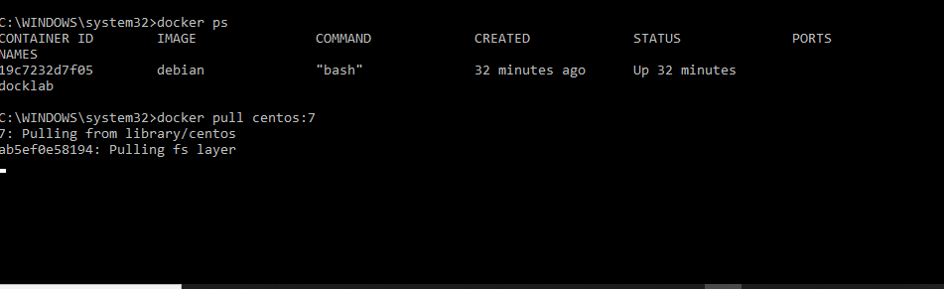

Command to install centos on this container : docker pull centos:7

This will pull an image of the centos7 from Docker Hub and create the container required to host applications on this Centos.

**Step 2 : Give a name to this container and start the container**

**docker run -it —name sdp -p 8085:8080 -v d:\sdp:/root/sdp centos:7 bin/bash**

docker run -it Starts and runs the container

-name Specifies a Name to this container (This will be helpful to start/stop the container easily)

-p 8085 Specifies the Port number on which this ServiceDesk plus application can be accessed after installation . Ex : http://localhost:8085

d:\sdp Specfies the folder on Host where the .bin file is located ( To move this to CentOs on Docker)

/root/sdp centos:7 Specifies the directory on Centos to install SDP



Step 3 : Navigate to **/root/sdp inside the CentOs container**

: Enter ls to find the bin file for installation

**:**Giveit permission for execution with ‘chmod +x’

run the command ./ManageEngine_ServiceDesk_Plus_64bits.bin --console

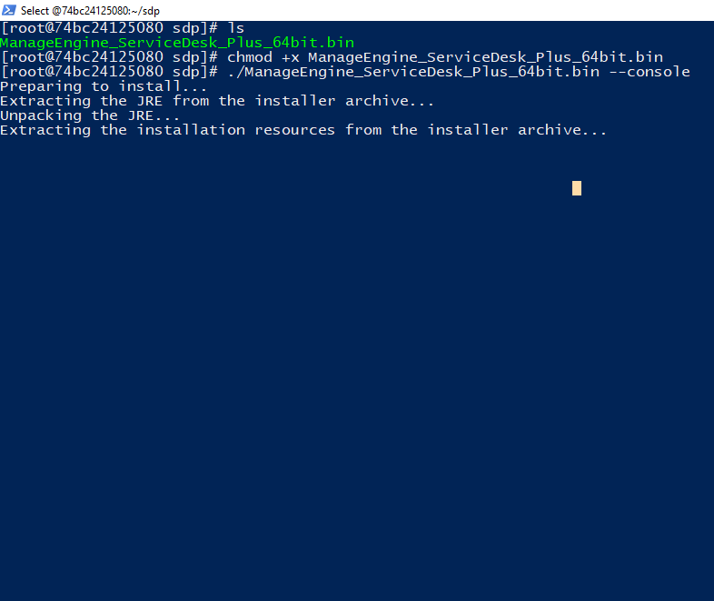

From this stage, the installation steps remains the same as how we normally install SDP on linux as mentioned : <https://help.servicedeskplus.com/introduction/installation-linux.html>

You might see this error on final stage of installation

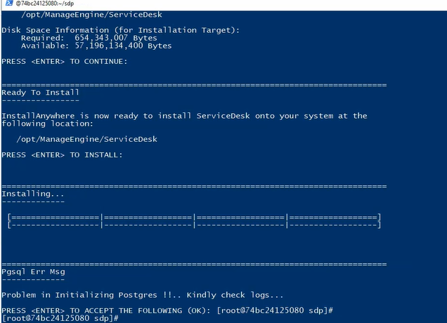

Hit ENTER to proceed and ignore this error.

**Step 4: Start ServiceDesk plus:**

Command ./run.sh

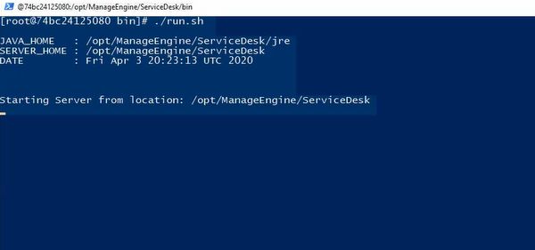

**Step 5 : Configuring ServiceDesk plus as a Service**

create a file inside /etc/init.d/

Command :**$ touch /etc/init.d/servicedesk**

* give permission for execution

Command :**chmod 755 /etc/init.d/servicedesk**

Access the startup script from : <https://help.servicedeskplus.com/servicedesk.txt>

open the file with your text editor, nano, emacs, vim, etc…

copy the contents and paste it on the newly created file

**$ nano /etc/init.d/servicedesk**

* change this line
  + MDIR=/home/guest/servicedesk/AdventNet/ME/ServiceDesk/bin
* to
  + MDIR=/opt/ManageEngine/ServiceDesk/bin

after that save the file

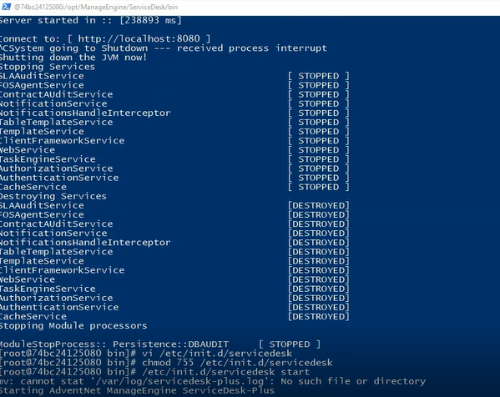

**Now you can start Servicedesk plus using the command : $ /etc/init.d/servicedesk start**

**Note :**

To exit the container without stopping it - use : Ctlr + p and q

Do not use Control D or the command #exit since this will stop the container

**Few commands:**

**To start a container**

**docker start <containername>**

**To login to the container**

**docker attach <container_name>**

**To stop the container**

$ docker <container_name> or <container_id> stop

**To remove a container**

$ docker rm <container_name> or <container_id>