**[1] PROBLEM DEFINITION**(It is just an example with sample data)

|  |  |
| --- | --- |
| **Title of the project** | Villa Management System |
| **Objective/vision/main goal** of developing the software application | To automate and computerize for the management of hotel data . |
| **What Problem will be solved by the proposed software application** (or real-life need/use of the software application) | Staff data management  We can easily manage data of employee and can easily know about sales.So we can work upon it. |
| **End-Users of the software:** different types of users/roles who are going to use the software like admin, customers, manager, employee, etc. | **Manager, Tariff Operators, Billing in Restaurant,Customer.** |
| **Listing of functionality/features/main modules** to be provided in the software to different end-users | **Manager User**   1. **Marketing** – To Advertise his hotel by some real market system criteria. 2. **Staff Management**  - Add employee, Update Employee, View Employee, Delete Employee details 3. **Sales Management –** Loss and gains in sale through different medium like gain through advertisement, and loss through customer satisfaction 4. **Revenue management-**Able to get idea about all gain and loss in revenue   **Tariff: (pending, common with other groups.)**  **Restaurant:**  **Customer: Will be selecting options from list**  **Billing: Selected options would correspond to certain price an formatted output will be shown.**  **Customer Panel:**  **Customer satisfaction=Customer can rate his experience which will help us in sales management,state their problem if any.** |
| **Important System-outputs to be generated from the software** | * Main_panel: manager,tariff,customer,resaurent * Manager_panel: sales management,revenue management,staff management |

**[2] PROJECT DESIGN**

**2.1 User Interface Design** -Design of Menus, Input and Output Screens

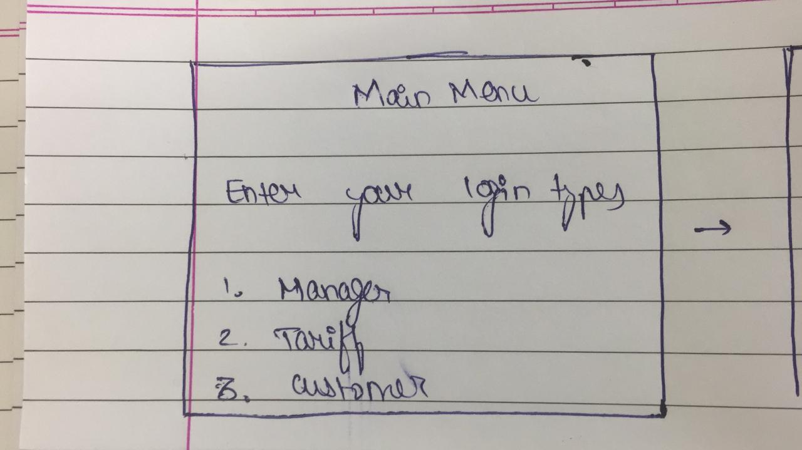

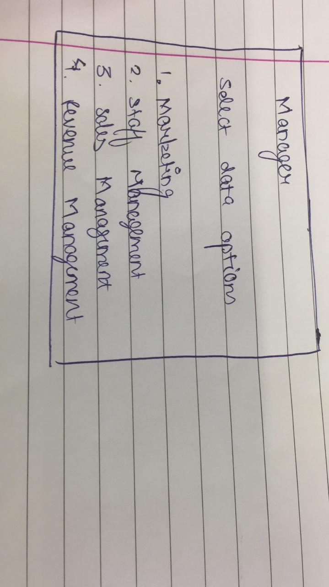

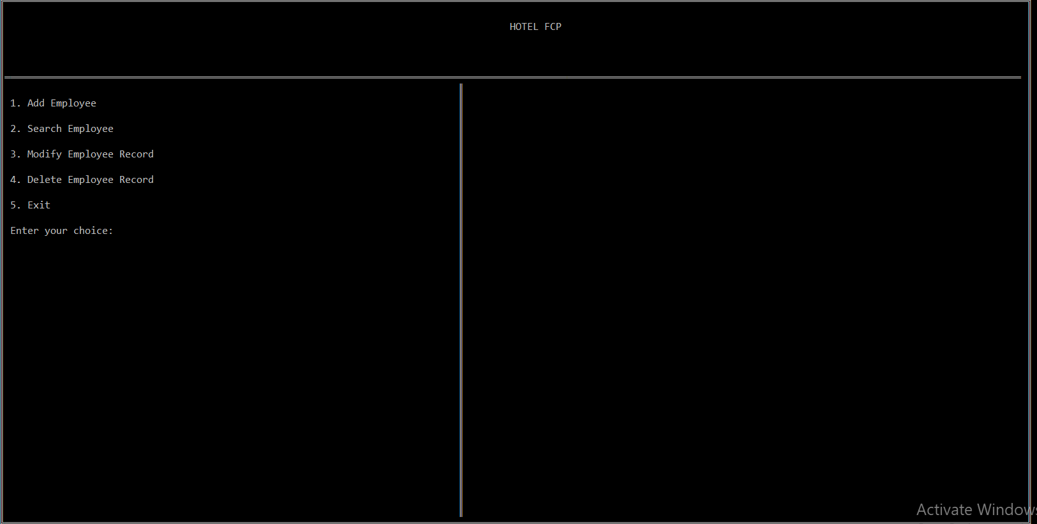

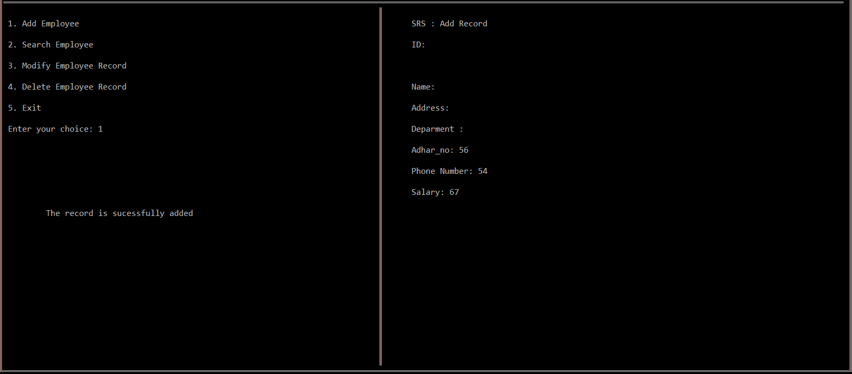

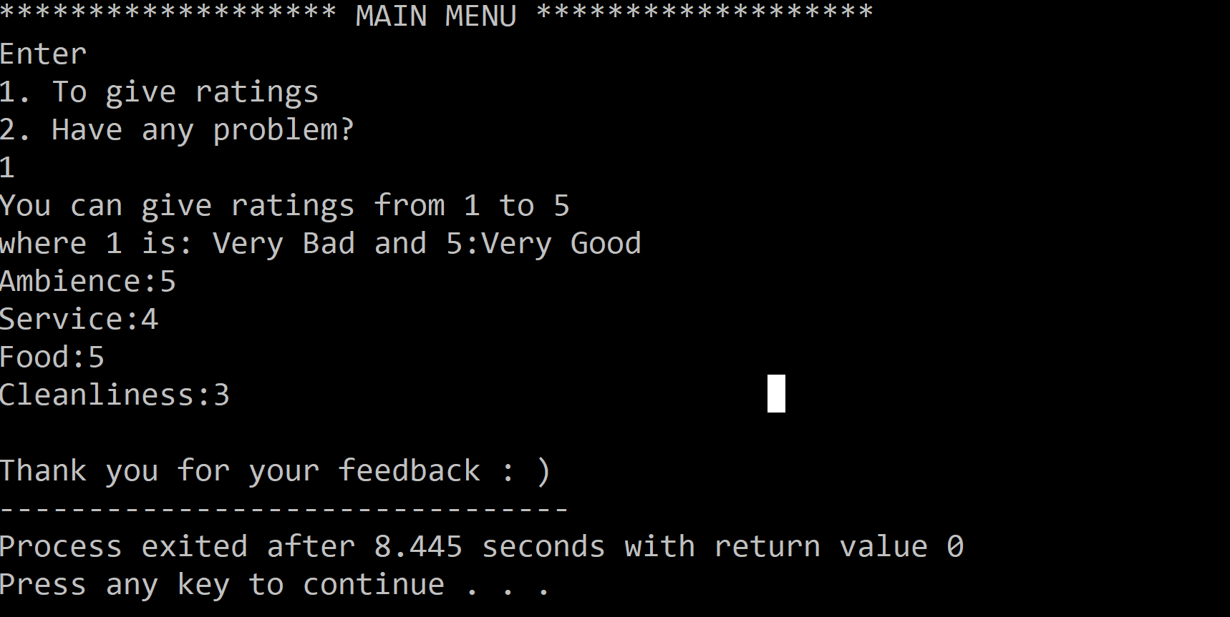

**2.2 Database Design**

The staff management system will require following files to store data.

* **Record.txt**
* **Temp.txt**

|  |  |  |  |
| --- | --- | --- | --- |
| Sr. No. | Name of the Field | Data Type | Sample Data |
| 1 | id | Char[15] | 100 |
| 2 | name | char [20] | Rakesh |
| 3 | add | char [20] | Gujarat |
| 4 | department | Char[10] | Pune |
| 5 | adhar_no | Long int | 1234567890 |
| 6 | phone_no | Long int | 9876543210 |
| 7 | salary | Long long int | 30,000 |