Natural Language based user interface for
computer games

Abstract

The game playing for the past decades is through keycombinations and gesture recognition . The player either way should have prior knowledge before playing. The limitation is that game player cannot have direct interactions with the other characters(bots) inside the game . This makes the game design not to produce any illusion of intelligence to the other characters inside the game(bots) .Moreover, a single keycombination or gesture cannot perform a complex action in the game . To solve the above mentioned limitations and build a rich game interaction in this paper , we propose an approach to build a computer game with natural language as input .

The game player will interact with the game through speech in his natural language . The speech will be converted to text and with inference techniques , the ground instructions will be pulled out and applied to the game . Now the game player can not only control his character , but can interact with other characters(bots) as well . Decisions for game playing can be made by consulting the characters(bots) .The player need not remember complex key combinations or gestures to play the game . Game player can give complex or sequence of instructions to the characters(bots) in the game .

Architecture
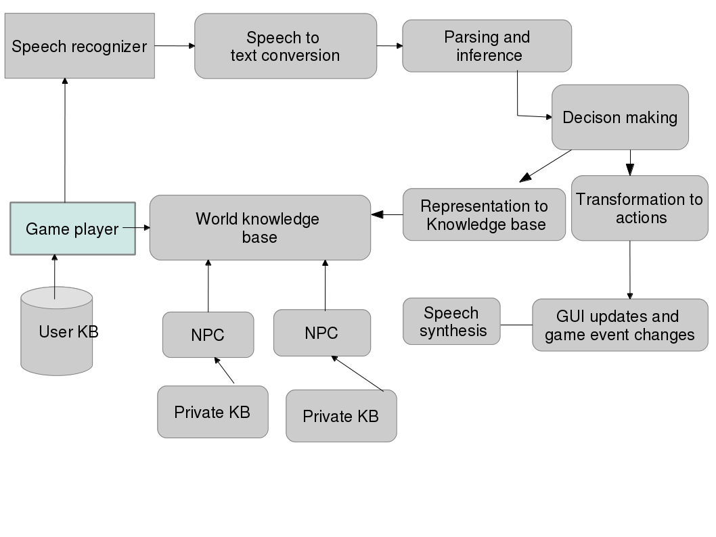

Implementation

Speech recognition engine
CMU Pocketsphinx
Language modelling toolkit
SRILM(stanford research institute language modelling)

Game implementation
SFML (simple and fast multimedia library )

