FITZONE – FITNESS & GYM WEBSITE
Website Design Documentation

1. Introduction
FITZONE is a fitness and gym website created using HTML and internal CSS. It provides visitors with information about gym programs, trainers, membership options, and contact details. The website uses a dark theme with bright lime-green highlights to create a modern and energetic fitness-focused appearance.

2. HTML Code
HTML is used to build the structure and content of the website. It defines the navigation menu, hero section, program cards, information sections, and other page elements. The navigation links allow users to move to sections such as Home, Programs, About, Trainers, Membership, and Contact. The hero section introduces the gym with the message “Build Your Best Version” and a button that directs visitors to the membership section.
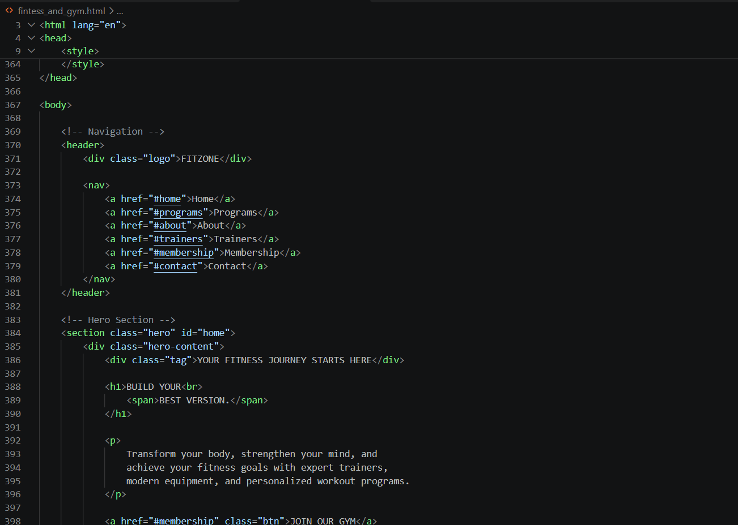

3. CSS Code
Internal CSS is written inside the style element in the HTML document. It controls the website’s design, colours, spacing, typography, and layout. The universal selector removes default margin and padding and applies border-box sizing. The body uses a dark background with white text, while the header is styled as a sticky navigation bar. Flexbox is used to align the logo and navigation links. Lime-green accents help important text and buttons stand out.
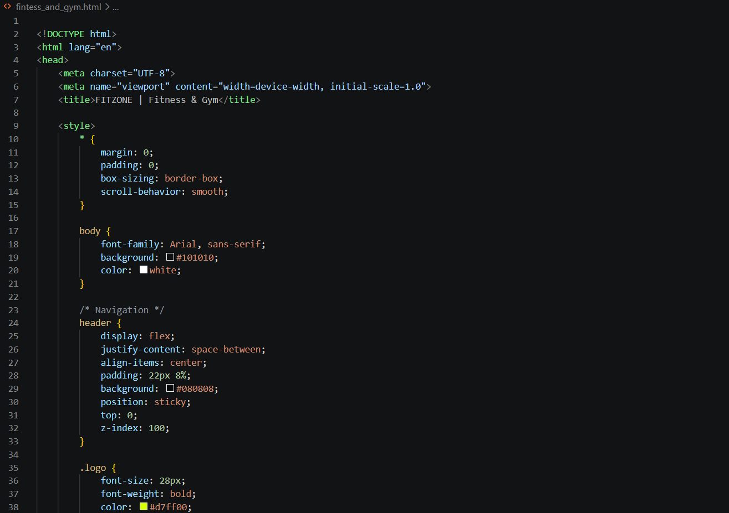

4. Output
The final output is a responsive-looking fitness and gym landing page with a dark visual theme. At the top, the FITZONE logo and navigation menu are displayed. The hero banner contains a gym background image, a fitness-focused heading, a short description, and a “Join Our Gym” button. Below it, the Our Programs section presents workout options such as Weight Training, Cardio & Fitness, and Yoga & Flexibility. A further section highlights why visitors should choose the gym, supported by a large gym photograph and a list of benefits.
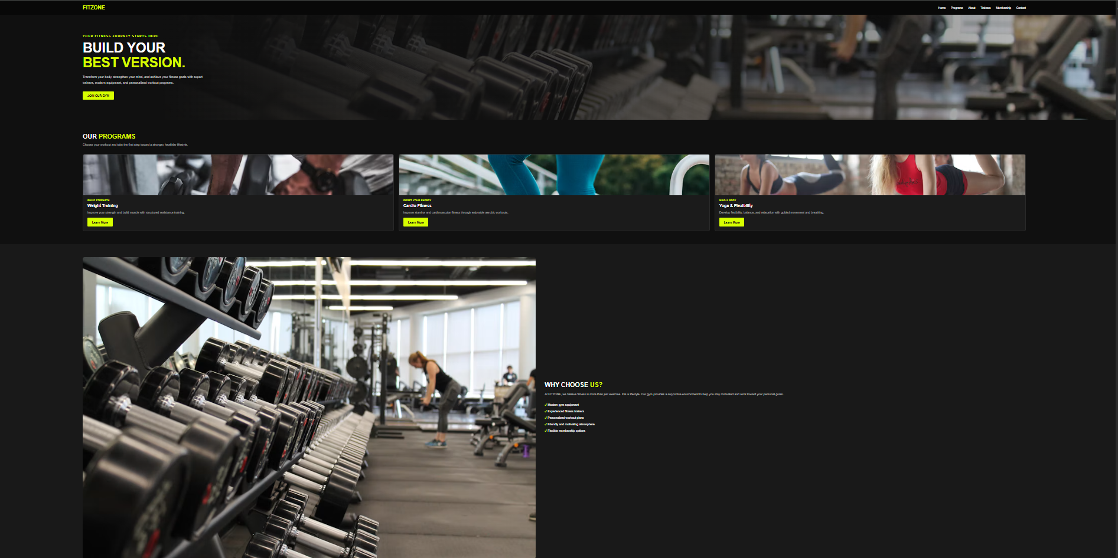

5. Conclusion
The FITZONE website demonstrates how HTML and CSS can be combined to create an attractive and informative gym website. HTML provides the page structure, while CSS improves its appearance and layout. The website presents fitness programs and gym facilities in a clear way and encourages visitors to explore membership options.

