GAMING AND ESPORTS
COMMUNITY
Web Page Project Documentation

Project: GameZone | Gaming & Esports

Introduction
The Gaming and Esports Community webpage is a modern, dark-themed website designed for people who enjoy video games and competitive esports. The page introduces the GameZone community and helps visitors explore featured games, esports tournaments, and top players. It also includes clear navigation links and buttons that encourage users to explore games and join the community.

Objectives of the Web Page
- Present gaming content in an attractive and organized layout.
- Show featured games with short descriptions and exploration buttons.
- Display tournament information and prize details.
- List top players and their scores in a leaderboard-style table.
- Encourage visitors to join the gaming community.

HTML Code
HTML (HyperText Markup Language) provides the structure and content of the webpage. In the code shown below, semantic elements such as <header>, <nav>, and <section> organize the page. The navigation menu links to Home, Games, Tournaments, and Leaderboard sections. The hero section contains the main heading “PLAY HARD. WIN BIG.”, a short introduction, and buttons for exploring games and joining the community.
The HTML also uses headings, paragraphs, links, and class attributes. These elements make the content meaningful and allow CSS styles to be applied to individual parts of the page.
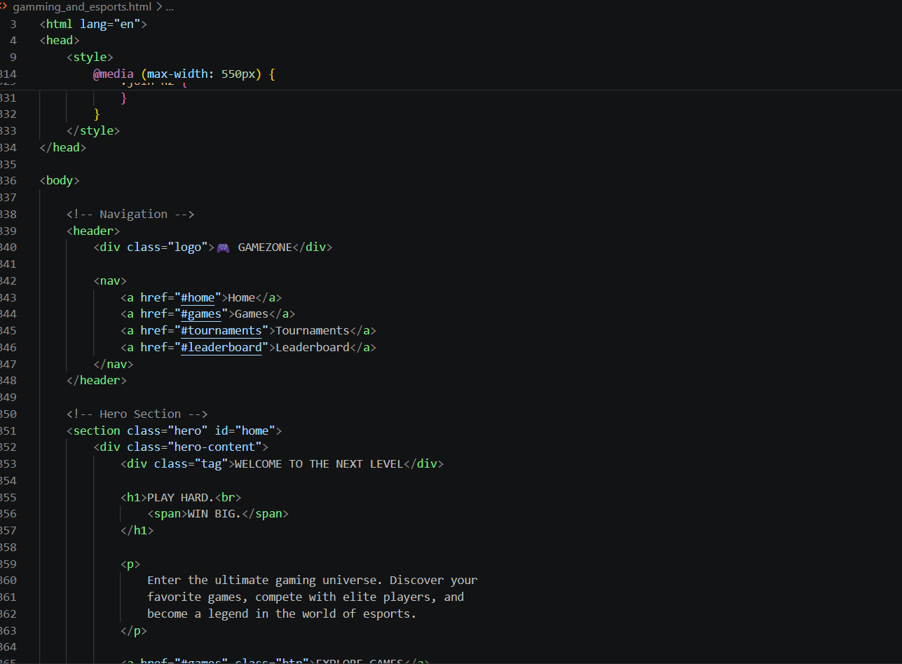
Figure 1: HTML structure for the GameZone webpage.

CSS Code
CSS (Cascading Style Sheets) controls the appearance and layout of the webpage. The code uses a dark background, white text, and bright cyan accents to create a gaming-inspired look. The universal selector resets margins and padding, while the body rule sets the font and background colour.
The header is styled with Flexbox to place the logo and navigation links neatly in one row. A sticky position keeps the navigation visible while scrolling. Additional CSS rules style the logo, cards, buttons, sections, and responsive layout. The media query helps the page adapt to smaller screens such as mobile phones.
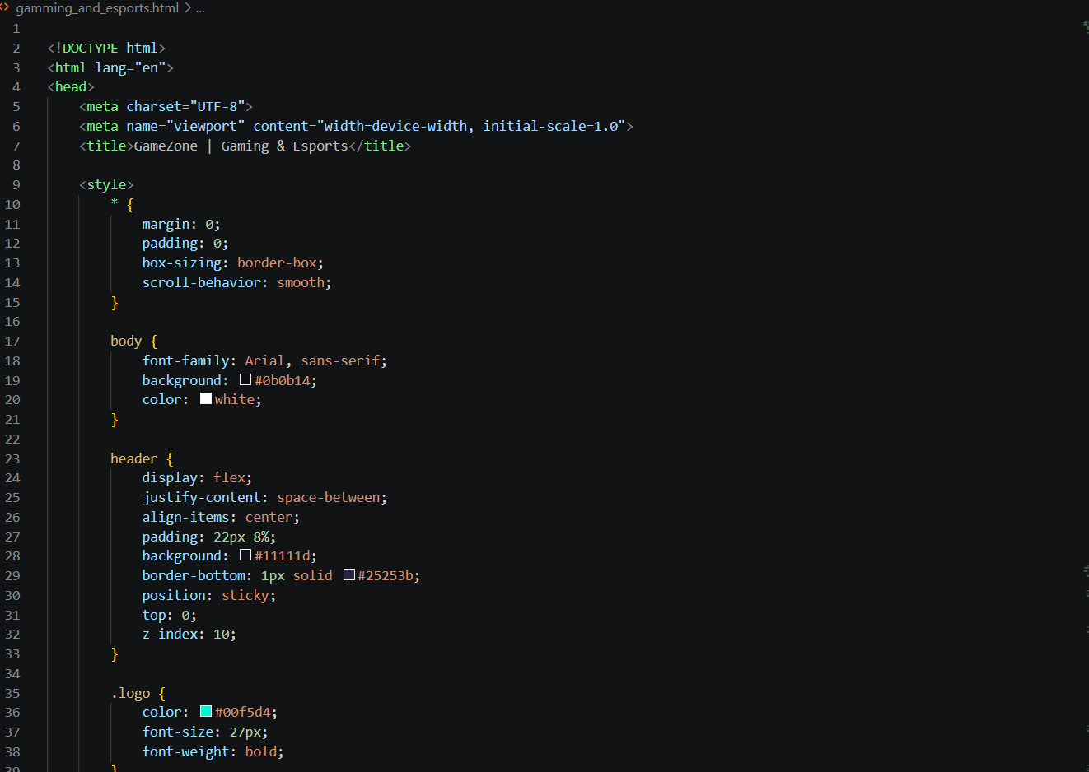
Figure 2: CSS styles used to design the GameZone webpage.

Output
The final output is a complete gaming and esports landing page. At the top, the hero banner welcomes visitors with the message “PLAY HARD. WIN BIG.” and provides quick action buttons. Below it, the Featured Games section displays three game cards with images and Explore buttons.
The Esports Tournaments section presents tournament information and a prize pool, while the Top Players section displays player names, scores, and skill levels in a table. A final call-to-action invites visitors to join the community, followed by a footer. The consistent dark theme and cyan highlights give the website a clear esports identity.
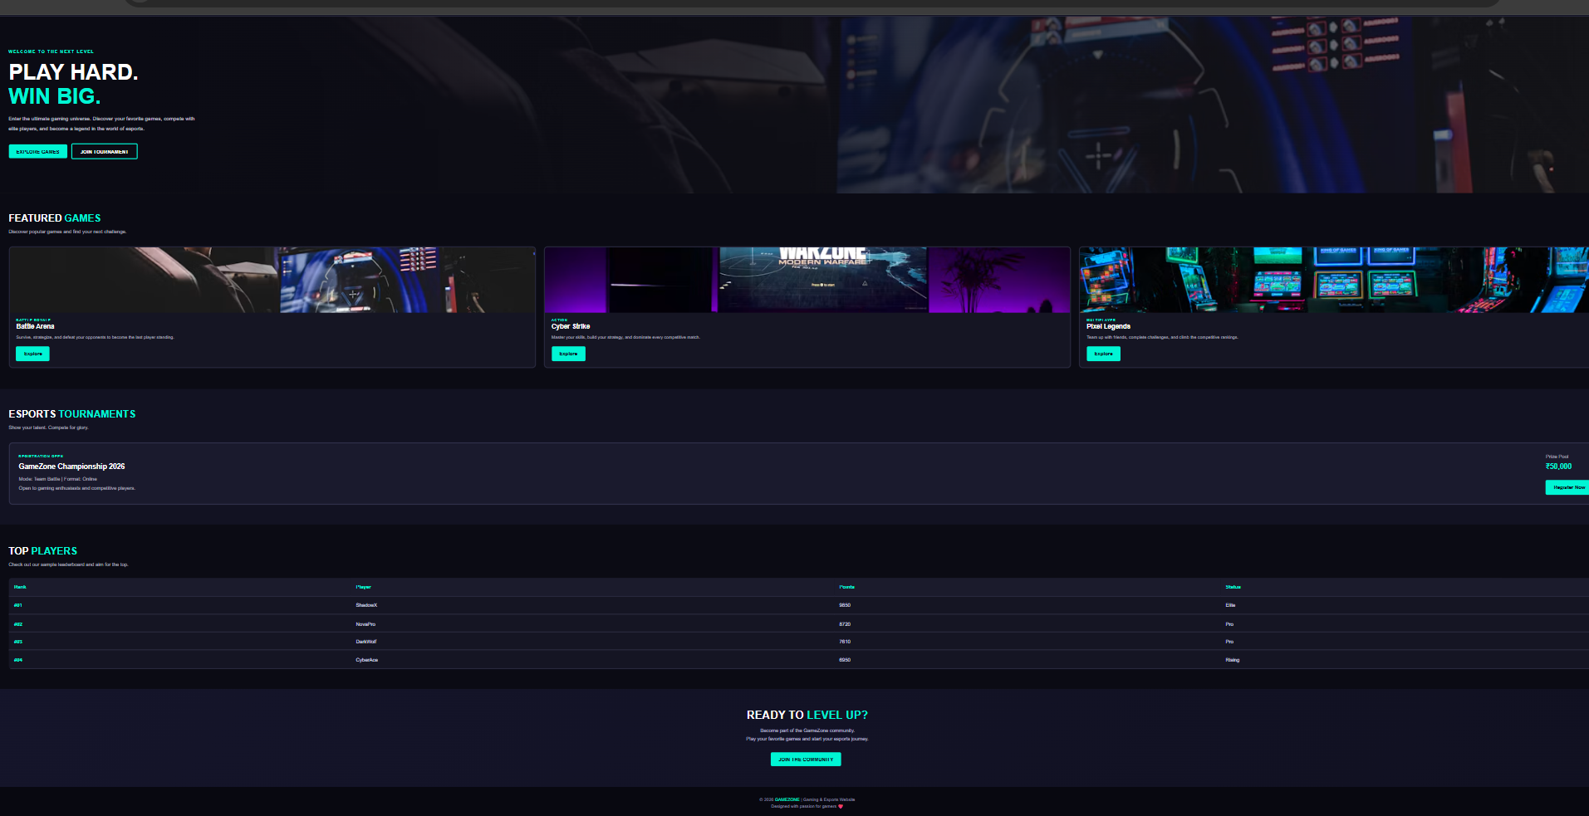
Figure 3: Final browser output of the Gaming and Esports Community webpage.

Conclusion
The Gaming and Esports Community webpage demonstrates how HTML and CSS can be combined to create an attractive and organized website. HTML defines the content and structure, while CSS provides the colours, spacing, layout, and responsive design. The completed GameZone page presents games, tournaments, and player rankings in one place and encourages users to become part of the gaming community. This project improves practical understanding of web development fundamentals.

