**Week 1: R Programming Assignment**

Dinesh Tavva

(MSBAN, Trine University)

(IS---5213-2O1--OL-SP-2023 - Data Science and Big Data)

(DONALD WEDDING)

(14 Jan 2024)

**Step 1: Describe the Data**

str( iris )

summary( iris )

head(iris,6)

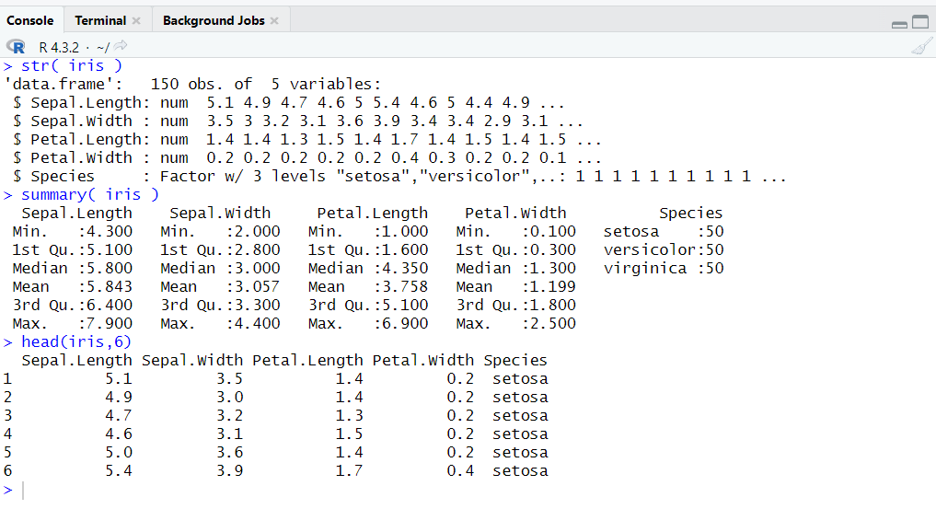

**Step 2: Box-Whisker Plots**

boxplot(Sepal.Length ~ Species, data = iris, notch = TRUE, col = c("red", "green", "blue"), main = "Dinesh Tavva's Box Plot")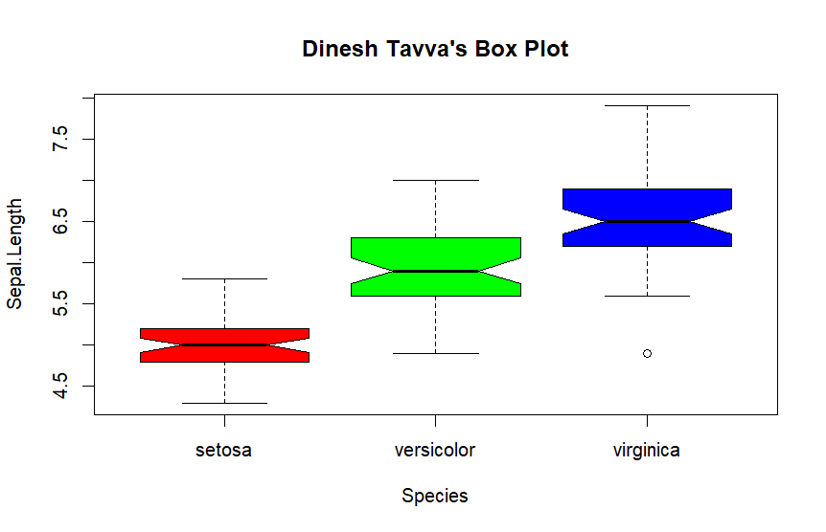

**Step 3: Histograms**

hist(iris$Sepal.Length, breaks = 20, col = "skyblue", main = "Histogram of Sepal.Length", xlab = "Sepal.Length")

lines(density(iris$Sepal.Length), col = "darkred", lwd = 2)

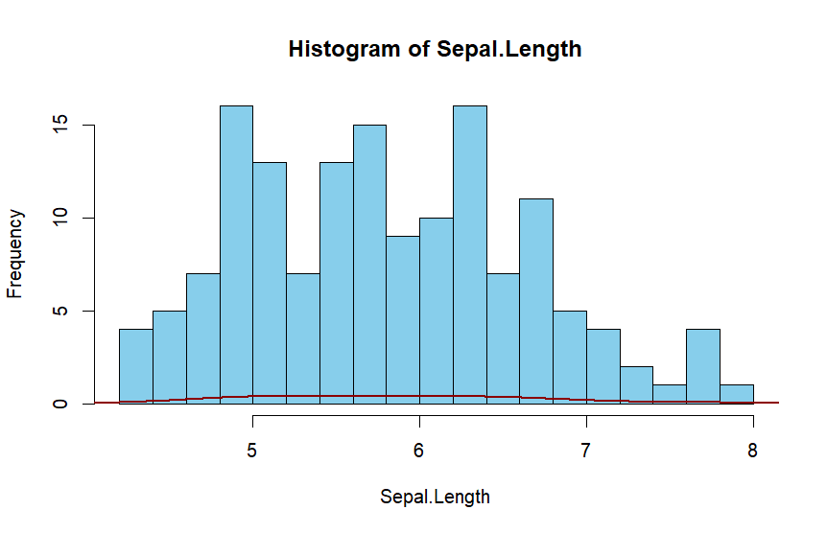

**Step 4: Scatter Plots**

plot(iris$Sepal.Length, iris$Sepal.Width, col = as.numeric(iris$Species), pch = 16, main = "Scatter Plot of Sepal.Length vs Sepal.Width", xlab = "Sepal.Length", ylab = "Sepal.Width")

legend("topright", legend = levels(iris$Species), col = c("red", "green", "blue"), pch = 16)

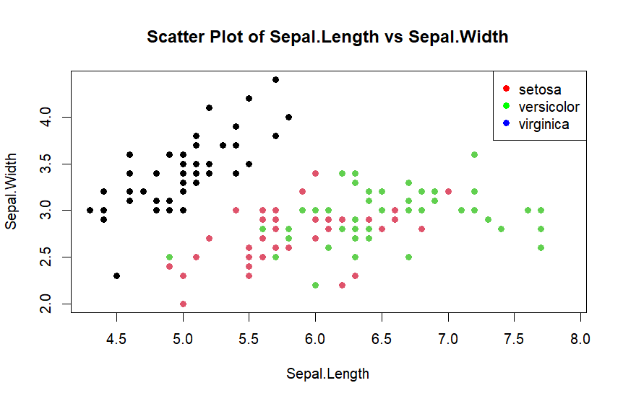

**Step 5: Simple Math**

mean_value <- mean(iris$Sepal.Length)

print(mean_value)

median_value <- median(iris$Sepal.Length)

print(median_value)

minimum_value <- min(iris$Sepal.Length)

print(minimum_value)

maximum_value <- max(iris$Sepal.Length)

print(maximum_value)

standard_deviation_value <- sd(iris$Sepal.Length)

print(standard_deviation_value)

median_species <- tapply(iris$Sepal.Length, iris$Species, median)

sorted_median_species <- sort(median_species, decreasing = TRUE)

**Output:**

