Twitter Bootstrap
It is a front end framework, includes code of HTML, CSS and javascript and used for building mobile first web applications that is first on small devices than on big screens. Please refer to my article on Html, CSS and 960 grid for proper understanding on this topic.

Why?
Increases Development speed
Build responsive websites
Code can be customize

How we can download?
1. Manually Download: Go to https://getbootstrap.com/ and click on download. Source files will be downloaded. Then, compiled code files shall be included in our project.

Just open the folder. Go to “dist”.
->From “CSS” folder. There is bootstrap.min.css file
->From “JS” folder. There is bootstrap.min.js file
Include these files into your project structure.

Insert this code into head tag:
<link rel="stylesheet" href="path of bootstrap.min.css">

Place this near the end of body tag:
<script src="https://code.jquery.com/jquery-3.2.1.slim.min.js" integrity="sha384-KJ3o2DKtIkvYIK3UENzmM7KCkRr/rE9/Qpg6aAZGJwFDMVNA/GpGFF93hXpG5KkN" crossorigin="anonymous"></script>
<script src="https://cdnjs.cloudflare.com/ajax/libs/popper.js/1.12.9/umd/popper.min.js" integrity="sha384-ApNbgh9B+Y1QKtv3Rn7W3mgPxhU9K/ScQsAP7hUibX39j7fakFPskvXusvfa0b4Q" crossorigin="anonymous"></script>
<script src="path of bootstrap.min.js"><script>

2. CDN(Content Delivery Network): A server that hosts all the files we need externally. We just need to include script in the css file. It is easy. While visiting another site, it will be loaded from cache when they visit your site, which leads to faster loading time. Also, once a user requests a file from it, it will be served from the server closest to them, which also leads to faster loading time.

Go to the above link. Under the Bootstrap CDN tab. Copy the code and paste in HTML file. And make sure that jquery file must be placed before javascript file.
Place in head :
<!-- Latest compiled and minified CSS -->
<link rel="stylesheet" href="https://maxcdn.bootstrapcdn.com/bootstrap/3.3.7/css/bootstrap.min.css">
Place in body at end:
<!-- jQuery library -->
<script src="https://ajax.googleapis.com/ajax/libs/jquery/3.3.1/jquery.min.js"></script>
<!-- Latest compiled JavaScript -->
<script src="https://maxcdn.bootstrapcdn.com/bootstrap/3.3.7/js/bootstrap.min.js"></script>

3. Bower and NPM: Can be seen from the above link on how to include. Steps are given.

Template:
<!DOCTYPE html>
<html lang="en">
<head>
<!-- Required meta tags -->
<meta charset="utf-8">
<meta name="viewport" content="width=device-width, initial-scale=1, shrink-to-fit=no">

<!-- Bootstrap CSS -->
<link rel="stylesheet" href="path of bootstrap.min.css">
</head>
<body>
<h1>Hello, world!</h1>

<!-- jQuery first, then Tether, then Bootstrap JS. -->
<script src="https://code.jquery.com/jquery-3.1.1.slim.min.js" integrity="sha384-A7FZj7v+d/sdmMqp/nOQwliLvUsJfDHW+k9Omg/a/EheAdgtzNs3hpfag6Ed950n" crossorigin="anonymous"></script>
<script src="https://cdnjs.cloudflare.com/ajax/libs/tether/1.4.0/js/tether.min.js" integrity="sha384-DztdAPBWPRXSA/3eYEEUWrWCy7G5KFbe8fFjk5JAIxUYHKkDx6Qin1DkWx51bBrb" crossorigin="anonymous"></script>
<script src="path of bootstrap.min.js"></script>
</body>
</html>

Output:
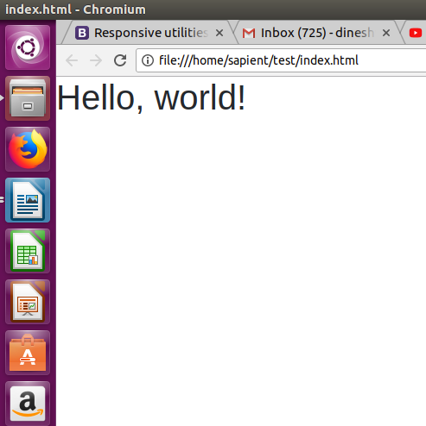

Responsive meta tag: When webpage is display on mobile, we have to zoom in. But if include meta viewport tag. It becomes mobile friendly with setting “content="width=device-width”, we donot have to zoom in or swipe left or right. But when we are in portrait mode, it gives us problem. So, we set “initial-scale=1”. So, page looks good in portrait as well as landscape mode.

<meta name="viewport" content="width=device-width, initial-scale=1, shrink-to-fit=no">

Container:
Are basic layout component.
Wrap and contain our data.
Provide basic padding anf margin
Can be fluid or fixed.
- The .container class provides a responsive fixed width container
- The .container-fluid class provides a full width container, spanning the entire width of the viewport.
<div class="container bg-dark">
<h1 class="text-light">Hello</h1>
</div>
<div class="container-fluid bg-dark">
<h1 class="text-light">Hello</h1>
</div>

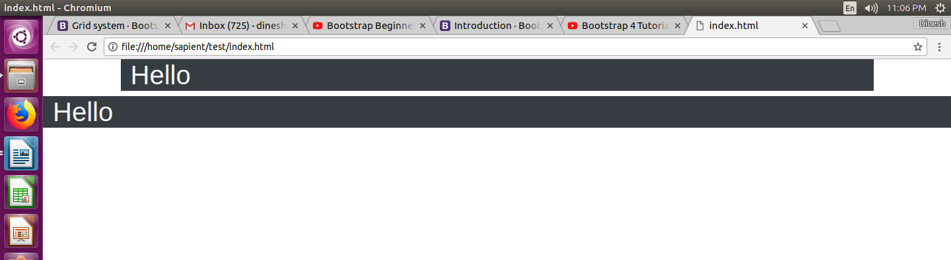

Grid System:
This is the like container in which 12 columns are laid out on which data and components are laid out such that the screen should be responsive. Whether it displays on HD desktops aur CRT monitors or even small phones, the components are adjusted by grid or are even stacked on top of each other to make it responsive.If you do not want to use all 12 columns individually, you can group the columns together to create wider columns.
The Bootstrap grid system has four classes. These are the breakpoints.
- xs (for phones - screens less than 768px wide)
- sm (for tablets - screens equal to or greater than 768px wide)
- md (for small laptops - screens equal to or greater than 992px wide)
- lg (for laptops and desktops - screens equal to or greater than 1200px wide)
Syntax:
<div class="col-*-*"></div>
The first asterisk describes the above mentioned intended class for particular device while second asterisk depicts number of columns to be covered.

Rules:
- Rows must be placed within a .container (fixed-width) or .container-fluid (full-width) for proper alignment and padding
- Use rows to create horizontal groups of columns
- Columns create gutters (gaps between column content) via padding. That padding is offset in rows for the first and last column via negative margin on .rows
- Grid columns are created by specifying the number of 12 available columns you wish to span. For example, three equal columns would use three .col-sm-4.
<div class="container">
<div class="row">
<div class="col-sm-4">
<p>Hello 1-4<p>
</div>
<div class="col-sm-4">
<p>Hello 5-8-4<p>
</div>
<div class="col-sm-4">
<p>Hello 9-12<p>
</div>
</div>

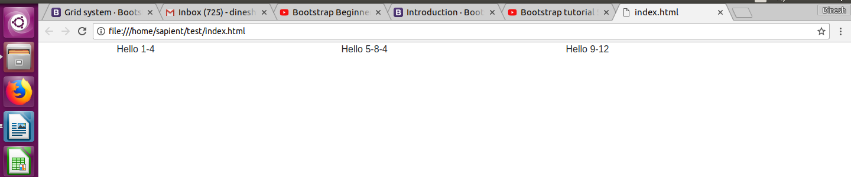
Alignment of text:
We use class as text-left, text-right, text-center, text-justified, and text-nowrap for alignment of the text.
Quick Floats:
“pull-left” and “pull-right” are used to float the data left or right.
“Clearfix” is used to set the child or data after float content to back to its normal position, otherwise it will be overriden by parent content.

Bootstrap Images
The .img-rounded class adds rounded corners to an image.
The .img-circle class shapes the image to a circle
The .img-thumbnail class shapes the image to a thumbnail.
<img src="cinqueterre.jpg" class="img-rounded" alt="Cinque Terre">
<img src="cinqueterre.jpg" class="img-circle" alt="Cinque Terre">
<img src="cinqueterre.jpg" class="img-thumbnail" alt="Cinque Terre">
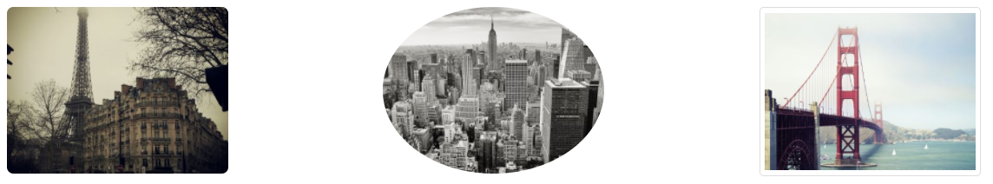
Contextual Colours:
<p class="text-muted">This text is muted.</p>
<p class="text-primary">This text is important.</p>
<p class="text-success">This text indicates success.</p>
<p class="text-info">This text represents some information.</p>
<p class="text-warning">This text represents a warning.</p>
<p class="text-danger">This text represents danger.</p>
<p class="text-secondary">Secondary text.</p>
<p class="text-dark">This text is dark grey.</p>
<p class="text-light">This text is light grey (on white background).</p>
<p class="text-white">This text is white (on white background).</p>

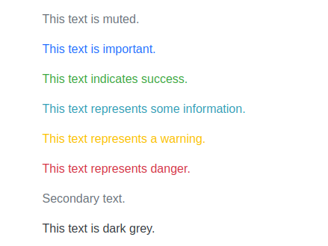

Button Styles:
<h2>Button Styles</h2>
<button type="button" class="btn">Basic</button>
<button type="button" class="btn btn-default">Default</button>
<button type="button" class="btn btn-primary">Primary</button>
<button type="button" class="btn btn-success">Success</button>
<button type="button" class="btn btn-info">Info</button>
<button type="button" class="btn btn-warning">Warning</button>
<button type="button" class="btn btn-danger">Danger</button>
<button type="button" class="btn btn-link">Link</button>

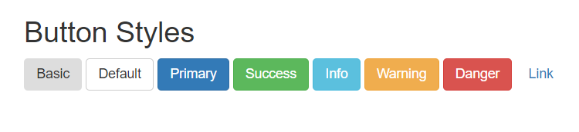
Bootstrap provides four button sizes:
- .btn-lg
- .btn-md
- .btn-sm
- .btn-xs
<div class="container">
<h2>Button Sizes</h2>
<button type="button" class="btn btn-primary btn-lg">Large</button>
<button type="button" class="btn btn-primary btn-md">Default</button>
<button type="button" class="btn btn-primary btn-sm">Small</button>
</div>
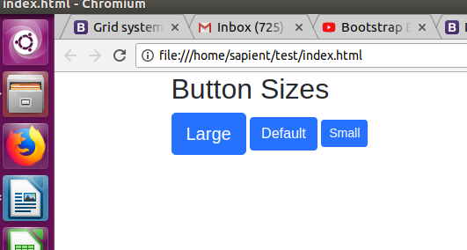

Bootstrap Form Layouts
Bootstrap provides three types of form layouts:
- Vertical form (this is default)
- Horizontal form
- Inline form
Standard rules for all three form layouts:
- Wrap labels and form controls in <div class="form-group">
- Add class .form-control to all textual <input>, <textarea>, and <select> elements
<form action="/action_page.php">
<div class="form-group">
<label for="email">Email address:</label>
<input type="email" class="form-control" id="email">
</div>
<div class="form-group">
<label for="pwd">Password:</label>
<input type="password" class="form-control" id="pwd">
</div>
<div class="checkbox">
<label><input type="checkbox"> Remember me</label>
</div>
<button type="submit" class="btn btn-default">Submit</button>
</form>

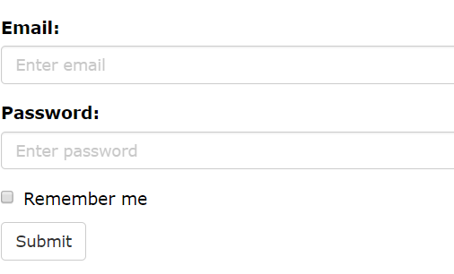

Bootstrap supports the following form controls:
- input
- textarea
- checkbox
- radio
- select

Creating a Jumbotron:
A jumbotron indicates a big box for calling extra attention to some special content or information.
A jumbotron is displayed as a grey box with rounded corners. It also enlarges the font sizes of the text inside it.
Use a <div> element with class .jumbotron to create a jumbotron:
Place the jumbotron inside the <div class="container"> if you want the jumbotron to NOT extend to the edge of the screen
<div class="container">
<div class="jumbotron">
<h1>Hello</h1>
<p>I am Dinesh Verma and I am not a terrorist.</p>
</div>
</div>

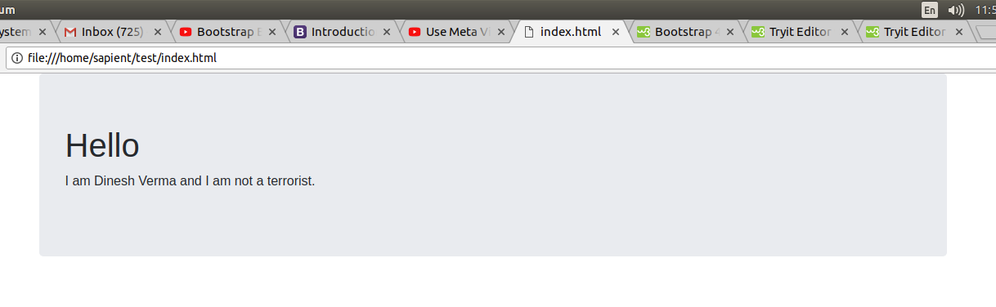

Alerts
Bootstrap provides an easy way to create predefined alert messages:
<div class="alert alert-success">
<strong>Success!</strong> Indicates a successful or positive action.
</div>
<div class="alert alert-info">
<strong>Info!</strong> Indicates a neutral informative change or action.
</div>
<div class="alert alert-warning">
<strong>Warning!</strong> Indicates a warning that might need attention.
</div>
<div class="alert alert-danger">
<strong>Danger!</strong> Indicates a dangerous or potentially negative action.
</div>
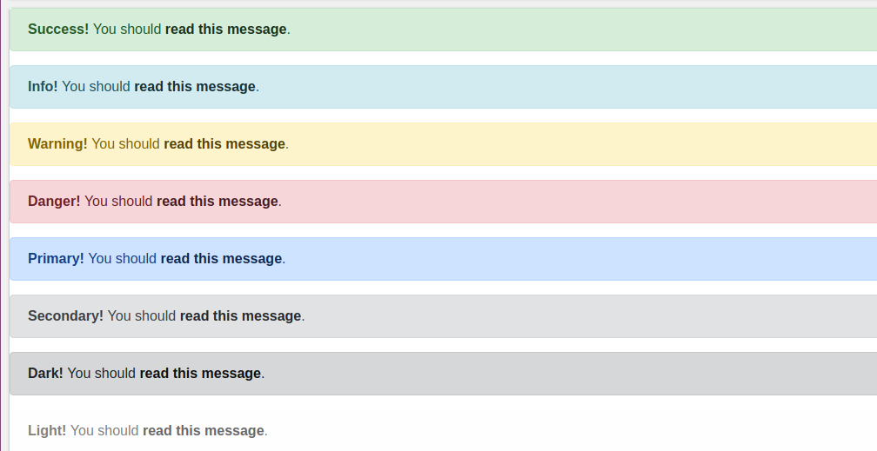
Media object:
This is used to make website responsive so that it can be viewed in mobile efficiently. It first detects the size of the screen of the device (smart phones, tablets, laptop, etc.) and based on that, it applies the stylesheet properties to the web components present on the webpage.
This is the important topic in CSS. Understand this very good.
@media keyword is used and some attributes with this to manage width or properties of elements.
<script>
Body{
background-color: yellow;
}
@media only screen and (max-width: 400px) {
Body{
background-color: yellow;
}
}
</script>

// Extra small devices (portrait phones, less than 576px)
// No media query since this is the default in Bootstrap

// Small devices (landscape phones, 576px and up)
@media (min-width: 576px) { ... }

// Medium devices (tablets, 768px and up)
@media (min-width: 768px) { ... }

// Large devices (desktops, 992px and up)
@media (min-width: 992px) { ... }

// Extra large devices (large desktops, 1200px and up)
@media (min-width: 1200px) { ... }

When the size of the viewport (here browser) is greater than 400 pixels then the background color visible is yellow.
Carousel:
It containes images that automatically moves. It is like a rectangle in whic our images move left or right automatically or even we can move it with help of glyphicons button.
The code can be found on bootstrap websites.

