Mastering HTML{
key: 960Grid value: CSS
} in an hour

This article is intended for students that are new to web development. Apart from this, it also includes some good topics to learn from.
HTML and CSS are the two basic languages for web development. HTML is markup language used to build web pages, developed by Tim Berners Lee and published in 1995, latest release version is 5.2 as on Dec 14,2017. CSS is a style sheet language used for describing the presentation and layout of HTML document, developed in 1996, latest version is 3. This is done to make the styling different from the structure document. We need to change only CSS file to make layout change in website. The 960 Grid System is used to make layout by providing commonly used dimensions, based on a width of 960 pixels. There are two variants: 12 and 16 columns over which elements are placed in proper manner. This is done so that data displayed should be standardized across multiple resolution screens.
Structure by HTML, cascading by CSS and layout by 960 makes th perfect static webpage.
First we go with HTML. Its elements are written using tags (angular brackets). We can use sublime text editor 3, notepad++ or notepad. Save the file with extension .htm or .html.
Link to download Sublime text editor: https://www.sublimetext.com/3

Historic logo Present Logo
Structure:
<html>
<head>
<title>My First Webpage</title>
</head>
<body>This section contains body of the web page</body>
</html>
The text between <html> and </html> describes the web page, and the text between <body> and </body> is the visible page content. The markup text "<title>This is a title</title>" defines the browser page title.
The Document Type Declaration <!Doctype html>is for HTML5.
Comment: Used for reader’s view only, not interpreted by browser.
<!-- This is a comment -->
HTML Elements: An HTML element usually consists of a start tag and end tag, with the content inserted in between:
<tagname>Content is here...</tagname>
HTML Attributes: Attributes provide additional information about an element. It is written in name/value pairs like: name="value".
Headings: 1 defines higher and 6 defines lower.
<h1>Heading level 1</h1>
<h2>Heading level 2</h2>
<h3>Heading level 3</h3>
<h4>Heading level 4</h4>
<h5>Heading level 5</h5>
<h6>Heading level 6</h6>
Paragraphs:
<p>Paragraph 1</p> <p>Paragraph 2</p>
Predefined Data:
<pre> Pre Defined… Display as it is including predefined spaces</pre>
Line Break: used to break the normal flow.
<br>
Links: To create a link that navigates to another web page or part of the page. Anchor tag <a> is used. The Head reference “href” attribute holds the URL address of the link.
To navigates to another web page:
<a href="https://www.url.com”>Click on this to move to given url</a>
To navigates to bottom of page from top of page:
At top-> <a href=”#bottom”>Navigator</a>
At bottom-> <a name=”bottom”>Bottom</a>
Image Inclusion: To include image. Source “src” contains path of image while Alternate text “alt” defines text in case image is not displayed. Width and height is used to set resolution of the image.
<img src=” ” alt=” “ width=” “ height=” ”>
List: There are two types of list: unordered (ul) and ordered(ol).
Unordered: <ul type=”square/circle/rectangle”> <li>List data 1</li>
<li>List data 2</li>
</ul>
Ordered: <ol type=”romans/numeric”> <li>List data 1</li>
<li>List data 2</li>
</ol>
Table: <tb> tag is used to define table while <tr> and <td> defines table row and table data respectively where table data is included in table row. We can also define table heading by <th>
Bold, Strong, italics and emphasis (<b>, <strong>, <i>, <em>): Bold and strong just make bold the data but strong is used in narrator in case of blinds, so try to use strong than bold. Italics is used to make data italics and emphasis is used in case of blinds as happens in case of strong.
Forms: to make form and get user data.
Combo Box: The <select> element defines a drop-down list. The <option> elements defines an option that can be selected.
<form action=”url of where to submit” type= ”get/ post(send data in secured form)”>
<input type="text" /> <!-- This is for text input -->
<input type="file" /> <!-- This is for uploading files -->
<input type="checkbox" /> <!-- This is for checkboxes -->
<input type="radio" group=”groupid” /> <!-- This is for radiobuttons -->
<input type="textarea" /> <!-- This is for textarea -->
<select name="cars">
<option value="volvo">Volvo</option>
<option value="saab">Saab</option>
<option value="fiat">Fiat</option>
<option value="audi">Audi</option>
</select>
</form>

Example:
Source code:
<!DOCTYPE html>
<html>
<head>
<title>My First Webpage</title>
</head>
<body>
1.<h1>Heading level 1</h1>
<hr> <!--horizontal line-->
2.<p>Paragraph 1</p> <p>Paragraph 2</p>
<hr>
3. <pre> Pre defined...Display as it is including predefined spaces<br>After line break</pre>
4. <a href="https://www.google.com">Click on this to refernce to given url</a>
<hr>
5. <h6>Heading level 6</h6>
<hr>
6.<b>Unordered List</b>
<ul type="square">
<li>List data 1</li>
<li>List data 2</li>
</ul>
7. <i>Ordered List</i>
<ol type="numeric">
<li>List data 1</li>
<li>List data 2</li>
</ol>
<hr>
8. <form action=”url of where to submit” type= ”get/ post(send data in secured form)”>
<input type="text" /> <!-- This is for text input -->
<input type="file" /> <!-- This is for uploading files -->
<input type="checkbox" /> <!-- This is for checkboxes -->
<input type="radio" group=”groupid” /> <!-- This is for radiobuttons -->
<input type="textarea" /> <!-- This is for textarea -->
<input type="submit" value="Go" /> <!-- This is for button -->
</form>
</body>
</html>

Output:
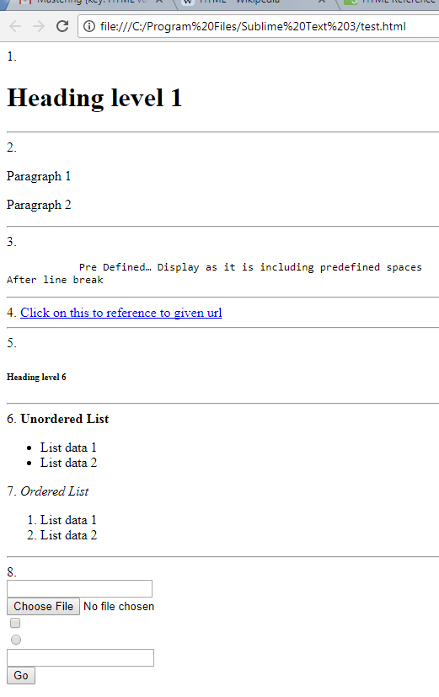

Now moving to some advanced tags.
The lang Attribute: The language is declared with the lang attribute in <html> tag.
It is important for accessibility applications (screen readers) and search engines.
Charset: To display an HTML page correctly, the browser must know what character set (character encoding) to use.
ASCII: American Standard Code for Information Interchange. It is 7-bit character set containing 128 characters.
It contains the numbers from 0-9, the upper and lower case English letters from A to Z, and some special characters.
ANSI (Windows-1252): ANSI was the default character set in Windows up to Windows 95. ANSI is also called Windows-1252.
ISO-8859-1: ISO-8859-1 is the default character in HTML 4.01.
ISO (The International Standards Organization) defines the standard character sets for different alphabets/languages.
For HTML 5, the default character encoding is UTF-8. Because the character sets listed above are limited, and not compatible in multilingual environments, the Unicode Consortium developed the Unicode Standard.
<!DOCTYPE html>
<html lang="en-US">
<charset=”utf-8”>
</head>
<body>
...
</body>
</html>
Formatting elements :
- <mark> - defines marked or highlighted text:
- <small> - defines smaller text:
- <del> - defines (removed) text.
- <ins> - defines inserted (added) text.
- <sub> - defines _{subscripted} text.
- <sup> - defines ^{superscripted} text.
<!DOCTYPE html>
<html>
<head>
<title>My First Webpage</title>
</head>
<body>
<h2>HTML <small>Small</small> Formatting</h2>
<h2>HTML <mark>Marked</mark> Formatting</h2>
<p>My favorite color is <del>blue</del> red.</p>
<p>My favorite <ins>color</ins> is red.</p>
<p>This is <sub>subscripted</sub> text.</p>
<p>This is <sup>superscripted</sup> text.</p>
</body>
</html>
Output:
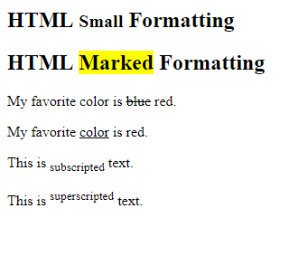

Block-level Elements: A block-level element always starts on a new line and takes up the full width available (stretches out to the left and right as far as it can).
Example:
<div>Hello</div>

Inline Elements: An inline element does not start on a new line and only takes up as much width as necessary.
Example:
<span>Hello</span>

Iframe: An HTML iframe is defined with the <iframe> tag. Use the height and width attributes to specify the size of the iframe.
Just go to YouTube. Then right click and press, “Embed code”. Now the code copied to the clipboard can be pasted in the source code.
HTML5 Datalist Elements: The <datalist> element specifies a list of pre-defined options for an <input> element.
Users will see a drop-down list of the pre-defined options as they input data.
The list attribute of the <input> element, must refer to the id attribute of the <datalist> element.
<form action="/action_page.php">
<input list="browsers">
<datalist id="browsers">
<option value="Internet Explorer">
<option value="Firefox">
<option value="Chrome">
<option value="Opera">
<option value="Safari">
</datalist>
</form>

HTML5 <output> Element:
The <output> element represents the result of a calculation (like one performed by a script).
<form action="/action_page.php"
oninput="x.value=parseInt(a.value)+parseInt(b.value)">
0
<input type="range" id="a" name="a" value="50">
100 +
<input type="number" id="b" name="b" value="50">
=
<output name="x" for="a b"></output>
<br><br>
<input type="submit">
</form>
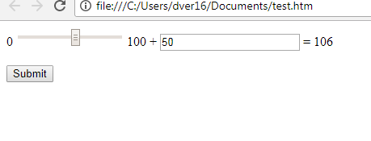

The readonly Attribute: The readonly attribute specifies that the input field is read only (cannot be changed).

The disabled Attribute: The disabled attribute specifies that the input field is disabled. A disabled input field is unusable and un-clickable, and its value will not be sent when submitting the form:
Semantic Elements: A semantic element clearly describes its meaning to both the browser and the developer.
Examples of non-semantic elements: <div> and <span>.
Examples of semantic elements: <form>, <table>, and <article>.

Structure Elements:
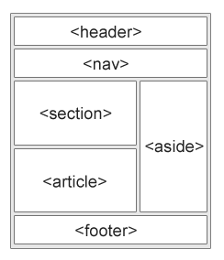
Header: The <header> element specifies a header for a document or section, should be used as a container for introductory content.
Section: The <section> element defines a section in a document
Article: The <article> element specifies independent, self-contained content.
An article should make sense on its own, and it should be possible to read it independently from the rest of the web site.
Examples of where an <article> element can be used:
- Forum post
- Blog post
- Newspaper article
Footer: The <footer> element specifies a footer for a document or section, contain information about its containing element.
Aside: The <aside> element defines some content aside from the content it is placed in (like a sidebar).The aside content should be related to the surrounding content.

CSS
Now we move to CSS part. We make the file with extension .css in css folder

In CSS, selectors declare which part of the markup a style applies to by matching tags and attributes in the markup itself.
Selectors may apply to:
- all elements of a specific type
- elements specified by attribute, in particular:
  - id: an identifier unique within the document
  - class: an identifier that can annotate multiple elements in a document
- elements depending on how they are placed relative to others in the document tree.

Reference: make the reference of css file in head tag by <link rel="stylesheet" type="text/css" href="source path">.
Now path can be absolute or relative. Absolute doesnot work in case of running files on server. Relative is fine as compared to absolute. “../”is used for one directory up.

Types to insert CSS:
- Internal CSS:
<!DOCTYPE html>
<html>
<head>
<meta charset="utf-8">
<style>
#xyz { color: blue; }
</style>
</head>
<body>
<p id="xyz" style="color: blue;"> To demonstrate specificity </p>
</body>
</html>
- External CSS: <link href="path/to/file.css" rel="stylesheet" type="text/css">
- Inline CSS: changing properties while writing HTML code.
<h1 style="color: red;"> Chapter 1. </h1>

Syntax:
The selector points to the HTML element you want to style.
The declaration block contains one or more declarations separated by semicolons.
Each declaration includes a CSS property name and a value, separated by a colon.
A CSS declaration always ends with a semicolon, and declaration blocks are surrounded by curly braces.
Structure: used to "find" (or select) HTML elements based on their element name, id, class, attribute, and more.
Selector{
Property:value;
}
Example:
p {
color: red;
text-align: center;
}
<!—makes the paragraph color red and align it to center- ->
For example, suppose the document contains the style element:
<style>
h1 {color: red;}
</style>

All h1 elements in the document will then automatically become red without any requiring any explicit code. If the author later wanted to make h1 elements blue instead, this could be done by changing the style element to:
<style>
h1 {color: blue;}
</style>

rather than by going through the document and changing the color for each individual h1 element.

Selectors can be class or id.
Suppose we have : <p>paragraph</p>

In case of class: to depict group of elements and make it as class
Html file: <p class=”para”>paragraph</p>
Css file: .center {
text-align: center;
color: red;
}

In case of id: to depict particular element
Html file: <p id=”para”>paragraph</p>
Css file: #center {
text-align: center;
color: red;
}

CSS Box Model:
- Content - The content of the box, where text and images appear
- Padding - Clears an area around the content. The padding is transparent
- Border - A border that goes around the padding and content
- Margin - Clears an area outside the border. The margin is transparent
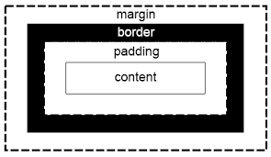
Example:
div {
width: 300px;
border: 25px solid green;
padding: 25px;
margin: 25px;
}
Background properties: The CSS background properties are used to define the background effects for elements.
- Background -> Sets all the background properties in one declaration
- background-attachment -> Sets whether a background image is fixed or scrolls with the rest of the page
- background-color -> Sets the background color of an element
- background-image -> Sets the background image for an element
- background-position -> Sets the starting position of a background image
- background-repeat -> Sets how a background image will be repeated

<!—index.htm-->
<!DOCTYPE html>
<html>
<head>
<title>My First Webpage</title>
<link rel="stylesheet" type="text/css" href="css/styles.css">
</head>
<body >
<h1>Hello</h1>
</body>
</html>
<!—styles.css-->
body{
background-image: url("../images/Tulips.jpg");
background-repeat: no-repeat;
background-color: yellow;
background-position: center;
}

Output:


Google fonts: We can also take reference of online google fonts and include reference in link tag.
Website : https://fonts.google.com/
Select the font of your choice and click on plus “+” on top right. After opening of dialog box.
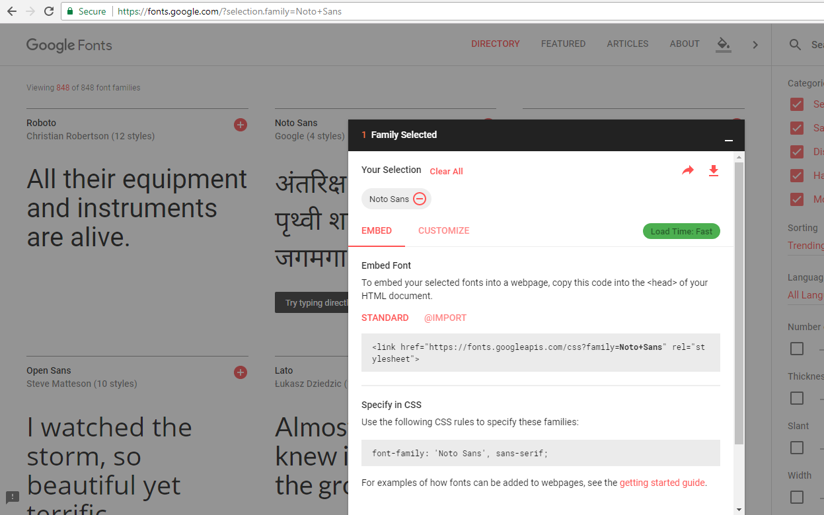Copy link tag value and include in html file. This is secondary link. Include it after primary links like 960 grid system files.
Also, copy Lower value from dialog box and include in CSS file.

\

960 Grid System
Now further moving to 960 Grid system. 960 grid is used so that data displayed should be standardized across multiple resolution screens
Link for the site: https://960.gs/
Download the source files folder.
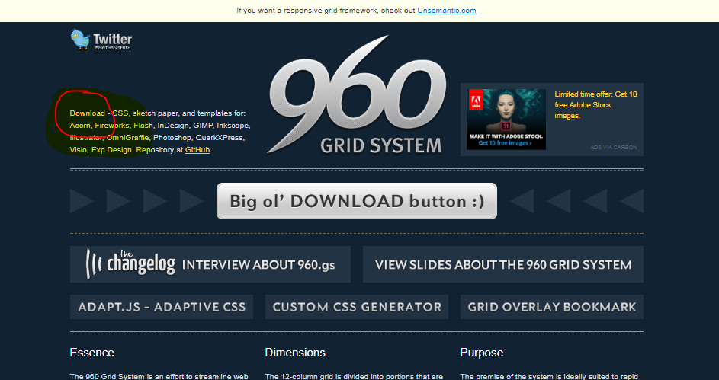

This is basically the grid over which through “container_12”, “container_16” or “container_24” class is applied that acts as a container and set respectively columns. These columns are used over which elements are placed. The 12-column grid is divided into portions that are 60 pixels wide. Each column has 10 pixels of margin on left and right.
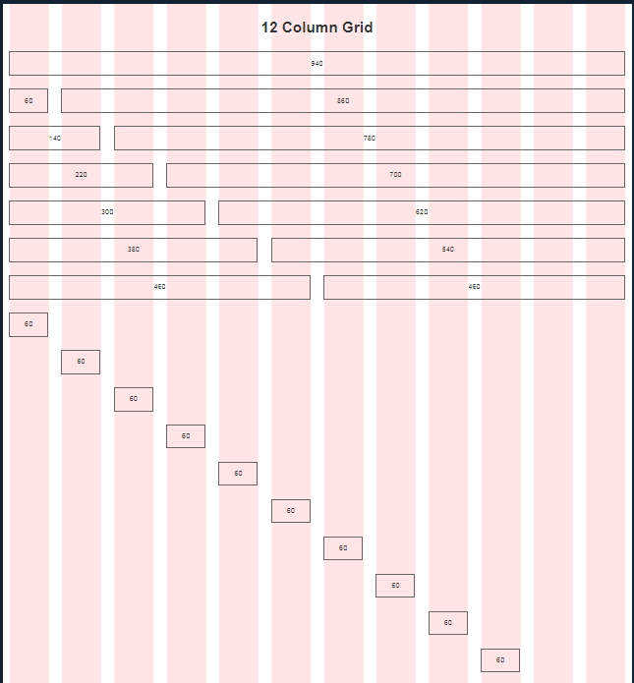

Now under code>CSS folder.
Copy the 960.css, reset.css and text.css into your project folder CSS folder.
Include the following code in your html’s head section.
<link rel="stylesheet" type="text/css" href="../css/gridCSS/960.css">
<link rel="stylesheet" type="text/css" href="../css/gridCSS/reset.css">
<link rel="stylesheet" type="text/css" href="../css/gridCSS/text.css">
These files should be included in same sequence as given. We should include first primary css files that is these type of files, then secondary and after that custom css files or user defined css files. Then
Now to occupy space, we first must include container and specify the number of columns. These can be “container_12”, “container_16” or “container_24”. “Grid_<number>” class is used to indicate number of columns we want to occupy. If we specify container as 12 , then total 12 columns should be occupied. After that, next row will be started.
Example:
<div class=”container_12”>
<div class=”grid_4”>
Hello 1-4 columns
</div>
<div class=”grid_4”>
Hello 5-8 columns
</div>
<div class=”grid_4”>
Hello 9-12 columns
</div>
</div>
Here, “container_12” depicts we are using 12 column grid. Now, “grid_4” indicates that data in this scope will occupy first four columns. Then again, data in next i.e. “Hello 5-8 columns” will be shown in next four columns and so on.
Full-fledged example:
<!DOCTYPE html>
<html>
<head>
<title>My First Webpage</title>
<link rel="stylesheet" type="text/css" href="960.css">
<link rel="stylesheet" type="text/css" href="reset.css">
<link rel="stylesheet" type="text/css" href="text.css">
</head>
<body >
<div class="container_12">
<div class="grid_4">
Hello 1-4 columns
</div>
<div class="grid_4">
Hello 5-8 columns
</div>
<div class="grid_4">
Hello 9-12 columns
</div>
</div>
</body>
</html>
Output:

