catkin_create_pkg keyboard
cd keyboard/
mkdir scripts
cp ~/keyboard.py scripts/
cp ~/key.launch .
mkdir src
cd ..
catkin build
Create ros package for keyboard then create a folder by the name scripts and copy the keyboard.py file to that folder
create a src folder (it should be empty) and do a catkin build

Run quatcopter - Terminal 1
cd ~/src/Firmware
source Tools/setup_gazebo.bash $(pwd) $(pwd)/build/px4_sitl_default
export ROS_PACKAGE_PATH=$ROS_PACKAGE_PATH:$(pwd)
export ROS_PACKAGE_PATH=$ROS_PACKAGE_PATH:$(pwd)/Tools/sitl_gazebo
export ROS_PACKAGE_PATH=$ROS_PACKAGE_PATH:$(pwd)/launch
export GAZEBO_PLUGIN_PATH=${GAZEBO_PLUGIN_PATH}:~/src/Firmware/build/px4_sitl_default/build_gazebo:/opt/ros/kinetic/lib/
export GAZEBO_MODEL_PATH=${GAZEBO_MODEL_PATH}:~/src/Firmware/Tools/sitl_gazebo/models
roslaunch px4 mavros_posix_sitl.launch world:=$(pwd)/Tools/sitl_gazebo/worlds/racks.world verbose:=true debug:=true
On Terminal 2
roslaunch keyboard key.launch

Copy the attached file to /opt/ros/kinetic/share/gazebo_ros/launch/
build a keyboard package in ~catkin_ws/src using catkin_create_pkg keyboard and paste the above file in the script subfolder and then run keyboard key.launch in a new terminal.
make sure you have copied the launch file in the location mentioned in last mail.

please save this as the keyboard.py file, looks like can't send any file from non cognizant network
#!/usr/bin/env python

import rospy
from getch import getch
from mavros_msgs.msg import State
from mavros_msgs.srv import CommandBool, SetMode
from geometry_msgs.msg import Pose, PoseStamped, Point, Quaternion
import math
import numpy as np
from geometry_msgs.msg import Twist, TwistStamped
from nav_msgs.msg import Odometry
from std_msgs.msg import Header, String , Int8
from threading import Thread
import pygame
pygame.init()
screen = pygame.display.set_mode((40, 40))
pygame.display.flip()
clock = pygame.time.Clock()

x=1
ekm1x=0
ekm1y=0
ekm1z=2
take_off=1
hold=0
holdkm1=0
xreal=0
yreal=0
zreal=0
count=0
land=0
hold_refr=[0,0,3]
print x

def start1():
global x

rate = rospy.Rate(10) # Hz
pygame.event.pump()
keys=pygame.key.get_pressed()
print "start"
if keys[pygame.K_t]:
x=1
print "take_off"
if x==1:
print "Arming"
result = arming_srv(value=True)
print result
print "Setting Offboard Mode"
result = mode_srv(custom_mode="OFFBOARD")
print result
x=0

print "position_set"

while not rospy.is_shutdown():
pos=set_p()
print "Setting Offboard Mode"
result = mode_srv(custom_mode="OFFBOARD")
print result
pos.header.stamp = rospy.Time.now()
print pos
vel_pub.publish(pos)
print "ok"
try:
rate.sleep()
print "sleep"
except rospy.ROSInterruptException:
pass

def state_cb(msg):
print msg
def odom_cb(msg1):
global xreal
global yreal
global zreal
xreal= msg1.pose.position.x
yreal= msg1.pose.position.y
zreal= msg1.pose.position.z
zang=msg1.pose.orientation.z

def set_p():
global hold
global holdkm1
global hold_refr
hold=0
pos=TwistStamped()
pos.twist=Twist()
pos.header = Header()
if take_off==1:
cont=con()
pos.twist.linear.x=cont[0]
pos.twist.linear.y=cont[1]
pos.twist.linear.z=cont[2]
else:
pos.twist.linear.x=0
pos.twist.linear.y=0
pos.twist.linear.z=0
pos.twist.angular.z=0
pygame.event.pump()
keys=pygame.key.get_pressed()

if keys[pygame.K_UP]:
pos.twist.linear.x=.8
elif keys[pygame.K_DOWN]:
pos.twist.linear.x=-.8
elif keys[pygame.K_RIGHT]:
pos.twist.linear.y=.8
elif keys[pygame.K_LEFT]:
pos.twist.linear.y=-.8
elif keys[pygame.K_w]:
pos.twist.linear.z=.8
print "rise"
elif keys[pygame.K_s]:
pos.twist.linear.z=-.8
elif keys[pygame.K_l]:
print "Dis-Arming"
result = arming_srv(value=False)
print result
print "Landed"
elif keys[pygame.K_z]:
pos.twist.angular.z=.5
hold=1
cont=con()
pos.twist.linear.x=cont[0]
pos.twist.linear.y=cont[1]
pos.twist.linear.z=cont[2]
elif keys[pygame.K_x]:
pos.twist.angular.z=-.5
hold=1
cont=con()
pos.twist.linear.x=cont[0]
pos.twist.linear.y=cont[1]
pos.twist.linear.z=cont[2]
else:
hold=1
if holdkm1==0 and hold==1:
hold_refr=hold_ref()

cont=con()
pos.twist.linear.x=cont[0]
pos.twist.linear.y=cont[1]
pos.twist.linear.z=cont[2]
pos.twist.angular.z=0
print "hold:"
print hold_refr
holdkm1=hold
return pos
def con():
global xreal
global yreal
global zreal
global ekm1x
global ekm1y
global ekm1z
kp=0.7
if take_off==1:
ref=takeoff(ekm1z)
refx=ref[0]
refy=ref[1]
refz=ref[2]
elif land==1:
ref=landing()
refx=ref[0]
refy=ref[1]
refz=ref[2]
if hold==1:
refx=hold_refr[0]
refy=hold_refr[1]
refz=1
odom_sub = rospy.Subscriber('/mavros/local_position/pose', PoseStamped, callback=odom_cb)
errorz=refz-zreal
errorx=refx-xreal
errory=refy-yreal
ekm1x=errorx
ekm1y=errory
ekm1z=errorz
if abs(ekm1x)<0.2 and abs(ekm1y)<0.2 and abs(ekm1z)<0.2 and land==1:
print "Dis-Arming"
result = arming_srv(value=False)
print result
print "Landed"
else:
print "x_pos:"
print xreal
print "ref_x:"
print refx
print "y_pos:"
print yreal
print "ref_y:"
print refy
print "z_pos:"
print zreal
print "ref_z:"
print refz
con_com_z=kp*errorz
con_com_x=kp*errorx
con_com_y=kp*errory
out=np.array([con_com_x,con_com_y,con_com_z])
return out

def hold_ref():
odom_sub = rospy.Subscriber('/mavros/local_position/pose', PoseStamped, callback=odom_cb)
out=np.array([xreal,yreal,zreal])
return out
def takeoff(zz):
global take_off
if take_off==1:
refx=0
refy=0
refz=3
if zz<0.1:
take_off=0
hold=1
out=np.array([refx,refy,refz])
return out
if __name__ == '__main__':
rospy.init_node('finenode', anonymous=True)
vel_pub = rospy.Publisher('/mavros/setpoint_velocity/cmd_vel', TwistStamped,queue_size=10)
arming_srv = rospy.ServiceProxy("/mavros/cmd/arming", CommandBool)
mode_srv = rospy.ServiceProxy("/mavros/set_mode", SetMode)
start1()
pos_thread = Thread(target=start1, args=())
pos_thread.daemon = True
pos_thread.start()
#state_sub = rospy.Subscriber('/mavros/state', State, callback=state_cb)

Steps for simulation setup and drone control:
Please ensure you are using Ubuntu 16.04

1. Gazebo with ROS
To install the development toolchain:
- Download ubuntu_sim_ros_gazebo.sh.
- Run the script in a bash shell:
source ubuntu_sim_ros_gazebo.sh
You may need to acknowledge some prompts as the script progresses.
Note:
- ROS is installed with Gazebo7 by default (we have chosen to use the default rather than Gazebo8 or Gazebo9 to simplify ROS development).
- Your catkin (ROS build system) workspace is created at ~/catkin_ws/.
The above will install, PX4, MAVROS, GAZEBO7.0, ROS Kinetic.

2. Google Cartographer
source link:
https://google-cartographerros.readthedocs.io/en/latest/compilation.html#building-installation

In order to build Cartographer ROS, we recommend using wstool and rosdep. For faster builds, we also recommend using Ninja.
sudo apt-get update
sudo apt-get install -y python-wstool python-rosdep ninja-build
Create a new cartographer_ros workspace in ‘catkin_ws’.
mkdir catkin_ws
cd catkin_ws
wstool init src
wstool merge -t src https://raw.githubusercontent.com/googlecartographer/cartographer_ros/master/cartographer_ros.rosinstall
wstool update -t src
Install cartographer_ros’ dependencies (proto3 and deb packages). The command ‘sudo rosdep init’ will print an error if you have already executed it since installing ROS. This error can be ignored.
src/cartographer/scripts/install_proto3.sh
sudo rosdep init
rosdep update
rosdep install --from-paths src --ignore-src --rosdistro=${ROS_DISTRO} -y
Build and install.
catkin_make_isolated --install --use-ninja

3. Point-Cloud-to-Laser
source: http://wiki.ros.org/pointcloud_to_laserscan
dependency: https://github.com/ros/geometry2

1. make a folder for point-cloud-to-laser
$ mkdir <folder-name>
$ cd <folder-name>/src
$ git clone http://wiki.ros.org/pointcloud_to_laserscan
$ git clone https://github.com/ros/geometry2
$ cd ..
$ catkin_make

Experiment 1
Basic Drone Control (with default drone)
a).Launching PX4:
*<catkin_ws> should contain mavros
$cd <folder name>/Firmware
$ source ~/<catkin_ws>/devel/setup.bash
source Tools/setup_gazebo.bash $(pwd) $(pwd)/build/px4_sitl_default
export ROS_PACKAGE_PATH=$ROS_PACKAGE_PATH:$(pwd)
export ROS_PACKAGE_PATH=$ROS_PACKAGE_PATH:$(pwd)/Tools/sitl_gazebo
$roslaunch px4 <roslaunch file>
b) launch the basic control file, vel_test.launch(single position), fine_test.launch(basic mission planner, with waypoint),key.launch(for keyboard control),(for changing functionality see source code ), Open this in new terminal
$ roslaunch <package_name_basic_control> <launch file name>
Experiment2
Adding sensor to drone
1.Start with a) step of experiment 1 to launch.
2.Right click on drone and go to edit model
3.Insert sensor from insert window
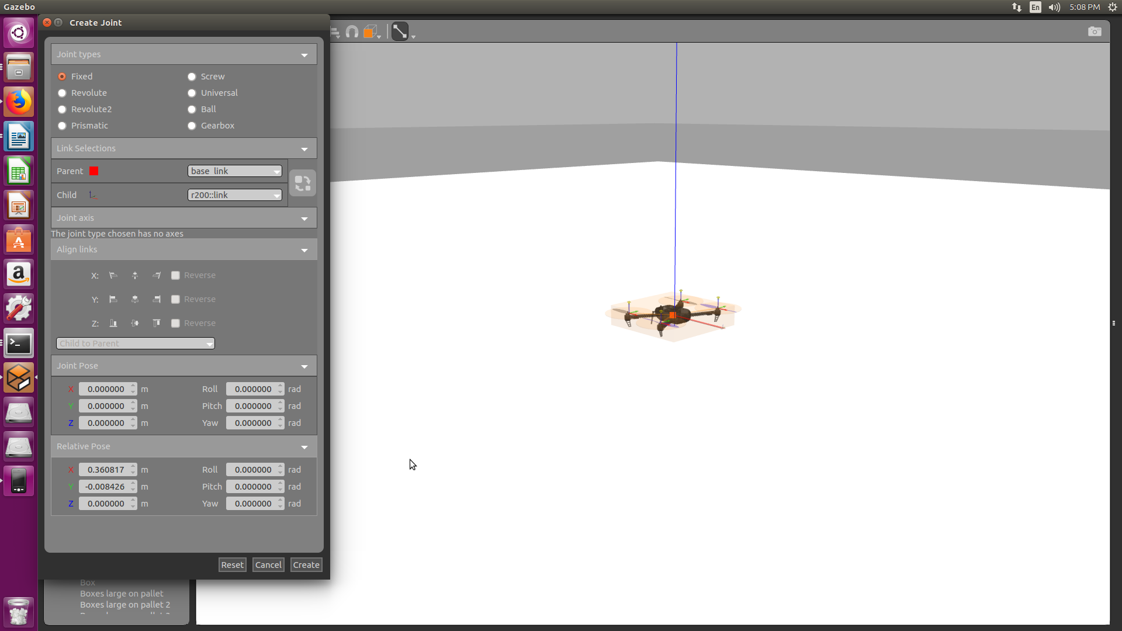
4.Add a joint with following configuration as shown above
5.Save the model in <workspace>/Firmware/Tools/sitl_gazebo/models
6.In the launch file mavros_posix_sitl.launch, create copy and change model path name as per required path:
<arg name="sdf" default="$(find mavlink_sitl_gazebo)/models/<model file name>/model.sdf"/>
7.relaunch
Experiment3
SLAM using google-cartographer
1.Launch px4 as in experiment 1
2.open another terminal and enter:
$ rosrun tf static_transform_publisher 0 0 0 -1.57 0 -1.57 /base_link /r200 100 (in case using other camera specify frame for that instead of r200, the frame name can be seen in sdf file of model)
3.Open another terminal and launch:
roslaunch pointcloud_to_laserscan sample_node1.launch(see launch file for details and if topics needs to be changed)
4.Open another terminal and source cartographer:
$ source ~/<cartographer work space>/devel_isolated/setup.bash
5. launch:
$ roslaunch cartographer_ros <launch file>
*(See .lua and .launch file file for setting parameter and in case of any change do it:<cartographer workspace>/install_isolated/share/cartographer_ros/configuration_files and <cartographer workspace>/src/cartographer_ros/configuration_files for .lua files and intead of /configuration_files go for /launch for launch files respectively)
see link for tuning SLAM parameters:https://google-cartographer-ros.readthedocs.io/en/latest/
()

