**Original Signal from shoulder exercises :**

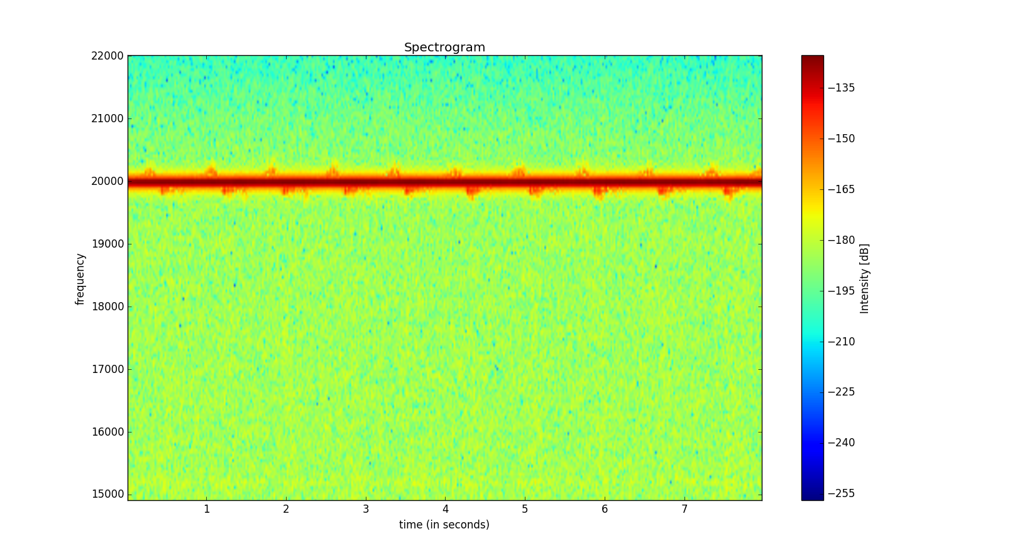

**Signal after applying FFT normalization :**

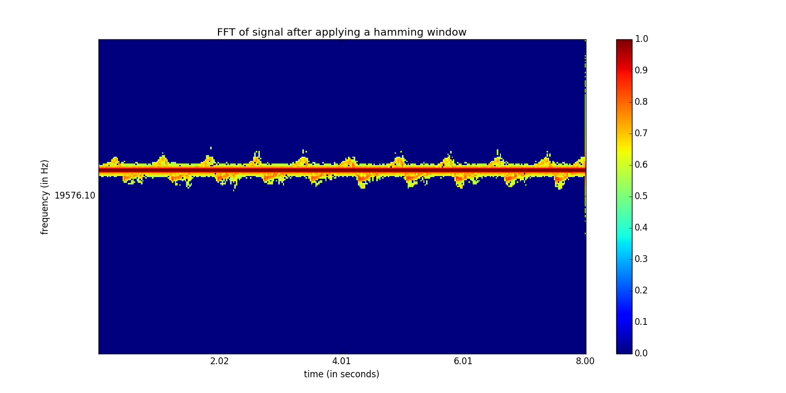

**Signal after Audio-signal segmentation** (*without the magnitudes in frequency bins squared)* :

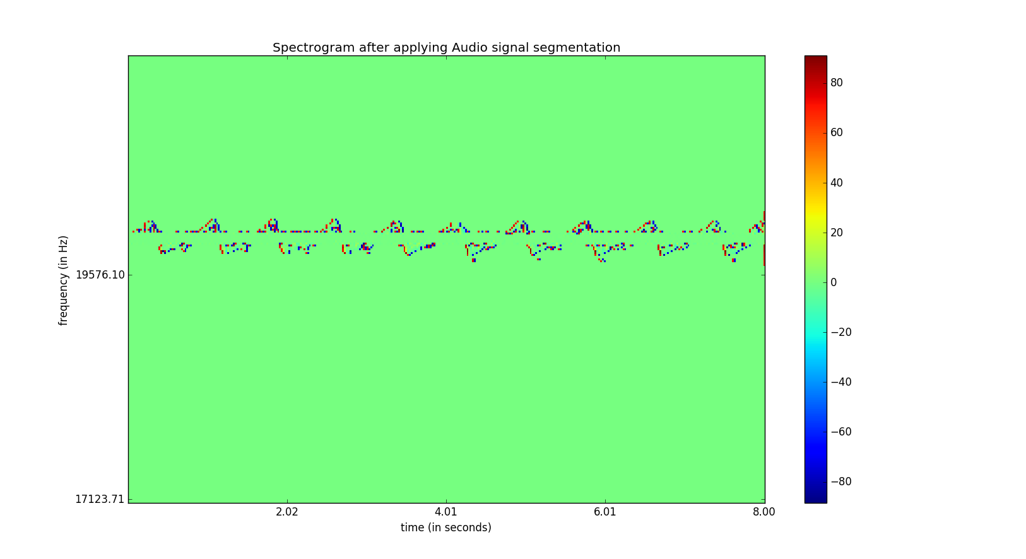

**Signal after Audio-signal segmentation** (*with squaring of magnitudes in frequency bins* ):

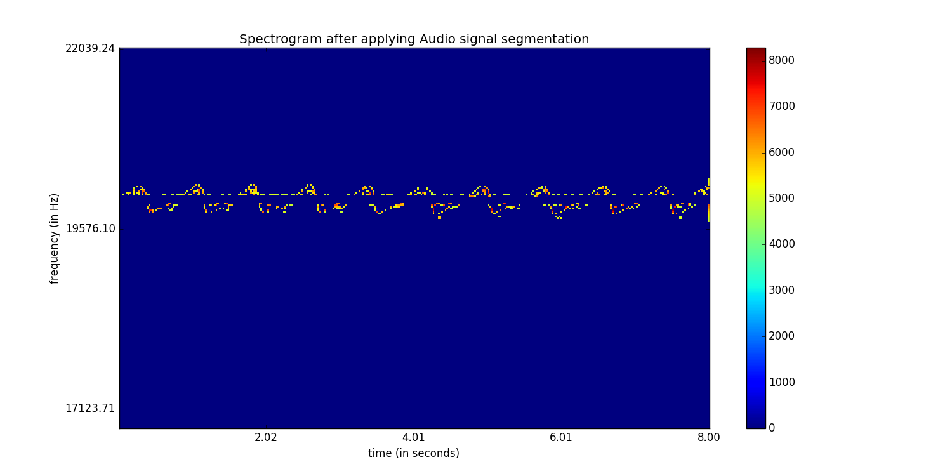

**Applying normalization** on top of this :

