TASK 2
Ansible Playbook is ran and Nginx is installed in the worker nodes.
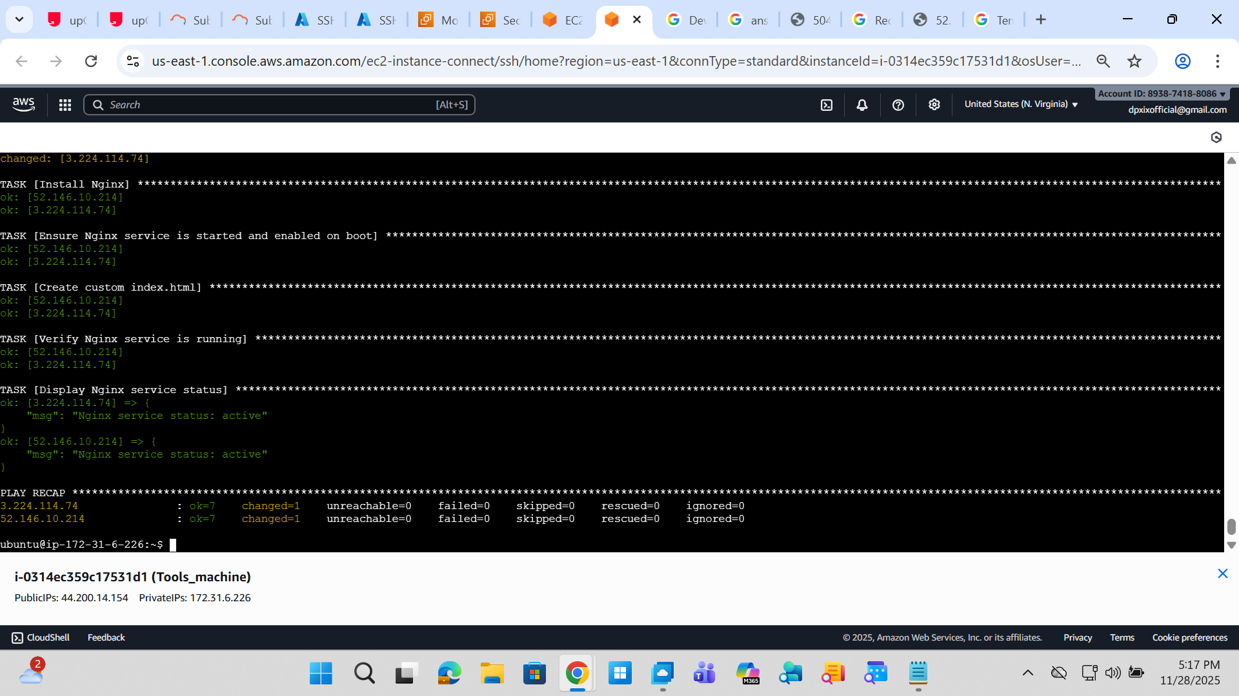
Nginx is installed via Ansible in AWS machine
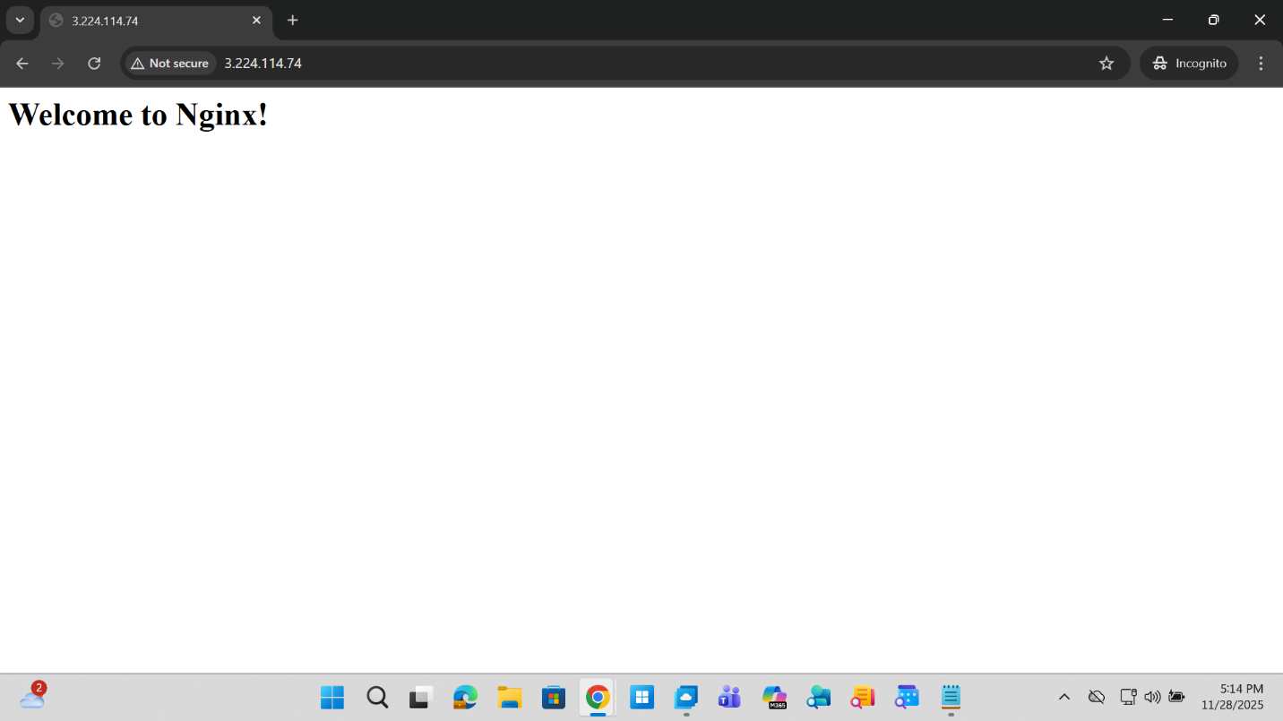

Nginx is installed in Azure machine via Ansible
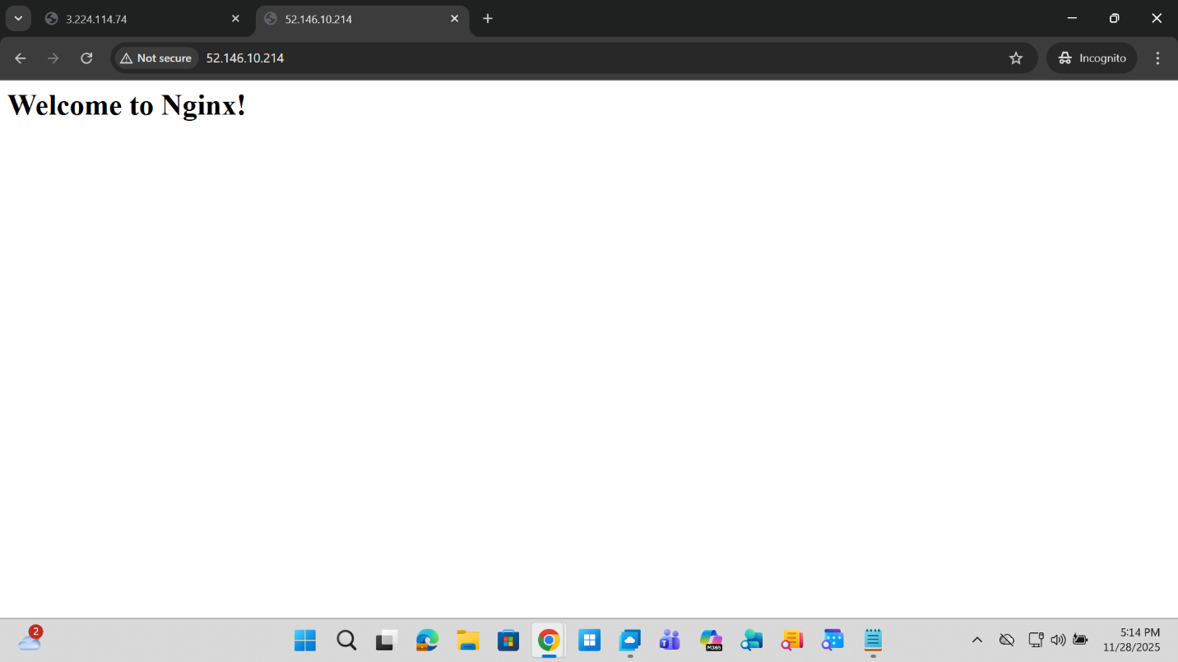
Ansible Playbook is run and the results:

