Task 1:
Tools Machine and Apps Machine are created via Terraform.
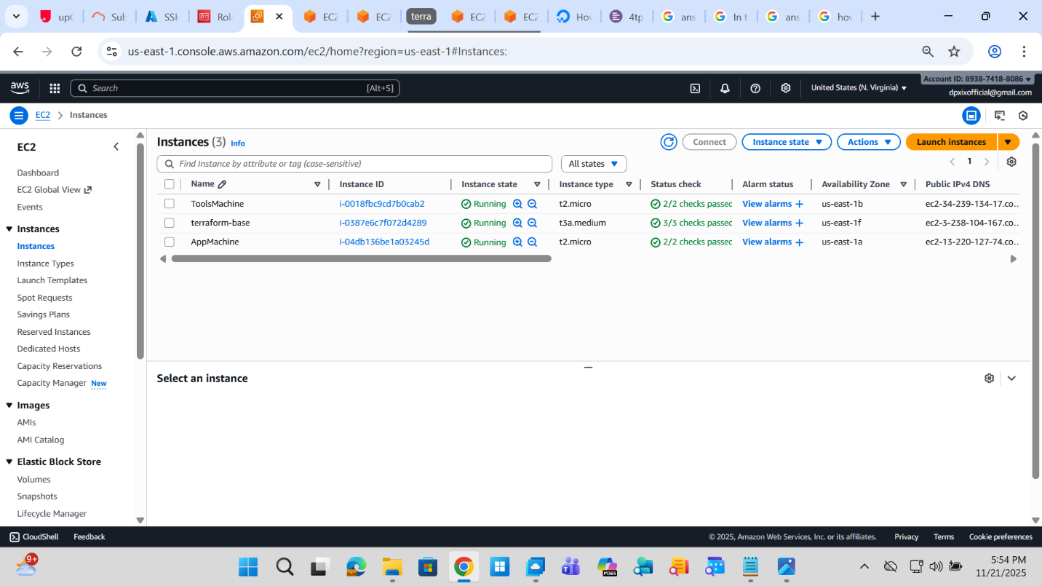
Ports 22 and 80 are opened in secuiry group
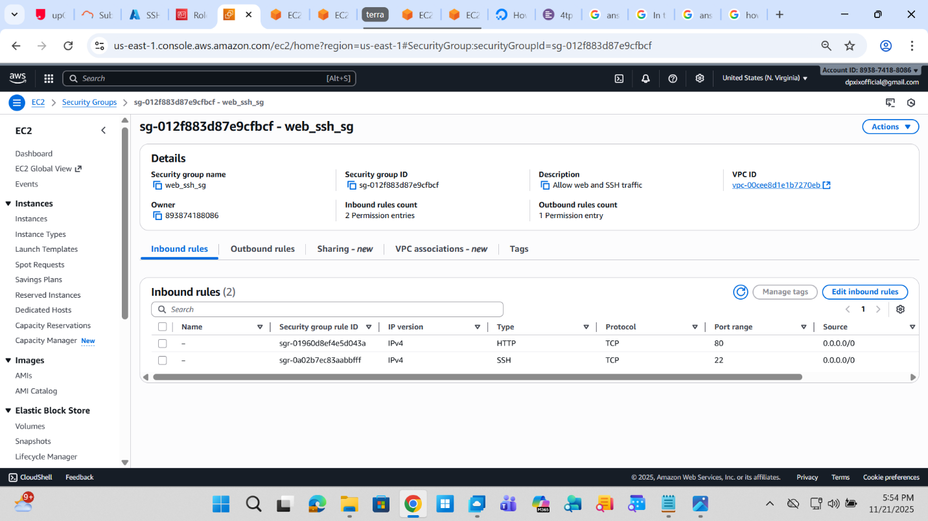

VPC and route tables are created
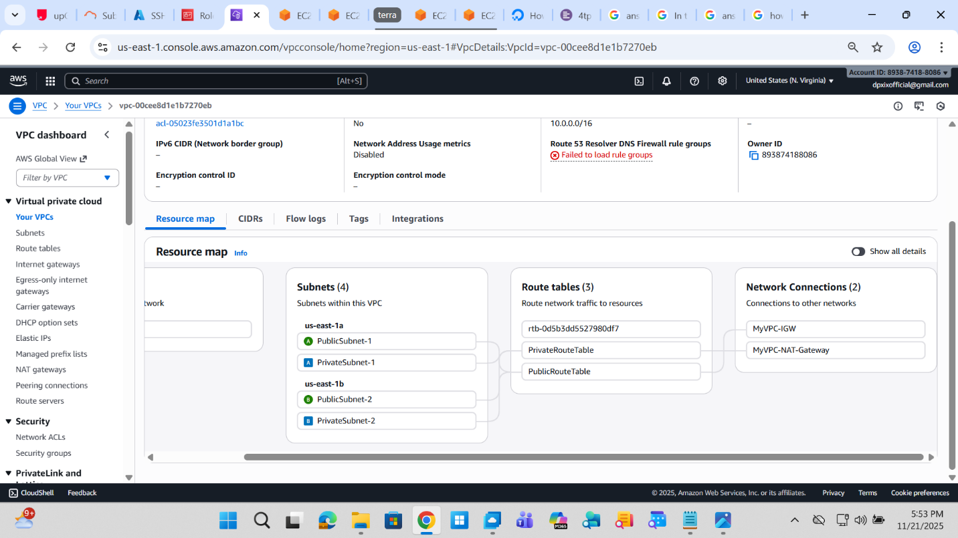
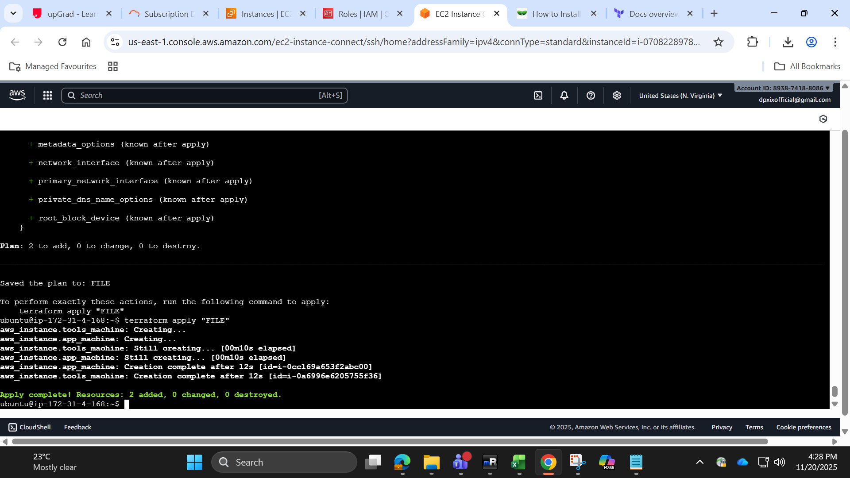

terraform {
required_version = ">= 1.0.0"
required_providers {
aws = {
source = "hashicorp/aws"
version = ">= 4.0"
}
tls = {
source = "hashicorp/tls"
version = ">= 4.0"
}
local = {
source = "hashicorp/local"
version = ">= 2.0"
}
}
}

variable "region" {
type = string
default = "us-east-1"
}

provider "aws" {
region = var.region
}

# --- VPC and Subnets ---
resource "aws_vpc" "main" {
cidr_block = "10.0.0.0/16"
enable_dns_hostnames = true
tags = { Name = "MyVPC" }
}

resource "aws_internet_gateway" "main" {
vpc_id = aws_vpc.main.id
tags = { Name = "MyVPC-IGW" }
}

data "aws_availability_zones" "available" {
state = "available"
}

resource "aws_subnet" "public" {
count = 2
vpc_id = aws_vpc.main.id
cidr_block = "10.0.${count.index}.0/24"
availability_zone = data.aws_availability_zones.available.names[count.index]
map_public_ip_on_launch = true
tags = { Name = "PublicSubnet-${count.index + 1}" }
}

resource "aws_subnet" "private" {
count = 2
vpc_id = aws_vpc.main.id
cidr_block = "10.0.${count.index + 2}.0/24"
availability_zone = data.aws_availability_zones.available.names[count.index]
tags = { Name = "PrivateSubnet-${count.index + 1}" }
}

# --- Route Tables ---
resource "aws_route_table" "public" {
vpc_id = aws_vpc.main.id
route {
cidr_block = "0.0.0.0/0"
gateway_id = aws_internet_gateway.main.id
}
tags = { Name = "PublicRouteTable" }
}

resource "aws_route_table_association" "public" {
count = 2
subnet_id = aws_subnet.public[count.index].id
route_table_id = aws_route_table.public.id
}

resource "aws_eip" "nat_gateway_eip" {
domain = "vpc"
}

resource "aws_nat_gateway" "main" {
allocation_id = aws_eip.nat_gateway_eip.id
subnet_id = aws_subnet.public[0].id
tags = { Name = "MyVPC-NAT-Gateway" }
depends_on = [aws_internet_gateway.main]
}

resource "aws_route_table" "private" {
vpc_id = aws_vpc.main.id
route {
cidr_block = "0.0.0.0/0"
nat_gateway_id = aws_nat_gateway.main.id
}
tags = { Name = "PrivateRouteTable" }
}

resource "aws_route_table_association" "private" {
count = 2
subnet_id = aws_subnet.private[count.index].id
route_table_id = aws_route_table.private.id
}

# --- Security Group ---
resource "aws_security_group" "web_ssh" {
vpc_id = aws_vpc.main.id
name = "web_ssh_sg"
description = "Allow web and SSH traffic"

ingress {
from_port = 22
to_port = 22
protocol = "tcp"
# Replace with your IP or a narrower CIDR for SSH
cidr_blocks = ["0.0.0.0/0"]
}

ingress {
from_port = 80
to_port = 80
protocol = "tcp"
cidr_blocks = ["0.0.0.0/0"]
}

egress {
from_port = 0
to_port = 0
protocol = "-1"
cidr_blocks = ["0.0.0.0/0"]
}

tags = { Name = "WebSSH-SG" }
}

# --- EC2 Key Pair ---
resource "tls_private_key" "app_key" {
algorithm = "RSA"
rsa_bits = 4096
}

resource "aws_key_pair" "app_key_pair" {
key_name = "app-key-${random_id.key_suffix.hex}"
public_key = tls_private_key.app_key.public_key_openssh
}

resource "random_id" "key_suffix" {
byte_length = 4
}

resource "local_file" "app_private_key" {
content = tls_private_key.app_key.private_key_pem
filename = "app-key.pem"
file_permission = "0400"
}

# --- Data Source for AMI ---
data "aws_ami" "ubuntu" {
most_recent = true
filter {
name = "name"
values = ["ubuntu/images/hvm-ssd/ubuntu-jammy-22.04-amd64-server-*"]
}
filter {
name = "virtualization-type"
values = ["hvm"]
}
owners = ["099720109477"]
}

# --- EC2 Instances (use security group IDs for VPC) ---
resource "aws_instance" "app_machine" {
ami = data.aws_ami.ubuntu.id
instance_type = "t2.micro"
subnet_id = aws_subnet.public[0].id
key_name = aws_key_pair.app_key_pair.key_name
vpc_security_group_ids = [aws_security_group.web_ssh.id]
tags = { Name = "AppMachine" }
}

resource "aws_instance" "tools_machine" {
ami = data.aws_ami.ubuntu.id
instance_type = "t2.micro"
subnet_id = aws_subnet.public[1].id
key_name = aws_key_pair.app_key_pair.key_name
vpc_security_group_ids = [aws_security_group.web_ssh.id]
tags = { Name = "ToolsMachine" }
}

# --- Outputs ---
output "app_public_ip" {
value = aws_instance.app_machine.public_ip
}

output "tools_public_ip" {
value = aws_instance.tools_machine.public_ip
}

output "private_key_file" {
value = local_file.app_private_key.filename
}

My application VM is created via Terraform
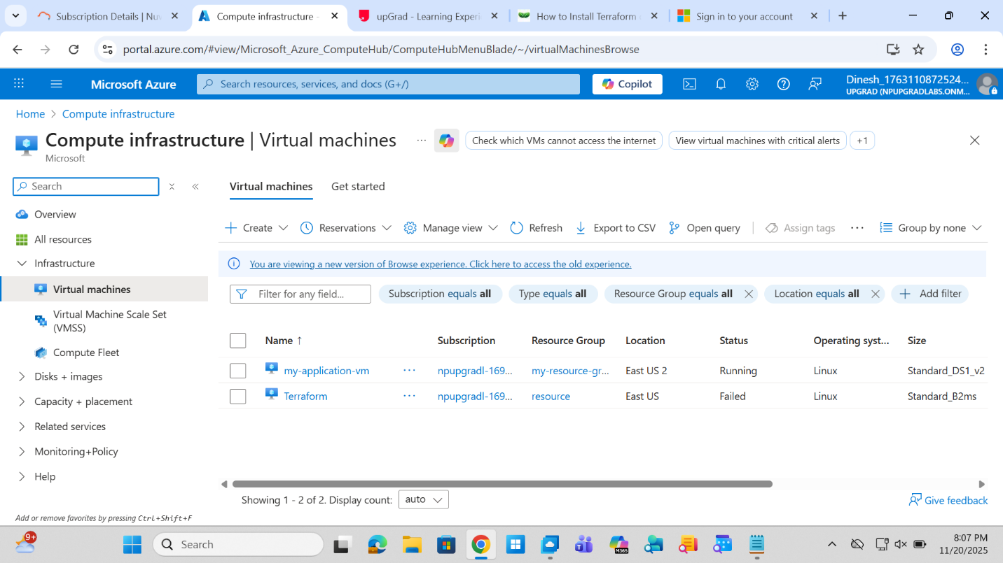

Ports 22 and 80 are opened in the NSG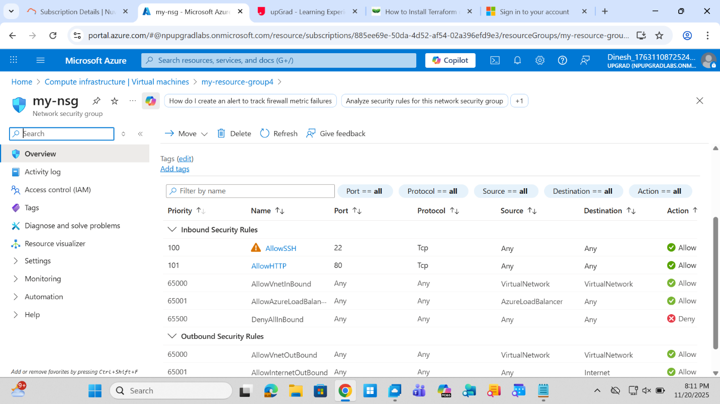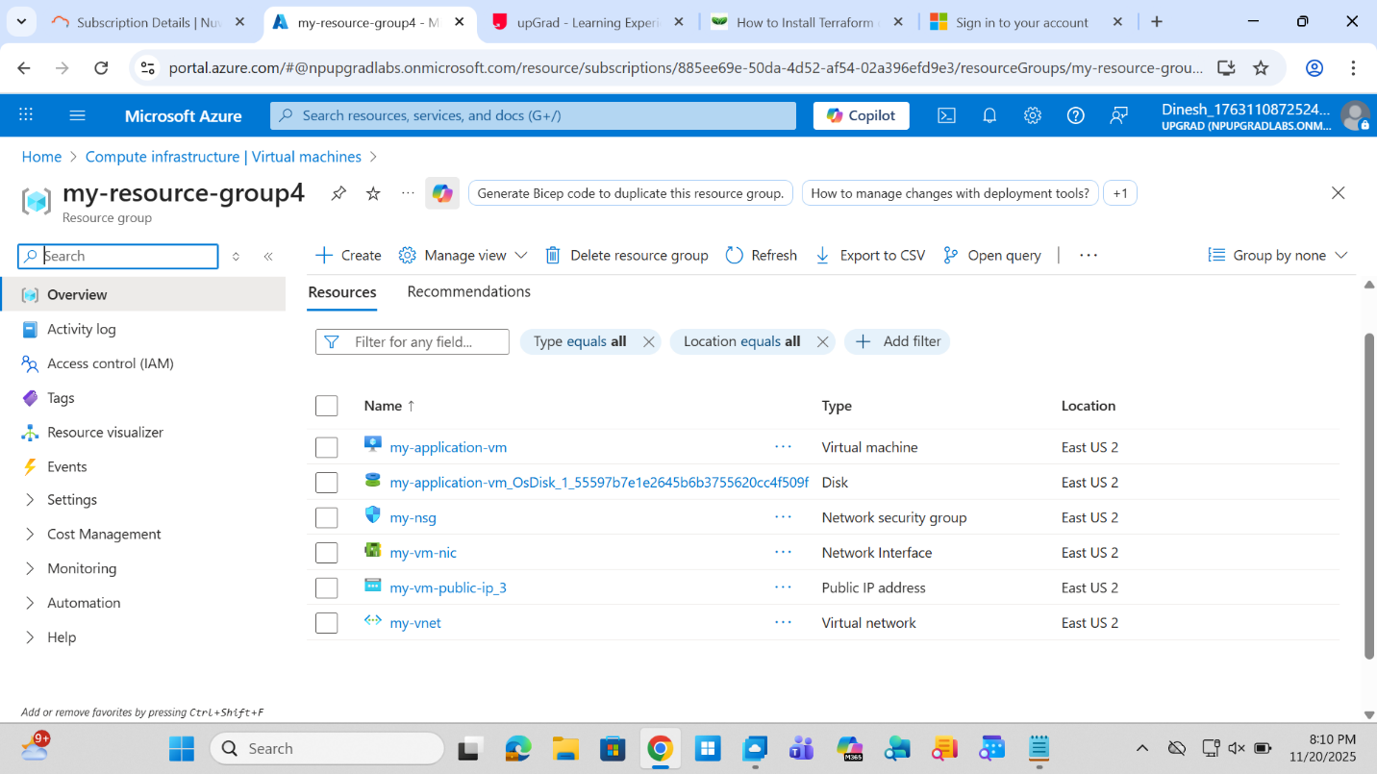
#azure output

terraform {
required_providers {
azurerm = {
source = "hashicorp/azurerm"
version = ">= 3.0"
}
}
}

provider "azurerm" {
features {}
resource_provider_registrations = "none"
subscription_id = "885ee69e-50da-4d52-af54-02a396efd9e3"
}

resource "azurerm_resource_group" "rg" {
name = "my-resource-group3"
location = "East US 2"
}

# Create a Virtual Network (VNet)
resource "azurerm_virtual_network" "vnet" {
name = "my-vnet"
address_space = ["10.0.0.0/16"]
location = azurerm_resource_group.rg.location
resource_group_name = azurerm_resource_group.rg.name
}

resource "azurerm_subnet" "subnet" {
name = "my-subnet"
resource_group_name = azurerm_resource_group.rg.name
virtual_network_name = azurerm_virtual_network.vnet.name
address_prefixes = ["10.0.1.0/24"]
}

resource "azurerm_network_security_group" "nsg" {
name = "my-nsg"
location = azurerm_resource_group.rg.location
resource_group_name = azurerm_resource_group.rg.name

security_rule {
name = "AllowSSH"
priority = 100
direction = "Inbound"
access = "Allow"
protocol = "Tcp"
source_port_range = "*"
destination_port_range = "22"
source_address_prefix = "*"
destination_address_prefix = "*"
}

security_rule {
name = "AllowHTTP"
priority = 101
direction = "Inbound"
access = "Allow"
protocol = "Tcp"
source_port_range = "*"
destination_port_range = "80"
source_address_prefix = "*"
destination_address_prefix = "*"
}
}

resource "azurerm_subnet_network_security_group_association" "nsg_association" {
subnet_id = azurerm_subnet.subnet.id
network_security_group_id = azurerm_network_security_group.nsg.id
}

resource "azurerm_public_ip" "vm_public_ip_2" {
name = "my-vm-public-ip_2"
location = azurerm_resource_group.rg.location
resource_group_name = azurerm_resource_group.rg.name
allocation_method = "Static"
sku = "Standard"
}

resource "azurerm_network_interface" "vm_nic" {
name = "my-vm-nic"
location = azurerm_resource_group.rg.location
resource_group_name = azurerm_resource_group.rg.name

ip_configuration {
name = "internal"
subnet_id = azurerm_subnet.subnet.id
private_ip_address_allocation = "Dynamic"
public_ip_address_id = azurerm_public_ip.vm_public_ip_2.id
}
}

resource "azurerm_linux_virtual_machine" "vm" {
name = "my-application-vm"
resource_group_name = azurerm_resource_group.rg.name
location = azurerm_resource_group.rg.location
size = "Standard_DS1_v2"
admin_username = "adminuser"
admin_password = "StrongPassword123!"
disable_password_authentication = "false"

network_interface_ids = [
azurerm_network_interface.vm_nic.id,
]

os_disk {
caching = "ReadWrite"
storage_account_type = "Standard_LRS"
}

source_image_reference {
publisher = "Canonical"
offer = "UbuntuServer"
sku = "18.04-LTS"
version = "latest"
}
}

