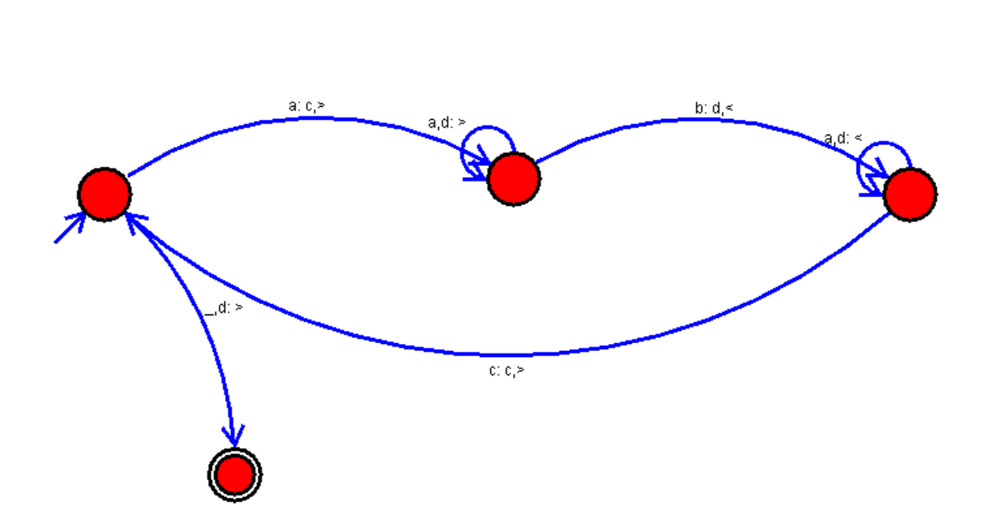15. AIM: Design Turing Machine using simulator over the set {a,b} to accept the input string anbn

DIAGRAM: